Agenda item:  Presented by:  Prepared by:  Date prepared:  Subject / title: | Jo Ward - Interim Chief Nurse  Charlotte Collings – Lead Nurse for Safe Staffing and Workforce  Polly Read – Interim Deputy Chief Nurse  15th May 2026  Safe Staffing Monthly report – March 2026
Purpose: | Approval |  | Decision |  |  | Information |  | x | Assurance |  | x
Key issues: | - A sustained overall registered staffing fill rate of >95% has been maintained.  - No wards recorded an overall fill rate below 75% during the reporting month.  - The continued increase in overall fill rates is multifactorial, including a rise in enhanced care requirements.  - The full year nursing and midwifery establishment review was completed in September 2025 and has since been approved at Board in February 2026  - Mid-Year establishment review took place in March 2026 and data being reviewed
Recommendation: | The committee are asked to note the information within this report.
Trust strategic objectives: |   Patients |   People |  |   Performance |  |  |   Places |  |  |   Pounds
Trust strategic objectives: | x | x |  | x |  |  |  |  |  | x
Previously considered by: | NA
Risk / links with the BAF: | BAF: 2.3 Workforce capacity
Legislation, regulatory, equality, diversity and dignity implications: | NHS England and CQC letter to NHSFT CEOs (31.3.14): Hard Truths Commitment regarding publishing of staffing data.  NHS Improvement letter: 22.4.16  NHS Improvement letter re CHPPD: 29/6/18
Appendices: | Appendix 1: Fill Rates  Appendix 2: Redeployment and trend data  Appendix 3: CHPPD  Appendix 4. Nursing Red Flags (NICE 2014), Incident Reports and Trend Data  Appendix 5: Nursing quality indicators

Executive Summary
Safe staffing was maintained in April 2026 with reasonable assurance. Registered nurse fill rates remained above 95% overall, and no wards fell below the 75% threshold, indicating sustained delivery against planned establishment. Overall fill rates remained high, supported by continued use of care staff and escalation capacity.
Care Hours Per Patient Day (CHPPD) increased slightly from the previous month, reflecting a continued response to patient acuity, dependency and enhanced care requirements rather than surplus staffing. CHPPD remains comparable with peer organisations and below the national median, providing external assurance.
Quality indicators present a mixed position. Falls increased, including those resulting in harm, indicating ongoing fragility in high-acuity areas. In contrast, reportable hospital-acquired pressure ulcers reduced slightly. Patient experience data shows increased complaints and PALS contacts, alongside fewer recorded compliments, although variation in reporting remains a contributory factor.
Nursing Red Flag reporting continues to provide important real-time intelligence; however, unreviewed SafeCare Red Flags continue to limit full assurance regarding risk mitigation and governance. Enhanced care remains a significant driver of workforce pressure, with demand largely met through bank staffing and a continued gap between required and filled hours.
Overall judgement: Staffing in April remained safe and was actively managed through established escalation and governance processes. While high fill rates demonstrate delivery against planned establishment, triangulated data indicates that patient acuity, dependency and enhanced care demand continue to place sustained pressure on the workforce. Safety is therefore increasingly reliant on escalation, temporary staffing and workforce flexibility, reinforcing the need for continued senior oversight and strengthened governance, particularly in relation to demand-based staffing and Red Flag actioning.
1.0 Introduction
This report outlines nursing and midwifery staffing deployment at PAHT during April 2026, demonstrating how safe staffing levels were achieved and maintained. It also sets out governance and workforce management arrangements supporting this position.
2.0 Background
Monthly staffing data is reviewed against expected levels and quality indicators in line with National Quality Board (NQB, 2016) and the Developing Workforce Safeguards (NHSI, 2018) guidance. The Trust remains committed to identifying improvements, addressing risks promptly, and sustaining high-quality patient care.
3.0 Inpatient Wards Fill Rate and Workforce Deployment
The Trust’s safer staffing submission for April 2026 was completed within the required timeframe. Table 1 provides a summary of overall fill rates for the month, with Table 2 showing a rolling 12-month trend. A ward-level breakdown is provided in Appendix 1.
In April, overall fill rates remained strong, with registered nurse fill at 99.2% and total fill at 103.6%. This indicates sustained delivery against funded establishment, supported by continued use of care staff and escalation capacity. Importantly, no wards recorded an average fill rate below 75%, providing assurance that minimum staffing requirements were consistently maintained.
As in previous months, fill rates reflect staffing delivered against planned establishment and roster templates, which are based on average demand rather than real-time acuity. While high fill rates demonstrate good roster performance, they do not in isolation confirm that staffing levels were sufficient to meet patient need, particularly where acuity and enhanced care requirements are high.
Further analysis continues to explore the relationship between staffing provision, patient dependency and enhanced care demand. This remains complex due to data availability. Work is also underway to develop a more robust approach to capturing and reporting actual staffing demand, rather than relying solely on fill rates against funded establishment. This will enable clearer visibility of the variance between planned and required staffing, providing a more accurate picture of safe staffing and reflecting fluctuations in patient acuity and dependency across the month.

Table 1. Overall fill rate
Average day fill rate - registered | Average day fill rate - care staff | Average night fill rate - registered | Average night fill rate - care staff | % Registered overall fill rate | % HCSW overall fill rate | % Overall fill rate
95.2% | 105.6% | 104.2% | 121.2% | 99.2% | 112.7% | 103.6%

Table 2. Inpatient fill rate including Maternity Wards Trend
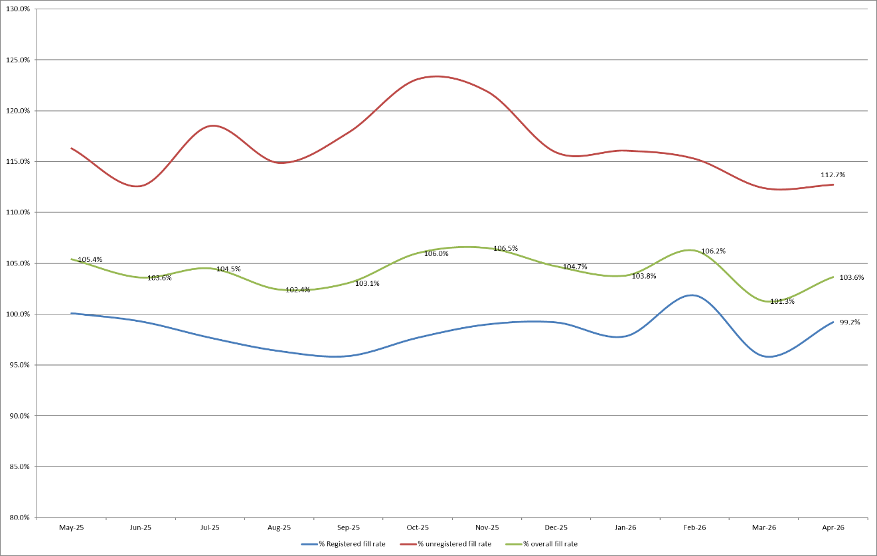
Appendix 1 sets out a ward-by-ward breakdown for the same period.
Workforce context, pipeline and establishment – Registered nurse vacancies remain at 8.01%, indicating a broadly stable position despite remaining above benchmark. HCSW vacancy levels are 13.39%, reflecting ongoing retention challenges and increased leavers, consistent with wider national trends. Registered midwifery workforce data is newly included this month and indicates an over-established position.
Following data validation, it was identified that March vacancy figures were extracted using a different methodology. A review of both datasets confirms that vacancy levels are broadly consistent across March and April.
Recruitment continues across nursing and HCSW roles, including targeted activity for newly qualified nurses and ongoing partnership work with Harlow College to support a more sustainable local HCSW pipeline. While these initiatives provide a more predictable supply, current recruitment activity alone is unlikely to fully offset workforce demand when considered alongside workforce attrition.
Recruitment to registered nurse degree apprenticeships is also underway; however, given the longer training pipeline, careful alignment to future workforce requirements and planned backfill remains essential to support long-term sustainability without increasing reliance on temporary staffing.
The end-of-year establishment review was approved by the Board in February 2026, and the mid-year establishment review has now concluded across inpatient nursing areas and both adult and paediatric Emergency Departments. Findings from the March 2026 SNCT review have been shared with ward teams, with a comprehensive report currently undergoing final review.
The next end-of-year establishment review is scheduled for September 2026. In line with Developing Workforce Safeguards guidance (NHSI, 2018), there are plans from 2027 to move to a biannual review cycle in January and June to better reflect seasonal variation in service demand.
Emergency Departments – Although Emergency Departments are excluded from national safer staffing reporting, local Adult and Paediatric ED data continues to be reported for assurance purposes (Appendix 1, Tables 1b and 1c).
In April, Paediatric ED continued to generate additional shifts beyond the agreed template, contributing to increased spend and indicating ongoing misalignment between staffing and demand. This position was reviewed through the SNCT feedback process and Nursing Roster Quality and Safety meetings, where it was again identified as a key area of focus.
The service has responded proactively, with a reduction in additional shifts and initiation of staff consultation to support the introduction of a middle shift aligned to peak demand. Benchmarking has also been undertaken with neighbouring paediatric Emergency Departments to better understand comparative staffing establishments and shift profiles, supporting local redesign and improvement.
Enhanced Care – A significant proportion of registered enhanced care demand relates to patients requiring mental health nursing input, for which the Trust does not hold a substantive workforce. Demand remains sustained, with ongoing reliance on bank staffing and a gap between required and filled hours (Appendix 1, Table 1d). While the overall position is broadly unchanged from the previous month, work continues to strengthen the accuracy of enhanced care data, including participation in RLDatix workshops to inform improved recording approaches and ongoing Task and Finish Group oversight to enhance ward-level data capture and governance.
3.1 Wards with < 75% average fill rate
No wards recorded an average fill rate below 75%.
3.2 Wards with > 100% average fill rate
Nine areas recorded average registered fill rates above 100% during April. This reflects staffing delivered above planned (funded) establishment, which is set against average patient need, to respond to fluctuations in patient acuity and dependency, informed by professional judgement, rather than over-establishment.
In most cases, this is associated with enhanced care requirements and the need for additional staffing to maintain patient safety, alongside variation in demand and patient flow across the month.
4.0 Redeployment
Appendix 2 outlines the data and trends for this month.
Redeployment continued to support safe staffing through daily safety huddles and real-time acuity review. In April, both substantive and overall redeployment reduced compared to the previous month, indicating a slightly decreased reliance on workforce flexibility, while remaining an important mitigation in response to operational pressure.
Wards with sustained higher fill rates continued to act as net providers of staff, supporting areas experiencing increased patient acuity, dependency and enhanced care demand. All redeployments were clinically risk assessed and governed through SafeCare and daily safety huddles, ensuring proportionate mitigation and ongoing oversight.
5.0 Care Hours Per Patient Day (CHPPD)
CHPPD measures staffing input rather than patient need. It is a simple calculation based on staff hours worked and patient numbers and does not account for skill mix, acuity or dependency. As such, it reflects the estimated care time available, not the level of care required, and should be considered alongside fill rates, acuity indicators, Red Flags and quality outcomes for assurance.
Appendix 3 provides the ward and divisional CHPPD breakdown and a planned versus actual comparison to identify areas where staffing deployment may not align with demand.
Table 3. Overall Care Hours Per Patient Day (CHPPD) April 2026
Registered CHPPD | Unregistered CHPPD | Total CHPPD
5.3 | 2.9 | 8.2
Appendix 3 provides a detailed breakdown of CHPPD by ward and division for April 2026.
Table 4. CHPPD Trend and benchmarking with peer and national data
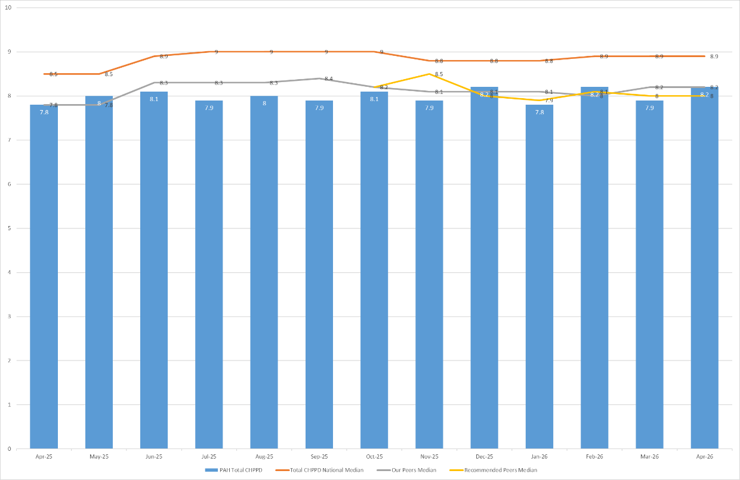
Peer organisations include East and North Hertfordshire NHS Trust and West Hertfordshire Teaching Hospitals NHS Trust. Recommended peers are Ashford and St Peter’s Hospitals NHS Foundation Trust, Buckinghamshire Healthcare NHS Trust, Dartford and Gravesham NHS Trust, George Eliot Hospital NHS Trust, Mid Cheshire Hospitals NHS Foundation Trust, Salisbury NHS Foundation Trust, Surrey and Sussex Healthcare NHS Trust, The Hillingdon Hospitals NHS Foundation Trust, West Suffolk NHS Foundation Trust and Wye Valley NHS Trust.
Benchmarking indicates that the Trust’s CHPPD remains comparable with peer organisations and below the national median, providing external assurance when viewed in the wider context.
6.0 Quality Indicators
6.1 Red Flags and Incident Reports Relating to Staffing
Appendix 4 outlines data and trends for Nursing Red Flags and staffing-related incidents.
Two Red Flag mechanisms continue to operate within the Trust. Automatic Red Flags, generated when registered staffing falls below 75% of the planned template, remained low during April, reflecting sustained compliance with minimum registered staffing thresholds.
Locally raised SafeCare Red Flags provide real-time intelligence based on professional judgement and include the six NICE (2014) indicators alongside locally agreed flags relating to enhanced care provision and unregistered (HCSW) staffing shortfalls. Reporting has increased across a few areas; however, this is likely to remain an underrepresentation of true staffing pressures.
Although a significant number of SafeCare Red Flags remain unactioned or unresolved, work has progressed during April to strengthen oversight and governance. This includes enhanced reporting through the introduction of review and outcome tracking, alongside reinforced communication to ward managers and matrons to support consistent review and closure. Continued focus is required to ensure that Red Flags are reliably actioned and provide assurance of effective risk mitigation.
Staffing-related Datix incidents for lack of suitably trained or skilled staff remained broadly stable during April and provide complementary assurance when considered alongside Red Flag, redeployment and CHPPD data.
6.2 Falls, pressure ulcers and complaints, PALS and compliments
April data demonstrates a mixed position across quality indicators, with some improvement alongside areas of continued pressure in high-acuity services.
Falls increased compared with the previous month, including unwitnessed falls and those resulting in harm. Triangulated review of falls, patient acuity and staffing deployment indicates that incidents remain concentrated within a small number of high-pressure clinical areas.
Pressure ulcers remained broadly consistent with the previous month in terms of reportable harm. A reduction in higher-category harm was noted; however, increases in device-related pressure ulcers and continued themes relating to sacral damage indicate ongoing challenges in prevention, particularly in high-acuity settings. Targeted quality improvement work and prevention initiatives continue to address this
Patient experience remained stable overall. While complaints and PALS contacts increased and recorded compliments reduced compared to the previous month, compliments data has only been available for two consecutive months and is not yet sufficient to establish a clear trend. Recurring themes continue to relate to delay and communication, particularly in high-pressure areas.
Overall, quality indicators continue to reflect the impact of sustained acuity, dependency and enhanced care demand, with some areas of improvement alongside ongoing fragility. This reinforces the importance of continued leadership oversight and triangulated review of staffing, patient need and quality outcomes.
Data and trends of quality indicators is provided in Appendix 5.
7.0 Conclusion: Assurance and Governance
April data demonstrates that safe staffing continues to be maintained; however, this is increasingly achieved through active workforce management in response to sustained patient acuity, dependency and enhanced care demand.
Established governance arrangements, including daily SafeCare huddles and senior clinical oversight, continue to provide effective mechanisms to identify and mitigate staffing risk. While reliance on redeployment reduced compared with the previous month, temporary workforce and escalation capacity remain key enablers of safe care delivery.
Triangulated review of staffing, quality and operational data highlights ongoing system pressure, with particular challenges in ensuring consistent visibility and closure of identified risks through SafeCare Red Flags. Strengthening these processes will be critical to improving assurance around real-time risk management.
Overall, the Trust continues to demonstrate a proactive and responsive approach to workforce management; however, sustained focus on demand-based staffing, data quality and governance will be required to support safe and effective care delivery.
8.0 Recommendation
The Board is asked to note the contents of this report, which provide assurance that nursing and midwifery staffing remained safe during April 2026, supported through established escalation and governance arrangements.
The Board is also asked to support continued focus on strengthening workforce governance, including oversight of enhanced care demand, demand-based staffing and workforce deployment, and the consistent review and closure of Nursing Red Flags to support effective real-time risk management during periods of sustained pressure.

Appendix 1: Fill Rates
Table 1a: Ward level data – fill rates April 2026 (Adjusted Standard Planned Ward Demand)
 | >100% |  | 95 – 100% |  |  | 75-95% |  |  | <75%
 |  | Day |  |  | Night
Ward name |  | Average fill rate - registered nurses/midwives (%) |  | Average fill rate - care staff (%) | Average fill rate - registered nurses/midwives (%) |  | Average fill rate - care staff (%) | % Registered overall fill rate |  | % HCSW overall fill rate | % Overall fill rate
Harvey |  | 104.7% |  | 139.8% | 132.2% |  | 136.6% | 115.9% |  | 138.2% | 124.0%
Henry Moore |  | 93.6% |  | 96.3% | 151.0% |  | 101.1% | 115.1% |  | 98.6% | 108.2%
ITU & HDU |  | 96.5% |  | 81.9% | 100.3% |  | 111.5% | 98.4% |  | 96.1% | 98.2%
John Snow |  | 85.4% |  | 57.3% | 81.8% |  | 30.0% | 83.7% |  | 44.3% | 70.5%
Penn |  | 96.5% |  | 117.5% | 101.7% |  | 143.2% | 98.7% |  | 127.3% | 108.9%
Saunders |  | 89.8% |  | 110.3% | 124.3% |  | 138.0% | 102.7% |  | 120.8% | 109.5%
Planned Pathways Total |  | 95.3% |  | 107.0% | 112.2% |  | 116.4% | 102.7% |  | 111.1% | 105.2%
Fleming |  | 87.5% |  | 106.9% | 100.0% |  | 115.8% | 92.8% |  | 111.1% | 98.4%
Harold |  | 95.9% |  | 99.0% | 101.9% |  | 114.2% | 98.5% |  | 106.3% | 101.0%
Kingsmoor |  | 94.8% |  | 130.6% | 118.2% |  | 147.3% | 103.7% |  | 138.6% | 116.7%
Lister |  | 95.4% |  | 117.4% | 100.0% |  | 137.6% | 97.3% |  | 127.0% | 109.2%
Locke |  | 94.1% |  | 118.0% | 100.8% |  | 139.8% | 97.0% |  | 128.4% | 109.5%
Nightingale |  | 100.1% |  | 66.7% | 100.0% |  | 89.6% | 100.1% |  | 77.7% | 88.9%
Opal |  | 102.8% |  | 107.2% | 99.9% |  | 106.5% | 101.4% |  | 106.9% | 103.6%
Ray |  | 103.8% |  | 108.6% | 120.8% |  | 157.3% | 111.0% |  | 127.1% | 116.8%
Tye Green |  | 89.2% |  | 107.0% | 97.3% |  | 148.6% | 92.7% |  | 123.9% | 104.9%
Winter |  | 95.9% |  | 116.1% | 99.2% |  | 137.6% | 97.3% |  | 126.4% | 108.9%
AAU |  | 84.4% |  | 125.3% | 100.4% |  | 153.9% | 91.5% |  | 139.0% | 101.5%
Charnley |  | 95.2% |  | 141.0% | 100.7% |  | 144.8% | 97.8% |  | 142.8% | 110.7%
Integrated Emergency and Medical Pathways Total |  | 93.9% |  | 112.2% | 103.1% |  | 133.7% | 97.9% |  | 122.1% | 106.4%
Birthing |  | 139.7% |  | 93.6% | 126.3% |  | 93.3% | 133.3% |  | 93.5% | 120.0%
Chamberlen |  | 98.2% |  | 66.7% | 94.8% |  | 83.3% | 96.6% |  | 74.6% | 91.1%
Dolphin |  | 92.8% |  | 65.2% | 98.2% |  | 86.4% | 95.2% |  | 72.3% | 89.5%
Labour |  | 91.0% |  | 85.9% | 89.0% |  | 82.5% | 90.0% |  | 84.3% | 88.8%
Neo-Natal Unit |  | 99.1% |  | 106.3% | 103.4% |  | 90.0% | 101.3% |  | 98.1% | 100.7%
Samson |  | 97.5% |  | 90.0% | 95.8% |  | 94.1% | 96.7% |  | 92.0% | 94.0%
Family, Diagnostics and community Total |  | 98.5% |  | 84.5% | 98.3% |  | 89.4% | 98.4% |  | 86.8% | 94.9%
Total |  | 95.2% |  | 105.6% | 104.2% |  | 121.2% | 99.2% |  | 112.7% | 103.6%
Table 1b: ED data – fill rates April 2026 (Standard Planned Demand)
Average day fill rate - registered | Average day fill rate - care staff | Average night fill rate - registered | Average night fill rate - care staff | % Registered overall fill rate | % HCSW overall fill rate | % Overall fill rate
100.8% | 102.2% | 111.5% | 118.6% | 105.6% | 109.5% | 106.8%
Table 1c: Paediatric ED data – fill rates April 2026 (Standard Planned Demand)
Average day fill rate - registered | Average day fill rate - care staff | Average night fill rate - registered | Average night fill rate - care staff | % Registered overall fill rate | % HCSW overall fill rate | % Overall fill rate
123.0% | 73.3% | 153% | 91.8% | 136.5% | 83% | 123.0%

Table 1d: Enhanced Care Data Demand Vs. Fill Rates April 2026
Registered | Hours
Overall number of ETOC hours provided in month | 1520
Number of ETOC hours provided by substantive staff | 0
Number of ETOC hours provided by bank staff | 1520
Number of ETOC hours provided by agency staff | 0
Number of unfilled hours for staff relating to ETOC | 1680
Unregistered
Overall number of ETOC hours provided in month | 6717
Number of ETOC hours provided by substantive staff | 1038
Number of ETOC hours provided by bank staff | 5679
Number of ETOC hours provided by agency staff | 0
Number of unfilled hours for staff relating to ETOC | 6495

Appendix 2: Redeployment and trend data

Table 1. Hours of substantive staff redeployed Apr-26

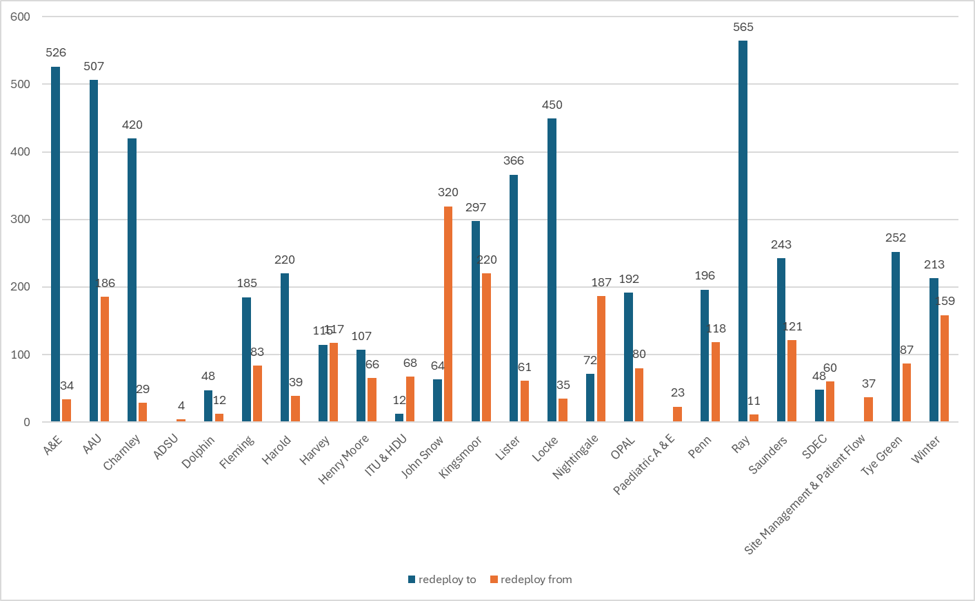

Table 2. Substantive staff redeployment ocasions trend May-25 –Apr-26
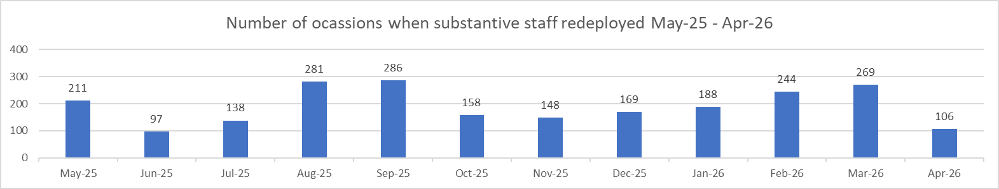

Table 3. % of substantive staff redeployed as % of total hours worked
Substantive staff hours redeployed | Total hours worked (inc. bank and agency) | % of total hours worked / substantive staff redeployed
2016.98 | 139887 | 1.44% (Mar: 1.62%)

Table 4. % of staff redeployed as % of total hours worked
All staff hours redeployed (including bank and agency but excluding Enhanced Care Team, Bank Pool and Rapid Response Pool) | Total hours worked (inc. bank and agency) | % of total hours worked / staff redeployed (including bank and agency but excluding Enhanced Care Team, Bank Pool and Rapid Response Pool)
2152.22 | 139887 | 1.53% (Mar: 1.91%)

Appendix 3: CHPPD

Table 1. Ward level data: CHPPD April 2026
Care Hours Per Patient Day (CHPPD)
Ward/Unit | Registered Nurses/Midwives | Non-registered Nurses/Midwives | Overall
Trust Total | 5.3 | 2.9 | 8.2
Harvey | 4.7 | 3.2 | 7.9
Henry Moore | 4.3 | 2.7 | 7.0
ITU & HDU | 27.2 | 2.7 | 29.8
John Snow | 6.6 | 1.8 | 8.4
Penn | 3.8 | 2.7 | 6.5
Saunders | 3.7 | 2.6 | 6.2
Planned Pathways Total | 5.9 | 2.7 | 8.6
Fleming | 3.8 | 2.0 | 5.7
Harold | 4.8 | 2.4 | 7.1
Kingsmoor | 3.8 | 3.0 | 6.8
Lister | 3.7 | 3.2 | 7.0
Locke | 3.7 | 3.2 | 6.9
Nightingale | 4.0 | 3.1 | 7.1
Opal | 4.8 | 3.4 | 8.2
Ray | 4.2 | 2.7 | 6.9
Tye Green | 3.9 | 3.4 | 7.3
Winter | 3.7 | 3.2 | 6.8
AAU | 6.0 | 2.4 | 8.4
Charnley | 4.2 | 2.5 | 6.7
Integrated Emergency and Medical Pathways Total | 4.2 | 2.8 | 7.0
Birthing Unit | 15.5 | 5.4 | 20.9
Chamberlen | 7.2 | 1.8 | 9.0
Dolphin | 15.2 | 3.8 | 19.0
Labour | 24.9 | 6.6 | 31.5
Neo-Natal | 10.2 | 2.0 | 12.1
Samson | 3.3 | 4.2 | 7.6
Family, Diagnostics and community Total | 9.7 | 3.7 | 13.4

Appendix 4. Nursing Red Flags (NICE 2014), Incident Reports and Trend Data

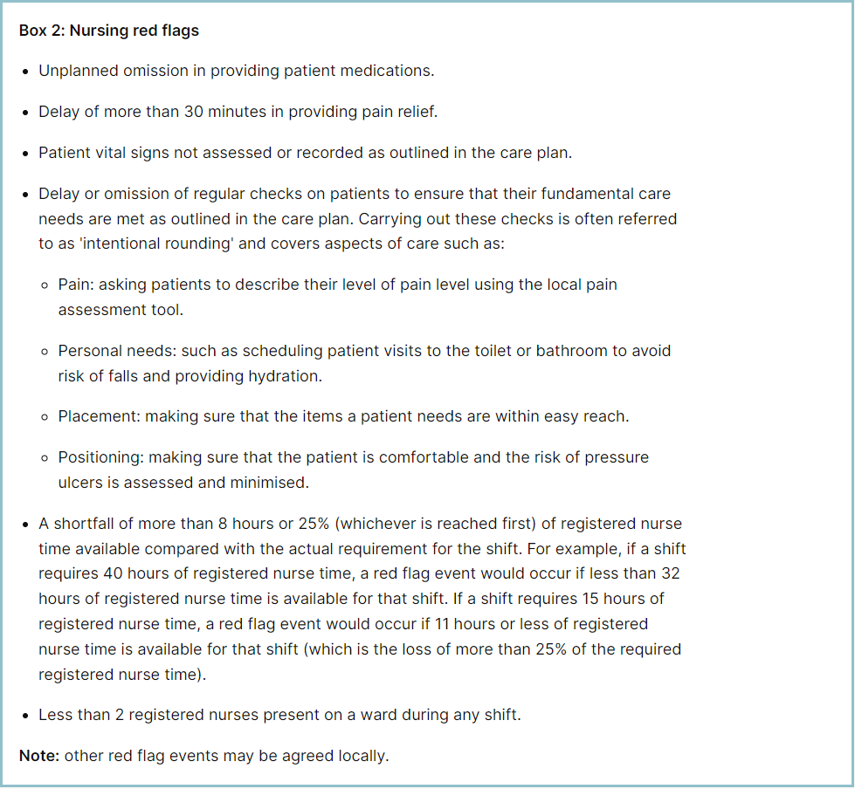
Staffing Red Flags and Trend Data
Table 1. Occasions when registered staffing fell below 75% of standard template Apr-26
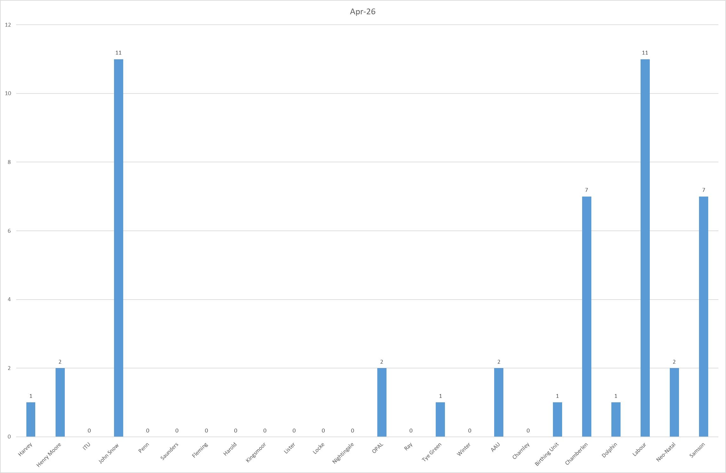

Table 2a. Occasions when all registered staffing fell below 75% of standard template. Trend Data May-25 –Apr-26
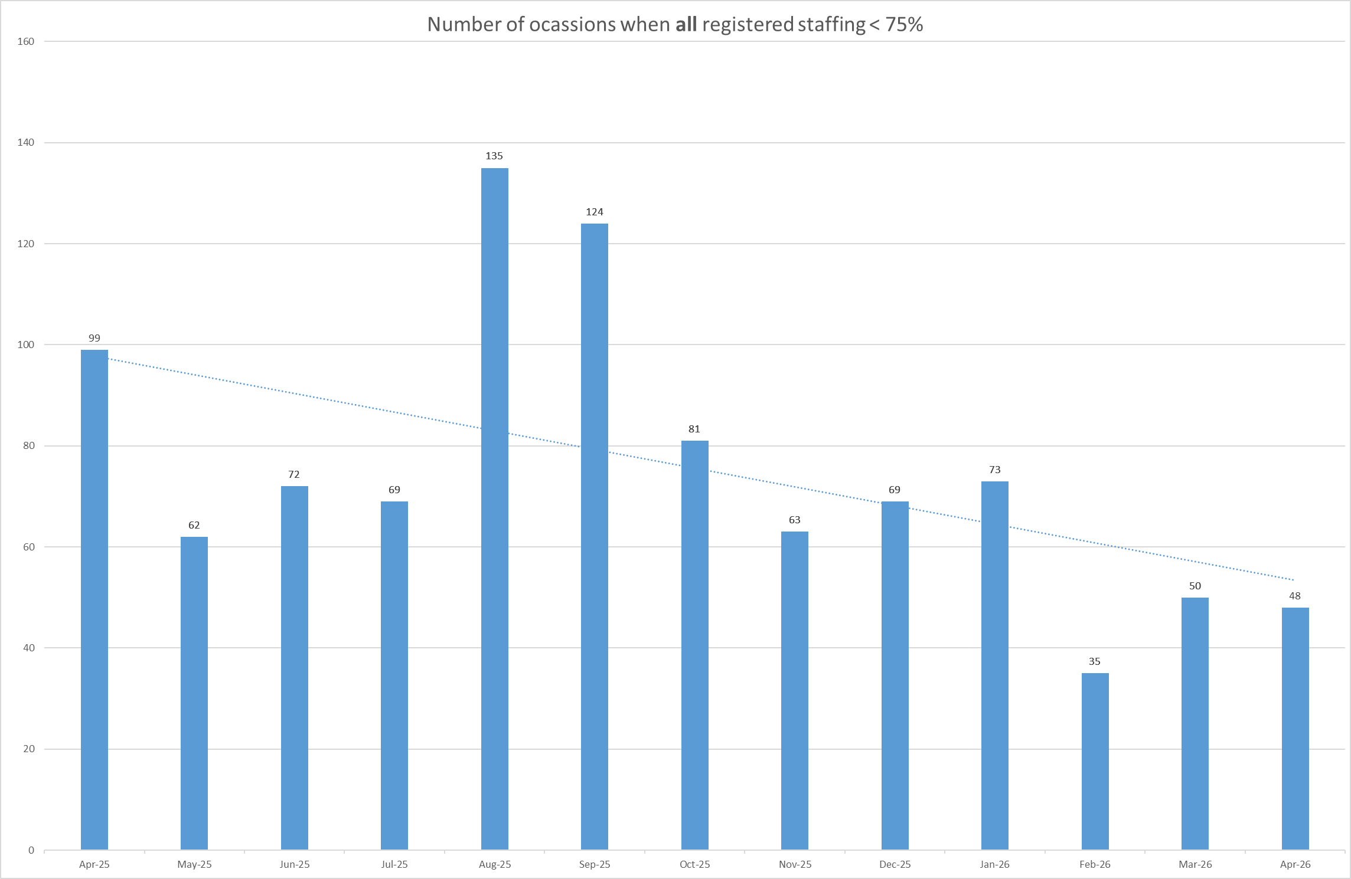

Table 2b. Occasions when registered maternity staffing fell below 75% of standard template. Trend Data May-25 – Apr-26
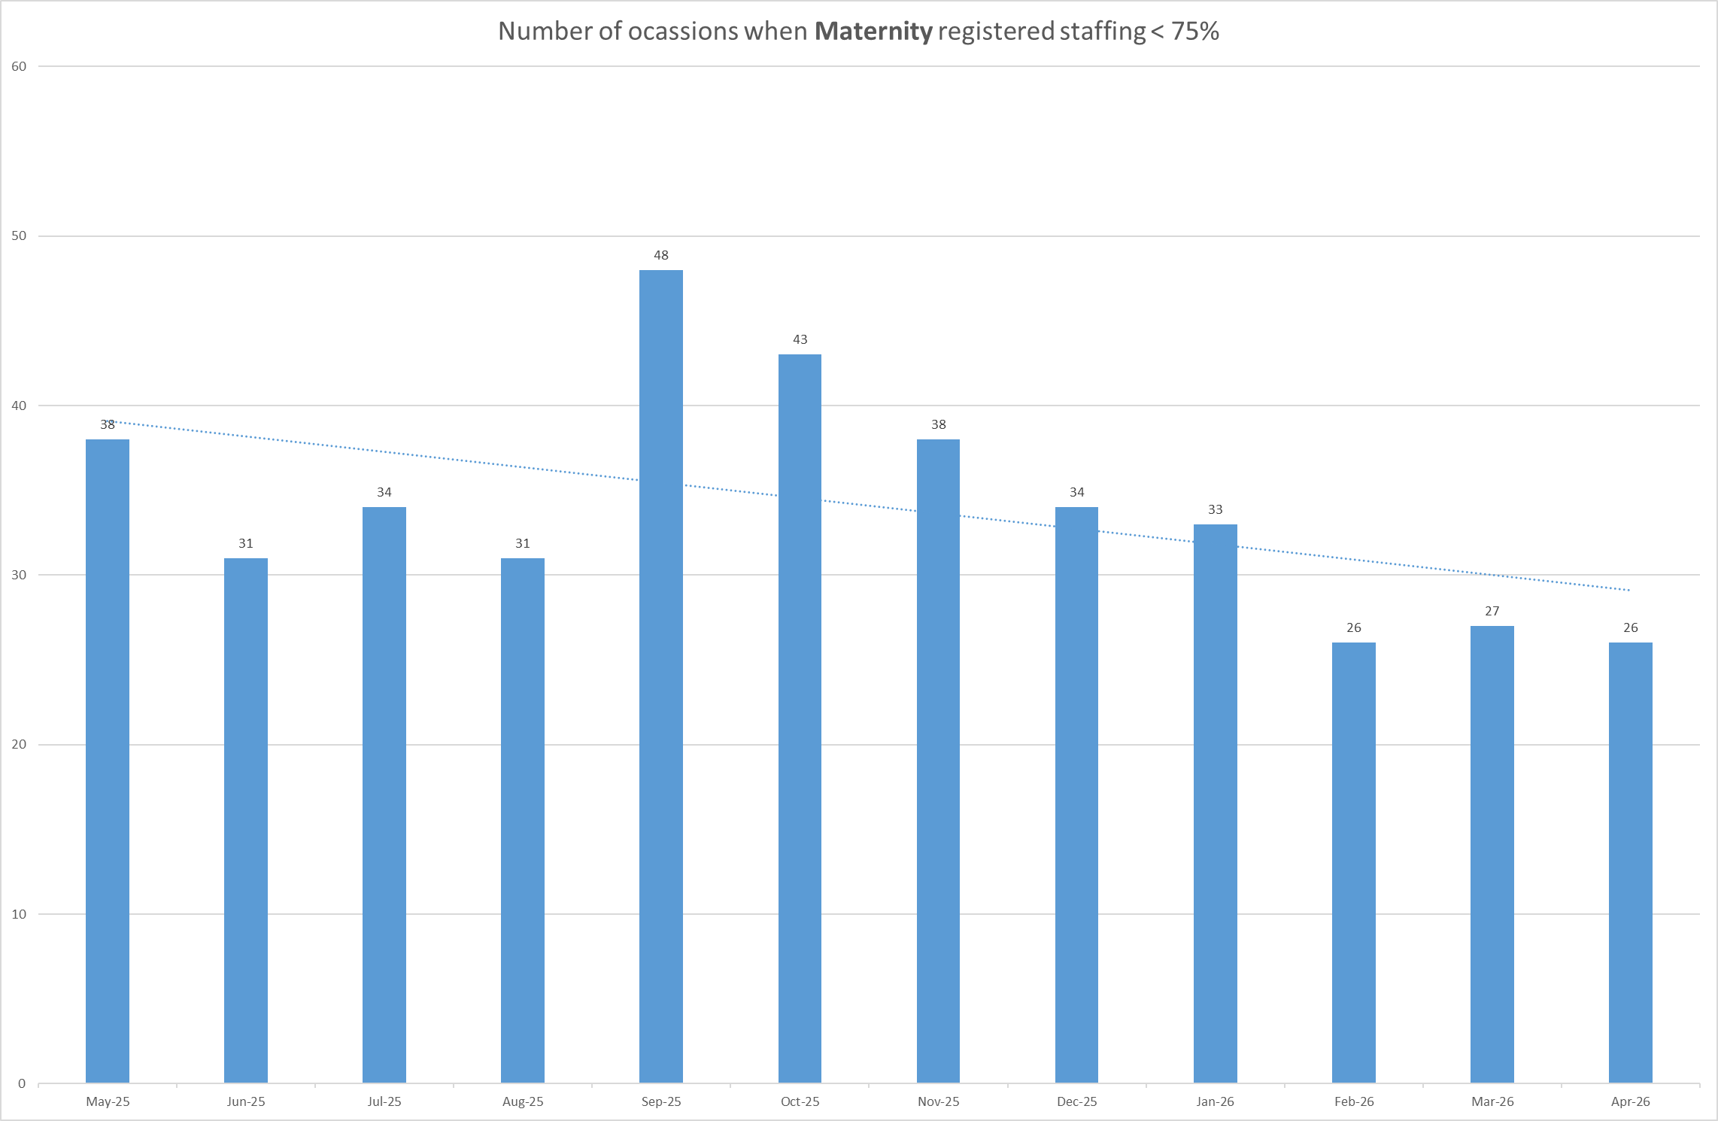

Table 3a. Red Flags raised via SafeCare Apr-26

Table 3b. Red Flags raised via SafeCare trend May-25 –Apr-26
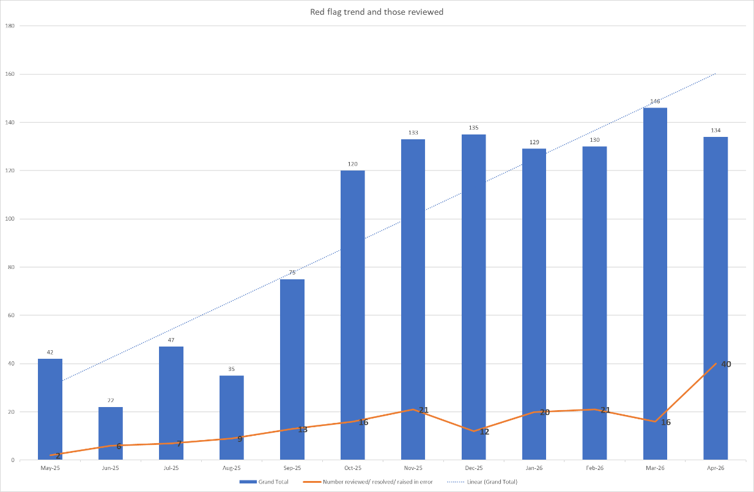

Table 3c. Datix for lack of suitably trained / skilled staff Jun-25 – Apr-26
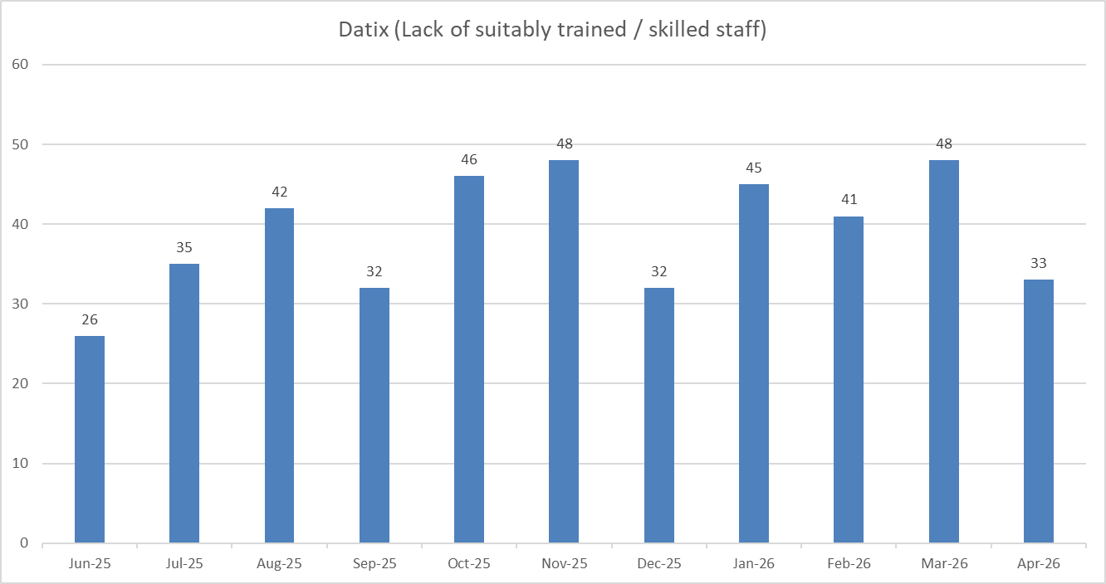

Appendix 5: Nursing quality indicators
Falls
Table 1. Number of falls and categories in April 2026, with the top 3 wards highlighted.
 | Total falls in month | Top 3 wards
Total falls | 80 | Kingsmoor – 12 | Winter – 9 | A&E & Lister – 6
Unwitnessed falls | 57 | Kingsmoor – 9 | Winter – 6 | Lister, A&E, Charnley – 5
Falls with harm * | 19 | Kingsmoor, Winter – 3 | Lister, Saunders – 2
*Subject to change following review at Falls Incident Oversight Group

Falls Rate per 1000 bed days April 2026 data
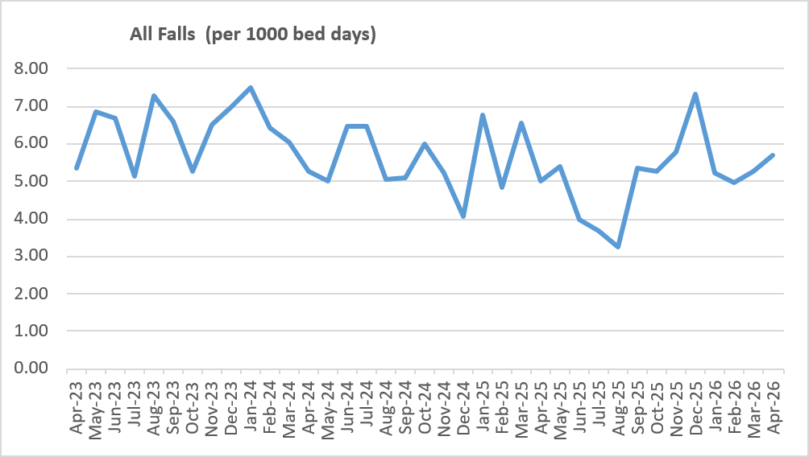
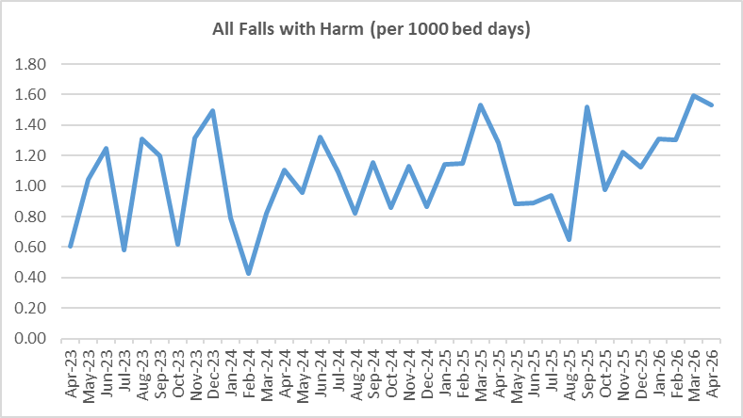

Pressure Ulcers

Table 2: Number of Hospital Acquired Pressure Ulcers (HAPU) Cat 2, 3 and 4
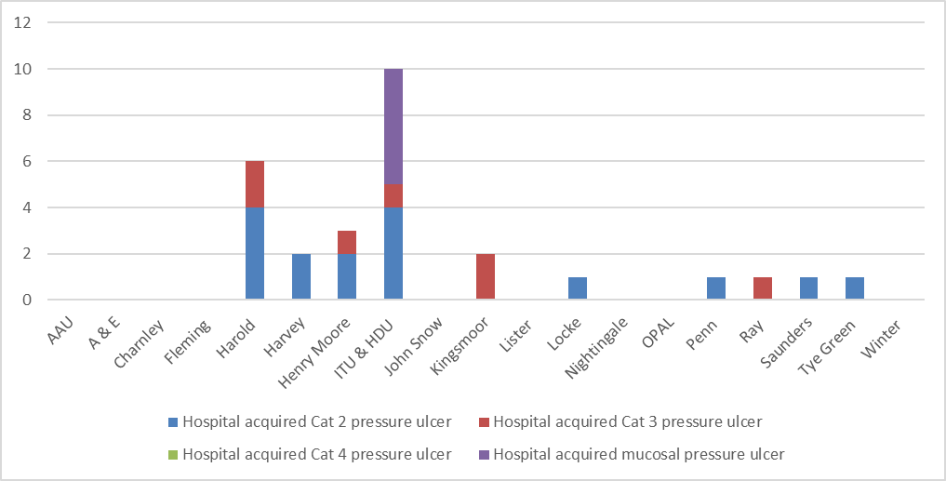

 | Total in month | Top Departments
Total skin changes | 71 | ITU & HDU – 18 | Harvey – 8 | Harold – 6
Reportable HAPU’s | 28 | ITU & HDU – 10 | Harold – 6 | Henry Moore – 3

Complaints, PALS and Compliments Trend Data Apr-25 – Mar-26
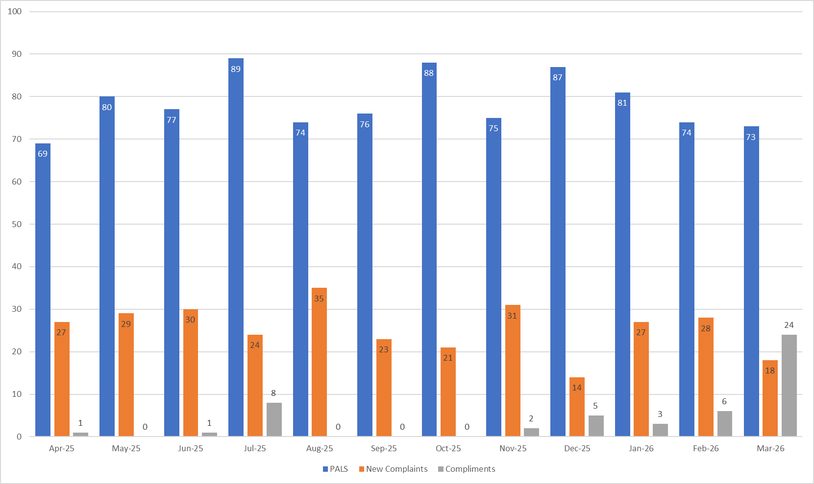

Table 3. Number of new Complaints, PALS and Compliments in March 2026 with top three wards highlighted
 | Total in month | Top Departments
New complaints | 25 | A&E & Kingsmoor – 4 |  | Henry Moore, Labour, P.ED, Winter and Harvey – 2
PALs | 75 | A&E – 20 | Fleming – 7 |  | Ray – 6
Compliments | 9 | Fleming - 5 | A&E & Henry Moore - 4

Complaints: main themes: Communications – 21.3%, Medical care – 17.75%, Nursing care – 16.57%
PALS: main themes: Delay – 35.67%, Communication – 23.78%, Appointments – 10.82%
Compliments: themes not provided – data capture remains inconsistent.

