SHOKE STUDENT CONSULT CHALLENGE

March 2026

The Princess Alexandar Hospital NHS Trust

Theme of the Challenge

Embedding Youth Voice within Sustainable, Data-Driven Healthcare Governance
The challenge centers on strengthening children and young people’s participation in health decision-making. It focuses on addressing health inequalities in Harlow by integrating youth engagement within existing NHS structures, using local data to guide priorities and actions.

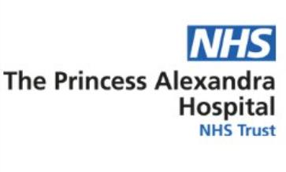

Team Introduction

 | Afolabi, Hephzibah  Mechatronics and Robotics Engineering  LinkedIn: https://www.linkedin.com/in/hephzibah-afolabi04298b298/  Email ID: afolabihephzibah2023@gmail.com
 | Aradana Murthy, Sunayna Murthy  MSc in Applied Data Science  LinkedIn: https://www.linkedin.com/in/sunaynamurthy/  Email ID: overseasunayna@gmail.comEmail
 | Mezene, Glwadys Falone  MSc public health and community wellbeing  LinkedIn: http://linkedin.com/in/glwadys-falone-mezene-b53915215 Email ID: gm949@student.aru.ac.uk
 | Galappaththi, Dewmini Dishara  BSc. (Hons) Biomedical Science  LinkedIn: www.linkedin.com/in/dewmini-galappaththi-abba2521b Email ID: dishara2004@gmail.com
 | Anuradha Gaikwad (Team Leader)  MSc International Business  LinkedIn: linkedin.com/in/anuradha-gaikwad-b40542190/  Email ID: anu.gaikwad1011@gmail.com

EXECUTIVE SUMMARY
This consultancy report presents a structured and evidence-informed framework to support The Princess
Alexandra Hospital NHS Trust (PAH) in strengthening and sustainably embedding a Children and Young People’s (CYP) Board. The project responds to documented health inequalities in Harlow and West Essex, including elevated mental health presentations, higher preventable mortality rates, childhood obesity, dental decay, and disparities associated with deprivation. Through structured secondary research, analysis of publicly available health intelligence data, and review of youth governance models nationally and internationally, the team identified barriers limiting meaningful youth engagement in healthcare systems. These barriers include psychological constraints, accessibility gaps, representation of inequalities, governance weaknesses, and sustainability risks. Rather than proposing a standalone youth forum, this report recommends a governance-embedded, data-driven CYP Board supported by inclusive recruitment strategies, co-production principles, hybrid engagement mechanisms, and measurable impact evaluation frameworks. The proposed activation model ensures that youth participation moves from consultation to structured influence, while remaining operationally feasible within the context of a District General Hospital.

INTRODUCTION
Children and young people (CYP) in Harlow experience significant health inequalities, including rising mental health presentations, higher levels of childhood obesity, dental decay, and preventable hospital admissions. As a District General Hospital serving West Essex, Princess Alexandra Hospital NHS Trust (PAH) plays a critical role not only in delivering acute care, but also in supporting prevention and community engagement.
Broader national evidence also highlights widening child health inequalities across England. The Marmot Review (2020) emphasizes that children growing up in deprived areas experience poorer physical and mental health outcomes, reinforcing the importance of place-based, equity-focused governance mechanisms. In the context of Harlow, this strengthens the case for embedding youth's voice within local healthcare decisionmaking.
This consultancy project explores how PAH can strengthen and sustainably embed a Children and Young People’s (CYP) Board that is inclusive, data-driven, and aligned with local health inequality priorities. The focus is not simply on creating a forum for consultation, but on designing a structured, governance-aligned mechanism that enables meaningful youth influence within the operational realities of a District General Hospital.

PROBLEM STATEMENT
The Princess Alexandra Hospital NHS Trust seeks to establish and strengthen a Children and Young People’s (CYP) Board that is inclusive, data-driven, and sustainable. However, youth engagement in healthcare governance is often limited by structural, psychological, and representation barriers, resulting in inconsistent participation and limited measurable impact.
The core challenge is how to design and embed a CYP Board within hospital governance that meaningfully engages diverse young people, aligns with local health inequality data, and remains operationally sustainable in the long term.

PROJECT OBJECTIVES
- To identify barriers affecting CYP engagement within healthcare settings.
- To analyze publicly available local health inequality data relevant to Harlow.
- To review governance and sustainability models from youth participation frameworks.
- To develop a structured mechanism for embedding a CYP Board within PAH governance.
- To propose measurable indicators for long-term impact and sustainability.

METHODOLOGY
This consultancy project was conducted using a structured secondary research approach. No primary data collection was undertaken. The methodology was designed to ensure analytical depth, alignment with publicly available evidence, and consistency with ethical and governance requirements.
The research process consisted of four key components.
- Review of Local Health Intelligence
The team analyzed publicly available health and demographic data relevant to Harlow and West Essex, including:
  - Essex County Council Joint Strategic Needs Assessment (JSNA) profiles
  - Public Health England Child Health Profiles
  - NHS England policy frameworks
  - Regional data on mental health presentations, obesity, dental decay, and preventable admissions
This review enabled the team to identify priority health concerns affecting children and young people locally, forming the evidence base for data-driven recommendations.
- Literature and Policy Review
A targeted review of national and international literature on youth participation and governance was conducted. This included:
- NHS England participation guidance
- The NHS Long Term Plan (2019)
- The Health and Care Act (2022)
- Research on barriers to youth participation (DCMS, 2023)
- Theoretical frameworks such as Hart’s Ladder of Participation (1992)
- This review informed the understanding of effective youth governance models, co-production principles, and common sustainability challenges.
- International healthcare organisations increasingly use youth advisory councils and participatory engagement programmes to strengthen youth voice in health system governance. For example, paediatric hospitals such as The Hospital for Sick Children (Canada) have established patient advisory councils and storytelling initiatives that enable young patients to contribute insights into service design, communication strategies, and digital innovation projects (SickKids, 2023).

- The Logic Tree: Analytical Framework
To analyze the challenge, the team developed a structured logic tree framework. Rather than moving directly to solutions, the logic tree enabled the team to break down the challenge into key thematic questions, including:
  - Barriers to youth engagement
  - Data accessibility and translation
  - Governance and influence pathways
  - Sustainability mechanisms
  - Partnership ecosystems
  - Impact measurement
This structured questioning ensured that the final recommendation was evidence-informed, strategically aligned, and feasible within the PAH context.
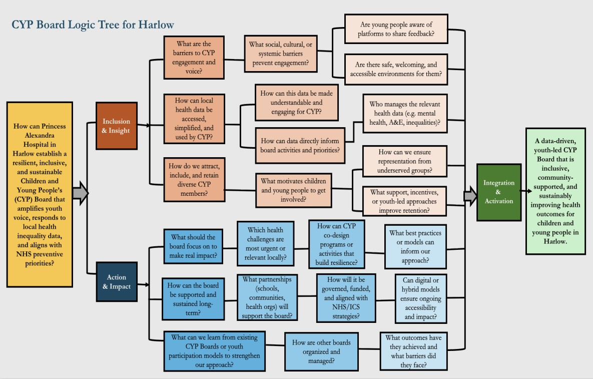
- Thematic Division of Research
The research was divided into two primary analytical streams:
- Inclusion & Insight - Focused on:
  - Engagement barriers
  - Representation inequalities
  - Data accessibility
  - Psychological and structural participation constraints
- Action & Impact - Focused on:
  - Learning from existing CYP Models
  - Governance structures
  - Sustainability frameworks
  - Partnership ecosystems
  - Co-production mechanisms
  - Digital and Hybrid Participation
  - Measurable evaluation models
Findings from both streams were synthesized into an integrated activation framework designed specifically for the PAH context.
E. Limitations
As this project relied exclusively on secondary data, the findings are based on publicly available information rather than direct stakeholder interviews. While this ensures alignment with existing evidence, further primary consultation with young people and PAH staff may enhance contextual specificity during implementation phases.

KEY FINDINGS
I. Inclusion and Insight Phase
The Inclusion & Insight phase focused on understanding the current state of youth engagement within healthcare settings, identifying the barriers that limit participation, and analyzing how local health inequality data can shape the priorities of a Children and Young People’s (CYP) Board at PAH.
- Structural Barriers to Youth Engagement:
Our research indicates that youth engagement within healthcare governance is often limited not by a lack of willingness, but by structural design issues. Many young people are unaware that opportunities to contribute to hospital decision-making exist. Engagement initiatives are frequently communicated through adult-facing channels that do not effectively reach younger audiences.
In addition, young people may perceive that their contributions do not lead to tangible change. When feedback is not visibly linked to service improvements, engagement risks become symbolic rather than meaningful. This perception of limited influence reduces trust and discourages sustained participation.
Healthcare environments are also inherently formal and hierarchical. Board-style meetings, professional language, and clinical terminology can create intimidating spaces for young people, particularly those without prior experience in governance settings. Without a clearly defined role and purpose, young people may struggle to understand how their input connects to decision-making processes within the hospital. For PAH, this suggests that engagement must be intentionally structured, with visible feedback mechanisms and clearly defined influence pathways.

- Psychological and Developmental Considerations:
Youth participation cannot be separated from a developmental context. Research highlights that confidence, self-efficacy, and communication skills vary significantly among young people, particularly across socioeconomic backgrounds. Those from deprived areas may feel less entitled to speak in institutional settings or may assume that their views will not be valued. Anxiety around public speaking and participation in adult-dominated spaces can further limit engagement. Traditional board formats often favor articulate and confident individuals, unintentionally excluding quieter voices. Without supportive facilitation and induction processes, participation may disproportionately reflect a narrow demographic. This reinforces the importance of onboarding, mentorship, and youth-friendly facilitation within any CYP Board structure.

- Accessibility and Inclusion Gaps:
Accessibility is another significant consideration. Meetings scheduled during school hours limit attendance, while jargon-heavy discussions and data-driven presentations can reduce comprehension. For young people with special educational needs or neurodivergent conditions, standard meeting formats may not provide adequate accommodation. Digital engagement offers flexibility, yet reliance solely on online participation may exclude young people in areas with limited digital access. Accessibility must therefore be multi-dimensional, encompassing timing, language, format, and communication style. For PAH, inclusion must be proactively designed rather than assumed. Engagement mechanisms should account for diverse communication needs and varied life circumstances.

- Representation Inequalities:
Local and national participation trends consistently demonstrate that certain groups of young people are underrepresented in civic and healthcare engagement structures. These include young people from highdeprivation wards, care-experienced children, young carers, neurodivergent youth, and ethnic minority communities. Participation also declines with age and is lower among young people eligible for free school meals. Without targeted outreach, engagement structures risk reinforcing existing inequalities by attracting only confident, already-engaged individuals. For PAH, this highlights the necessity of equitybased recruitment strategies that prioritize underrepresented voices rather than relying solely on open calls for participation.

- Data Translation and Insight Gap:
Significant health data exist within Harlow and West Essex, including information on mental health presentations, childhood obesity, dental decay, and preventable admissions. National data further reinforce mental health as a priority. NHS Digital (2023) reports that approximately 1 in 5 children aged 8–16 have a probable mental disorder, and research suggests that around 50% of lifetime mental health conditions begin before age 14 (Kessler et al., 2005). This evidence strengthens the need for structured youth engagement on prevention priorities such as mental health. However, this data is primarily designed for professional audiences and is often presented in technical formats that are inaccessible to young people. There is a disconnect between available public health intelligence and youth-informed interpretation. Young people are rarely involved in reviewing or discussing local health data, despite being directly affected by the trends it represents. Evidence suggests that when information is translated into youth-friendly formats, young people can engage critically with complex topics. Therefore, the challenge is not capability, but accessibility and framing. For PAH, a data-driven CYP Board must include mechanisms for translating and contextualizing health data to ensure informed and meaningful participation.

❖ Overall Insight from Inclusion & Insight Phase: The overarching finding from this phase is that young people are not disengaged by default. Rather, engagement structures often fail to account for psychological safety, representation of equity, accessibility design, and visible influence. Effective youth engagement requires intentional design. Participation must be supported, translated, inclusive, and linked to measurable outcomes. Without these elements, a CYP Board risks operating as a consultative forum rather than a meaningful governance mechanism.
→ For PAH, strengthening the CYP Board requires moving beyond simply inviting participation and toward actively designing an inclusive, structured, and data-informed engagement system.

II. Action and Impact Phase

The Action & Impact phase examined how a CYP Board at Princess Alexandra Hospital (PAH) can be embedded within governance structures, sustained long-term, supported through partnerships, and evaluated for measurable impact. Rather than focusing solely on participation, this phase addresses how youth voice can be institutionalized within NHS systems in a way that is operationally feasible, accountable, and sustainable.
Learning from Existing CYP Boards and Youth Participation Models
- International youth participation frameworks provide important insights into how children and young people can be meaningfully involved in governance and decision-making processes. Several countries have developed structured youth advisory mechanisms that offer valuable lessons for healthcare institutions seeking to strengthen youth voice.
- In the United States, Youth Advisory Councils (YACs) are commonly used within schools, municipal governments, and health agencies to incorporate youth perspectives into policy development. These councils typically include members aged 13–24 and operate through formal bylaws, defined leadership roles, and scheduled meetings. In some cases, youth representatives also participate in formal decision-making boards. Evidence suggests that these councils have contributed to improvements in mental health service accessibility, anti-bullying policies, and youth-centred health education programmes (Fletcher et al., 2021; Checkoway, 2011). However, challenges such as tokenistic participation and limited resources can reduce their impact if governance structures are not clearly defined.
- European models also demonstrate alternative approaches to youth participation. In France, Local Youth Councils (Conseil Local de Jeunesse) operate within municipal governance systems and enable young people to participate in themed commissions focusing on issues such as health, environment, and social rights. These councils have supported youth-led initiatives promoting mental wellbeing and sexual health awareness. Research suggests that thematic working groups and mentoring structures strengthen youth ownership while improving collaboration between young participants and adult policymakers (Institut de la jeunesse et de l’éducation populaire, 2019; Slunge et al., 2020).
- In Japan, Kodomo Mirai Councils (Child and Future Councils) promote intergenerational participation by bringing together young people, parents, community leaders, and professionals to address issues affecting children and youth. These councils have supported community-wide health campaigns and schoolcommunity initiatives encouraging physical activity. Studies suggest that intergenerational participation can strengthen legitimacy and community ownership of youth engagement programmes (Japanese Ministry of Health, Labour and Welfare, 2018).
- Similarly, in South Africa, Youth Advisory Panels linked to health agencies and non-governmental organisations focus on major public health challenges including HIV/AIDS prevention, mental health awareness, and violence reduction. Youth-led communication initiatives, including peer education and social media campaigns, have been shown to increase trust in health services and reduce stigma around accessing care (Mthembu et al., 2019). However, participation programmes in this context often face structural barriers such as resource limitations and geographic inequality.
- Collectively, these international examples highlight several key principles for effective youth governance structures: clearly defined roles and responsibilities, meaningful decision-making influence, mentorship support, and opportunities for youth-led initiatives.
These insights informed the development of the proposed Children and Young People’s (CYP) Board model for Princess Alexandra Hospital.

➢ Governance Structure: Embedding Youth Voice Within Decision-Making
For the CYP Board to have meaningful impact, it must be formally embedded within PAH’s governance system. Youth participation should not operate as a parallel or symbolic structure, but as a recognized advisory body linked to existing committees such as Patient Experience, Quality Improvement, or Governance Boards. This requires:
- A clearly defined Terms of Reference outlining purpose, scope, authority, and reporting lines.
- Defined pathways showing how CYP recommendations move from discussion to executive review.
- Agendas aligned with hospital priorities such as mental health, prevention, inequalities, and patient experience.
- Transparent feedback mechanisms to demonstrate which recommendations were accepted, progressed, or not feasible — and why.
→ Research from international Youth Advisory Councils demonstrates that youth engagement becomes impactful when young people are given structured influence rather than informal consultation. When governance pathways are unclear, participation risks becoming tokenistic. For PAH, governance embedding ensures that youth voice contributes to service redesign, prevention strategies, and patient experience improvements in a visible and accountable way.
→ International youth participation frameworks also emphasize the importance of clear authority, defined influence pathways, and accountability structures to prevent tokenism (Lundy, 2007). Embedding these principles within PAH’s governance model will ensure youth participation is meaningful rather than symbolic.

- Sustainability Framework: Ensuring Long-Term Continuity
A sustainable CYP Board must be designed with retention, continuity, and development in mind. Volunteer structures often fail due to lack of clarity, high turnover, and limited role progression. To address this, the Board should implement:

  - Structured Onboarding - New members should receive a formal induction package including:
    - Board purpose and mission
    - Safeguarding commitments
    - Role descriptions and time expectations
    - Explanation of governance structure
    - Overview of how their input influences decisions
    - Orientation sessions with senior leaders can reinforce legitimacy and institutional connection.
  - Defined Terms and Succession Planning - Members should serve 18–24–month terms. This prevents full turnover at once and preserves institutional memory. Clear succession pathways and exit interviews can support continuous improvement and leadership development.
  - Mentorship and Development - Pairing new members with experienced participants builds confidence and supports knowledge transfer. Quarterly learning sessions, external speakers, and skills workshops strengthen capacity and resilience
  - Recognition and Retention - Acknowledging contributions through certificates, milestone recognition, or public appreciation reinforces motivation. Evidence shows that meaningful recognition improves volunteer retention and engagement sustainability. Sustainability is therefore not solely dependent on funding; it depends on structured support, clarity of role, and meaningful participation.
→ Governance research indicates that clearly defined roles, structured onboarding, and recognition mechanisms significantly improve volunteer retention and institutional continuity (Board Source, 2021; Haski-Leventhal & Bargal, 2008). Integrating these principles strengthens the long-term stability of the CYP Board.
- Partnership Ecosystem: Expanding Reach and Representation
To ensure diversity and inclusion, the CYP Board must operate within a broader partnership ecosystem.
Recruitment should not rely solely on open applications, as this risk attracts only already-engaged youth. Strategic partnerships may include:
    - Harlow Youth Council
    - Local secondary schools and colleges
    - SEND networks and advocacy groups
    - Community and faith-based organizations
    - Parent and carer support groups
    - Existing NHS youth engagement initiatives
→ These partnerships can strengthen outreach to underrepresented groups, particularly those from deprived wards, care-experienced backgrounds, or minority communities. Embedding recruitment through trusted institutions improves legitimacy and increases equity.
→ Evidence from national youth engagement initiatives suggests that collaboration with existing youth structures increases legitimacy and improves recruitment diversity. Partnering with established bodies such as local Youth Councils and school networks reduces duplication and strengthens institutional trust.

- Co-Production Mechanisms: From Consultation to Collaboration
Meaningful youth engagement requires moving beyond consultation toward co-production. Coproduction involves shared decision-making power, collaborative service design, and visible ownership of projects. Practical mechanisms may include:
    - Youth-led service redesign workshops (e.g., improving waiting areas, communication materials, digital booking systems)
    - Peer mental health ambassador programmes to promote awareness and early intervention
    - Youth research internships evaluating hospital services
    - Digital storytelling initiatives to integrate lived experience into improvement strategies

- International models demonstrate that youth boards are most effective when assigned specific projects rather than abstract advisory roles. Clear ownership of initiatives strengthens confidence, relevance, and institutional impact.
- International pediatric healthcare organizations provide useful examples of how youth voice can be embedded within service improvement through narrative engagement. For instance, The Hospital for Sick Children (SickKids) in Canada integrates patient storytelling within its patient engagement and youth advisory initiatives. Through programmes facilitated by the Office of Engagement, young patients are encouraged to share lived experiences of illness, treatment journeys, and hospital interactions. These stories are used to inform quality improvement initiatives, digital health innovation projects, and advocacy campaigns. The SickKids Patient Advisory Council, composed of young people aged approximately 12–18, provides structured input into hospital strategy, patient experience design, and communication improvements. Evidence suggests that storytelling can strengthen psychological coherence and resilience among young people while simultaneously enabling healthcare providers to better understand patient needs and service gaps. This approach demonstrates how youth engagement can extend beyond consultation to become an integral component of organizational learning and patientcentered care (SickKids, 2023; Lundy, 2007).

➢ Digital and Hybrid Participation
Accessibility is essential for sustainability. Hybrid models that combine in-person meetings with structured digital participation reduce barriers linked to transport, school schedules, or anxiety. Digital engagement tools may include:
- Online surveys linked to board discussions
- Youth-friendly dashboards presenting health data
- Structured digital consultation platforms
- Hybrid meeting options for remote participation

- Digital models must be facilitated and structured. Contributions should be recorded, tracked, and linked to governance discussions to ensure impact rather than passive engagement.
- International digital governance initiatives also demonstrate how technology can expand youth participation in public decision-making. Estonia, widely recognized for its advanced digital governance system, integrates youth participation into policy consultation through digital youth councils and online engagement platforms. Programmes such as the Digital Leap in the Youth Field initiative support youth organizations in using digital tools to participate in policy dialogue, share feedback, and contribute ideas for national and local decision-making. These systems combine digital consultation platforms with local youth participation bodies, allowing young people to engage with public institutions even when in-person participation is limited. Evidence from European youth governance initiatives suggests that digital participation tools can increase accessibility and inclusivity by enabling broader engagement across geographic, social, and time constraints (European Commission, 2022; Harno, 2021). For healthcare organizations such as PAH, similar digital consultation mechanisms could complement CYP Board activities and expand opportunities for wider youth input.

➢ Measurable Evaluation and Impact
To ensure accountability and long-term legitimacy, the CYP Board must include measurable evaluation mechanisms. Impact should not be assumed; it must be monitored. Key indicators may include:
- Diversity and representation of membership
- Attendance and retention rates
- Number of youth-led initiatives implemented
- Evidence of CYP recommendations influencing service changes
- Self-reported perception of influence among members
- Alignment with local health inequality priorities
Annual self-assessments, structured feedback surveys, and governance reviews can support continuous improvement. Crucially, feedback loops must be visible. Young people should clearly see how their contributions shape decisions. Without this transparency, engagement declines. Digital feedback tools can also provide real-time insight dashboards that track themes, participation trends, and response rates, strengthening evidence-based governance reporting.
❖ Overall Insight from Action & Impact Phase: The evidence from governance literature and international youth participation models consistently highlights that successful youth boards share common characteristics:
- Formal integration within governance structures
- Clear authority and influence pathways
- Structured onboarding and retention mechanisms
- Inclusive recruitment strategies
- Partnership support
- Co-production principles
- Measurable evaluation frameworks
→ For PAH, strengthening the CYP Board requires moving from a participation concept to a governanceembedded mechanism. When youth's voice is structured, supported, and measured, it becomes a strategic asset rather than a symbolic initiative.

RECOMMENDATIONS
Based on the Inclusion & Insight and Action & Impact findings, we recommend that PAH adopt a GovernanceEmbedded, Data-Driven CYP Engagement Model. The purpose is not to create a new forum, but to enhance the current structure into a measurable, inclusive, and operationally embedded governance mechanism.
- Engages diverse young people across Harlow
- Aligns with local health inequality data
- Embeds youth voice within hospital decision-making
- Sustains participation over time
- Demonstrates measurable institutional impact
The following phased model is designed to be realistic within existing PAH resources and governance cycles, minimizing disruption while maximizing institutional impact.
Phase 1: Foundation & Governance Setup (Build the right system first) - Before engaging young people, PAH must ensure the board is properly positioned within governance and that the right young people are recruited.
- Formal Governance Embedding Within PAH Structures
For the CYP Board to influence change meaningfully, it must be formally embedded within PAH’s governance architecture.
Recommendation:
  - Embed the CYP Board within the Patient Experience or Quality Governance structure.
  - Establish a reporting pathway from the CYP Board to senior leadership.
  - Include one youth representative annually in a relevant governance discussion (e.g., quality improvement review, patient experience forum).

Why this matters for PAH: As a District General Hospital, PAH operates within structured governance cycles. Without formal embedding, youth engagement risks remaining advisory rather than influential. Formal integration ensures youth voice is:
  - Accountable
  - Recorded
  - Considered in operational decisions
  - Visible in governance documentation

- Targeted and Inclusive Recruitment Strategy
PAH serves a socioeconomically diverse population, including areas of high deprivation. Recruitment should therefore be equity-focused rather than open-only.

Recommendation:
✓ PAH should develop partnerships with:
- Harlow Youth Council members
- Secondary schools and sixth-form colleges
- Special Educational Needs and Disabilities (SEND) networks
- Young carers’ organizations
- Care-experienced support groups
- Local community and faith organizations
- GP and primary care networks
- Parent groups (particularly for younger age cohorts 4–10) ✓ Recruitment Approach:
- Application-based selection (not competitive elections).
- Clear role description outlining expectations and benefits.
- Transparent selection criteria prioritizing representation.
- Annual recruitment cycle with staggered intake.

Why This matters for PAH: Open invitations alone often attract already-confident participants. Without targeted outreach, underrepresented groups remain excluded. For PAH, whose priorities include reducing health inequalities, representation must reflect:
- Deprivation-linked communities
- Ethnic minority groups
- Neurodivergent youth
- Care-experienced young people
- Young carers
- Inclusive recruitment aligns with NHS equality and prevention priorities.
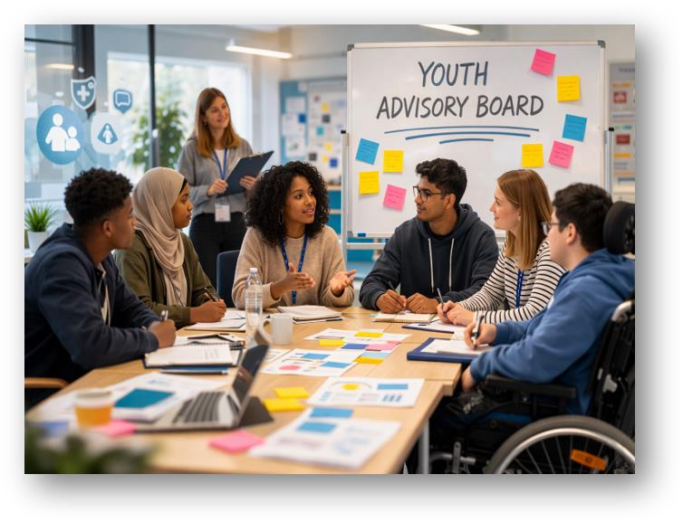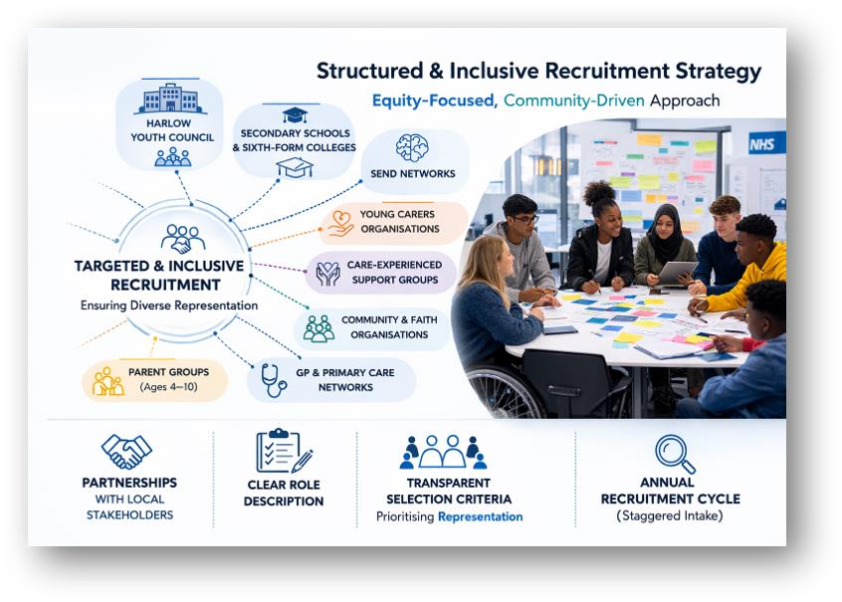

Phase 2: Activation and Engagement (How the board actually works) - These are about how young people participate meaningfully and why they stay engaged.

❑ Structured Engagement and Retention Framework
PAH’s primary concern is sustaining engagement long-term. Sustainability depends on perceived value and progression. Young people remain engaged when participation provides:
- Skills development
- Recognition
- Career value
- Clear influence Recommendation:
✓ Youth Development Pathway - Introduce a tiered structure:
- Level 1 – Member
- Level 2 – Active Contributor
- Level 3 – Youth Ambassador
- Level 4 – Board Lead ✓ Each level includes:
- NHS-branded digital badge
- Certificate signed by PAH leadership
- LinkedIn or professional recognition
- Reference support for CVs or university applications
- Public acknowledgment via PAH communications
This formalizes participation as a developmental opportunity rather than a voluntary obligation.

Why This Supports PAH: Retention reduces recruitment burden and builds institutional memory. A structured pathway aligns with workforce development objectives and may inspire NHS careers.

❑ Data-Driven Thematic Engagement Model
One of the strongest opportunities for PAH is linking youth engagement directly to local health data.

- Operational Mechanism: Each quarter, PAH identifies a priority issue using publicly available data, such as:
  - Mental health admissions
  - A&E presentations
  - Childhood obesity
  - Dental decay
  - Preventable hospital admissions
- The CYP Board then operates through structured thematic cycles:
  - Data translated into youth-friendly formats.
  - Themed workshop conducted.
  - Youth co-design recommendations developed.
  - Findings presented to governance.
  - Feedback summary published.
Example: If mental health presentations are high → Youth Mental Health Co-Design Workshop.
This ensures participation is purposeful and aligned with prevention strategies.
- Strategic Value
  - Data-driven engagement:
  - Links youth voice to measurable priorities
  - Strengthens ICS alignment
  - Demonstrates evidence-informed governance

❑ Digital Feedback & Listening Mechanism
- To strengthen accessibility and real-time engagement, PAH should implement a Digital Patient Feedback System designed for children and young people. Evidence from youth participation platforms such as UReport demonstrates that digital polling and structured anonymous feedback tools can significantly increase response rates while maintaining safety and moderation. The digital system should be:
  - Themed prompts such as “Tell us about your clinic experience”
  - Rating scales combined with optional comment boxes
  - Quick “pulse” surveys sent shortly after appointments
  - QR codes printed on discharge leaflets linking directly to feedback forms
  - Mobile-first design so feedback can be completed on a phone
- A hybrid model is essential to ensure inclusivity. Not all young people are comfortable with digital-only systems. Therefore, feedback should also be accessible through:
  - Anonymous online submissions
  - Tablets in waiting areas
  - Paper forms for those who prefer them
  - Facilitated listening sessions
  - A PC café-style access hub where support is available
- Crucially, the system must incorporate visible feedback loops through a “You Said – We Did” dashboard to build trust and demonstrate impact. All digital engagement must comply with NHS data governance standards, including GDPR compliance, secure data storage, safeguarding escalation pathways, and moderated platforms to prevent misuse.
- This mechanism strengthens continuous engagement beyond formal board meetings and enables wider participation across the CYP population.
❑ Co-Production and Shared Influence
- To avoid tokenism, CYP members should participate in tangible projects. Examples of Co-Produced
Initiatives
  - Redesign of pediatric waiting areas
  - Review of youth-facing hospital communications
  - Development of mental health awareness campaigns
  - Youth-friendly digital resource improvements
  - Patient experience feedback redesign
- Co-production ensures that young people are not only consulted but actively shaping service improvement.

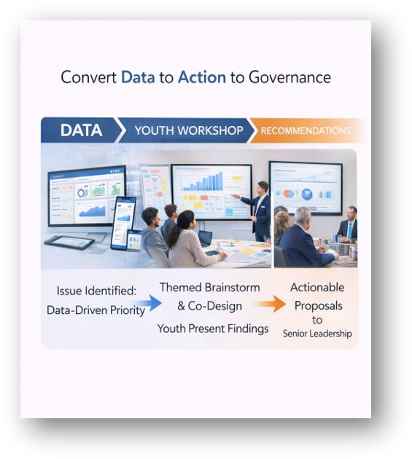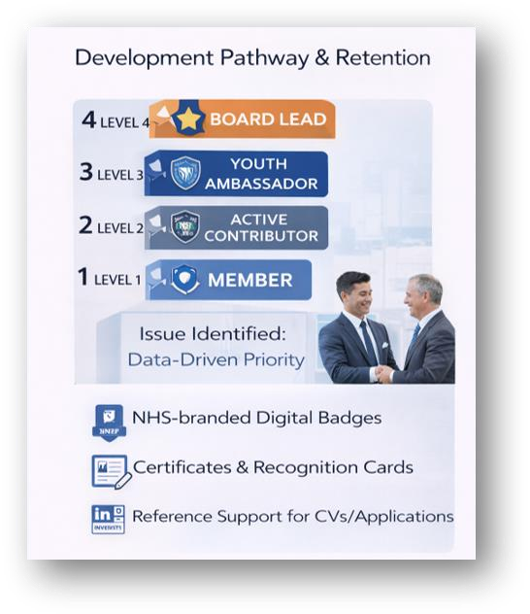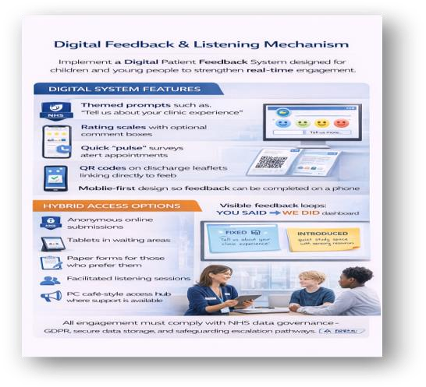

Phase 3: Sustainability & Longevity (How we keep it running long-term) - These protect long-term engagement, reduce dropout, and ensure institutional continuity.

- Hybrid Participation and Accessibility
Barriers to participation often include timing, transport, anxiety, and digital exclusion.

Recommended Adjustments:
  - Hybrid meeting format (in-person and online).
  - Meetings are scheduled outside of school hours.
  - Plain-language materials.
  - Facilitator training for youth-inclusive dialogue.
  - SEND adjustments and reasonable accommodations. Accessibility must be proactively designed, not assumed.

- Sustainability and Continuity Framework
Sustained engagement requires structural continuity.
- Proposed Structure
  - 18–24-month staggered terms.
  - Formal onboarding pack and induction session.
  - Mentor pairing system (experienced member with new member).
  - Annual review and evaluation cycle.
  - Exit interviews to capture learning. ✓ Funding may be supported through:
  - PAH engagement budgets
  - PAH Charity
  - ICS prevention funding
  - Community grants
- This reduces reliance on individual champions and embeds sustainability institutionally.

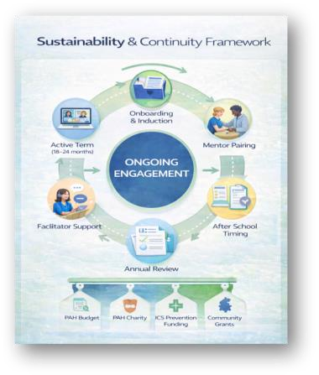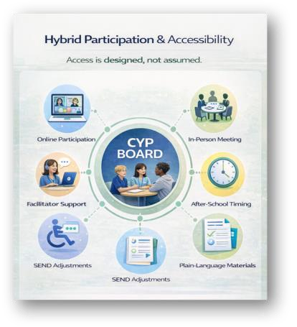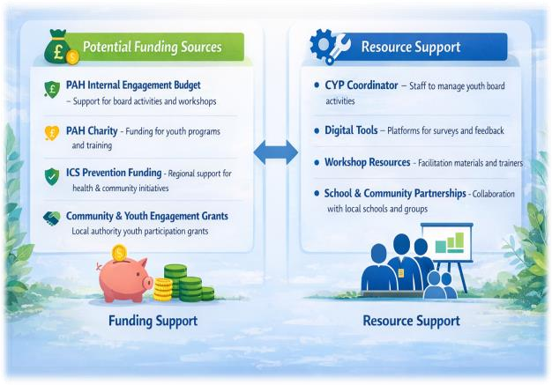

CONCLUSION
This report has presented a structured, governance-embedded model for strengthening the Children and Young People’s (CYP) Board at Princess Alexandra Hospital NHS Trust. By aligning youth engagement with local health inequality data, embedding formal governance pathways, and implementing structured recruitment, retention, and evaluation mechanisms, PAH can move from consultative engagement toward measurable institutional influence. The proposed phased framework ensures that youth participation is inclusive, sustainable, and operationally feasible within a District General Hospital context. When embedded effectively, youth voice becomes not an initiative, but a strategic asset supporting prevention, equity, and service improvement.

REFERENCES
- Barnardo’s (2022) Engaging Children and Young People in Health Services. Available at:
https://www.barnardos.org.uk/research
- Board Source (2021) Leading with Intent: Board Source Index Nonprofit Board Practices. Available at: https://leadingwithintent.org
- Checkoway, B., & Richards-Schuster, K. (2003). Youth participation in community evaluation research.
- Children and Young People (CYP): Case Studies. NHS England. Available at:
https://www.england.nhs.uk/get-involved/get-involved/how/children-and-young-people/
- Estonian National Youth Council (ENL) (2022) Youth Participatory Councils and Bodies. Available at:
https://enl.ee/youth-participatory-councils-bodies/
- European Commission (2022) Digital Leap in the Youth Field – Estonia. Available at:
https://digital-skills-jobs.europa.eu/en/inspiration/good-practices/digital-leap-youth-field-estonia
- Fletcher, A., et al. (2021) Youth-Engaged Policy Change: Evaluation of Youth Advisory Councils.
Journal of Community Psychology.
- Harno (2021) Youth Field Digital Leap Programme. Available at:
https://harno.ee/en/Youth-field-digital-leap
- Hart, R. (1992). Children’s Participation: From Tokenism to Citizenship. UNICEF. Available at: https://www.unicef-irc.org/publications/100-childrens-participation-from-tokenism-to-citizenship.html
- Haski-Leventhal, D., & Bargal, D. (2008) The volunteer stages and transitions model: Organizational socialization of volunteers. Human Relations, 61(1). Available at: https://journals.sagepub.com/doi/10.1177/0018726707085946
- Institut de la Jeunesse et de l’Éducation Populaire (2019) Local Youth Councils in France.
- Japanese Ministry of Health, Labour and Welfare (2018) Community Youth Participation Initiatives.
- Japanese Ministry of Health, Labour and Welfare (2018) Community Youth Participation Initiatives.
- Kessler, R. C., et al. (2005) Lifetime prevalence and age-of-onset distributions of DSM-IV disorders.
Archives for General Psychiatry.
- Lundy, L. (2007) “Voice is not enough.” British Educational Research Journal.
- Marmot, M., et al. (2020) Health Equity in England: The Marmot Review 10 Years On.
- Mthembu, N., et al. (2019) Participatory Youth Health Governance in South Africa. South African Journal of Public Health.
- McDaid, D., et al. (2019) The economic case for mental health prevention.
- NHS England (2019) The NHS Long Term Plan.
- Office for Health Improvement and Disparities (2023) Child Health Profiles. Available at:
https://fingertips.phe.org.uk/profile/child-health-profiles
- Patient and Public Participation Policy. Available at: https://www.engage.england.nhs.uk/survey/strengtheningppp/supporting_documents/ppppolicyeasyread.pdf
- Patient Information Forum (2021) Making Health Information Work for Young People. Available at:
https://pifonline.org.uk/resources/publications/
- Search Institute (n.d.) Developmental Assets Framework. Available at:
https://searchinstitute.org/resources-hub/developmental-assets-framework
- Simmonds, M., et al. (2016) Predicting adult obesity from childhood obesity. Lancet Child & Adolescent Health.
- SickKids (2023) Office of Patient and Family Engagement. Available at:
https://www.sickkids.ca/en/patients-visitors/office-of-engagement/
- SickKids (2023) Patient Advisory Council. Available at: https://www.sickkids.ca/en/patients-visitors/office-of-engagement/patient-advisory-council/
- SickKids (2023) Quality Improvement Plan. Available at: https://www.sickkids.ca/en/about/strategy-performance/quality-improvement-plan/
- Wellings, K., et al. (2013) Sexual health series. The Lancet.
- Wolfe, I., et al. (2014). Child health and health services. The Lancet.
- Youth Council. Available at:
https://www.harlow.gov.uk/your-council/councillors-and-chair-council/youth-council

