Patient Panel Report – One Vision, One Care
Bishop’s Stortford and East Herts Public Meeting – September 2025
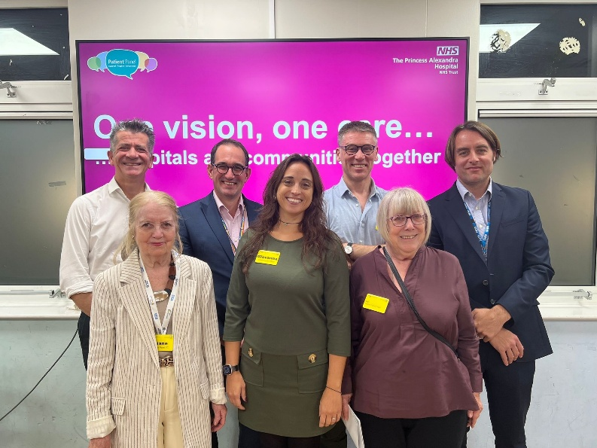
Overview
This report summarises the recent One Vision, One Care public meeting held with the Chief Executive and senior leadership team of Princess Alexandra Hospital NHS Trust (PAHT). More than 50 attendees — including members of the public and GP representatives from across West Essex — took part.
The event provided an opportunity for the community to hear about the Trust’s future plans and to share their views directly with senior decision-makers. It strengthened relationships between PAHT and local residents and offered valuable insight into what matters most to patients and partners.
Key topics discussed included:
- The Trust’s vision and strategic direction
- The future of Herts & Essex Hospital
- Progress on plans for the new hospital
- Development of Integrated Care Boards (ICBs)
- Updates on the My Alex Health digital platform
The session included a detailed Q&A and opportunities for attendees to provide feedback through comment cards. As the second event of its kind, it marked a positive step towards ongoing, open, and collaborative engagement with the community. PAHT is now exploring how this model of dialogue can become a regular feature of how the Trust listens, learns, and improves.
The Patient Panel: Role and Achievements
The Patient Panel, established 11 years ago, continues to ensure that patients’ voices are central to decision-making. Its work includes:
- Producing annual reports
- Hosting public meetings in Bishop’s Stortford and Harlow
- Facilitating topic-focused sessions on:
  - Diabetes (including live international contributions and research presentations)
  - End of Life Care, including DNACPR and Power of Attorney
  - Hospital discharge
  - Ebola preparedness
  - Cancer care (with work later recognised by the Royal College of Nursing)
  - Nutrition (award-winning work now published by Governance International and presented internationally)
The Panel’s contribution has been recognised nationally. It received an ‘Outstanding’ rating from the CQC, the Queen’s Award for Voluntary Service (2020), and in 2024 the Chair received the British Empire Medal for services to the NHS.
This ongoing collaboration between the Trust, its staff, and local residents forms the foundation of the One Vision, One Care events. The meeting offered the public a direct route to discuss priorities, raise concerns, and influence future healthcare delivery across the region.
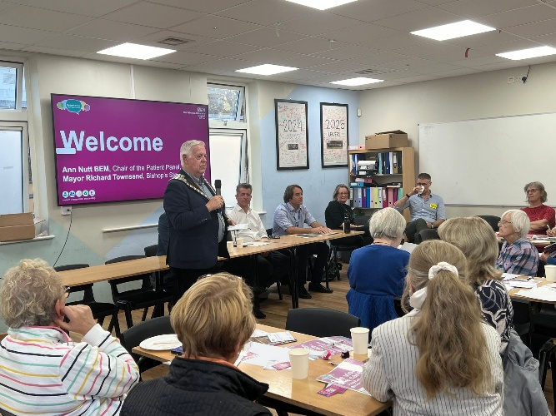
Event Welcome
The event opened with a welcome from Ann Nutt, Chair of the Patient Panel, accompanied by the Mayor of Bishop’s Stortford. Both expressed their appreciation for the strong turnout and highlighted the importance of community engagement.
They introduced Thom Lafferty, Chief Executive of PAHT, who presented members of his senior leadership team. Each leader remained available throughout the evening to contribute to discussions and answer questions.
Public Engagement and Community Feedback
A key theme of the evening was PAHT’s commitment to open, transparent engagement with the public. Attendees were invited to share views on a range of issues, including:
- Digital and remote healthcare
- Transport and access to hospital sites
- Future cancer service provision
- Improvements in patient communication
The leadership team reaffirmed that public feedback plays a central role in shaping the Trust’s priorities. The discussions demonstrated PAHT’s focus on patient-centred care and its determination to work in partnership with the community.

Key Strategic Priorities and Plans


- Shifting care closer to home
Dr Andrew Kelso – Chief Medical Officer
- PAHT is expanding digital healthcare options through My Alex Health, enabling patients to access consultations and remote monitoring at home.
- Routine outpatient appointments will increasingly be moved away from hospital sites and delivered through GP practices and community hubs.

- Integrated Services Across Health Systems
Thom Lafferty – CEO
- The Trust is working to break down organisational silos and improve coordination across hospital, primary, and community care.
- Integrated financial planning will support more efficient use of resources and better outcomes for patients.

- Workforce Development and Role Redesign
Giovanna Leeks – Chief People Officer
- PAHT is addressing workforce challenges through role redesign, enhanced training, leadership development, and stronger partnerships with GPs and community providers.
- These initiatives aim to ensure PAHT has the skills and capacity needed for future healthcare demands.
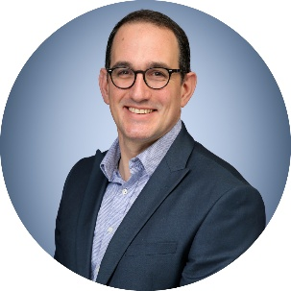
- Finance and Infrastructure Investment
Tom Burton – Director of Finance
- PAHT is undertaking significant long-term investment in its estate, including more than £22 million allocated this year for maintenance and upgrades.
- The Trust operates with an annual budget of £450 million.

- New Hospital Development
Michael Meredith – Chief Strategy Officer
- The national programme has delayed the expected completion date for the new hospital, now projected for 2035–2037.
- The new facility will support high-quality, sustainable care for a growing local population.
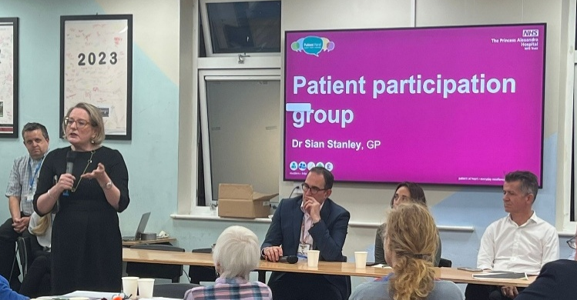
- Primary Care and Community Collaboration
Dr Sian Stanley – GP
- Dr Stanley emphasised the central role of primary care in improving patient experience.
- Priorities include strengthening communication, addressing transport concerns, and enhancing access to cancer care.
- Public feedback will continue to be integral to shaping improvements.
Public Questions
Q1: Funding Models and PFI
Question: Will the new hospital use a Private Finance Initiative (PFI) model?
Response: No. Funding will come through government borrowing under the national Building Development and Care (BDC) programme. Limited private partnerships may be used for non-clinical areas such as car park management.
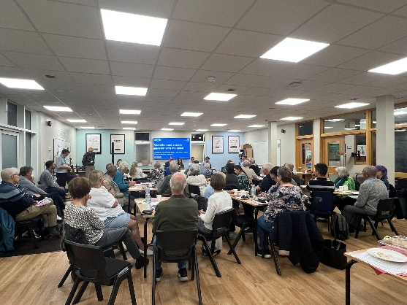
Q2: Transport Access to Care
Question: How will the Trust improve access to care for patients with limited transport options?
Response: PAHT chairs the Health and Care Partnership Board and is working with local authorities and voluntary groups to improve public transport, non-emergency patient transport, and shuttle options for off-site parking.
Q3: Cancer Services
Question: What steps are being taken to improve access to cancer care?
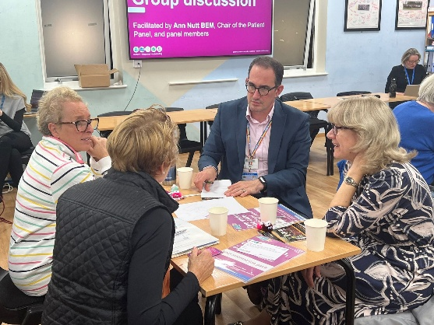
Response: The Trust is strengthening partnerships with cancer charities and improving integration across the system to reduce delays and improve outcomes.
Q4: Virtual and Hybrid Care
Question: How will virtual consultations work, and will care quality be maintained?
Response: Hybrid models will allow patients to choose virtual or in-person consultations based on clinical need. GPs will help determine suitability, ensuring personalised and high-quality care.

What Happens Next? Actions Agreed
PAHT committed to the following key actions:
- Improve Communication and Appointment Letters
  - Reviewing digital and written communication to improve clarity and accessibility.
  - Lead: Chief Information Officer
- Transport and Access Improvements
  - Continued collaboration with councils and transport partners to improve routes and explore shuttle services.
  - Lead: Estates and Strategy Teams
- Enhancing Cancer Services
  - Strengthening partnerships with charities and local providers to reduce delays and improve support.
  - Lead: Medical Director
- Developing Digital and Virtual Care
  - Expanding My Alex Health and continuing pilot programmes for virtual consultations and home-based care.
  - Lead: Clinical Transformation Team
- Optimising Herts & Essex Hospital
  - Exploring opportunities to expand diagnostic capacity and improve utilisation.
  - Lead: Operations Team
- Ongoing Public Engagement
  - Scheduling future public meetings and continuing to embed patient voices in decision-making.
  - Lead: Patient Panel and Communications Team
Community Engagement Opportunities
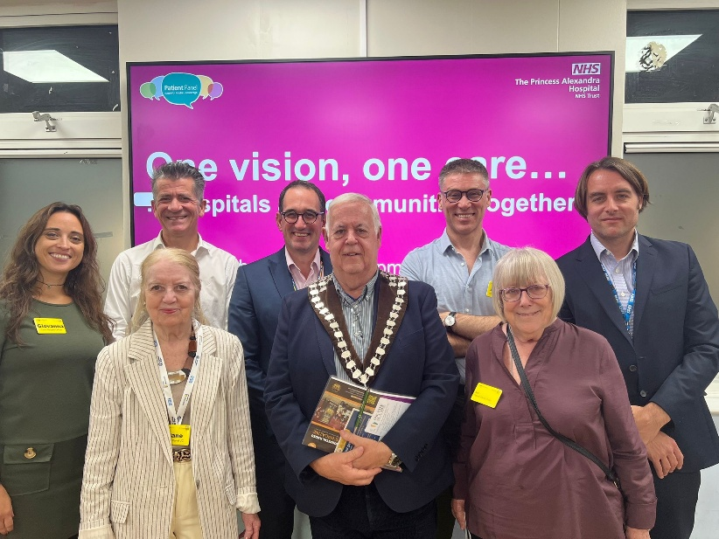
The Patient Panel introduced a new Bishop’s Stortford Sounding Board Forum, which received immediate interest — ten people signed up during the meeting. Two attendees also expressed interest in joining the Panel, and four volunteered to support activities on a flexible basis.
Ann Nutt confirmed that items raised during the session will be taken forward to relevant committee meetings and updates will be shared with the focus group.
To widen engagement, the Mayor has committed to sharing the meeting report through his networks. The report will also be published on both the Princess Alexandra Hospital and Patient Panel websites.

