NHS Wi-Fi INSTRUCTIONS

- Connect to – ‘ NHS Wifi ‘
- Go to – Create account in small writing at the bottom
- Enter details
- Next screen will show you a password under your email (remember it as you will need it for the next stage)
- Enter password given and then change it to whatever password you want
- You will then be connected to the Wi-Fi

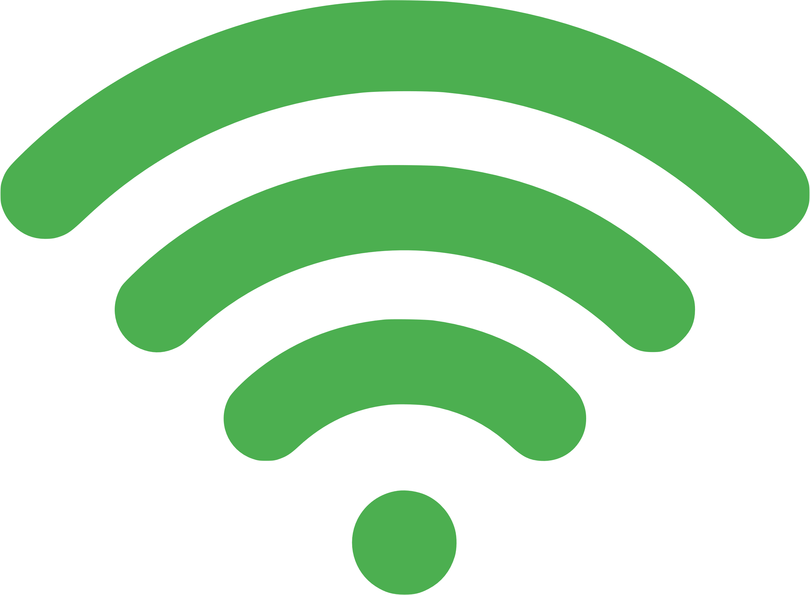
(If it doesn’t work, click on ‘ NHS Wi-Fi ‘ again, click on ‘ forget network ‘ then connect again using the above instructions – this would normally work!)

