Trust Board (Public) – 2 October 2025

Agenda item:  Presented by:  Prepared by:  Date prepared:  Subject: | 5.5  Arleen Brown Head of Equality, Diversity & Inclusion  Arleen Brown Head of Equality, Diversity & Inclusion  28 July 2025  PAHT Equality, Diversity & Inclusion Annual Report 2024-2025
Purpose: | Approval | x | Decision |  |  | Information |  |  | Assurance |  | x
Key issues:  please don’t expand this cell; additional information should be included in the main body of the report | - The EDI annual Report 2024 -2025 provides assurance that the Trust is meeting its statutory duties under the Equality Act 2010.  - The report outlines the progress made towards delivering the Trust’s annual equality objectives.  - Reports on the progress made against the NHSE High Impact Actions.  - To note this is mainly a retrospective report showing annual compliance with the national requirements.  - Appendix 1 provides a snapshot of staff diversity data as at 31 March 2025.  - Appendix 2 provides information of patient service users from Alex health data, October 2024 to March 2025.
Recommendation: | The Board is asked to:  - Note the contents of this report  - Approve for publishing in line with national requirements
Trust strategic objectives: please indicate which of the five Ps is relevant to the subject of the report |   Patients |   People |  |   Performance |  |  |   Places |  |  |   Pounds
 | x | x |  | x |  |  | x |  |  | x
Previously considered by: | PC.29.09.25
Risk / links with the BAF: | Robust performance in relation to equality, diversity and inclusion helps mitigate against risks of service/policy gaps that put protected groups at a disadvantage.
Legislation, regulatory, equality, diversity and dignity implications: | Compliance with the Equality Act 2010  Public Sector Equality Duty  CQC Well Led Framework  Equality Delivery System
Appendices: | Appendix 1 - Workforce Information EDI Profiles  Appendix 2 - Patient Information

- Purpose and background to the report

1.1 The Princess Alexandra Hospital NHS Trust (PAH) publishes diversity data annually as statutory requirement and as an enabler to meeting its general and specific duties under the under the Equality Act 2010.

The Trust has a general Public Sector Equality Duty (PSED) to:
- Eliminate discrimination, harassment, victimisation and any other conduct that is prohibited by the Equality Act 2010;
- Advance equality of opportunity between persons who share a relevant protected characteristic and persons who do not share it;
- Foster good relations between persons who share a relevant protected characteristic and persons who do not share it.

The Trust also has specific duties under the Equality Act 2010 to:
- Publish equality information at least once a year to show how we have complied with the equality duty;
- Prepare and publish equality objectives at least every 4 years.

1.2 The general duty applies to the protected characteristics set out under Section 4 of the Equality Act 2010:

- Age
- Disability
- Gender reassignment
- Marriage and civil partnership
- Pregnancy and maternity
- Race
- Religion or belief (including no belief)
- Sex
- Sexual orientation

1.3 PAH publishes diversity data annually as statutory requirement and as an enabler to meeting its general and specific duties under the under the Equality Act 2010. Our Equality, Diversity and Inclusion (EDI) Reports for:

    - Annual Reporting – Equality Objectives
    - Work force race equality Standard (WRES)
    - Workforce Disability Equality Standard (WDES)
    - Equality Delivery System (EDS)
    - Gender Pay Gap Report
    - Ethnicity Pay Gap Report

Published on our public website.

Equality, diversity and inclusion - The Princess Alexandra Hospital NHS Trust

- Introduction

2.1 PAH, is a 414-bed acute hospital in Harlow, serving a diverse community that includes areas of significant deprivation.

PAH employs 4000 staff and it is vital that our people reflect the wider society that we serve, bringing diverse experience, attitudes and opinions to our work.

This annual equality report is a valuable reflection of our commitment to our vision and achievements and our programme of work as we look forward to continuing to make a difference to the lives our people, our patients, and our community.

2.2 We are committed to ensuring that we meet the requirements of the PSED, by monitoring our EDI objectives and reviewing them every 4 years. We have identified appropriate actions in our EDI Strategy 2023 to 2030, which covers both the workforce and patients. In 2024 we developed our EDI delivery plan to deliver the strategy with a summary of the progress being evidenced through this report.

- Delivering our Equality Diversity & Inclusion Strategy 2024 -2025

3.1 Our EDI governance process

3.1.1 Our EDI Strategy Delivery Plan features our governance timetable and our EDI
annual projects. It ensures our projects are ratified in line with NHSE deadlines. The EDI Delivery of the Plan is monitored through our EDI steering group.

The group consists of a diverse range of managers from departments across the Trust e.g. Freedom to Speak Up Guardian; Head of services from the People & Organisational Development Team; Staff Network Chairs, Head of Communications; Head of Patient Experience; and a variety of representatives from the Clinical Divisions.

3.1.2 The Group is chaired by the Chief People Officer the main purpose of the group is to monitor the EDI Delivery Plan and projects, and to help shape the organisation’s strategies and policies to improve the experience of staff and patients
.
The steering group meets quarterly and reports progress to the People committee, as a sub-committee of the board, to ensure visibility and scrutiny of all interventions.

3.2 External drivers set by NHSE

3.2.1 All of our Equality, Diversity and Inclusion reports are ratified through; our EDI Steering Group; Joint Staff Consultative Committee; Executive Board; People Committee; and then to our Trust Board.

3.2.2 Workforce Race and Disability Equality Standards - The national data submissions for the Workforce Race Equality Standard, and the Workforce Disability Standard have been reviewed and an action plan has been developed in response to the findings.

3.2.3 Gender and Ethnicity Pay Gap reporting - The annual Gender Pay Gap Report 2024 has been audited and published. This is the first year that we have also completed an audit and publication on our Ethnicity Pay Gap Report 2024.

3.2.4 Disability Pay Gap Reporting - This year we will be producing our first Disability Pay Gap Report.

3.2.5 Equality Delivery System (EDS) is designed to help NHS Trusts to improve the services we provide to our local communities and provide better working environments, free from discrimination for our staff. The overall aim of EDS is for us to evidence how we meet the requirements of the Equality Act 2010 - Public Sector Equality Duty.

Since April 2014, EDS has been mandated in the NHS Standard Contract and is cited as a key implementation requirement.

During 2024 to 2025 under EDS we reviewed the following services; Paediatrics Maternity & Outpatients.

Our Reports can be found on our website:

Equality, diversity and inclusion - The Princess Alexandra Hospital NHS Trust

3.3 NHSE High Impact Actions
3.3.1 In June 2023, NHS England released a mandated plan for all trusts with the following high impact actions:
1. Measurable objectives for EDI for chairs chief executives and board members.
2.Overhaul recruitment processes and embed talent management processes.
3.Eliminate total pay gaps with respect to race disability and gender
4.Address health inequalities within their workforce
5.Comprehensive induction and onboarding program for international recruited staff
6.Eliminate conditions and environment in which bullying harassment and physical harassment occurs.
3.3.2 Our progress against the 2024/25 actions is summarised in the table below.
Green | Yellow | RED
Green signifies actions that were fully underway or completed by 31st March 2025. | Yellow are actions that were started and will be underway or completed by 31st March 2026 | Actions that have not been started

High Impact Actions | Actions | RAG Rating
1 Chief executives, chairs and board members must have specific and measurable EDI objectives to which they will be individually and collectively accountable. | Every board and executive team member must have EDI (SMART) objectives and be assessed against these as part of their annual appraisal process (by March 2024).
 | NHS boards must review relevant data to establish EDI areas of concern and prioritise actions. Progress will be tracked and monitored via the Board Assurance Framework (by March 2024).
 | Board members should demonstrate how organisational data and lived experience have been used to improve culture (by March 2025).
2.. Embed fair and inclusive recruitment processes and talent management strategies that target under-representation and lack of diversity. | Create and implement a recruitment plan to improve the diversity of executive and senior leadership teams (by June 2024) and evidence progress of implementation (by June 2025)
Implement a plan to widen recruitment opportunities within local communities, aligned to the NHS Long Term Workforce Plan. This should include the creation of career pathways into the NHS such as apprenticeship programmes and graduate
management training schemes (by October 2024).
3. Develop and implement an improvement plan to eliminate pay gaps. | Implement the Mend the Gap review recommendations for medical staff and develop a plan to apply those recommendations to senior non-medical workforce (by March 2024).
 | Implement an effective flexible working policy including advertising flexible working options on organisations’ recruitment campaigns. (March 2024)
4. Develop and implement an improvement plan to address health inequalities within the workforce. | Line managers and supervisors should have regular effective wellbeing conversations with their teams, using resources such as the national NHS health and wellbeing framework. (by October 2023).
 | Work in partnership with community organisations, facilitated by ICBs working with NHS organisations and arm’s length bodies, such as the NHS Race and Health Observatory. (by April 2025).
5. Implement a comprehensive induction, onboarding and development programme for internationally-recruited staff. | Before they join, ensure international recruits receive clear communication, guidance and support around their conditions of employment including clear guidance on latest Home Office immigration policy, conditions for accompanying family members, financial commitment and future career options (by March 2024).
 | Create comprehensive onboarding programmes for international recruits, drawing on best practice. The effectiveness of the welcome, pastoral support and induction can be measured from, for example, turnover, staff survey results and cohort feedback (by March 2024).
 | Line managers and teams who welcome international recruits must maintain their own cultural awareness to create inclusive team cultures that embed psychological safety (by March 2024).
 | Give international recruits access to the same development opportunities as the wider workforce. Line managers must proactively support their teams, particularly international staff, to access training and development opportunities. They should ensure that personal development plans focus on fulfilling potential and opportunities for career progression (by March 2024).
6. Create an environment that eliminates the conditions in which bullying, discrimination, harassment and physical violence at work occur. | Review data by protected characteristic on bullying, harassment, discrimination and violence. Reduction targets must be set (by March 2024) and plans implemented to improve staff experience year-on-year.
 | Review disciplinary and employee relations processes. This may involve obtaining insights on themes and trends from trust solicitors. There should be assurances that all staff who enter into formal processes are treated with compassion, equity and fairness, irrespective of any protected characteristics. Where the data shows inconsistency in approach, immediate steps must be taken to improve this (by March 2024).
 | Ensure safe and effective policies and processes are in place to support staff affected by domestic abuse and sexual violence (DASV). Support should be available for those who need it, and staff should know how to access it. (By June 2024)
 | Create an environment where staff feel able to speak up and raise concerns, with steady year-on-year improvements. Boards should review this by protected characteristic and take steps to ensure parity for all staff (by March 2024).
 | Provide comprehensive psychological support for all individuals who report that they have been a victim of bullying, harassment, discrimination or violence (by March 2024).

3.4 East of England Anti-racism Strategy
3.4.1 We have been working towards achieving the outcomes in the East of England (EoE) Anti-racism Strategy under the following four pillars:
Pillar 1 - Education & Commitment
Pillar 2 – Civility, Respect and Safety
Pillar 3 – Representation
Pillar 4 - Policies
3.4.2 Delivery of the Strategy is monitored through our PAH EDI Strategy Delivery Plan. We will be working through 2025 to 2026 to continue to deliver the actions of the Strategy through our People Directorate and staff networks.
During 2024 to 2025 we have achieved the following:
- Signed up to Unison Race Charter.
- Engaged in a psychological support contract in place from April 2024. The continuation of the service has been promoted widely.
- Implement debias recruitment NHS Programme in line with NHS EDI High Impact actions Attract, recruit and retain.

4.0 Our EDI Strategy Equality Objectives to comply with the PSED
Within our EDI Delivery Plan to comply with the PSED we have published our equality information.

- Our objectives - Our four Goals to demonstrate are additional activity

- Appendix 1 - Workforce Information EDI Profiles

- Appendix 2 – Patient Information

4.1 Goal 1: To put equality, diversity and inclusion at the heart of our organisation
4.1.1 Staff Networks

The Trust currently has three staff networks, which are the Disability and Wellbeing Network (DAWN), the Race Equality & Cultural Heritage (REACH) staff network and the Alex Pride (LGBTQ+) staff network.

The REACH has supported the organisation to move forward on race equality with a focus on its three primary objectives:
- The promotion of Psychological Safety
- Support for Continuing Professional Development
- Achieving our goals through Allyship with other networks.

4.1.2 The network is committed to creating an inclusive working environment where individuals from the global majority are respected, supported and valued in the workplace. The network is a safe place for people to discuss the issues they face and share experiences.

However, we have noticed a decline in attendance and we are actively trying to understand why this has happened, and see how we can address and improve attendance. We want to support our staff so that their voices are heard, and they are able to contribute to any changes needed within the Trust.

4.1.3 The DAWN has been operating for just over 2 years and formed in response to feedback from staff and review of staff survey findings. The purpose of the network is to be an independent and effective voice for staff with long term health conditions and disabilities. We want to ensure that the organisation recognises and responds to the needs of all its staff, thereby increasing staff morale and improving the patient experience.

4.1.4 The LGBTQ+ staff network re-established its name to Alex Pride in 2024 and is running virtually. The network has invited members of the LGBTQ+ community to meetings to share learning and as an opportunity to inform trust policies and practices. The network is linked in with the East of England LGBTQ+ network.

4.1.5 We are developing our staff networks and are in the process of starting a Religion & Belief Women’s and Allies network. Our Staff Networks all have executive leads who work with the Chairs to develop the activity for the networks.

Equality impact assessments

4.1.6 Conducting an Equality Impact Assessments (EIA) is part of our legal duty under the Equality Act 2010. We want to ensure that the impact of our decisions is assessed in a structured and robust way. We need to understand and evaluate the impact on the workforce, patients and services users, from different protected groups.

4.1.7 EIA is a tool and that assists the process and supports the Trusts’ responsibility to assess the impact of our policies, processes, practices and strategies. The purpose of an EIA is to predict possible positive or negative impacts, and take appropriate action such as removing or mitigating any negative impacts. Where possible, we maximise and promote any potential for positive impacts.

4.1.8 In order for this tool to support our objectives we have engaged with senior leaders to review the process for 2025. We are in the process of reviewing our EIA Template in line with our Quality Impact Assessments, and are working with the H& WE ICS to produce a template to be used across the region.

4.2 Goal 2: Recruit, Retain, Develop and support a diverse workforce
4.2.1 Our Resourcing team has significantly expanded its outreach and engagement activity over the past year. Working closely with community partners, educational institutions, and employability services, we’ve strengthened pathways into healthcare careers and ensured our recruitment activity reaches a broad and diverse audience.

4.2.2 To improve our aims on creating inclusive recruitment practices we have:

- Reviewed areas identified for improvement based on the Disabled NHS Directors Network (DNDN) Good Practice Toolkit.
- Outline the actions being taken to enhance the inclusivity of our recruitment processes.
- Introduce the transition to Jobtrain, which will enable us to implement more accessible and flexible recruitment practices.
- Actions to be incorporated into next year’s Trust-wide Resourcing Action Plan, which will also include actions from the NHS England De-biasing Recruitment Toolkit.

Learning and development

4.2.3 The Trust has rolled out a variety of training ranging from; corporate induction; EDI awareness as part of; inclusive management training for managers. Below is an update on completion of training from last year.

Training | Number of attendees
Corporate Induction (Equality, Diversity & Inclusion). | 574
Inclusive Managers | 86
Oliver McGowan – e-Learning  Webinar  In-Person | 1390
Oliver McGowan – e-Learning  Webinar  In-Person | 300
Oliver McGowan – e-Learning  Webinar  In-Person | 194
EDI e-Learning | 1396
System Leadership Development (ADDS, Mary Seacole) | 8

4.2.4 Talent management and succession planning - A paper regarding proposal for talent management and succession planning process has been approved by the board, with the intention to begin work during Q3/Q4 2025 (pending any potential organisational changes). The strategy and processes include mechanisms to promote diversity and inclusion. Work has begun on identifying external training providers for development training which will be based on the NHS leadership competency framework.

4.2.5 Staff survey – summary of key findings and organisational priorities - In 2024, the staff survey participation rate was 49%, half of the employees surveyed would recommend PAHT as an employer, an improvement on the previous year. There were improvements in the majority of people promise areas, however a slight regression in the area of ‘we are compassionate and inclusive’.

Further to analysis, three key areas were selected by the executive board as organisational themes for improvement.
- We are compassionate and inclusive
- We are a team
- We are rewarded

4.2.6 Apprenticeships We had 17 application with 24/25 of which 8 were approved throughout the year. The following tables show a breakdown of successful applications;

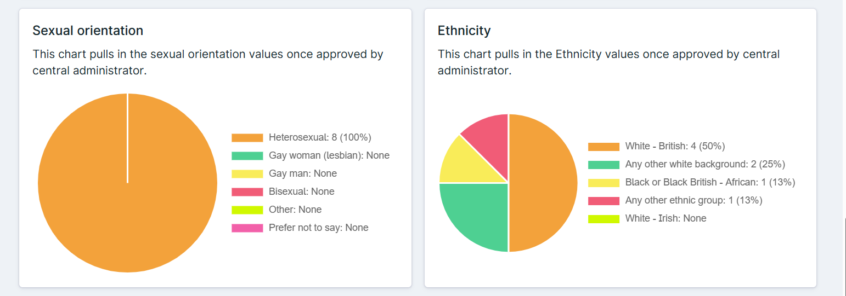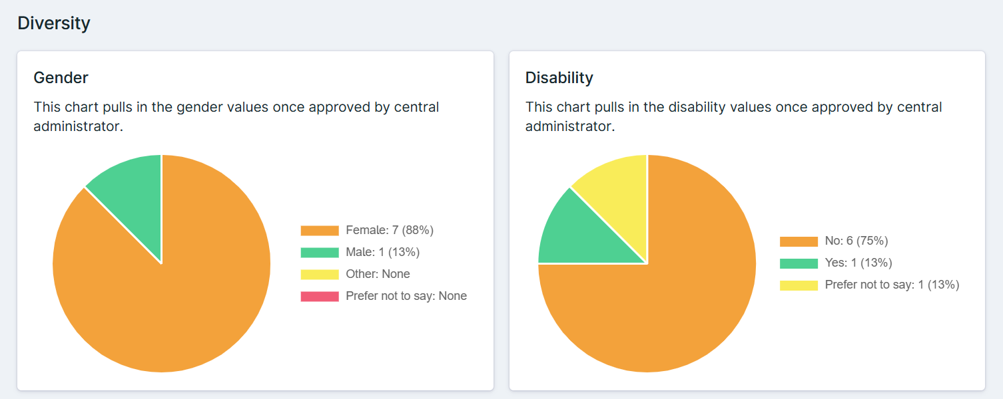

4.2.7 For 25/26, we have completed an apprenticeship strategy which has been approved by executive board. The strategy includes identifying roles and vacancies that could be filled by upskilling internal employees through apprenticeship training (before sourcing external options), whilst increasing opportunities for jobs and training for external candidates in more diverse areas such as facilities management, IT, finance, HR and business administration.

CPD

4.2.8 We had 680 applications of which 531 applications were improved. The breakdown is as follows;
Ethnicity Representation
- White ethnic group forms the largest segment, around 38% of applicants. (204)
- Asian/Asian British staff represent about 27%. (141)
- Black/Black British applicants make up roughly 11%. (57)
- Mixed/multiple ethnic groups constitute approximately 14%. (76)
- Other ethnic groups, including those of Middle Eastern and other origins, account for the remaining 10%. (53)

4.2.9 Gender Distribution
Female applicants (431) represent the majority, constituting roughly 81% of the approved applications.
- Male applicants (98) account for approximately 18%.
- A very small percentage, likely less than 1%, identify as non-binary or have not disclosed their gender.

4.2.10 Disability Status

  - Approximately 2% of applicants (12) identify as having a disability.
  - The majority (505), around 95%, report no disability.
  - A small fraction (14), less than 3%, chose not to disclose their disability status.

4.2.11 Sexual Orientation
  - The majority (480), roughly 90%, identify as heterosexual or straight.
  - Those who did not want to disclose their status was approximately 1%.
  - A small fraction, less than 1%, were bisexual.
  - A minor percentage, around 8% (42), preferred not to disclose their sexual orientation.

4.2.12 Work is underway for an extensive Training Needs Analysis in clinical areas to improve the mapping of skills gaps with training courses, which should be complete by February 2026.

Health & Wellbeing
4.2.13 The staff survey results showed a marginal reduction that our people felt that we are keeping them safe and healthy, however the health and safety climate score has seen an improvement, this sub score includes the question relating to my organisation takes positive action on health and wellbeing increased by 0.76%.

4.2.14 As part of our focus on psychological support in April 2024 the health and wellbeing team were successful in being awarded funding from the Trust to support a psychological staff support service commissioned service with Here for You (HFY) via Essex Partnership University Trust, after central funding ceased via the ICS in January 2024. The HFY Staff support service is a core aspect of the Health and Wellbeing offer and strategic direction for staff at PAHT. While it is a specialist clinical service offering psychological assessment and intervention for staff and teams, the service also provides subject-expert led webinars and resources as well as consultation back into the wider organisation and system.

4.2.15 We will be improving our EDI monitoring of staff who use our well-being services across the protected characteristics, by March 2026 we will be setting up monitoring processes.

Our Zero tolerance abuse campaign

4.2.16 In December 2024 we launched a new zero-tolerance campaign, titled ‘no excuse for abuse’, aimed at combating the risk of violence and aggressive behaviour towards our people and encouraging patients and visitors to reflect on their actions.
The new campaign aims to embed a culture of support, safety, and respect at all times and to create an environment that is free from abuse of all kinds, including verbal, physical, and racist taunts.

The visual assets for the campaign are promoted across the hospital, off-site offices, and community sites through vinyl graphics and posters on entrance doors and lifts, including our off-site locations, as well as through digital messaging display screens and social media channels.

4.2.17 In order to further reflect our commitment to creating a workplace that prioritises your safety and wellbeing, the campaign is underpinned by:
- The encouragement of reporting all incidents relating to violence and aggressive behaviour through Datix.
- Enhancing policies and protocols in place to manage challenging behaviours and to guide appropriate action to be taken.
- Introducing a straightforward process to exclude patients from the hospital and community sites, when it is clinically safe to do so, if they have acted violently or aggressively towards our people.
- Providing adequate safety and de-escalation training for colleagues in 'high-risk' environments.
- Developing a violence prevention and reduction strategy.

Sexual Safety Charter Implementation
4.2.18 A subject matter expert (consultant Breast Surgeon) has been appointed from September 2025 to increase compliance of the sexual safety in the workplace e-learning module. This will now be essential training and compliance will be tracked through divisions. A preferred supplier for bespoke situational training has been selected, and a business case is being written for the funding required.

4.2.19 The national MS form has been adopted to report Sexual safety concerns. This has been branded as Tell Alex and will be launched with a communications campaign in October 2025.

4.2.20 The Trust will adopt the national sexual safety policy; this will go for ratification to policy group in October.

Employee Relations Data
4.2.21 Last year we implemented a new system to record our Employee Relation (ER) data and activity. The following data analyses the total number of staff entering a formal ER process, from April 2024 to March 2025 broken down by ethnicity, gender, disability and age group.

Case Type | Closed | Open | Total | % of Total Cases
Capability Ill – Health | 108 | 214 | 322 | 68.66%
Dignity at Work | 7 | 2 | 9 | 1.92%
Disciplinary | 22 | 9 | 31 | 6.61%
ET | 6 | 4 | 10 | 2.13%
MHPS | 11 | 9 | 20 | 4.26%
Grievance | 19 | 13 | 32 | 6.82%
Performance Management | 14 | 3 | 17 | 3.62%
Probation | 24 | 4 | 28 | 5.97%
Grand Total | 211 | 258 | 469 | 100%

Ethnicity | Closed | Live | Total | % of Total Cases
White | 109 | 154 | 263 | 56.08%
BME | 94 | 94 | 188 | 40.09%
Not Stated | 8 | 10 | 18 | 3.84%
Grand Total | 211 | 258 | 469 | 100%

Disability | Closed | Live | Total | % of Total Cases
Disabled | 14 | 19 | 33 | 7.04%
Not Declared | 110 | 58 | 168 | 35.82%
Not Disabled | 87 | 181 | 268 | 57.14%
Grand Total | 211 | 258 | 469 | 100%

Gender | Closed | Live | Total | % of Total Cases
Female | 163 | 191 | 354 | 75.48%
Male | 44 | 65 | 109 | 23.24%
Not declared | 4 | 2 | 6 | 1.28%
Grand Total | 211 | 258 | 469 | 100%

Age Band | Closed | Live | Total | % of Total Cases
16-20 | 3 | 3 | 6 | 1.28%
21-25 | 9 | 14 | 23 | 4.90%
26-30 | 16 | 39 | 55 | 11.73%
31-35 | 23 | 30 | 53 | 11.30%
36-40 | 22 | 36 | 58 | 12.37%
41-45 | 25 | 30 | 55 | 11.73%
46-50 | 22 | 24 | 46 | 9.81%
51-55 | 23 | 23 | 46 | 9.81%
56-60 | 22 | 34 | 56 | 11.94%
61-65 | 15 | 18 | 33 | 7.04%
66-70 | 1 | 1 | 2 | 0.43%
71-75 | 1 | 2 | 3 | 0.64%
Blanks | 29 | 4 | 33 | 0.07
Grand Total | 211 | 258 | 469 | 100%

Freedom to Speak Up (FTSU)

4.2.23 The FTSU service has increased the number of ambassadors from a wide range of ethnic and professional backgrounds to help break down barriers to speaking up. We currently have 29 FTSU ambassadors who have a wide range of ethnic and professional backgrounds.

4.2.24 There is a plan to increase the number of guardians to include staff from ethnic backgrounds and the guardians will continue to attend the staff network meetings to raise their profile and to try and understand the barriers to some staff speaking up to identify actions required to address them. The guardians have begun formal training with the Trust EDI lead to raise their awareness as well as the annual refresher module they undertake on EDI.

4.2.25 The data on the protected characteristics was very limited this year so to address this the new feedback forms will include voluntary submission for staff to feed back any PCs.
The following diagram is a summary of the cases (by concern theme) we handled over the last year.

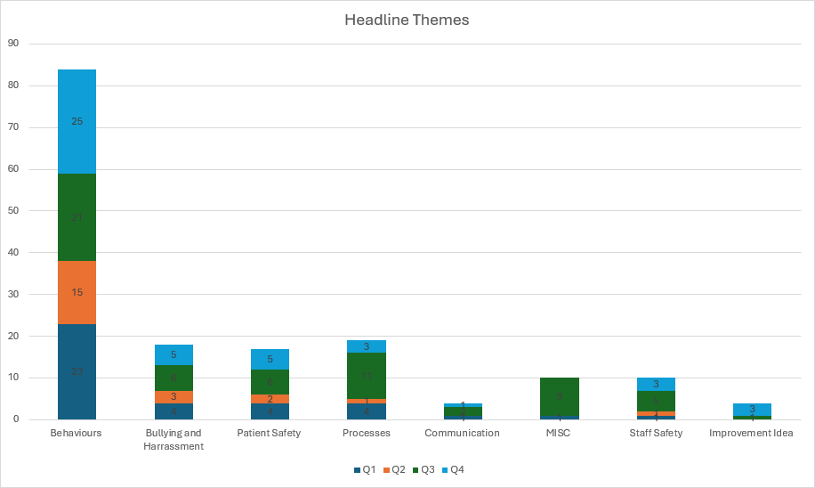

4.3 Goal 3: Improve patient experience and outcomes for people with protected characteristics and other communities who experience marginalisation.

Appendix 2 – Sets out our patient service user demographics.

4.3.1 Over the coming year we will be working on:

  - Improving the recording and monitoring of protected characteristic data for patients.
  - Use patients and service user experiences to inform and improve the design of our services.
  - Ensuring working practices and spaces are accessible for all - (Accessible information Standard - AIS).

4.4 Goal 4: Engage our diverse communities across our services and pathways

4.4.1 Over the coming year we will be working on:

- Reviewing the implementation of Patient & Carer Race Equality Framework (NHS Standard Contract).
- Increasing collaboration and co-design and production with protected groups, particularly in our work on the new hospital and new electronic health record aligned to CORE20PLUS5 and the major conditions.
- Engage all relevant stakeholders in the promotion of the Equality Delivery System (EDS) agenda and achievements ensuring all protected characteristics are addressed

Partnership working

4.4.2 The Trust also actively participates in the ICS-wide EDI network. Strong relationships have been developed with the other participants in the ICS and PAH working collaboratively on a number of diversity initiatives including recruitment, leadership development, and anti-racism awareness.

Business Disability Forum

4.4.3 Through our new membership with the Business Disability Forum, we will be undertaking a disability self-assessment audit by February 2026, to examine and improve policies and practices across the organisation.
We will work in partnership with other Trusts to improve the experience of staff, patients and service users.

- NHS Confederation Diversity in Health and Care Partners Programme

5.1 In July 2025 we successfully completed the NHS Confederation Diversity in Health and Care Partners Programme.

5.2 The areas below cover the objectives of the programme and will continue to help us in the transformation needed to embed EDI into our culture and foster PAH to carry on being an inclusive organisation.

5.3 Strategic reasons for joining the programme:

Transformation and sustainable change;
- Become more strategic
- Effect EDI Change
- Develop the EDI function following a restructure
- Develop EDI leads in their career paths
- Weave EDI through everything we do.

Shared and collaborative learning;
- Network, sharing. Benchmarking and learning
- Go outside our organisational bubble
- Shared approach to the NHS EDI Improvement Plan
- Be empowered and inspired
- Celebrate beliefs and share life stories

Develop anti-racist strategies:
- Identify intervention in line with Too Hot to Handle Report
- Support Internationally educated colleagues
- Address the causes of racial inequality

Inclusive Leadership
- Improve leadership behaviours and accountability
- Compliance with the Public Sector Equality Duty
- Empower leaders to align their leadership to the National EDI agenda

5.4 Operational reasons for joining the programme:

Build stronger staff engagement cultures
- Develop staff networks
- Develop a culturally competent workforce
- Empower managers to handle difficult conversations

Improve recruitment, retention, and progression strategies
- Ensure equitable representation across all levels
- Develop an enhanced recruitment and career development process

Address bullying, harassment and violence in the workplace
- Promote positive behaviours
- Develop clear strategies to tackle systemic inequalities
- Support staff with lived experience
- Support sexual safety and prevent sexual harassment
- Increase psychological safety

Data competent
- Use and analyse data through an EDI dashboard
- Improve EDI metrics
- Enhance equality analysis (EIA’S) and risk monitoring practices
- Create performance indicators that hold managers to account

6.0 Recommendations

6.1 The Board is asked to:
- Note the content of this report

- Approve for publishing in line with national requirements

Appendix 1 - PAHT Equality Workforce Profile March 2025

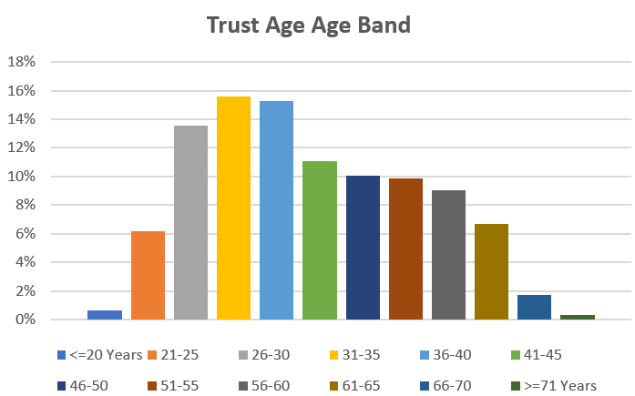
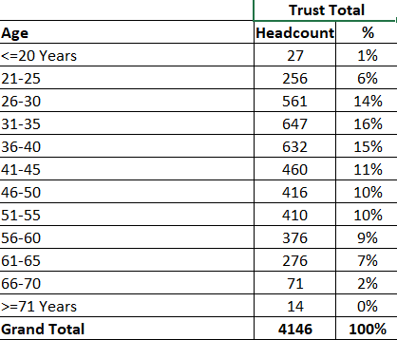

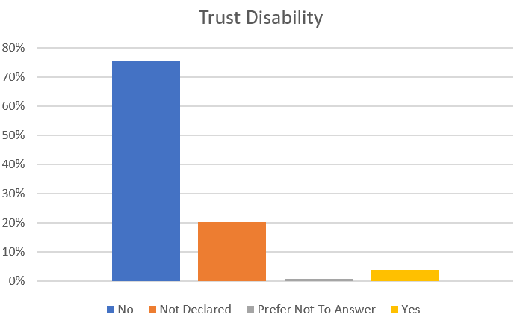
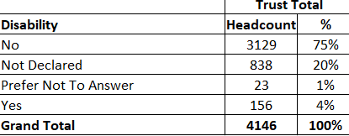

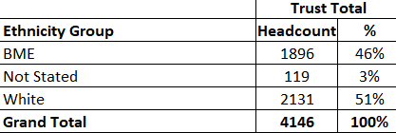
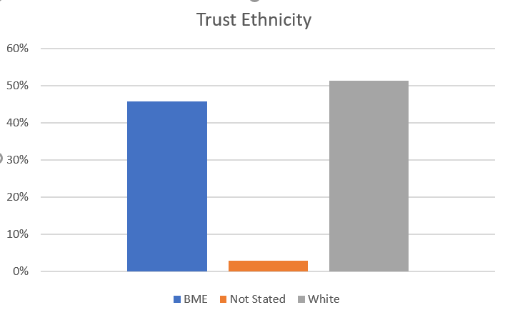
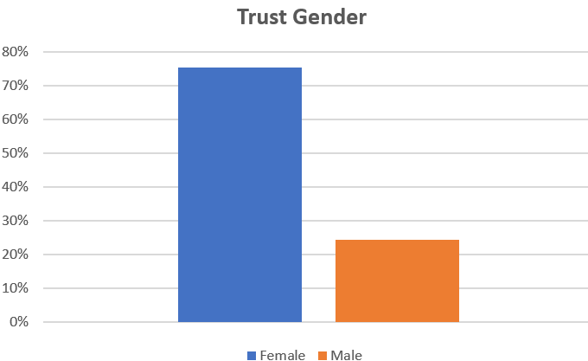
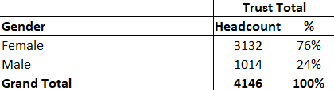

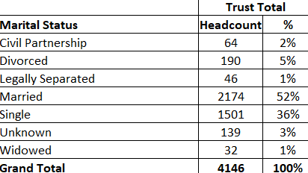
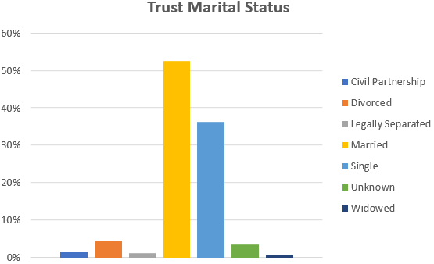

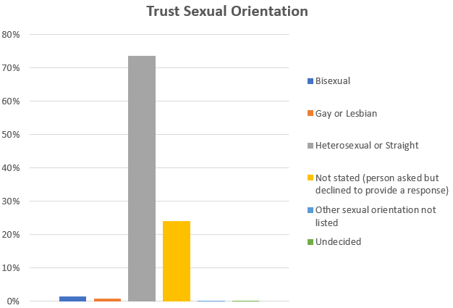
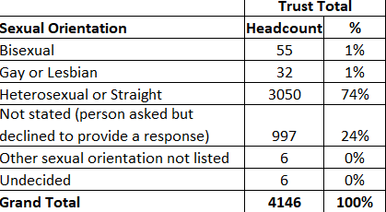

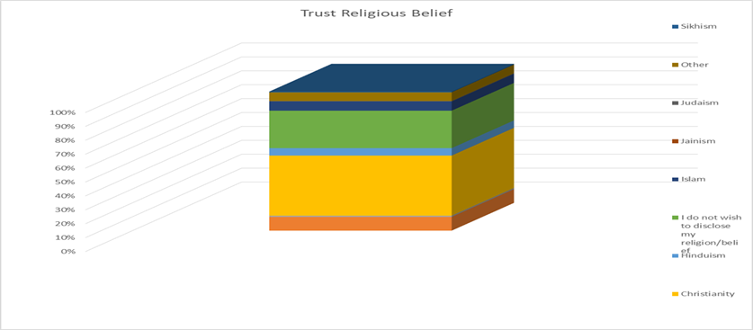

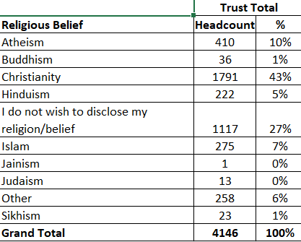

Appendix 2 – Informatics Patient Demographics

Notes
- Data is between period of October 2024 - April 2025
- Cosmic data – April 2024 - October 2024
- Alex Health data – 4th November – 31 April 2025

Our Patient by Age March 2024

Our Patient by Age Band 2025

Our Patient by Gender March 2024

.

Our Patient by Gender March 2025

Our Patients by Ethnicity March 2024

Our Patients by Ethnicity March 2025

