People Committee 27 March 2023

Agenda item:  Presented by:  Prepared by:  Date prepared:  Subject: | 4.1  Ogechi Emeadi – Director of People  Nathaniel Williams, People Information and Systems Manager  18 January 2023  Gender Pay Gap Reporting 2022
Purpose: | Approval |  | Decision |  |  | Information |  | x | Assurance
Key issues:  please don’t expand this cell; additional information should be included in the main body of the report | Gender pay gap reporting legislation is distinct from equal pay. Equal pay is concerned with men and women earning equal pay for the same or similar work. The gender pay gap is about the difference between men and women average pay within an organisation  - The gender pay gap as at 31 March 2022 reports men have higher mean and median average pay than women  - The difference between mean pay of men and women is 24% and that of median average pay is 16%  - Whilst medical and dental staff are separated from agenda for change staff and very senior managers, the mean gap is that women earn 1% less than men and the median gap is in favour for women earning 5%more than men  - The medical and dental mean and median pay gap is 10% and 15% in favour for men
Recommendation: | For information and discussion
Trust strategic objectives: please indicate which of the five Ps is relevant to the subject of the report | 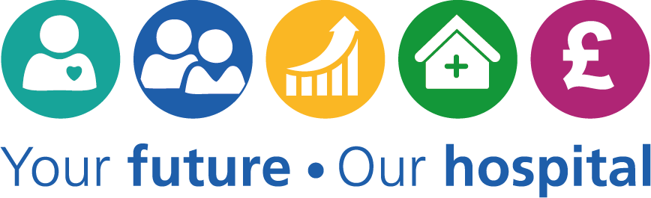  Patients |   People |  |   Performance |  |  |   Places |  |  |   Pounds
 | x | x |  | x |  |  | x |  |  | x
Previously considered by: | Equality and Inclusion Steering Group
Risk / links with the BAF: | 2.1 Workforce capacity  2.3 Internal engagement  2.4 Workforce capabilities
Legislation, regulatory, equality, diversity and dignity implications: | The Trust is required by law to publish their gender pay gap report
Appendices:

- Introduction

The gender pay reporting legislation requires all organisations employing more than 250 people to measure and publish their gender pay information based on earnings.
As at 31 March 2022, our gender profile is 78% women and 22% men.

- Background & context

  - The legislation framework can be referenced to the Equality Act 2010 -Specific Duties and Public Authorities - Regulations 2017.

  - It is important to note that the gender pay gap reporting legislation is distinct from equal pay. Equal pay is concerned with men and women earning equal pay for the same or similar work. The gender pay gap is about the difference between men and women average pay within an organisation.

  - The NHS has a national pay structure, job evaluation system and contractual terms and conditions for medical and non-medical staff, which has been developed in partnership with trade unions. This national framework provides a robust set of arrangements for pay determination.

  - The gender pay reporting requirements were introduced to highlight the differences in pay between men and women giving more transparency across all industry sectors. This assists employers to consider the reasons for any differences and to take any corresponding action.

- Requirements

Information taken as of 31 March 2022 looks at the following:

- Mean pay gap – the difference between the mean (average hourly earnings, excluding overtime) of men and women employees
- Median pay gap – the difference between the median (the difference between the midpoints of hourly rates of earnings, excluding overtime) of men and women employees
- Mean bonus gap – the difference between the mean bonus paid to men and women employees (bonus pay exclusively made up of local and national consultant clinical excellence awards, discretionary points and the welcome bonus for our international Nurses)
- Pay distribution by gender – the proportion of men and women employees in the lower, lower middle, upper middle and upper quartile pay bands

- Mean and median ordinary pay

The trust mean gender pay gap indicates that women earn 24% less than men for the reporting period compared to 29% in 2018. The median pay gap indicates that women earn 16% less than men, an improvement from the previous reporting periods. The high pay difference is partly due to medical & dental staff being the highest paid staff group.

The tables below give a clear separation of medical and dental staff group when compared to Agenda for Change (AFC) pay bands (inc very senior managers - VSM) for this reporting period only.

AFC &VSM | Mean Hourly Rate | Median Hourly Rate |  | M&D only | Mean Hourly Rate | Median Hourly Rate
Men | £17.08 | £14.46 |  | Men | £36.91 | £35.44
Women | £16.94 | £15.21 |  | Women | £33.09 | £30.11

The mean pay gap for Agenda for Change pay band including VSM, show the mean hourly rate women earn is 1% less than men and the median pay shows that women earn 5% more than men. Within medical and dental staff, the mean and median pay gap indicates that women earn 10% and 15% less respectively than men.

- Mean and median bonus pay gap

The Consultant staff group were the only staff group prior to this reporting period in receipt of bonuses (in line with NHS national terms and conditions for medical staff). This reporting period includes a welcome bonus payment for our international nurses. For the purposes of this report, bonuses are exclusively made up of local and national consultant clinical excellence awards, discretionary points and welcome bonus.

The tables below give a clear separation of the bonus paid to consultants and the welcome bonus paid to our international nurses for this reporting period.

M&D only | Mean Bonus Payment | Median Bonus Payment |  | International Nurses | Mean Bonus Payment | Median Bonus Payment
Men | £13,082.23 | £12,063.96 |  | Men | £200.00 | £200.00
Women | £10,301.05 | £6,717.90 |  | Women | £200.00 | £200.00

- Total Employees paid bonus

The chart shows more women received the bonus payment in this reporting period than men. This is due to the one hundred and seventeen international staff who were women that received the £200 welcome bonus compared to only nineteen men who received the £200 welcome bonus.

- Pay distribution by gender

The chart shows the proportion of men and women employees in each quartile. Employees are allocated into each quartile based on their hourly rate of pay. Lower quartile is our lowest pay quartile and upper quartile is our highest pay quartile.

- Reducing the gender pay gap

The trust remains committed to ensuring equality within the workforce and on this basis, identified a number of actions for 2022/23:

- Continue to promote and encourage flexible working arrangements where practicable across all areas
- Raising awareness on shared parental leave
- Promote guidance to help support any staff members experiencing menopausal symptoms, encourage open conversations and create a better working environment
- Establish a women’s network

For 2022/23 clinical excellence awards, the trust will continue to follow the national guidance of apportioning the available funds across all eligible consultants. The Equality, Diversity and Inclusion Steering Group will monitor delivery of these recommendations

- Recommendations

The Committee is asked to note the gender pay gap data including the publication date of this data and continue to support ongoing actions to address the gender pay gap

