Agenda item:  Presented by:  Prepared by:  Date prepared:  Subject / title: | Safe Staffing Monthly report  Giuseppe Labriola – Deputy Chief Nurse  Charlotte Collings, Lead Nurse for Safer Staffing and Workforce and Giuseppe Labriola – Deputy Chief Nurse  17th October 2025  Report on Nursing and Midwifery staff levels for September 2025 to Board.
Purpose: | Approval |  | Decision |  |  | Information |  | x | Assurance |  | x
Key issues: | There has been a sustained overall registered fill of > 95%.  No wards achieved < 75% overall fill rate in month. The increase in overall fill rates continue to be multifaced with an increase of enhanced care needs  The mid-year nursing and midwifery establishment review is currently following the governance processes and will be approved at board in October 2025
Recommendation: | The committee are asked to note the information within this report.
Trust strategic objectives: |   Patients |   People |  |   Performance |  |  |   Places |  |  |   Pounds
Trust strategic objectives: | x | x |  | x |  |  |  |  |  | x
Previously considered by: | NA
Risk / links with the BAF: | BAF: 2.3 Workforce capacity
Legislation, regulatory, equality, diversity and dignity implications: | NHS England and CQC letter to NHSFT CEOs (31.3.14): Hard Truths Commitment regarding publishing of staffing data.  NHS Improvement letter: 22.4.16  NHS Improvement letter re CHPPD: 29/6/18
Appendices: | Appendix 1: Ward and divisional fill rates by month against adjusted standard planned template.  Appendix 2: Ward and divisional CHPPD data  Appendix 3: Nursing red flags  Appendix 4: Nursing quality indicators

1.0 Introduction
This paper illustrates how PAHT’s nursing and midwifery staffing has been deployed for September 2025. It shows how safe staffing has been achieved and how this is supported by nursing and midwifery recruitment and deployment.

2.0 Background
The National Quality Board (NQB 2016) recommend that monthly, actual staffing data is compared with expected staffing and reviewed alongside quality of care, patient safety, and patient and staff experience data. The Trust is committed to ensuring that improvements are learned from and celebrated, and areas of emerging concern are identified and addressed promptly. This paper will show staffing and actions taken in September 2025. The following sections identify the processes in place to demonstrate that the Trust proactively manages nursing and midwifery staffing to support patient safety.
3.0 Inpatient wards fill rate
The Trust’s safer staffing submission has been submitted to NHS Digital for September 2025 within the data submission deadline. Table 1 shows the summary of the overall fill rate for this month. Table 2 shows a summary of overall fill rate percentages for a rolling 12-month period.
Appendix 1 illustrates a ward-by-ward breakdown for this period.
3.1 Wards with < 75% average fill rate
Nightingale had an overall fill rate of <75% in September.
Nightingale was temporarily closed with its staffing moved to St Margarets Hospital – Poplar Ward to support essential maintenance in other areas, so can be disregarded for this month.
3.2 Wards with > 100% average fill rate
Henry Moore Ward continues to have an increased fill rate due to fluctuating capacity and opening of additional surgical beds and a Level 1 area for post-operative patients, the Level 1 bay is staffed by ITU, and the staffing is reflected in their numbers. Therefore, the additional staff are reflective of the required workforce to meet the activity demands. As part of the mid-year nursing and midwifery establishment review, the board have approved changes to the establishment which should reflect in future reports.
Greater than 100% fill rate for Registered Nurse (RN) shifts continues to be mainly attributable to enhanced care requirements, a task and finish group is now in place reviewing enhanced care requirements. This is evident in Ray, Saunders and Dolphin wards in September.
The Trust continues to use NHS Professionals to mitigate vacant shifts and in addition agency nursing to support patients that need Registered Mental Health Nurse’s. Additional control measures continue to be in place about the creation of additional duties.
Furthermore, our senior nurses and midwives are also supporting individual areas when needed. SafeCare data continues to be collected three times a day to enhance staffing governance across the organisation.
Further detail can be found in Appendix 1

Table 1. Overall fill rate
Average day fill rate - registered nurses/midwives | Average day fill rate - care staff | Average night fill rate - registered nurses/midwives | Average night fill rate - care staff | % Registered overall fill rate | % HCSW overall fill rate | % Overall fill rate
92.9% | 112.2% | 99.6% | 124.6% | 95.9% | 117.9% | 103.1%

Table 2. Inpatient fill rate including Maternity Wards Trend

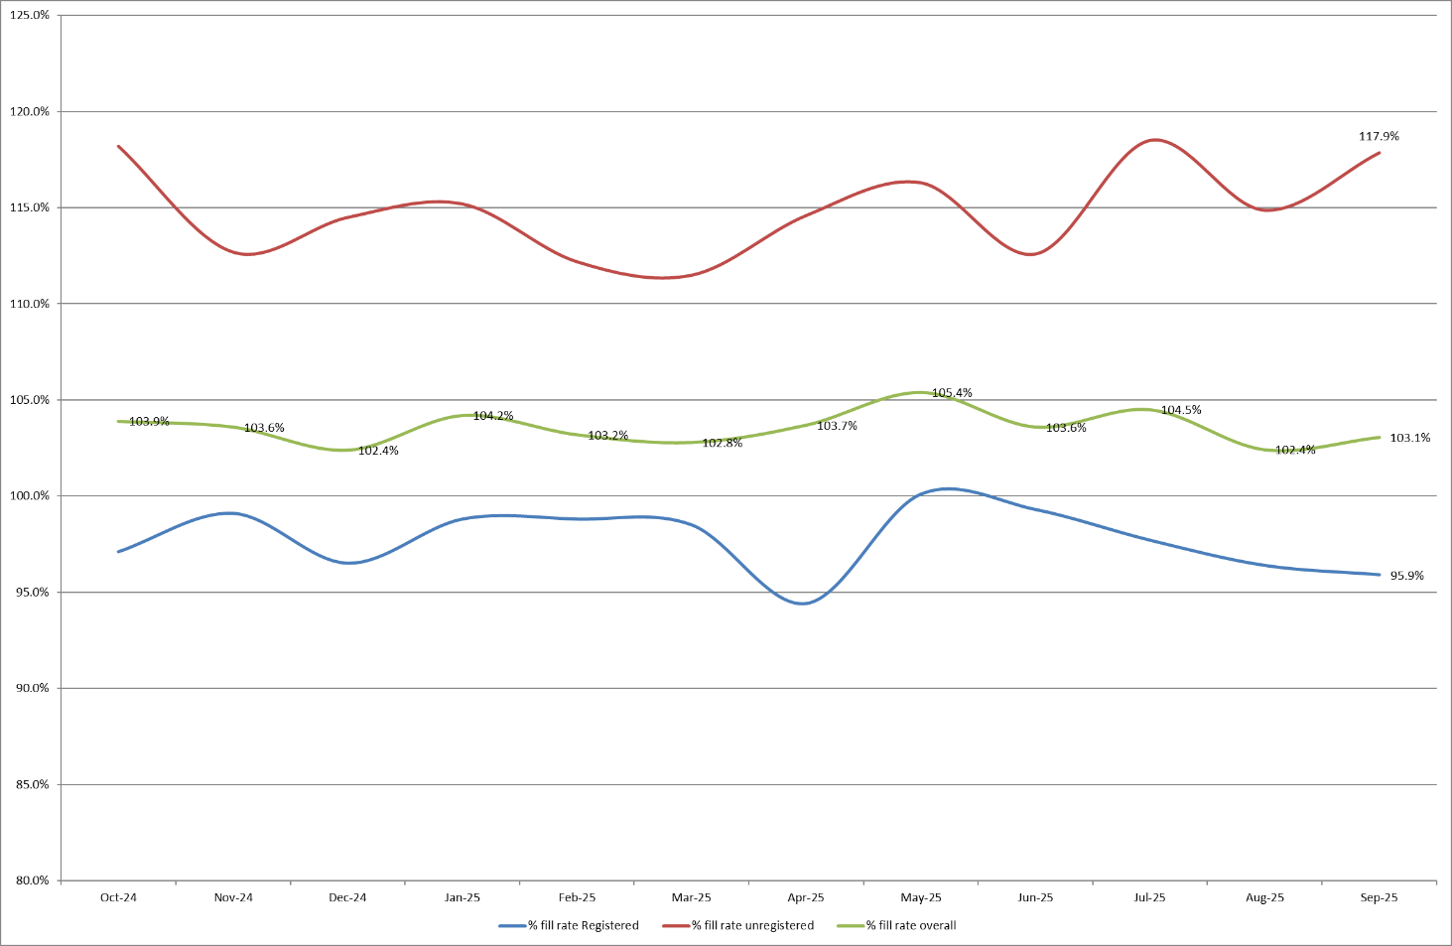

4.0 Care Hours Per Patient Day (CHPPD)

CHPPD allows comparison and benchmarking of a ward’s CHPPD figure with that of other wards in the hospital, or with similar wards in other hospitals. It can be used to look at variation between similar wards to ensure the right staff are being used in the right way and in the right numbers.
The hours worked during day and night shifts by registered nurses and midwives and healthcare assistants are added together. This figure is then divided by the number of patients at midnight; this then gives the total CHPPD.
By itself, the CHPPD does not reflect the total amount of care provided on a ward nor does it directly show whether care is safe, effective or responsive. It should therefore be considered alongside measures of quality and safety.

Table 3. Overall Care Hours Per Patient Day (CHPPD) September 2025

Registered CHPPD | Unregistered CHPPD | Total CHPPD
5.0 | 3.0 | 7.9

The Model Hospital data (June 2025) shows the Trust with a CHPPD of 8.0 against the national median of 9.0. Table 4 also shows the Trusts total CHPPD against our peers (East and North Hertfordshire NHS Trust and West Hertfordshire Teaching Hospitals NHS Trust).
Appendix 2 shows the individual ward and divisional CHPPD for August 2025
Table 4. CHPPD Trend

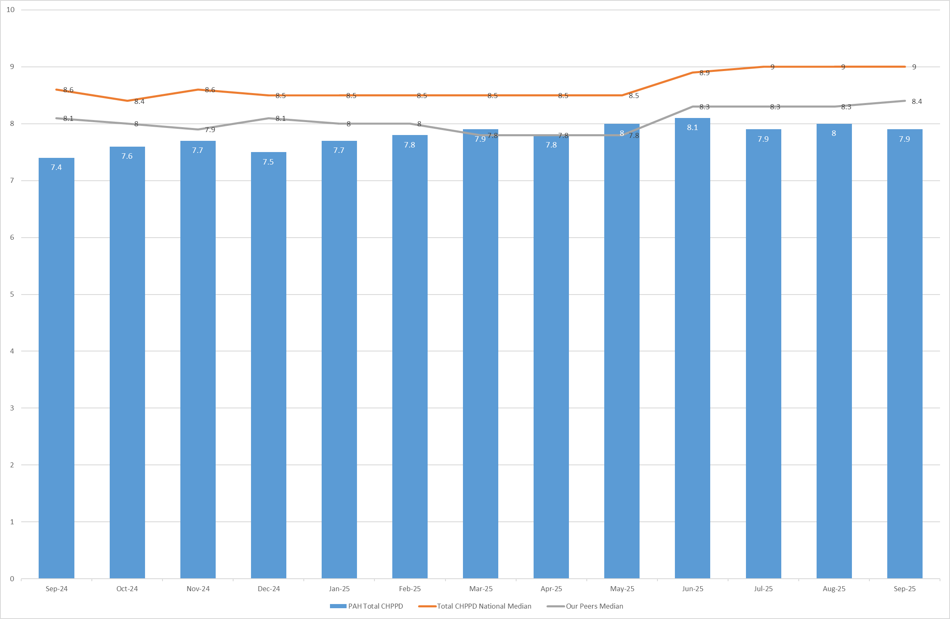

5.0 Quality Indicators

5.1 Nursing Red Flags
Nursing red flags prompt an immediate response by the registered nurse in charge of the ward. The response may include distributing additional nursing staff to the ward or other appropriate responses. Appendix 3 details the NICE (2014) definition of Nursing Red Flags. This includes the number of occasions when registered staffing fell below 75% of the standard template with trend, and the number of Red Flags raised in SafeCare.

5.2 Quality indicators (Falls, pressure ulcers and complaints, PALS and compliments)
There have been increases in quality concerns across Adult ED, OPAL, Ray, Winter and Saunders. Presently there is no correlation between fill rates and this emerging trend, all areas did have increased requirements for enhanced care in September. These are being closely monitored. A review of quality indicators can be found in Appendix 4.

6.0 Conclusion
The Trust continues to achieve a sustained overall registered fill of > 95%. The increase in overall fill rates for support workers is due to enhanced care needs.
7.0 Recommendation
The board are asked to note the information in this report to provide assurance on the daily mitigation of nursing and midwifery staffing.

Appendix 1: Ward level data and narrative: fill rates September 2025 (Adjusted Standard Planned Ward Demand)
>100% | 95 – 100% | 75-95% | <75%

 | Day |  | Night
Ward name | Average fill rate - registered nurses/midwives (%) | Average fill rate - care staff (%) | Average fill rate - registered nurses/midwives (%) | Average fill rate - care staff (%) | % Registered overall fill rate | % HCSW overall fill rate | % Overall fill rate
Harvey | 84.3% | 126.8% | 98.9% | 119.9% | 90.3% | 123.5% | 102.3%
Henry Moore | 133.9% | 159.7% | 183.2% | 166.7% | 153.6% | 163.0% | 157.7%
ITU & HDU | 94.6% | 103.5% | 96.0% | 128.8% | 95.3% | 115.6% | 97.2%
John Snow | 100.5% | 64.8% | 96.7% | 37.6% | 98.7% | 51.8% | 83.0%
Penn | 93.7% | 135.6% | 96.7% | 171.2% | 94.9% | 149.1% | 114.3%
Saunders | 92.7% | 125.8% | 122.2% | 180.9% | 103.7% | 146.7% | 119.9%
Surgery Total | 97.2% | 127.1% | 107.6% | 144.4% | 101.8% | 134.6% | 111.4%
Fleming | 85.3% | 103.8% | 98.4% | 105.0% | 90.9% | 104.3% | 95.0%
Harold | 90.8% | 107.6% | 99.4% | 123.2% | 94.6% | 115.0% | 101.1%
Kingsmoor | 85.0% | 130.3% | 102.1% | 139.4% | 91.5% | 134.7% | 107.6%
Lister | 92.6% | 126.0% | 100.0% | 145.9% | 95.8% | 135.5% | 111.6%
Locke | 87.8% | 119.5% | 99.1% | 132.0% | 92.6% | 125.5% | 105.7%
Nightingale | 69.2% | 20.0% | 48.3% | 19.7% | 59.2% | 19.9% | 39.5%
Opal | 103.4% | 113.7% | 78.2% | 136.0% | 91.3% | 124.4% | 104.6%
Ray | 108.2% | 127.7% | 124.2% | 161.3% | 115.0% | 140.4% | 124.1%
Tye Green | 86.7% | 119.8% | 92.8% | 146.2% | 89.4% | 130.5% | 105.4%
Winter | 92.5% | 136.7% | 105.8% | 152.8% | 98.1% | 144.4% | 116.6%
Medicine Total | 90.8% | 114.2% | 97.8% | 129.3% | 93.8% | 121.2% | 104.1%
AAU | 85.8% | 124.2% | 97.1% | 150.4% | 90.9% | 136.7% | 100.5%
Charnley | 89.7% | 139.6% | 91.4% | 159.6% | 90.5% | 149.2% | 107.3%
UEC Total | 87.3% | 131.9% | 94.7% | 155.0% | 90.7% | 142.9% | 103.4%
Birthing | 78.4% | 71.8% | 85.1% | 88.8% | 81.6% | 79.9% | 81.1%
Chamberlen | 94.8% | 76.7% | 88.1% | 66.7% | 91.6% | 71.9% | 86.7%
Dolphin | 99.9% | 99.0% | 110.8% | 108.8% | 104.7% | 102.3% | 104.1%
Labour | 92.9% | 86.8% | 92.0% | 80.0% | 92.5% | 83.6% | 90.5%
Neo-Natal Unit | 99.6% | 56.7% | 103.3% | 33.3% | 101.5% | 45.0% | 92.1%
Samson | 97.8% | 85.1% | 93.6% | 88.0% | 95.8% | 86.5% | 90.5%
CHAWS Total | 95.2% | 83.4% | 96.8% | 80.9% | 96.0% | 82.2% | 91.8%
Total | 92.9% | 112.2% | 99.6% | 124.6% | 95.9% | 117.9% | 103.1%

Trust wide – there has been a successful recruitment event for newly qualified nurses to join trust wide positions, it is expected they will join teams throughout the Autumn. There are subsequent rounds of interviews being organised for newly qualified nurses due to anticipated attrition in the coming months.
John Snow Ward – the HCSW shifts are often under template by 1 WTE, this is due to fluctuating ward capacity throughout the month in addition to the HCSW being re-deployed to other areas through the daily safe staffing meetings. This will be reviewed in the SNCT data from September to determine if the 2nd HCA is needed within the establishment moving forward.
OPAL Unit – Have returned to their usual shift pattern after a short trial, however as the beds have been in demand on the nights, this was not possible to continue safely. They have had a high sickness rate in September attributing to the low RN fill rate on night shifts.
Neonatal Unit – low fill rates on day shifts for HCSW and nursery nurse shifts, They have had a new starter in September who has been on supernumerary, whilst there has been high annual leave this month alongside maternity leave. This is likely to be isolated, but there is still 1.0 WTE vacancy.
Maternity – the service continues to robustly review staffing through twice weekly staffing reviews and the use of BirthRate Plus. Safety is maintained by daily staffing huddles and staff deployment according to acuity, support continues to be provided by specialist midwives and matrons being redeployed as needed. Birthrate Plus have been commissioned to review the workforce, and the workforce intentions will be available within the full year nursing and midwifery establishment review starting in September 2025.
The end of year establishment review (which underpins the rota templates) commenced in September 2025 and finished 14th October 2025 This is for adult and paediatric inpatient wards and assessment units along with main and paediatric emergency departments.

Emergency Departments – national reporting is currently for inpatient areas and therefore does not include areas including the emergency department. To ensure the Board is sighted to staffing in these areas, the data for both adult ED and Paediatric ED is included below (Appendix 1a and 1b) using the same methodology as the full UNIFY report.

Appendix 1a: ED data and narrative: fill rates September 2025 (Standard Planned Demand)

Average day fill rate - registered nurses/midwives | Average day fill rate - care staff | Average night fill rate - registered nurses/midwives | Average night fill rate - care staff | % Registered overall fill rate | % HCSW overall fill rate | % Overall fill rate
98.0% | 99.8% | 111.9% | 120.3% | 104.2% | 108.9% | 105.7%

Appendix 1b: Paediatric ED data and narrative: fill rates September 2025 (Standard Planned Demand)

Average day fill rate - registered nurses/midwives | Average day fill rate - care staff | Average night fill rate - registered nurses/midwives | Average night fill rate - care staff | % Registered overall fill rate | % HCSW overall fill rate | % Overall fill rate
116.7% | 80.0% | 141.2% | 88.8% | 127.6% | 84.4% | 114.3%

Paediatric Emergency Department – Shows a low overall fill rate for HCSW’s and higher than template for RNs in ED. Following discussions with the divisional team and reviewing SNCT data, it has been identified that creating a middle shift should mitigate some of these figures as the key driver is improving the workforce efficiency, this is under review.

Appendix 2: Ward level data: CHPPD September 2025

Care Hours Per Patient Day (CHPPD)
Ward | Registered Nurses/Midwives | Non-registered Nurses/Midwives | Overall
Trust Total | 5.0 | 3.0 | 7.9
Harvey Ward | 3.7 | 2.9 | 6.5
Henry Moore Ward | 3.6 | 2.9 | 6.5
ITU & HDU | 18.3 | 2.2 | 20.5
John Snow Ward | 6.1 | 1.6 | 7.7
Penn Ward | 3.9 | 3.5 | 7.4
Saunders Unit | 3.6 | 3.1 | 6.7
Surgery Total | 5.3 | 2.9 | 8.3
Fleming Ward | 3.7 | 1.9 | 5.5
Harold Ward | 4.5 | 2.5 | 7.0
Kingsmoor General | 3.3 | 2.9 | 6.2
Lister Ward | 3.6 | 3.4 | 7.0
Locke Ward | 3.5 | 3.1 | 6.7
Nightingale Ward | 15.7 | 5.3 | 21.0
Opal Unit | 4.8 | 4.4 | 9.2
Ray Ward | 4.3 | 2.9 | 7.2
Tye Green Ward | 3.8 | 3.5 | 7.3
Winter Ward | 3.7 | 3.6 | 7.3
Medicine Total | 3.9 | 3.1 | 7.0
AAU | 5.8 | 2.3 | 8.2
Charnley Ward | 3.9 | 2.6 | 6.6
UEC Total | 4.9 | 2.5 | 7.4
Birthing Unit | 15.6 | 7.7 | 23.3
Chamberlen Ward | 6.1 | 1.6 | 7.7
Dolphin Ward | 10.9 | 3.5 | 14.4
Labour Ward | 17.0 | 4.4 | 21.4
Neo-Natal Unit | 12.6 | 1.1 | 13.8
Samson Ward | 2.6 | 3.1 | 5.6
CHAWS Total | 8.1 | 3.0 | 11.1
Appendix 3. Nursing Red Flags (NICE 2014) and trend data

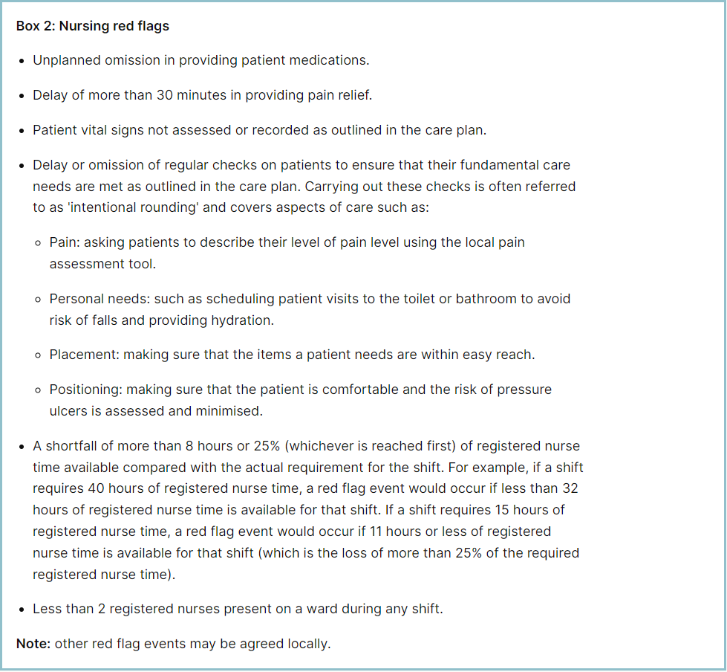

Staffing red flags and trend data

Table 1 shows the number of shifts across all clinical areas – including maternity – where fill rates fell below 75%, with a monthly trend in Table 2. In September 2025, this decreased by 11 to 124 occasions. Maternity accounted for 41 red flags, an increase of 17 from last month.
Penn was temporarily relocated as part of the deep clean programme, resulting in a reduced bed base. This reduction impacted the ward’s staffing template, which appeared red on the roster system but did not accurately reflect true staffing levels due to the lower bed capacity.
In addition, Nightingale Ward was temporarily closed, which automatically generated 40 red flags within the system. These combined factors account for the apparent increase in red flags during the reporting period. When both wards are excluded from the total, the overall red flag levels remain consistent with previous months.
OPAL continues to report high red flag volumes, particularly on night shifts they have had higher volumes of sickness this period, most nursing quality incidents raised have occurred on day shifts where staffing is above template, and not on the night shifts. The patients on the ward have been very high risk, and the majority of falls were witnessed.

Table 1. Occasions when registered staffing fell below 75% of standard template September 2025

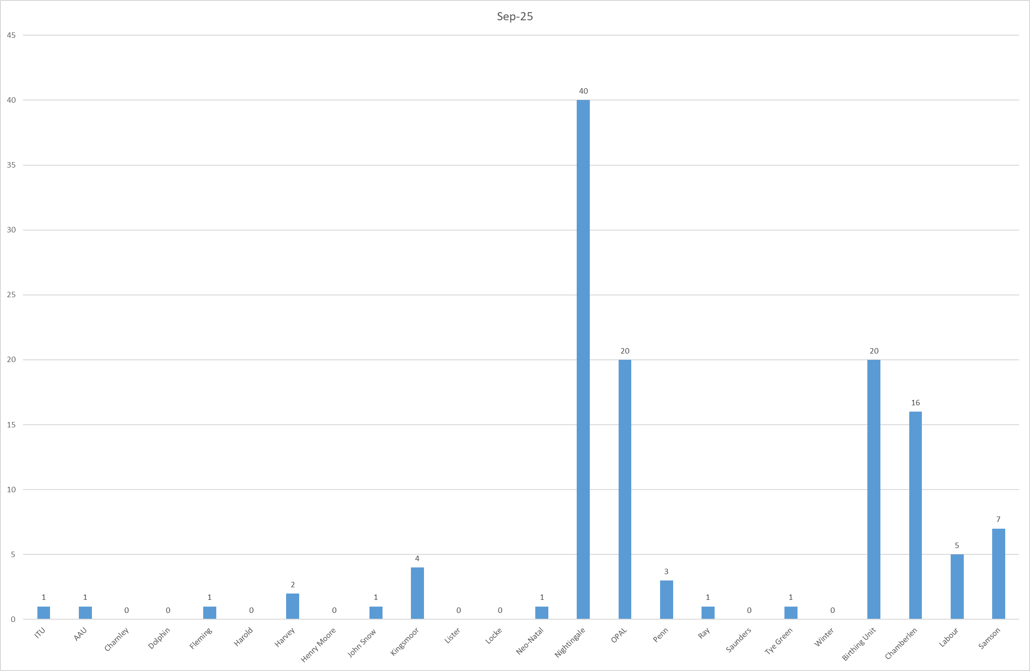

Table 2. Occasions when registered staffing fell below 75% of standard template.
Trend Data October 2024 – September 2025

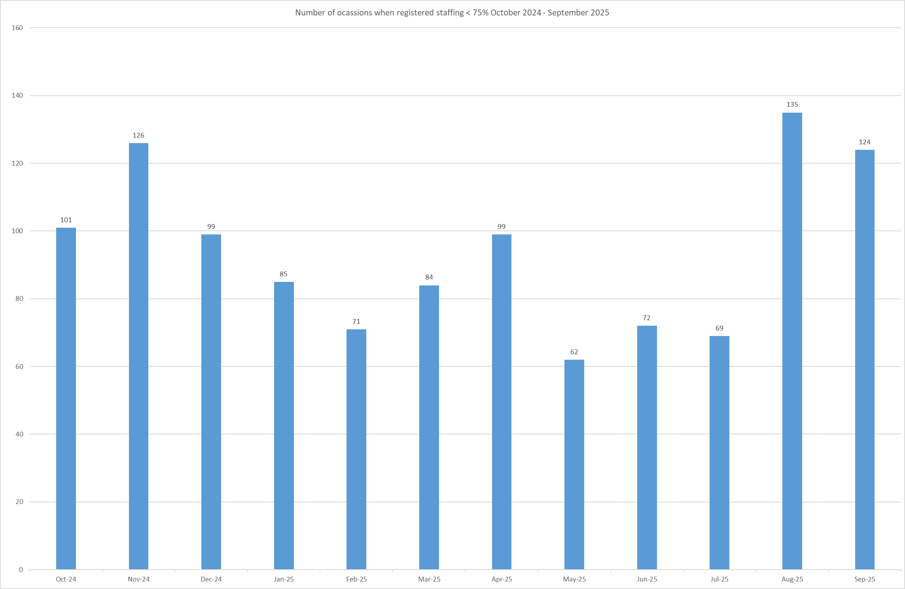
All adult inpatient areas record staffing shortfalls in SafeCare via Red Flags. In September 2025, 75 Red Flags were raised (Table 3a), up from 35 in August (Table 3b and chart). The main drivers were shortfalls in RN time (30) and inability to provide Enhanced Care (29), with Tye Green (22) and Locke (14) wards most affected.

A new local Red Flag for unmet Enhanced Care and a Level 3 Enhanced Care patient task have been introduced across adult inpatient wards to improve oversight and support data sharing with the Enhanced Care Collaborative. Adult ED has now adopted this functionality, recording three incidents in September, and continues to raise awareness among staff.

Of the 75 Red Flags raised, 62 remain open and only 10 have been resolved, highlighting inconsistent use of SafeCare and under-utilisation of the system. While Red Flags support daily staffing decisions when used effectively, further training and communication are needed to improve reporting and closure rates. This has been addressed on the daily staffing huddles and including open red flags to the staffing deployment decisions.

Table 3a. Red Flags raised via SafeCare September 2025

Table 3b. Red Flags raised via SafeCare trend November 24 – September 25

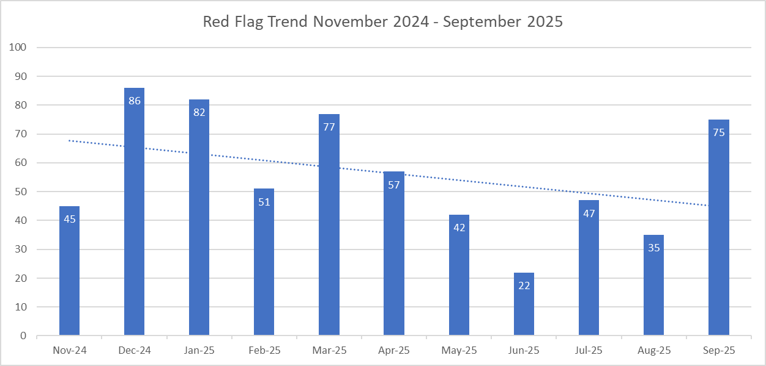

Redeployment

Redeployment of staff continues to support safe staffing through daily huddles. In September 2025, 286 substantive staff redeployments were recorded, a slight increase from 281 in August but significantly higher than previous months (Chart 2). Nightingale redeployed the most staff, followed by John Snow, while A&E and Locke were the largest net receivers (Chart 1).

Redeployed hours accounted for 1.98% of substantive staff hours and 2.19% of total hours worked (Tables 6 & 7). These figures exclude agency, bank, and multi-post holders.

Although redeployment remains low overall, the sustained increase over two consecutive months may indicate an emerging trend. This could be linked to the temporary closure of Nightingale ward and will require monitoring to understand underlying drivers. Governance and oversight remain strong.

Table 4. Hours of substantive staff redeployed August 2025

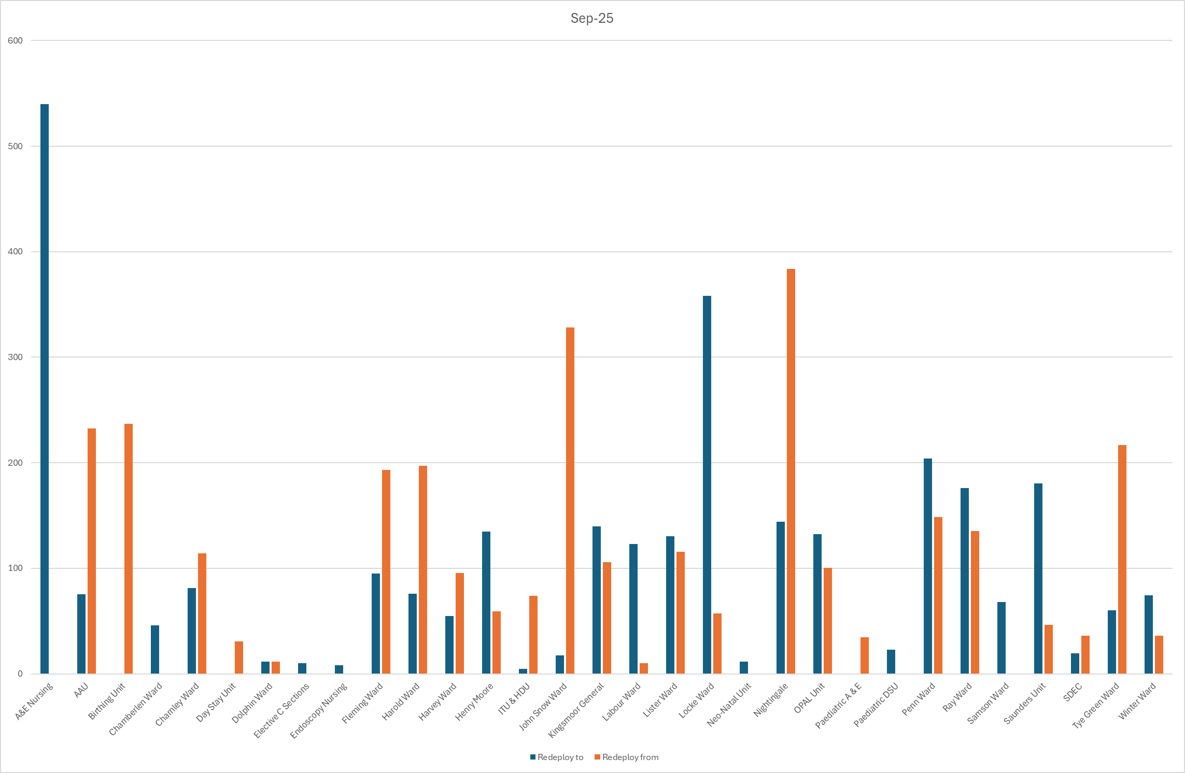

Table 5. Substantive staff redeployment trend

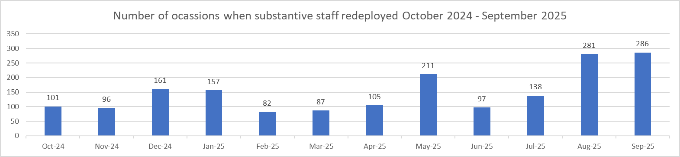
Table 6. % of substantive staff redeployed as % of total hours worked
Substantive staff hours redeployed | Total hours worked (inc bank and agency) | % of total hours worked / substantive staff redeployed
2713.41 | 136971 | 1.98%

Table 7. % of staff redeployed as % of total hours worked
All staff hours redeployed (including bank and agency but excluding Enhanced Care Team, Bank Pool and Rapid Response Pool) | Total hours worked (inc bank and agency) | % of total hours worked / staff redeployed (including bank and agency but excluding Enhanced Care Team, Bank Pool and Rapid Response Pool)
2999.83 | 136971 | 2.19%

Appendix 4: Nursing quality indicators

Table 1. Number of falls, unwitnessed falls and falls with harm in September 2025, with the top 3 wards being highlighted.
 | Total falls in month | Top 3 wards
Total falls | 75 | A&E – 11 | OPAL – 7 | Ray – 7
Unwitnessed falls | 55 | A&E – 6 | Ray – 5 | Winter & Saunders – 4
Falls with harm * | 20 | OPAL and Ray – 3 |  | AAU – 2
*Subject to change following review at Falls Incident Oversight Group

September’s data sees an overall increase in total falls from 55 to 75, an increase of unwitnessed falls from 43 to 55 and increase of falls with harm from 10 to 20.

The Trust falls reduction strategy and workplan (2025/2026) is still in place and mandatory falls training has increased to 97%. Matron for Kingsmoor and Harold is doing targeted work to support reducing unwitnessed falls in these areas.

Falls Rate per 1000 bed days September 2025 data

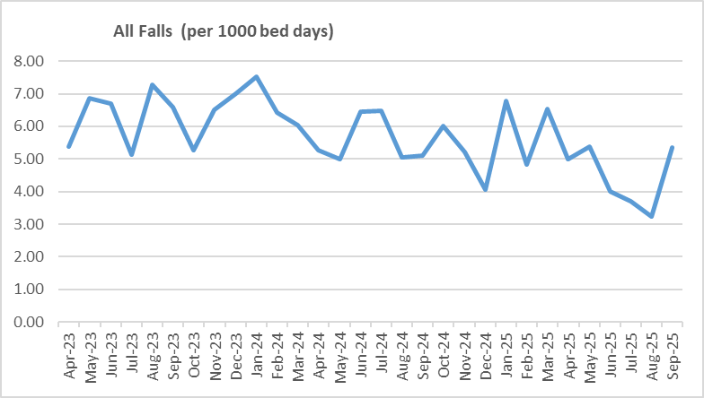

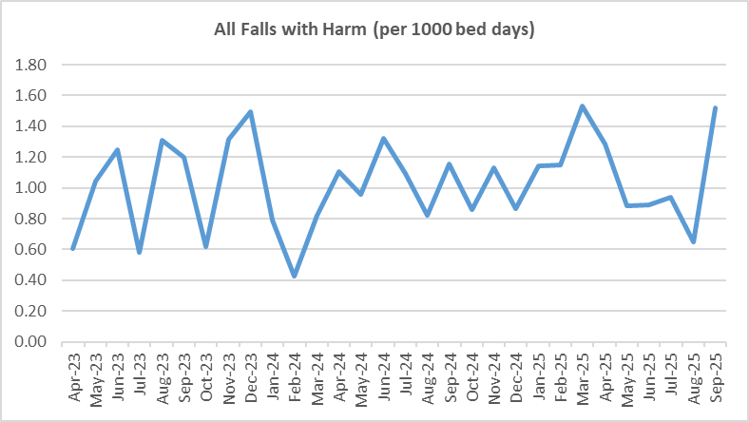

Pressure Ulcers

Table 2a. Number of Hospital Acquired Pressure Ulcers (HAPU) Cat 2 and Cat 3 Pressure Ulcers
There was a decrease in September for reportable HAPUs (32 to 24) and non-reportable skin changes (63 to 54) compared to last month and a significant increase in category 3 HAPUs (14 from 4). Of the 7 incidents for category 3 currently 6 are deemed moderate harms and 1 minor harms – this will be validated with PS&Q discussion once all investigations are complete.

2 wards remain under quality surveillance and improvements noted in one area. However, 10 wards recorded with no skin changes, or no reportable harm through September, which is commendable.

Through September, a quality summit was held to discuss the 14 category 3 and 4 HAPU’s acquired in August facilitated by the TVN team, it was identified that 40% of patients who developed these HAPUs were in temporary escalation spaces, which may or may not have contributed to the development of their HAPU’s.

From October the trust will be implementing the ‘All you have to do is ASK’ campaign which will form the theme for ‘Stop the Pressure Day’ in November

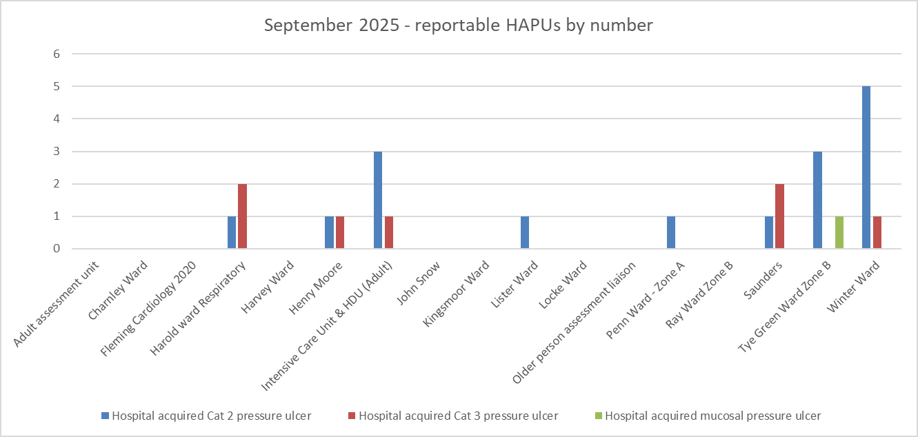

Total in month | Top 3 wards
24 | Winter - 6 | Tye Green - 4 | ITU & HDU - 4

Table 2b. Reported Incidents and Actual Hospital Acquired Pressure Ulcers September 2025

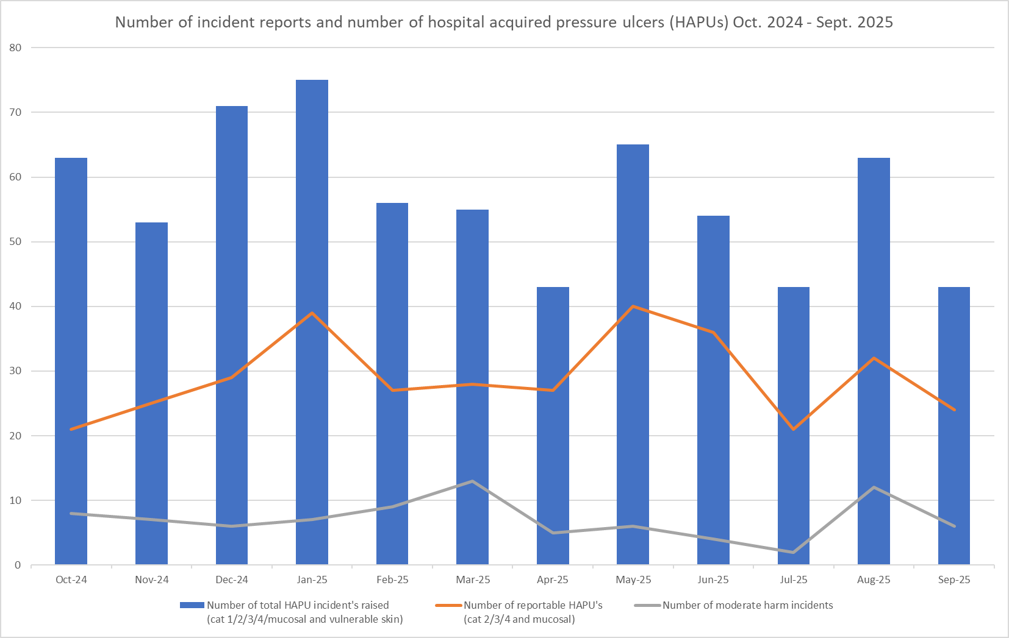


Hospital acquired pressure ulcer data taken from different sources can be inconsistent and not comparable. Due to these variables a more unified approach to data capture and data reporting is underway and therefore the rate per 1000 occupied bed days is currently not being completed. As a consequence the footfall is not reflected in the graph.
The above chart captures:
- The number of incident forms completed per month relating to total number of skin changes (category 1,2,3,4, mucosal and vulnerable skin/deep tissue injury)
- The actual number of reportable pressure ulcers per month
- The number of moderate harm incidents validated.

The number of reportable HAPU’s has decreased this month, as have the number of validated moderate harm incidents.

It is important to note that the number of incidents reported does not equal the number of HAPUs. Multiple incidents reported in the year will have included more than one HAPU per incident due to the patient's skin being vulnerable.

Complaints, PALS and Compliments Trend Data January 2025 – September 2025

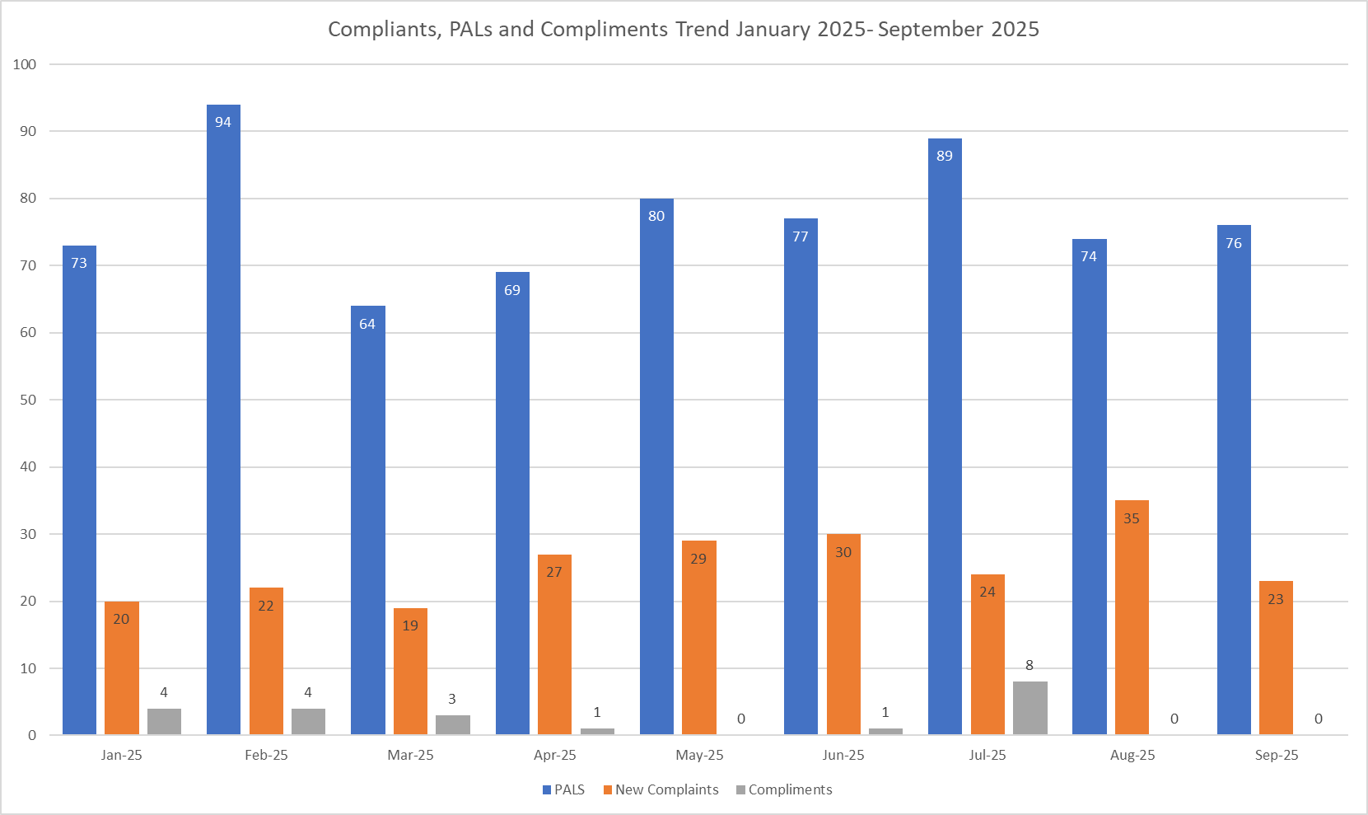

Table 3. Number of new Complaints, PALS and Compliments in September 2025 with top three wards highlighted

 | Total in month | Top Departments
New complaints | 23 | A&E – 9 | Winter, Saunders, P.ED – 2
PALs | 76 | A&E – 21 | Kingsmoor – 7 | Lister, P.ED, Penn - 6
Compliments | None recorded

The main themes for PALS concerns received in September 2025 are as follows:

- Delay – 32.55%
- Communication – 24.41%
- Cancellations – 10.61%
- Appointments – 10.14%

The main themes for Complaints received in September 2025 are as follows:

- Communication – 18.32%
- Medical care – 16.03%
- Delay – 16.03%

The main themes for Compliments received in September 2025 are as follows:
Unfortunately, compliments received in September 2025 have not been logged on Datix this month.

