Agenda item:  Presented by:  Prepared by:  Date prepared:  Subject / title: | Safe Staffing Monthly report  Polly Read – Deputy Chief Nurse  Charlotte Collings – Lead Nurse for Safer Staffing and Workforce  XX  Report on Nursing and Midwifery staff levels for October 2025 to Board.
Purpose: | Approval |  | Decision |  |  | Information |  | x | Assurance |  | x
Key issues: | There has been a sustained overall registered fill of > 95%.  No wards achieved < 75% overall fill rate in month. The increase in overall fill rates continue to be multifaced with an increase of enhanced care needs  The mid-year nursing and midwifery establishment review is currently following the governance processes and will be approved at board in October 2025.  The end of year nursing and midwifery establishment review commenced in September and is following the governance processes, it is due to go to the people committee in November 2025
Recommendation: | The committee are asked to note the information within this report.
Trust strategic objectives: |   Patients |   People |  |   Performance |  |  |   Places |  |  |   Pounds
Trust strategic objectives: | x | x |  | x |  |  |  |  |  | x
Previously considered by: | NA
Risk / links with the BAF: | BAF: 2.3 Workforce capacity
Legislation, regulatory, equality, diversity and dignity implications: | NHS England and CQC letter to NHSFT CEOs (31.3.14): Hard Truths Commitment regarding publishing of staffing data.  NHS Improvement letter: 22.4.16  NHS Improvement letter re CHPPD: 29/6/18
Appendices: | Appendix 1: Ward and divisional fill rates by month against adjusted standard planned template.  Appendix 2: Ward and divisional CHPPD data  Appendix 3: Nursing red flags  Appendix 4: Nursing quality indicators

1.0 Introduction
This paper illustrates how PAHT’s nursing and midwifery staffing has been deployed for October 2025. It shows how safe staffing has been achieved and how this is supported by nursing and midwifery recruitment and deployment.

2.0 Background
The National Quality Board (NQB 2016) recommend that monthly, actual staffing data is compared with expected staffing and reviewed alongside quality of care, patient safety, and patient and staff experience data. The Trust is committed to ensuring that improvements are learned from and celebrated, and areas of emerging concern are identified and addressed promptly. This paper will show staffing and actions taken in October 2025. The following sections identify the processes in place to demonstrate that the Trust proactively manages nursing and midwifery staffing to support patient safety.
3.0 Inpatient wards fill rate
The Trust’s safer staffing submission has been submitted to NHS Digital for October 2025 within the data submission deadline. Table 1 shows the summary of the overall fill rate for this month. Table 2 shows a summary of overall fill rate percentages for a rolling 12-month period.
Appendix 1 illustrates a ward-by-ward breakdown for this period.
3.1 Wards with < 75% average fill rate
No wards had less than 75% average fill rate through November.
3.2 Wards with > 100% average fill rate
Henry Moore Ward continues to have an increased fill rate due to fluctuating capacity and opening of additional surgical beds and a Level 1 area for post-operative patients, the Level 1 bay is staffed by ITU, and the staffing is reflected in their numbers. Therefore, the additional staff are reflective of the required workforce to meet the activity demands. The Board approved changes have been applied to the roster commencing 22nd December 2025.
Greater than 100% fill rate for Registered Nurse (RN) shifts continues to be mainly attributable to high patient acuity / enhanced care requirements, a task and finish group is now in place reviewing enhanced care requirements.
The Trust continues to use NHS Professionals to mitigate vacant shifts and in addition agency nursing to support patients that need Registered Mental Health Nurse’s. Additional control measures continue to be in place about the creation of additional duties.
Furthermore, our senior nurses and midwives are also supporting individual areas when needed. SafeCare data continues to be collected three times a day to enhance staffing governance across the organisation.
Further detail can be found in Appendix 1

Table 1. Overall fill rate
Average day fill rate - registered nurses/midwives | Average day fill rate - care staff | Average night fill rate - registered nurses/midwives | Average night fill rate - care staff | % Registered overall fill rate | % HCSW overall fill rate | % Overall fill rate
94.2% | 112.8% | 102.0% | 135.5% | 97.7% | 123.1% | 106.0%

Table 2. Inpatient fill rate including Maternity Wards Trend

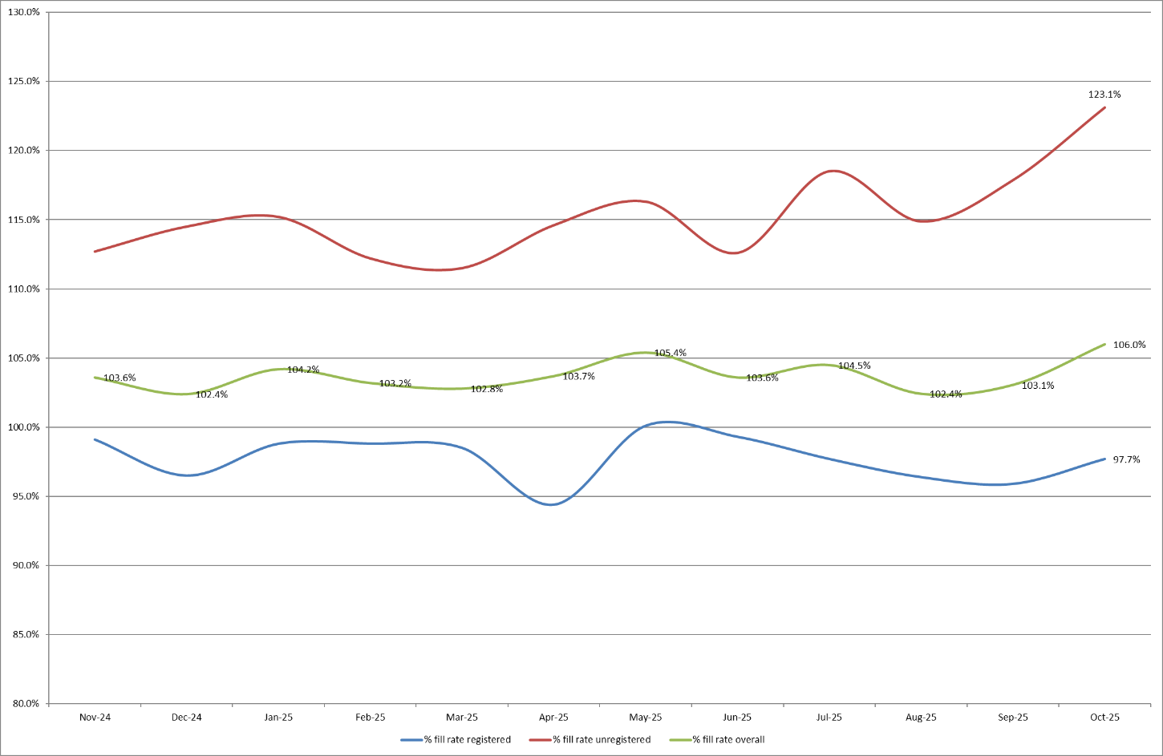

4.0 Care Hours Per Patient Day (CHPPD)

CHPPD allows comparison and benchmarking of a ward’s CHPPD figure with that of other wards in the hospital, or with similar wards in other hospitals. It can be used to look at variation between similar wards to ensure the right staff are being used in the right way and in the right numbers.
The hours worked during day and night shifts by registered nurses and midwives and healthcare assistants are added together. This figure is then divided by the number of patients at midnight; this then gives the total CHPPD.
By itself, the CHPPD does not reflect the total amount of care provided on a ward nor does it directly show whether care is safe, effective or responsive. It should therefore be considered alongside measures of quality and safety.

Table 3. Overall Care Hours Per Patient Day (CHPPD) October 2025

Registered CHPPD | Unregistered CHPPD | Total CHPPD
5.0 | 3.1 | 8.1

The Model Hospital data (August 2025) shows the Trust with a CHPPD of 8.0 against the national median of 9.0. Table 4 also shows the Trusts total CHPPD against our peers (East and North Hertfordshire NHS Trust and West Hertfordshire Teaching Hospitals NHS Trust).
Appendix 2 shows the individual ward and divisional CHPPD for October 2025
Table 4. CHPPD Trend

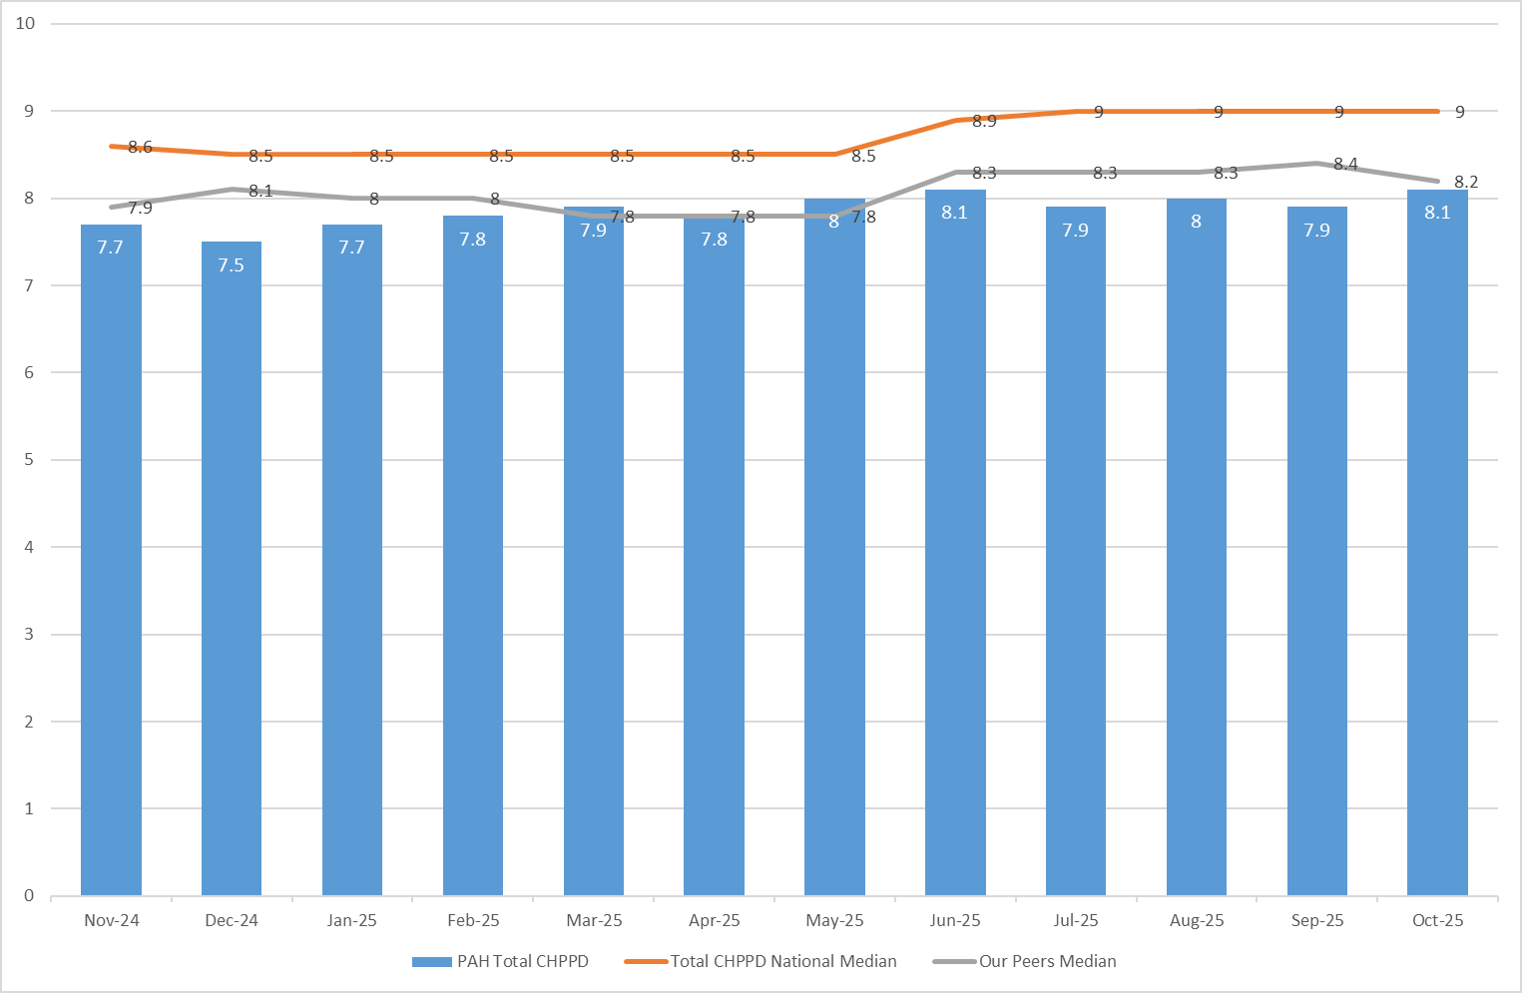

5.0 Quality Indicators

5.1 Nursing Red Flags
Nursing red flags prompt an immediate response by the registered nurse in charge of the ward. The response may include distributing additional nursing staff to the ward or other appropriate responses. Appendix 3 details the NICE (2014) definition of Nursing Red Flags. This includes the number of occasions when registered staffing fell below 75% of the standard template with trend, and the number of Red Flags raised in SafeCare.
5.2 Quality indicators (Falls, pressure ulcers and complaints, PALS and compliments)
October data shows a slight increase in falls (78 vs 75), with Kingsmoor and Ray remaining the highest contributors. Pressure ulcers rose to 30 from 24, including Category 3 cases; however, professional review indicates these were largely unavoidable, providing assurance. Two wards remain under quality observation, both with high enhanced care needs, while nine wards reported zero HAPUs – one of these has maintained this for over 12 months. Complaints and PALS volumes were highest in ED and Kingsmoor, with themes of delays and communication. Compliment data continues to be inconsistently captured, limiting opportunities to share positive experiences and celebrate good practice. Red Flags increased to 120 (from 75), mainly due to RN shortfalls and unmet enhanced care needs, with Tye Green and OPAL recording the most. A review of quality indicators can be found in Appendix 4.

6.0 Conclusion
The Trust continues to achieve a sustained overall registered fill of > 95% and staffing levels are safe. However, acuity-driven pressures persist, reflected in continued high enhanced care demand.
7.0 Recommendation
The board are asked to note the information in this report to provide assurance on the daily mitigation of nursing and midwifery staffing.

Appendix 1: Ward level data and narrative: fill rates October 2025 (Adjusted Standard Planned Ward Demand)
>100% | 95 – 100% | 75-95% | <75%

 | Day |  | Night
Ward name | Average fill rate - registered nurses/midwives (%) | Average fill rate - care staff (%) | Average fill rate - registered nurses/midwives (%) | Average fill rate - care staff (%) | % Registered overall fill rate | % HCSW overall fill rate | % Overall fill rate
Harvey | 87.6% | 145.7% | 100.3% | 162.7% | 92.8% | 153.8% | 114.9%
Henry Moore | 136.5% | 165.1% | 184.9% | 177.2% | 155.9% | 170.8% | 162.4%
ITU & HDU | 95.6% | 73.1% | 99.4% | 117.9% | 97.5% | 94.5% | 97.2%
John Snow | 103.4% | 55.8% | 98.5% | 48.2% | 101.1% | 52.2% | 84.7%
Penn | 95.2% | 115.9% | 99.2% | 179.0% | 96.9% | 139.8% | 112.3%
Saunders | 89.7% | 109.8% | 122.4% | 173.8% | 101.9% | 134.0% | 114.0%
Surgery Total | 98.2% | 118.9% | 109.9% | 155.1% | 103.4% | 134.6% | 112.5%
Fleming | 85.9% | 106.4% | 99.2% | 125.7% | 91.5% | 115.6% | 98.9%
Harold | 90.8% | 115.5% | 103.8% | 136.4% | 96.5% | 125.5% | 105.6%
Kingsmoor | 86.6% | 144.7% | 105.4% | 167.1% | 93.7% | 155.4% | 116.7%
Lister | 92.0% | 121.3% | 100.2% | 150.6% | 95.4% | 135.3% | 111.4%
Locke | 86.0% | 110.6% | 100.1% | 121.5% | 92.0% | 115.8% | 101.5%
Nightingale | 114.3% | 44.0% | 80.9% | 62.8% | 98.3% | 53.0% | 75.7%
Opal | 101.4% | 134.2% | 93.9% | 147.3% | 97.8% | 140.5% | 114.9%
Ray | 93.7% | 105.7% | 109.8% | 171.8% | 100.5% | 130.8% | 111.4%
Tye Green | 89.5% | 128.7% | 100.5% | 164.6% | 94.2% | 143.3% | 113.4%
Winter | 92.6% | 129.1% | 104.3% | 171.7% | 97.5% | 149.5% | 118.3%
Medicine Total | 91.3% | 116.6% | 101.1% | 144.3% | 95.5% | 129.3% | 108.3%
AAU | 87.5% | 134.6% | 97.6% | 140.2% | 92.0% | 137.3% | 101.5%
Charnley | 95.0% | 143.8% | 100.2% | 161.5% | 97.5% | 152.2% | 113.1%
UEC Total | 90.4% | 139.2% | 98.7% | 150.8% | 94.2% | 144.8% | 106.4%
Birthing | 86.1% | 76.2% | 84.2% | 84.0% | 85.2% | 79.9% | 83.4%
Chamberlen | 91.8% | 87.5% | 92.2% | 80.6% | 92.0% | 84.2% | 90.0%
Dolphin | 104.7% | 97.9% | 114.7% | 101.4% | 109.1% | 99.1% | 106.6%
Labour | 95.6% | 87.9% | 92.8% | 92.6% | 94.3% | 90.1% | 93.4%
Neo-Natal Unit | 99.4% | 80.6% | 98.7% | 83.9% | 99.0% | 82.3% | 96.2%
Samson | 100.3% | 84.3% | 91.6% | 83.9% | 96.1% | 84.1% | 89.3%
CHAWS Total | 95.0% | 100.7% | 97.5% | 105.2% | 96.2% | 102.8% | 98.0%
Total | 94.2% | 112.8% | 102.0% | 135.5% | 97.7% | 123.1% | 106.0%

Trust wide – there has been multiple successful recruitment events for newly qualified nurses to join trust wide positions, it is expected they will join teams throughout the Autumn and Winter.
The end of year establishment review (which underpins the rota templates) commenced in September 2025 and finished 14th October 2025 This is for adult and paediatric inpatient wards and assessment units along with main and paediatric emergency departments. This will be presented and need approval through Winter via the various meetings and committees.

John Snow Ward – the HCSW shifts are often under template by 1 WTE, this is due to fluctuating ward capacity throughout the month in addition to the HCSW being re-deployed to other areas through the daily safe staffing meetings. This was reviewed in the September SNCT which will be presented to Board in December.
Neonatal Unit – Fill rate has improved in October because of new starters joining the team.
Maternity – the service continues to robustly review staffing through twice weekly staffing reviews and the use of BirthRate Plus. Safety is maintained by daily staffing huddles and staff deployment according to acuity, support continues to be provided by specialist midwives and matrons being redeployed as needed. Birthrate Plus have been commissioned to review the workforce, and the workforce intentions will be available within the full year nursing and midwifery establishment review starting in September 2025. We are currently pending this data.
Emergency Departments – national reporting is currently for inpatient areas and therefore does not include areas including the emergency department. To ensure the Board is sighted to staffing in these areas, the data for both adult ED and Paediatric ED is included below (Appendix 1a and 1b) using the same methodology as the full UNIFY report.
Appendix 1a: ED data and narrative: fill rates October 2025 (Standard Planned Demand)

Average day fill rate - registered nurses/midwives | Average day fill rate - care staff | Average night fill rate - registered nurses/midwives | Average night fill rate - care staff | % Registered overall fill rate | % HCSW overall fill rate | % Overall fill rate
96.8% | 90.8% | 111.7% | 111.1% | 103.5% | 99.8% | 102.3%

Adult Emergency Department – Fill rate is typically above template for nights shifts with a lower fill rate in the day, more noticeable for unregistered staffing.

Appendix 1b: Paediatric ED data and narrative: fill rates October 2025 (Standard Planned Demand)

Average day fill rate - registered nurses/midwives | Average day fill rate - care staff | Average night fill rate - registered nurses/midwives | Average night fill rate - care staff | % Registered overall fill rate | % HCSW overall fill rate | % Overall fill rate
118.9% | 58.2% | 147.7% | 92.4% | 131.7% | 75.3% | 114.4%

Paediatric Emergency Department – Shows a low overall fill rate for HCSW’s and higher than template for RNs in ED. Shift profiling has been reviewed and the team commenced middle and twilight shifts to mitigate this. This should be reflected in next months report.

Appendix 1c: Enhanced Care data submitted to NHSE ETOC Collaborative October 2025

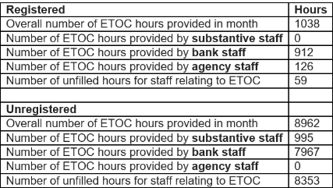

Enhanced Care – Data collected in October indicates high volumes of care that was unfilled by both registered and unregistered staff, with the majority of this being provided by temporary staffing. This could indicate insufficient substantive posts to meet actual demands for enhanced care needs.

Appendix 2: Ward level data: CHPPD October 2025

Care Hours Per Patient Day (CHPPD)
Ward | Registered Nurses/Midwives | Non-registered Nurses/Midwives | Overall
Trust Total | 5.0 | 3.1 | 8.1
Harvey Ward | 3.8 | 3.5 | 7.3
Henry Moore Ward | 3.5 | 2.9 | 6.5
ITU & HDU | 18.8 | 1.8 | 20.7
John Snow Ward | 5.5 | 1.4 | 6.9
Penn Ward | 3.7 | 3.0 | 6.7
Saunders Unit | 3.6 | 2.9 | 6.5
Surgery Total | 5.3 | 2.8 | 8.1
Fleming Ward | 3.7 | 2.1 | 5.7
Harold Ward | 4.6 | 2.7 | 7.3
Kingsmoor General | 3.4 | 3.4 | 6.8
Lister Ward | 3.8 | 3.6 | 7.5
Locke Ward | 3.6 | 3.0 | 6.5
Nightingale Ward | 9.2 | 4.9 | 14.1
Opal Unit | 4.9 | 4.7 | 9.6
Ray Ward | 3.8 | 2.7 | 6.5
Tye Green Ward | 3.9 | 3.8 | 7.7
Winter Ward | 3.7 | 3.7 | 7.4
Medicine Total | 4.0 | 3.3 | 7.2
AAU | 6.2 | 2.5 | 8.7
Charnley Ward | 4.2 | 2.7 | 6.9
UEC Total | 6.2 | 2.5 | 8.7
Birthing Unit | 17.1 | 8.0 | 25.1
Chamberlen Ward | 7.1 | 2.2 | 9.2
Dolphin Ward | 10.5 | 3.2 | 13.6
Labour Ward | 27.4 | 7.5 | 34.8
Neo-Natal Unit | 11.0 | 1.8 | 12.8
Samson Ward | 2.5 | 2.9 | 5.4
CHAWS Total | 8.5 | 3.3 | 11.8

Appendix 3. Nursing Red Flags (NICE 2014), Datix’s and trend data

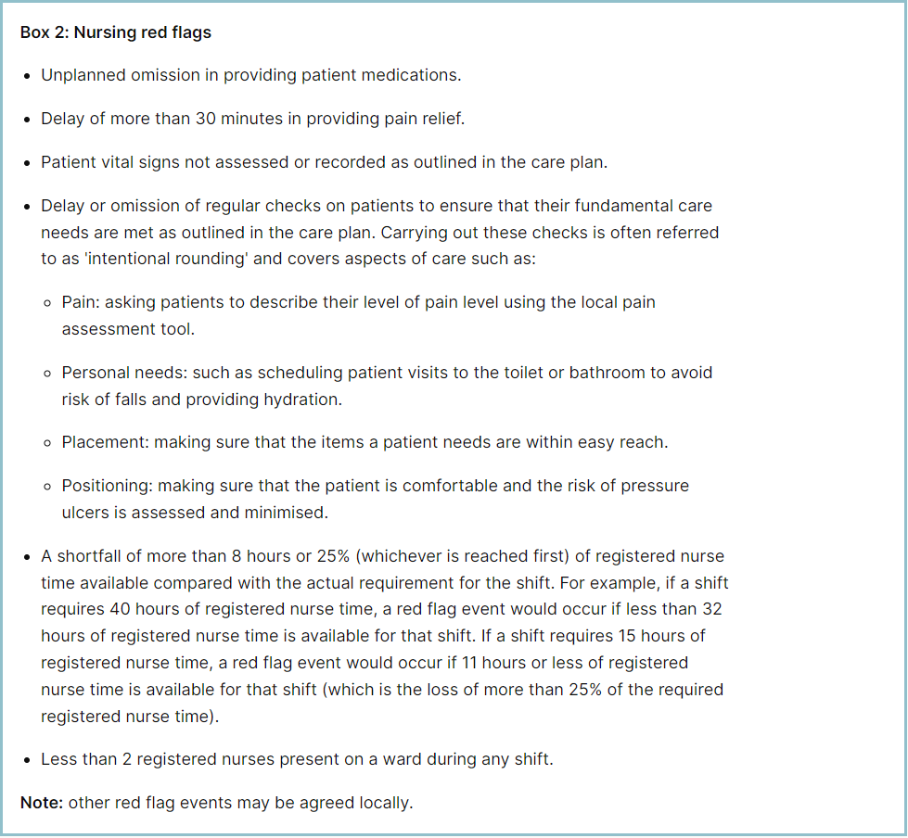

Staffing red flags and trend data

Table 1 shows the number of shifts across all clinical areas – including maternity – where fill rates fell below 75%, with a monthly trend in Table 2. In October 2025, this decreased by 43 to 81 occasions.
The highest volume of red flags consistently remains in maternity accounting for 43 red flags, a decrease of 5 from last month.
The 2-month period of increased red flags for staffing are attributed to the temporary closure of Nightingale ward and ward relocations and are not of concern.
Nightingale and OPAL recorded the highest red flags for this period. Nightingale was partially closed at the start of October which accounts for this. OPAL had high sickness through October, accounting for 7.87% of total unavailability which is a contributing factor to these red flags.

Table 1. Occasions when registered staffing fell below 75% of standard template Oct-25

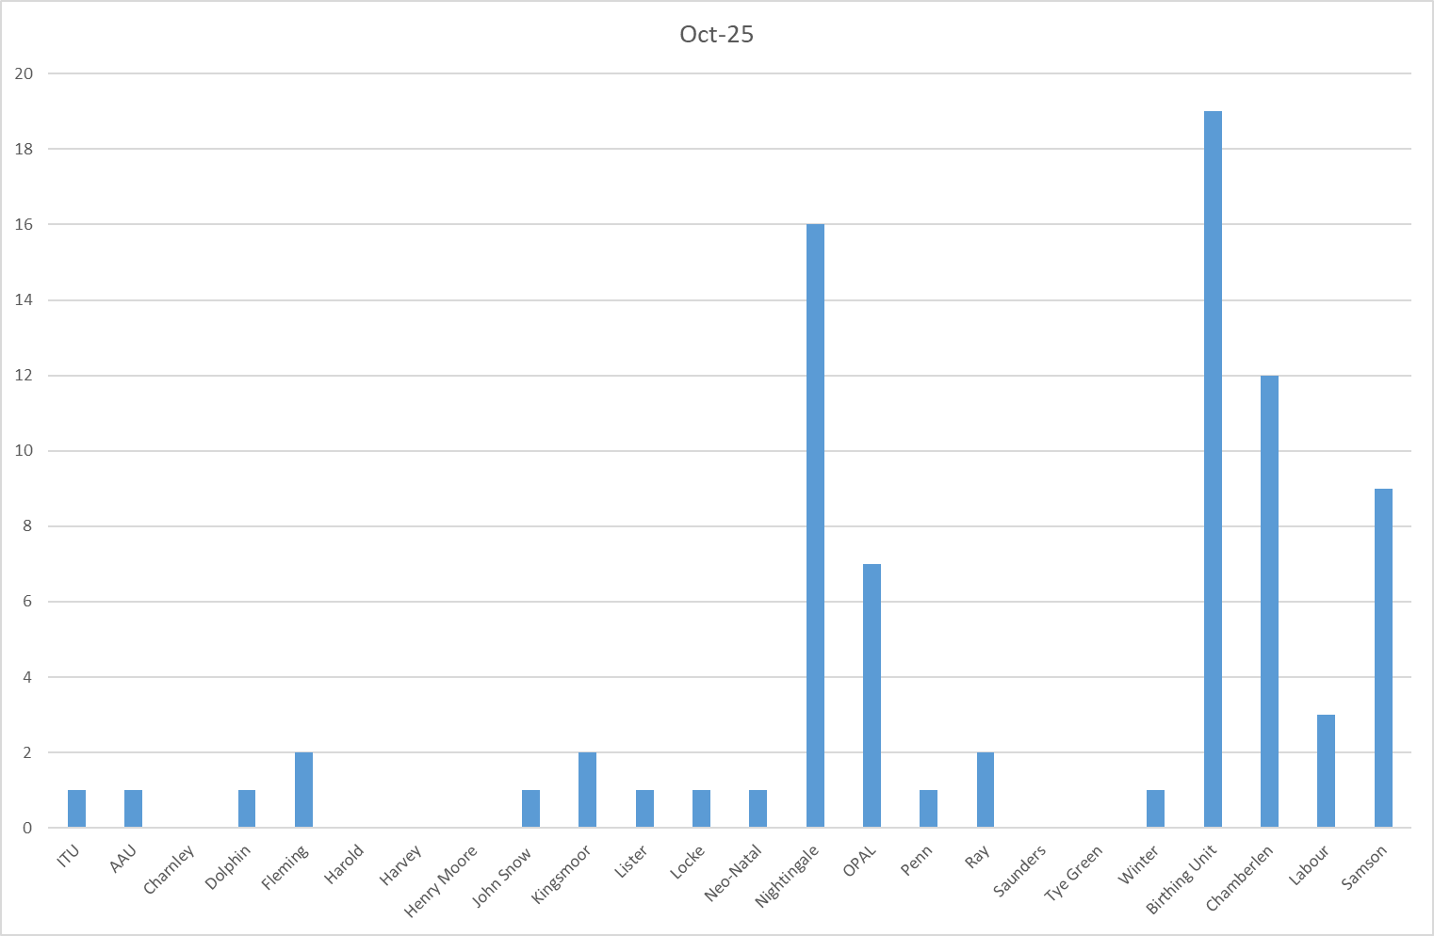

Table 2a. Occasions when all registered staffing fell below 75% of standard template.
Trend Data Nov-24 – Oct-25

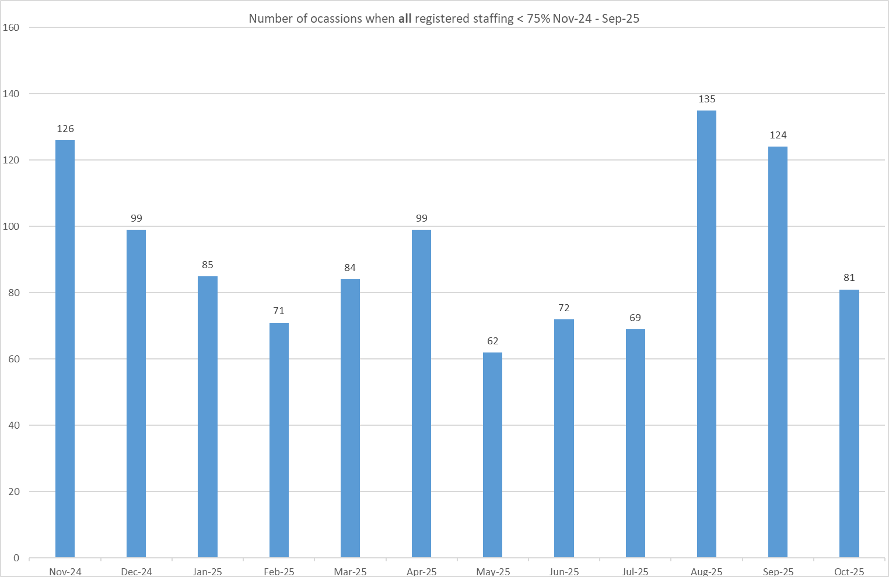
Table 2b. Occasions when registered maternity staffing fell below 75% of standard template. Trend Data Nov-24 – Oct-25

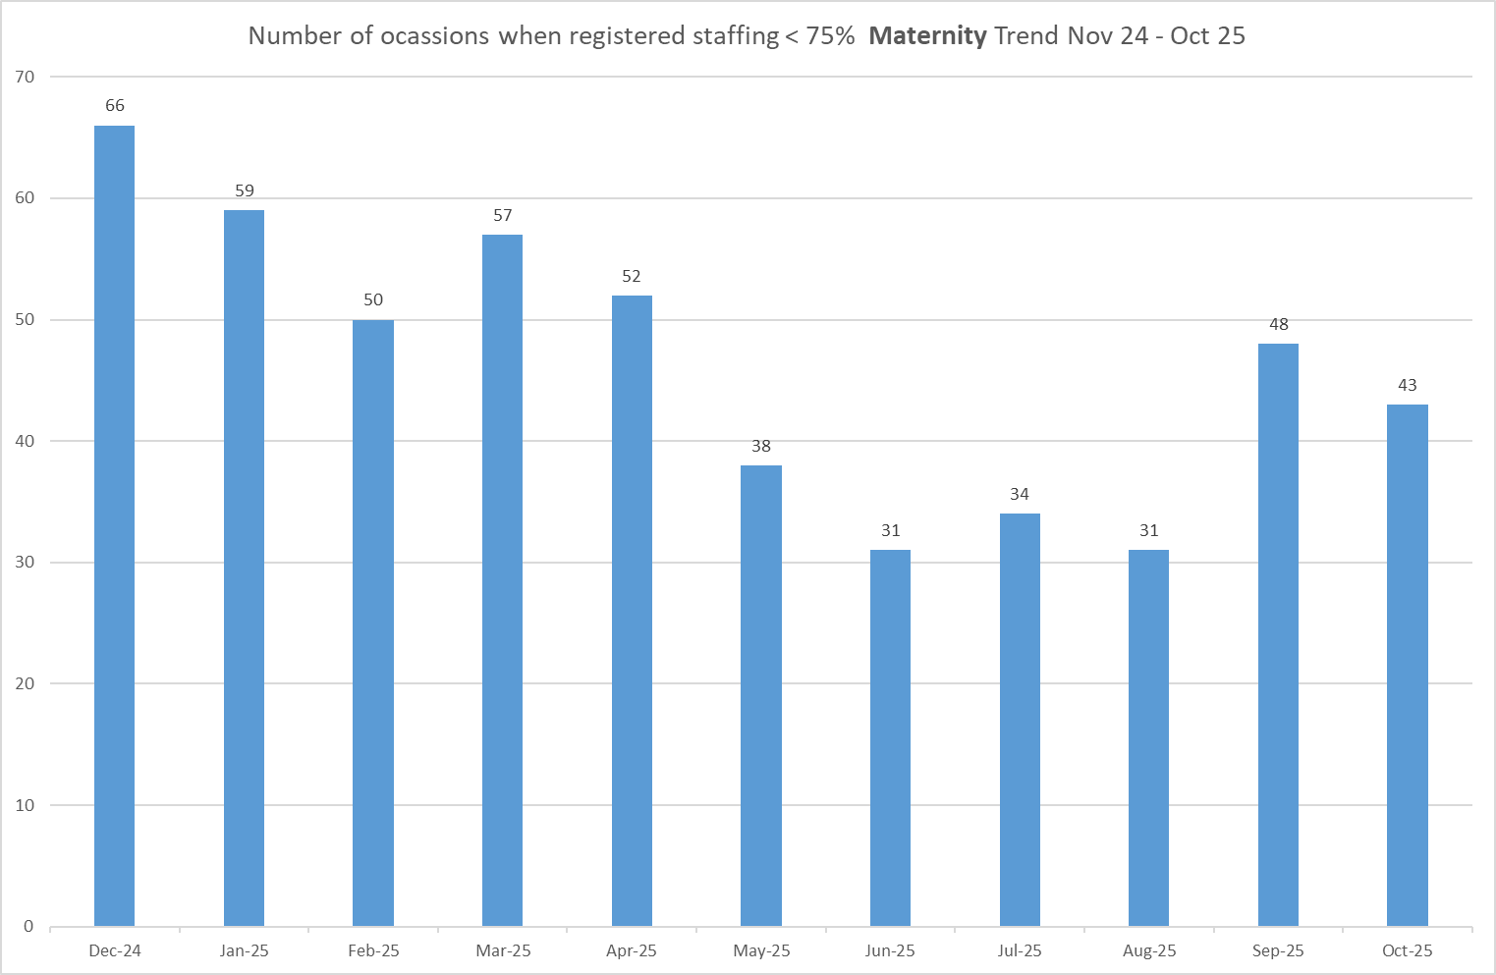

All adult inpatient areas record staffing shortfalls in SafeCare via Red Flags. In October 2025, 120 Red Flags were raised (Table 3a), up from 75 in September (Table 3b and chart). The main drivers were shortfalls in RN time (47) and inability to provide Enhanced Care (53), with Tye Green (35) and OPAL (17) raising the most red flags this month.

A local Red Flag for unmet Enhanced Care and a Level 3 Enhanced Care patient task have been introduced across adult inpatient wards to improve oversight and support data sharing with the Enhanced Care Collaborative. Adult ED has now adopted this functionality from September 2025, and the team continues to raise awareness among staff to use this.

Of the 120 Red Flags raised, 16 remain open and only 10 have been resolved, highlighting inconsistent use of SafeCare and under-utilisation of the system, however we recognise a 2 monthly trend of improved use. While Red Flags support daily staffing decisions when used effectively, further training and communication are needed to improve reporting and closure rates. This has been addressed on the daily staffing huddles and including open red flags to the staffing deployment decisions and is part of staff training in preceptorship and band 6 development days.

Table 3a. Red Flags raised via SafeCare Oct-25

Table 3b. Red Flags raised via SafeCare trend Nov-24 – Oct-25

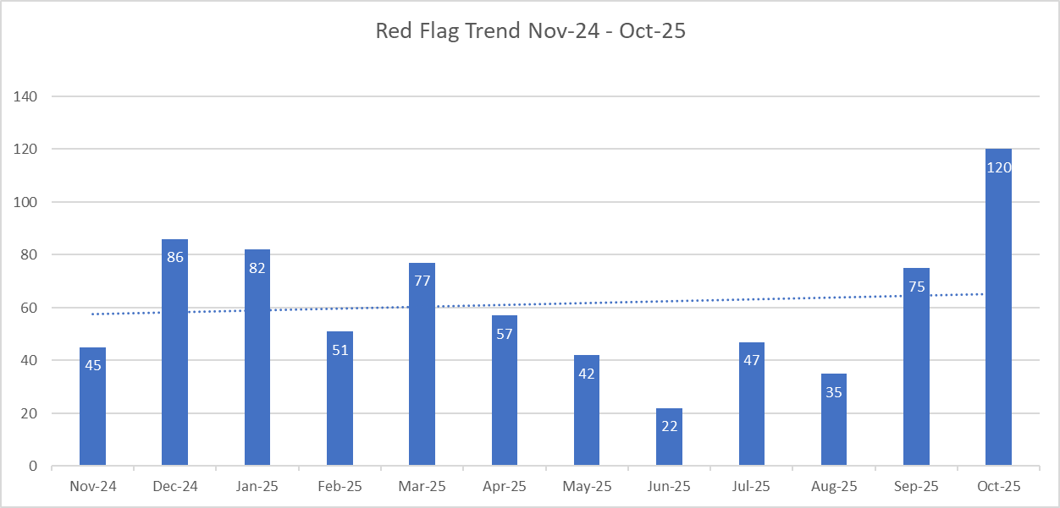

Table 3c. Datix for lack of suitably trained / skilled staff

There were 46 Datix’s recorded for October (40 nursing, 6 maternity) the 3 highest recorded areas are: Winter – 10, Tye Green – 9 and Ray – 5.
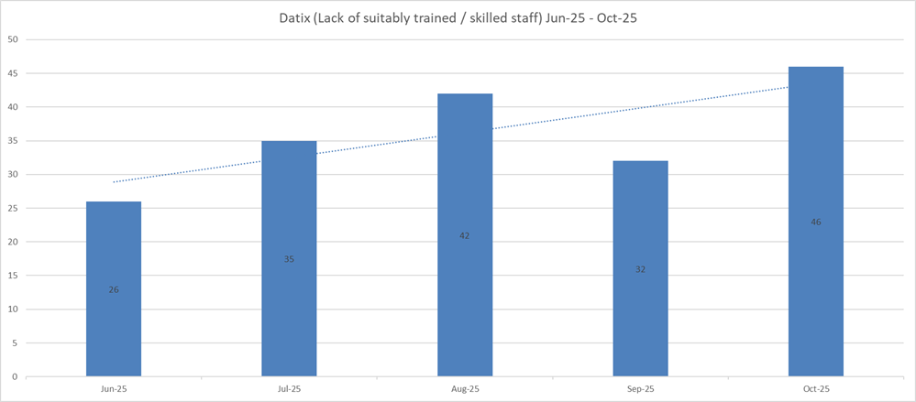

Redeployment

Redeployment of staff continues to support safe staffing through daily huddles. In October 2025, 158 substantive staff redeployments were recorded, a decrease of 158 occasions compared to September (Table 5). Nightingale redeployed the most staff, followed by Tye Green while A&E and Locke were the largest net receivers (Table 4).

Redeployed hours accounted for 1.79% of substantive staff hours and 2.07% of total hours worked (Tables 6 & 7). These figures exclude agency, bank, and multi-post holders.
There has been a considerable drop in redeployment throughout October compared to the prior two months. Governance and oversight remain strong.

Table 4. Hours of substantive staff redeployed October 2025

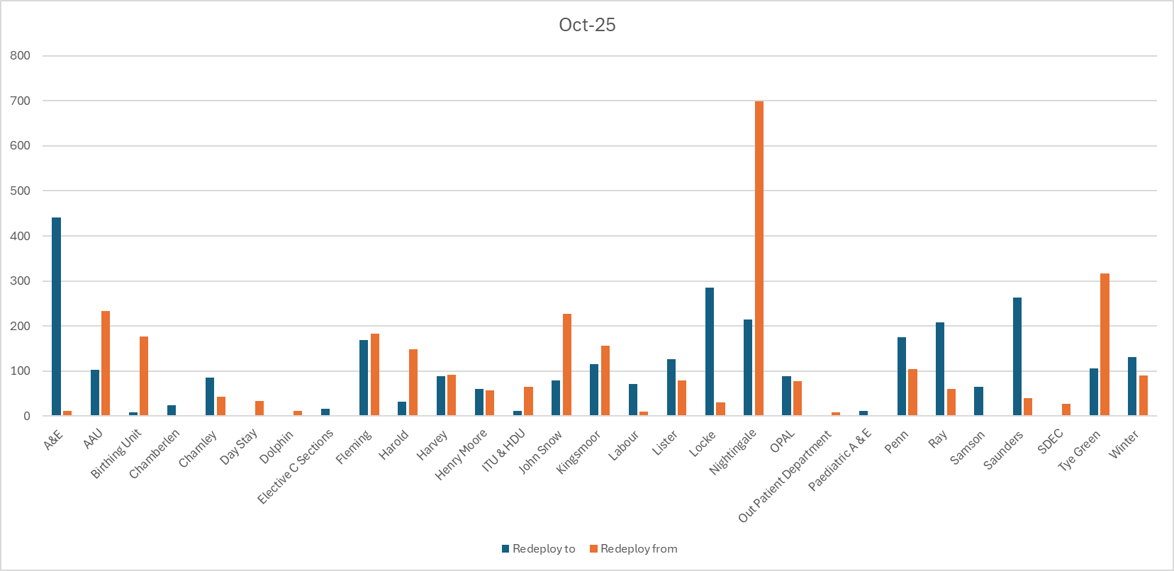

Table 5. Substantive staff redeployment trend

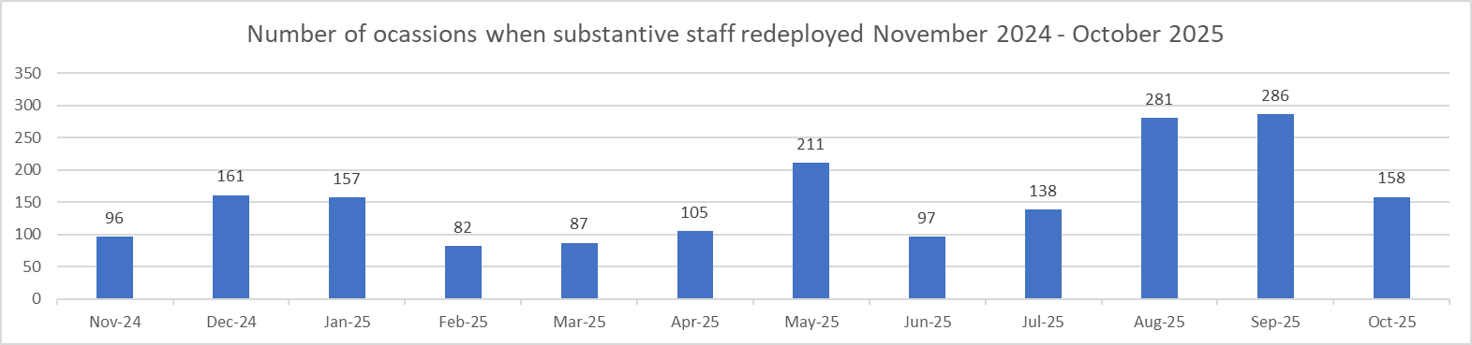

Table 6. % of substantive staff redeployed as % of total hours worked

Substantive staff hours redeployed | Total hours worked (inc. bank and agency) | % of total hours worked / substantive staff redeployed
2579.5 | 144321 | 1.79%

Table 7. % of staff redeployed as % of total hours worked

All staff hours redeployed (including bank and agency but excluding Enhanced Care Team, Bank Pool and Rapid Response Pool) | Total hours worked (inc. bank and agency) | % of total hours worked / staff redeployed (including bank and agency but excluding Enhanced Care Team, Bank Pool and Rapid Response Pool)
2982.5 | 144321 | 2.07%

Appendix 4: Nursing quality indicators

Table 1. Number of falls, unwitnessed falls and falls with harm in October 2025, with the top 3 wards being highlighted.
 | Total falls in month | Top 3 wards
Total falls | 78 | Kingsmoor – 13 | Ray – 9 | A&E – 7
Unwitnessed falls | 57 | Kingsmoor – 7 | Ray – 6 | A&E, Lister – 4
Falls with harm * | 14 | Winter, OPAL, AAU – 2
*Subject to change following review at Falls Incident Oversight Group

October’s data sees a minor increase in total falls from 75 to 78, an increase of unwitnessed falls from 55 to 57 and decrease of falls with harm from 20 to 14.

Training compliance remains over 97% across the trust and work is still ongoing in Kingsmoor and Harold wards to support targeted training in the clinical areas.

Falls Rate per 1000 bed days October 2025 data

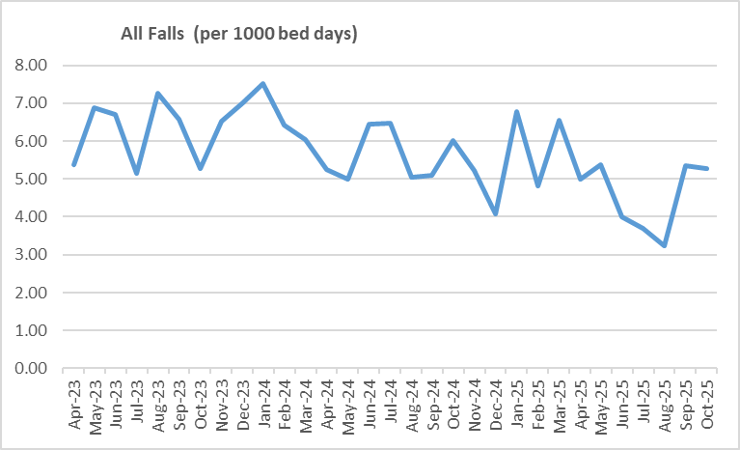

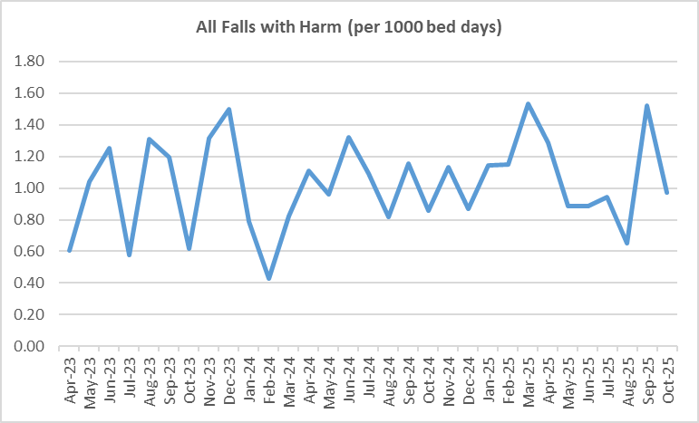

Pressure Ulcers

Table 2a. Number of Hospital Acquired Pressure Ulcers (HAPU) Cat 2 and Cat 3 Pressure Ulcers
There was an increase in October for reportable HAPUs (24 to 30) and non-reportable skin changes (43 to 75) compared to last month and a significant increase in category 3 HAPUs (14 from 4). All 8 category 3 are deemed moderate harms – this will be validated with PS&Q discussion once all investigations are complete.

2 wards remain under quality surveillance (Tye Green and Kingsmoor) and improvements noted in Kingsmoor. However, 9 wards reported no HAPUs in October, which is commendable.

Hospital acquired pressure ulcer data taken from different sources can be inconsistent and not comparable. Due to these variables a more unified approach to data capture and data reporting is underway and therefore the rate per 1000 occupied bed days is currently not being completed. As a consequence the footfall is not reflected in the graph (Table 2b).
It is important to note that the number of incidents reported does not equal the number of HAPUs. Multiple incidents reported in the year will have included more than one HAPU per incident due to the patient's skin being vulnerable.

Tissue viability will soon be introducing a system to monitor all category 1s and vulnerable skin ensuring pressure care is in place and capturing any resolved skin damage.

From October the trust will be implementing the ‘All you have to do is ASK’ campaign which will form the theme for ‘Stop the Pressure Day’ in November. All Trusts in the ICB will be participating this year with a patient questionnaire to raise awareness of pressure ulcers, we will be engaging with in-patients and visitors to complete questionnaires.

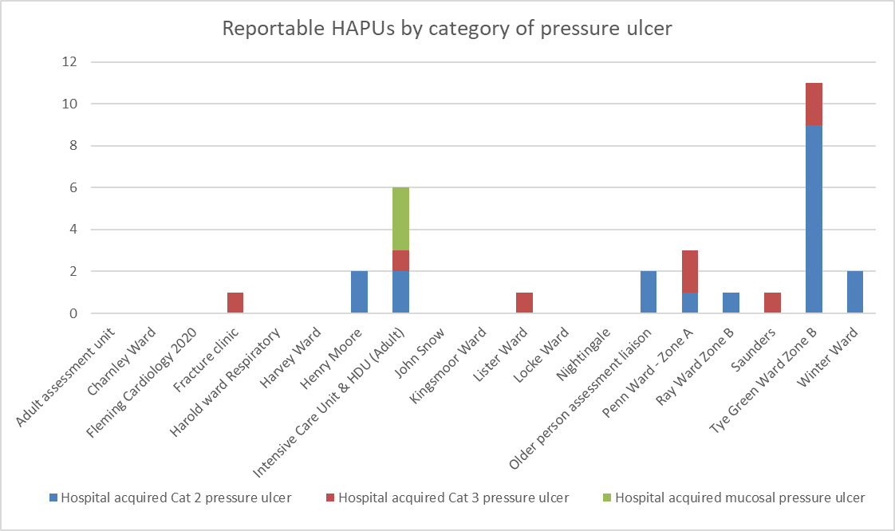

Total in month | Top 3 wards
30 | Tye Green – 11 | ITU/HDU – 6 | Penn – 3

Table 2b. Reported Incidents and Actual Hospital Acquired Pressure Ulcers October 2025

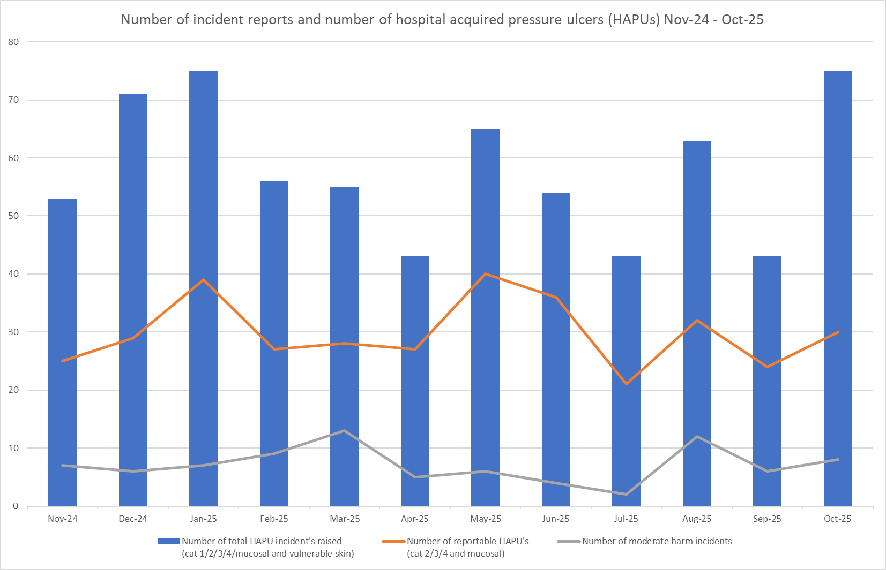
Complaints, PALS and Compliments Trend Data January 2025 – October 2025

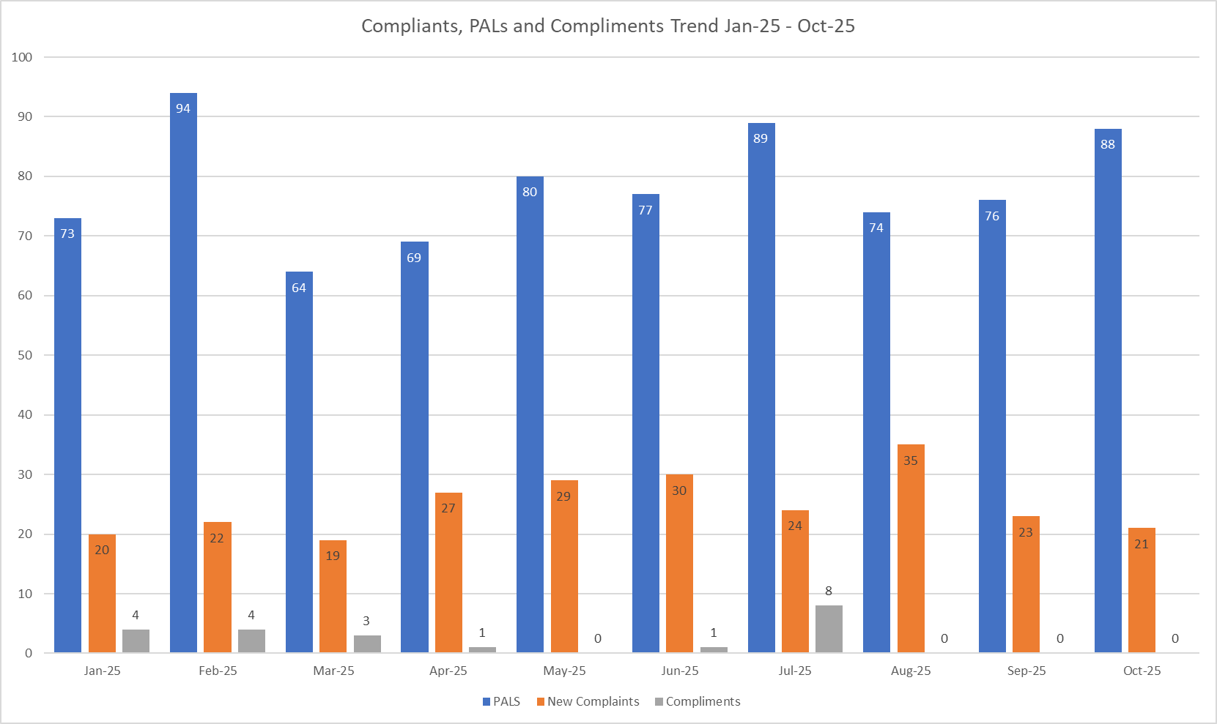

Table 3. Number of new Complaints, PALS and Compliments in October 2025 with top three wards highlighted
 | Total in month | Top Departments
New complaints | 21 | P.ED – 5 | Kingsmoor, Henry Moore and ITU/HDU – 3
PALs | 88 | A&E – 15 | Charnley – 9 | Fleming, Lister, Saunders and Winter – 6
Compliments | None recorded
The main themes for PALS concerns received in October 2025 are as follows:

- Delay – 38.43%
- Communication – 24.16%
- Cancellations – 9.77%

The main themes for Complaints received in October 2025 are as follows:

- Communication – 25.61%
- Medical care – 17.07%
- Delay – 15.85%

The main themes for Compliments received in October 2025 are as follows:
Unfortunately, compliments received in October 2025 have not been logged on Datix this month.

