Agenda item:  Presented by:  Prepared by:  Date prepared:  Subject / title: | Jo Ward - Interim Chief Nurse  Charlotte Collings – Lead Nurse for Safe Staffing and Workforce  Polly Read – Interim Deputy Chief Nurse  19 December 2025  Safe Staffing Monthly report – November 2025
Purpose: | Approval |  | Decision |  |  | Information |  | x | Assurance |  | x
Key issues: | - A sustained overall registered staffing fill rate of >95% has been maintained.  - No wards recorded an overall fill rate below 75% during the reporting month.  - The continued increase in overall fill rates is multifactorial, including a rise in enhanced care requirements.  - The full year nursing and midwifery establishment review was completed in September 2025 and is progressing through the agreed governance processes, with submission to the People Committee in January 2026 and the Trust Board in February 2026.
Recommendation: | The committee are asked to note the information within this report.
Trust strategic objectives: |   Patients |   People |  |   Performance |  |  |   Places |  |  |   Pounds
Trust strategic objectives: | x | x |  | x |  |  |  |  |  | x
Previously considered by: | NA
Risk / links with the BAF: | BAF: 2.3 Workforce capacity
Legislation, regulatory, equality, diversity and dignity implications: | NHS England and CQC letter to NHSFT CEOs (31.3.14): Hard Truths Commitment regarding publishing of staffing data.  NHS Improvement letter: 22.4.16  NHS Improvement letter re CHPPD: 29/6/18
Appendices: | Appendix 1: Ward and divisional fill rates by month against adjusted standard planned template.  Appendix 2: Ward and divisional CHPPD data  Appendix 3: Nursing red flags  Appendix 4: Nursing quality indicators

Executive Summary
Safe staffing was maintained in November with reasonable assurance, supported by daily safety huddles, redeployment, and use of temporary staffing. Registered fill rates remained strong, and no wards fell below the minimum threshold. However, the position remains safe but fragile.
Persistent pressures include high enhanced care demand, an increase in Red Flags, and CHPPD remaining below national benchmarks, reflecting sustained acuity-driven workload. These pressures correlate with upward trends in harm, particularly falls and pressure ulcers, and with patient experience themes relating to delays and communication, most notably within the Emergency Department (ED). Maternity and Paediatric ED continue to demonstrate fragility in HCSW cover, mitigated through Birthrate Plus deployment and targeted shift adjustments.
Positive actions provide assurance that risks are being actively managed. These include improved redeployment practices, proactive escalation via Datix, strong mandatory training compliance, and implementation of targeted improvement plans. Recruitment of newly qualified nurses and the completion of the establishment review will further strengthen workforce resilience. However, immediate priorities remain enhanced care workforce planning, red flag closure compliance on SafeCare, and focused support for maternity and ED.
Overall judgement: Staffing was safe in November; however, continued close oversight and proactive workforce planning are required to sustain assurance.
1.0 Introduction
This paper outlines how nursing and midwifery staffing at the Princess Alexandra Hospital Trust (PAHT) was deployed during November 2025, demonstrating how safe staffing levels were achieved and maintained. It also sets out how this position has been supported through targeted recruitment, effective deployment, and workforce management arrangements.
2.0 Background
The National Quality Board (NQB, 2016) recommends that monthly actual staffing data is compared with expected staffing levels and reviewed alongside indicators of quality of care, patient safety, and patient and staff experience. The Trust remains committed to ensuring that improvements are identified, learned from and celebrated, and that emerging risks are recognised and addressed promptly.
This paper presents nursing and midwifery staffing data and associated actions for November 2025. The sections that follow set out the governance, assurance and operational processes in place to demonstrate how the Trust proactively manages nursing and midwifery staffing in support of safe, high-quality patient care.
3.0 Inpatient wards fill rate
The Trust’s safer staffing submission for November 2025 was submitted to NHS Digital within the required data submission timeframe. Table 1 presents a summary of the overall fill rate for the month, while Table 2 provides the overall fill rate percentages across a rolling 12-month period.
Appendix 1 sets out a ward-by-ward breakdown for the same period.
3.1 Wards with < 75% average fill rate
No wards recorded an average fill rate below 75% during November 2025.
3.2 Wards with > 100% average fill rate
Henry Moore Ward continues to report an increased fill rate, reflecting fluctuating capacity, the opening of additional surgical beds, and the establishment of a Level 1 post-operative care area. The Level 1 bay is funded through the ITU establishment, and the additional staffing therefore reflects the workforce required to safely meet increased activity and acuity. Board-approved establishment changes have been applied to the roster from 22 December 2025 and will be reflected in future reports.
Healthcare Support Worker (HCSW) fill rates exceeding 100% remain primarily attributable to high patient acuity and enhanced care requirements.
3.3 Mitigation and Governance
To maintain safe staffing during November, the Trust applied a range of controls underpinned by robust governance arrangements:
- Real-time oversight: Daily SafeCare huddles and three-times-daily acuity and dependency reviews ensured continuous oversight of staffing and safe, informed redeployment decisions.
- Senior clinical support: Senior nurses and midwives provided direct clinical support to areas of need when required.
- Temporary staffing: NHSP filled vacant shifts, including RMN’s used appropriately to support patients with assessed mental health needs.
- Enhanced care oversight: A local Red Flag for unmet enhanced care and Level 3 patient tasks was introduced to improve visibility and assurance, with data shared through the Enhanced Care Collaborative.

- SafeCare governance: Red Flags are reviewed daily and actively inform deployment decisions. Training on reporting and closure is embedded within preceptorship and Band 6 development programmes.

- Redeployment governance: In November, 158 substantive redeployments were recorded (1.06% of substantive hours), with oversight maintained through daily huddles and monthly reporting.

- Escalation and assurance: Staffing risks are escalated via divisional leadership and monitored through twice-daily compliance checks, weekly SafeCare reports, and f monthly Board reporting.

Table 1. Overall fill rate
Average day fill rate - registered nurses/midwives | Average day fill rate - care staff | Average night fill rate - registered nurses/midwives | Average night fill rate - care staff | % Registered overall fill rate | % HCSW overall fill rate | % Overall fill rate
95.9% | 111.0% | 103.0% | 134.8% | 99.0% | 121.9% | 106.5%

Table 2. Inpatient fill rate including Maternity Wards Trend

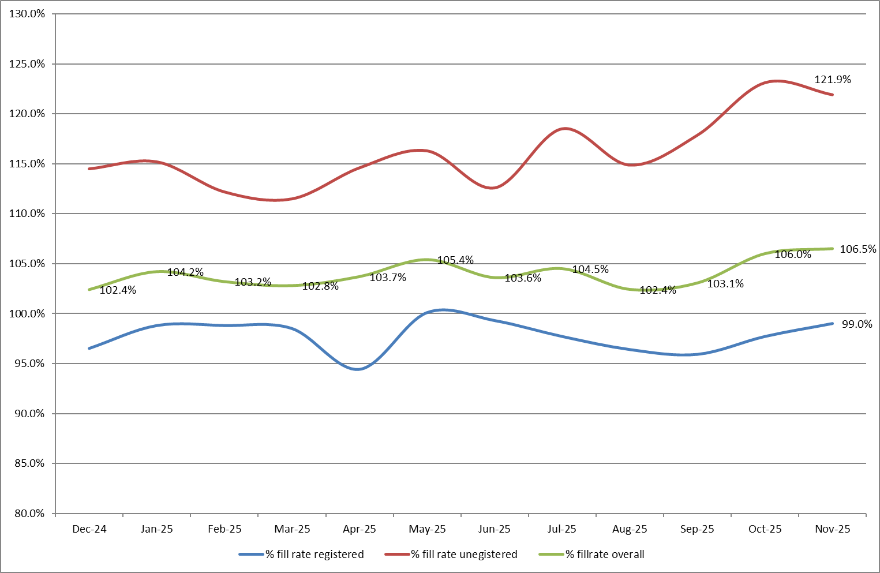
4.0 Care Hours Per Patient Day (CHPPD)
Care Hours Per Patient Day (CHPPD) enables comparison and benchmarking of staffing levels within the Trust and against similar wards in other organisations. It supports the identification of variation between comparable wards, helping to ensure the right staff are deployed, in the right numbers, and in the right skill mix.
CHPPD is calculated by adding the total hours worked across day and night shifts by registered nurses, midwives and healthcare support workers, and dividing this by the number of patients at midnight to give the total care hours per patient day.
CHPPD should not be interpreted in isolation. While it provides a useful indicator of staffing input, it does not directly measure the quality, safety or effectiveness of care. It must therefore be considered alongside other quality, safety and patient experience indicators to provide meaningful assurance.
Table 3. Overall Care Hours Per Patient Day (CHPPD) November 2025

Registered CHPPD | Unregistered CHPPD | Total CHPPD
5.0 | 3.0 | 7.9
Model Hospital data (November 2025) indicates that the Trust’s CHPPD is 7.9, compared with a national median of 8.8. Table 4 also presents the Trust’s total CHPPD benchmarked against peer organisations, which have a median CHPPD of 8.1 (East and North Hertfordshire NHS Trust and West Hertfordshire Teaching Hospitals NHS Trust). The Trust’s CHPPD therefore remains below both peer and national median benchmarks.
Appendix 2 provides a detailed breakdown of CHPPD by ward and division for November 2025.
Table 4. CHPPD Trend
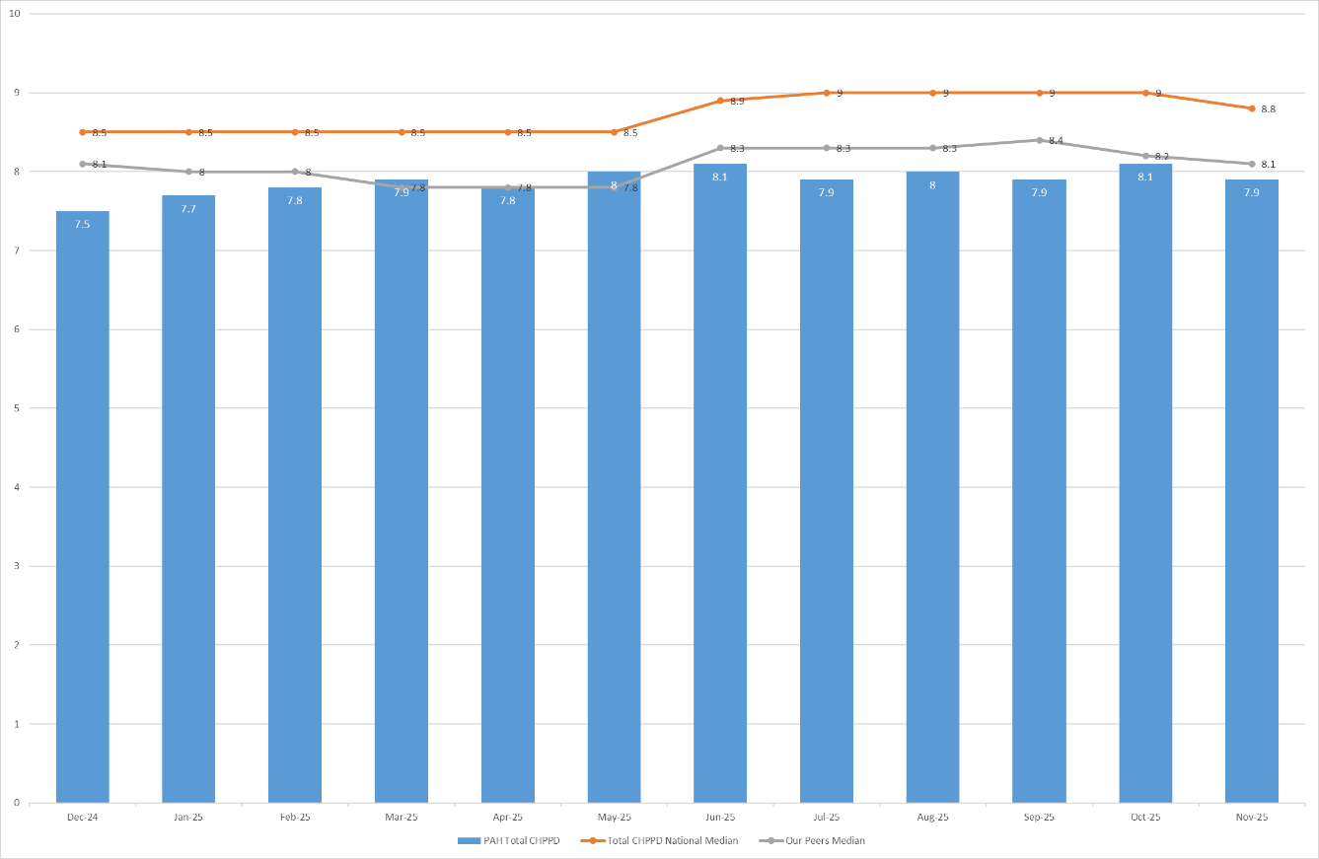
5.0 Quality Indicators
5.1 Nursing Red Flags
Nursing Red Flags prompt an immediate response by the registered nurse in charge of the ward. This may include the deployment of additional nursing staff or other appropriate mitigating actions to manage risk. Appendix 3 sets out the NICE (2014) definition of Nursing Red Flags, including the number of occasions where registered staffing fell below 75% of the standard template, with associated trend data, and the number of Red Flags recorded in SafeCare.
The number of Red Flags recorded in SafeCare is increasing. This reflects improved awareness and training in the use and purpose of the SafeCare tool, leading to better identification and escalation of risk. Despite this improvement, under-reporting is still likely, and continued focus remains on embedding consistent use of the system to strengthen assurance.
5.2 Quality indicators (Falls, pressure ulcers and complaints, PALS and compliments)
November data shows a slight increase in falls (80 compared to 78 in the previous period), with Winter and Lister wards the highest contributors. Pressure ulcers increased to 41 from 30; however, professional review indicates that these were largely unavoidable, providing assurance on care quality. Two wards remain under quality surveillance, both associated with high enhanced care demand, while nine wards reported zero hospital-acquired pressure ulcers (HAPUs), one of which has sustained this position for over 12 months.
Complaints and PALS activity were highest in the Emergency Department (ED) and Lister Ward, with recurring themes relating to delays and communication. Compliment data continues to be inconsistently captured, limiting opportunities to share positive patient experiences and celebrate good practice.
Nursing Red Flags increased to 133 (from 120), predominantly related to registered nurse shortfalls and unmet enhanced care needs, with Tye Green and Penn wards reporting the highest numbers.
A detailed review of quality and safety indicators is provided in Appendix 4.
6.0 Conclusion
The Trust continues to maintain a sustained overall registered fill rate of >95%, providing assurance that staffing levels remain safe. However, acuity-driven pressures persist, evidenced by ongoing high enhanced care demand, and continue to place pressure on workforce resilience.
7.0 Recommendation
The Board is asked to note the contents of this report, which provide assurance on the daily management and mitigation of nursing and midwifery staffing risks.

Appendix 1: Ward level data and narrative: fill rates November 2025 (Adjusted Standard Planned Ward Demand)
>100% | 95 – 100% | 75-95% | <75%

 | Day |  | Night
Ward name | Average fill rate - registered nurses/midwives (%) | Average fill rate - care staff (%) | Average fill rate - registered nurses/midwives (%) | Average fill rate - care staff (%) | % Registered overall fill rate | % HCSW overall fill rate | % Overall fill rate
Harvey | 97.3% | 165.2% | 112.2% | 176.0% | 103.4% | 170.4% | 127.7%
Henry Moore | 142.4% | 143.6% | 184.2% | 163.1% | 159.1% | 152.9% | 156.4%
ITU & HDU | 103.4% | 99.0% | 103.8% | 101.4% | 103.6% | 100.2% | 103.3%
John Snow | 102.2% | 46.9% | 100.0% | 37.0% | 101.1% | 42.2% | 81.5%
Penn | 100.6% | 123.9% | 100.2% | 203.2% | 100.4% | 154.0% | 119.6%
Saunders | 89.8% | 119.9% | 122.2% | 204.4% | 101.9% | 151.9% | 120.8%
Surgery Total | 103.7% | 124.6% | 113.4% | 163.2% | 108.0% | 141.3% | 117.7%
Fleming | 84.8% | 105.3% | 100.2% | 128.3% | 91.3% | 116.3% | 99.0%
Harold | 90.3% | 101.5% | 101.1% | 119.8% | 95.1% | 110.2% | 99.9%
Kingsmoor | 93.7% | 126.6% | 112.1% | 143.2% | 100.7% | 134.5% | 113.3%
Lister | 100.3% | 106.3% | 112.5% | 135.4% | 105.5% | 120.2% | 111.4%
Locke | 93.0% | 107.8% | 100.8% | 145.4% | 96.3% | 125.7% | 108.1%
Nightingale | 100.7% | 69.1% | 102.0% | 99.8% | 101.3% | 83.8% | 92.5%
Opal | 103.7% | 130.1% | 93.9% | 146.6% | 99.0% | 138.0% | 114.6%
Ray | 91.2% | 93.9% | 103.3% | 150.9% | 96.3% | 115.5% | 103.2%
Tye Green | 88.9% | 120.6% | 94.2% | 158.3% | 91.2% | 136.0% | 108.6%
Winter | 95.6% | 115.3% | 100.0% | 159.4% | 97.4% | 136.4% | 113.0%
Medicine Total | 93.2% | 108.8% | 102.0% | 139.8% | 96.9% | 123.1% | 106.8%
AAU | 90.6% | 145.9% | 101.4% | 142.6% | 95.4% | 144.3% | 105.7%
Charnley | 95.3% | 140.8% | 95.4% | 164.8% | 95.4% | 152.3% | 111.6%
UEC Total | 92.4% | 143.3% | 98.9% | 153.7% | 95.4% | 148.3% | 108.2%
Birthing | 90.3% | 91.7% | 85.6% | 80.0% | 88.0% | 86.1% | 87.4%
Chamberlen | 96.0% | 87.9% | 90.8% | 102.7% | 93.5% | 95.0% | 93.9%
Dolphin | 90.0% | 88.3% | 100.1% | 94.2% | 94.5% | 90.3% | 93.5%
Labour | 95.8% | 85.0% | 95.7% | 81.7% | 95.7% | 83.4% | 93.0%
Neo-Natal Unit | 93.6% | 83.6% | 100.3% | 73.3% | 97.0% | 78.5% | 93.9%
Samson | 98.0% | 94.3% | 94.5% | 87.8% | 96.3% | 91.2% | 93.4%
CHAWS Total | 94.1% | 89.8% | 95.9% | 86.5% | 94.9% | 88.2% | 92.9%
Total | 95.9% | 111.0% | 103.0% | 134.8% | 99.0% | 121.9% | 106.5%
Trust wide:
- Recruitment continues to be positive, with 31 offers made to Newly Qualified Nurses (NQNs) and 29 starters in post as of 8 December. A further recruitment event is planned for January 2026, targeting Spring graduates, including five internal apprentices.
- The end-of-year establishment review covering adult and paediatric inpatient wards, assessment units and the Emergency Department concluded on 14 November 2025 and is scheduled for Board approval in February 2026. This review will inform future roster templates and is intended to address acuity-driven pressures, including those identified through CHPPD benchmarking and enhanced care demand.
John Snow Ward - Healthcare Support Worker (HCSW) shifts were consistently delivered at approximately 1 WTE below the agreed template. This reflected informed decision-making based on real-time assessment of patient capacity and acuity, with redeployment agreed through daily safety huddles to ensure staffing remained safe and appropriate to clinical need. The position was formally reviewed and captured as part of the September SNCT submission.
Maternity - Fill rates for registered and unregistered staff remain amber across most areas, driven by vacancies, sickness absence and high levels of maternity leave. Twice-weekly staffing reviews and deployment in line with Birthrate Plus continue to maintain safety, supported by matrons and specialist midwives. A Birthrate Plus workforce review is currently underway, with recommendations expected in the New Year, which will inform longer-term workforce planning and resilience.
Emergency Departments - While national safer staffing reporting excludes Emergency Departments, local staffing data for Adult and Paediatric ED is included for assurance (Appendices 1a and 1b). Registered Nurse fill rates remain strong; however, Healthcare Support Worker (HCSW) cover remains fragile, particularly within Paediatric ED, where overall fill averaged 82.3%.
Shift profiling changes, including the introduction of middle and twilight shifts, commenced in November and are expected to improve workforce resilience from December onwards.
Appendix 1a: ED data and narrative: fill rates November 2025 (Standard Planned Demand)

Average day fill rate - registered nurses/midwives | Average day fill rate - care staff | Average night fill rate - registered nurses/midwives | Average night fill rate - care staff | % Registered overall fill rate | % HCSW overall fill rate | % Overall fill rate
103.5% | 90.9% | 111.8% | 124.5% | 107.2% | 105.8% | 106.8%

Appendix 1b: Paediatric ED data and narrative: fill rates November 2025 (Standard Planned Demand)

Average day fill rate - registered nurses/midwives | Average day fill rate - care staff | Average night fill rate - registered nurses/midwives | Average night fill rate - care staff | % Registered overall fill rate | % HCSW overall fill rate | % Overall fill rate
112.5% | 78.1% | 135.5% | 86.5% | 122.7% | 82.3% | 110.3%

Appendix 1c: Enhanced Care data submitted to NHSE ETOC Collaborative November 2025

Enhanced Care – In November, the Trust required 10,569 enhanced care hours, of which 10,196 hours (96.5%) were delivered. Temporary staffing provided 78.7% of all required enhanced care hours (NHS Professionals 76.6%, agency 2.0%), with 3.5% remaining unfilled.
All registered enhanced care was delivered through temporary staffing (Bank 89.2%, Agency 10.8%), with 3.1% of required registered hours unfilled. Unregistered enhanced care demonstrated a greater substantive contribution (22.9% of hours delivered), although 74.3% of required hours continued to be met through temporary staffing.
This profile confirms a structural establishment gap in enhanced care provision, consistent with the observed increase in Red Flags relating to unmet enhanced care needs. A Task and Finish Group will be re-established in January 2026 to review enhanced care demand and ensure a safe, sustainable workforce model, focusing on risk assessment and validation, decision-making and utilisation of the Enhanced Care team, training requirements, and strengthened governance, including oversight of usage, WTE and financial impact.
Appendix 2: Ward level data: CHPPD November 2025

Care Hours Per Patient Day (CHPPD)
Ward | Registered Nurses/Midwives | Non-registered Nurses/Midwives | Overall
Trust Total | 5.0 | 3.0 | 7.9
Harvey Ward | 4.3 | 4.0 | 8.2
Henry Moore Ward | 3.6 | 2.7 | 6.3
ITU & HDU | 20.0 | 1.9 | 21.9
John Snow Ward | 6.6 | 1.4 | 7.9
Penn Ward | 3.8 | 3.3 | 7.1
Saunders Unit | 3.6 | 3.2 | 6.8
Surgery Total | 5.6 | 3.0 | 8.6
Fleming Ward | 3.7 | 2.1 | 5.7
Harold Ward | 4.6 | 2.4 | 7.0
Kingsmoor General | 3.7 | 2.9 | 6.6
Lister Ward | 4.0 | 3.0 | 7.0
Locke Ward | 3.6 | 3.1 | 6.7
Nightingale Ward | 3.6 | 3.0 | 6.6
Opal Unit | 4.4 | 4.1 | 8.5
Ray Ward | 3.7 | 2.5 | 6.3
Tye Green Ward | 3.7 | 3.6 | 7.3
Winter Ward | 3.6 | 3.4 | 7.0
Medicine Total | 3.9 | 3.0 | 6.8
AAU | 6.2 | 2.5 | 8.7
Charnley Ward | 4.1 | 2.6 | 6.7
UEC Total | 5.2 | 2.6 | 7.7
Birthing Unit | 12.5 | 6.1 | 18.6
Chamberlen Ward | 6.3 | 2.1 | 8.5
Dolphin Ward | 8.8 | 2.8 | 11.5
Labour Ward | 22.1 | 5.5 | 27.6
Neo-Natal Unit | 11.6 | 1.9 | 13.5
Samson Ward | 2.7 | 3.4 | 6.1
CHAWS Total | 8.1 | 3.2 | 11.4

Appendix 3. Nursing Red Flags (NICE 2014), Datix’s and trend data

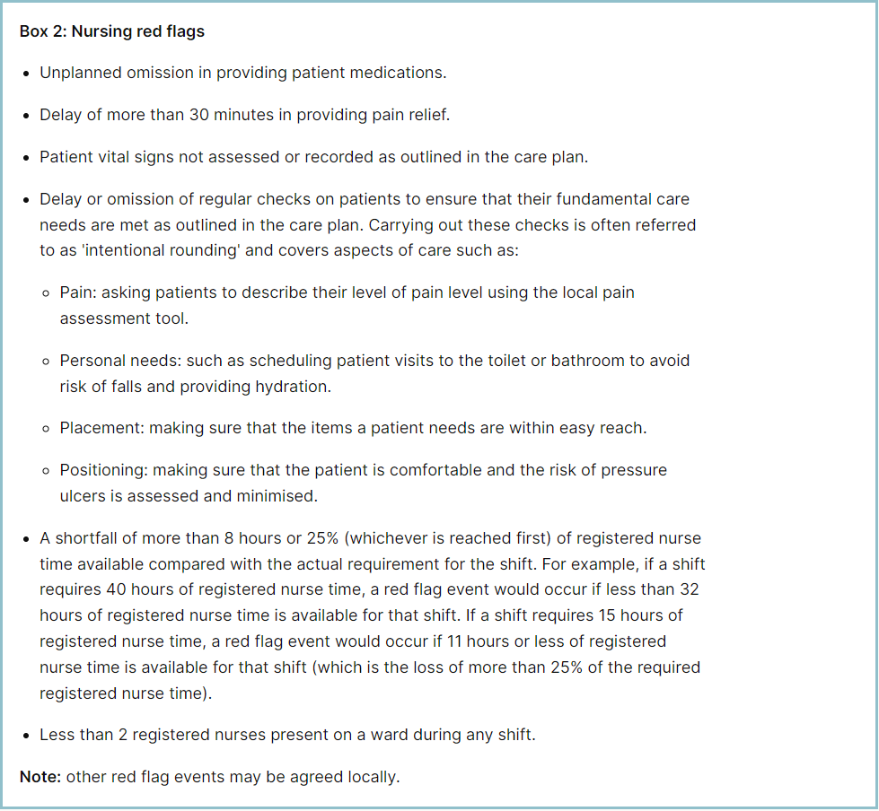

Staffing Red Flags and Trend Data
In November, 63 shifts fell below 75% of template (↓18 vs October), continuing a downward trend (Table 2a).
Across adult inpatient areas, 133 Red Flags were raised via SafeCare (+13 vs October), driven by RN shortfalls (44) and unmet enhanced care (70) (Table 3a). Maternity accounted for 38 Red Flags (↓5 vs last month), remaining the largest contributor (Table 2b). Adult inpatient hotspots included Tye Green (47) and Penn (24), with OPAL also notable due to sickness (7.87% unavailability).
Of the 133 Red Flags, 112 remain open and only 15 resolved, highlighting inconsistent closure despite improved reporting trends.
To strengthen oversight, a local Red Flag for unmet enhanced care and a Level 3 Enhanced Care patient task were introduced across adult inpatient wards, with Adult ED adopting this functionality in September. Training and daily huddles now include open Red Flags in deployment decisions, and closure compliance is embedded in preceptorship and Band 6 development days.

Table 1. Occasions when registered staffing fell below 75% of standard template Nov-25

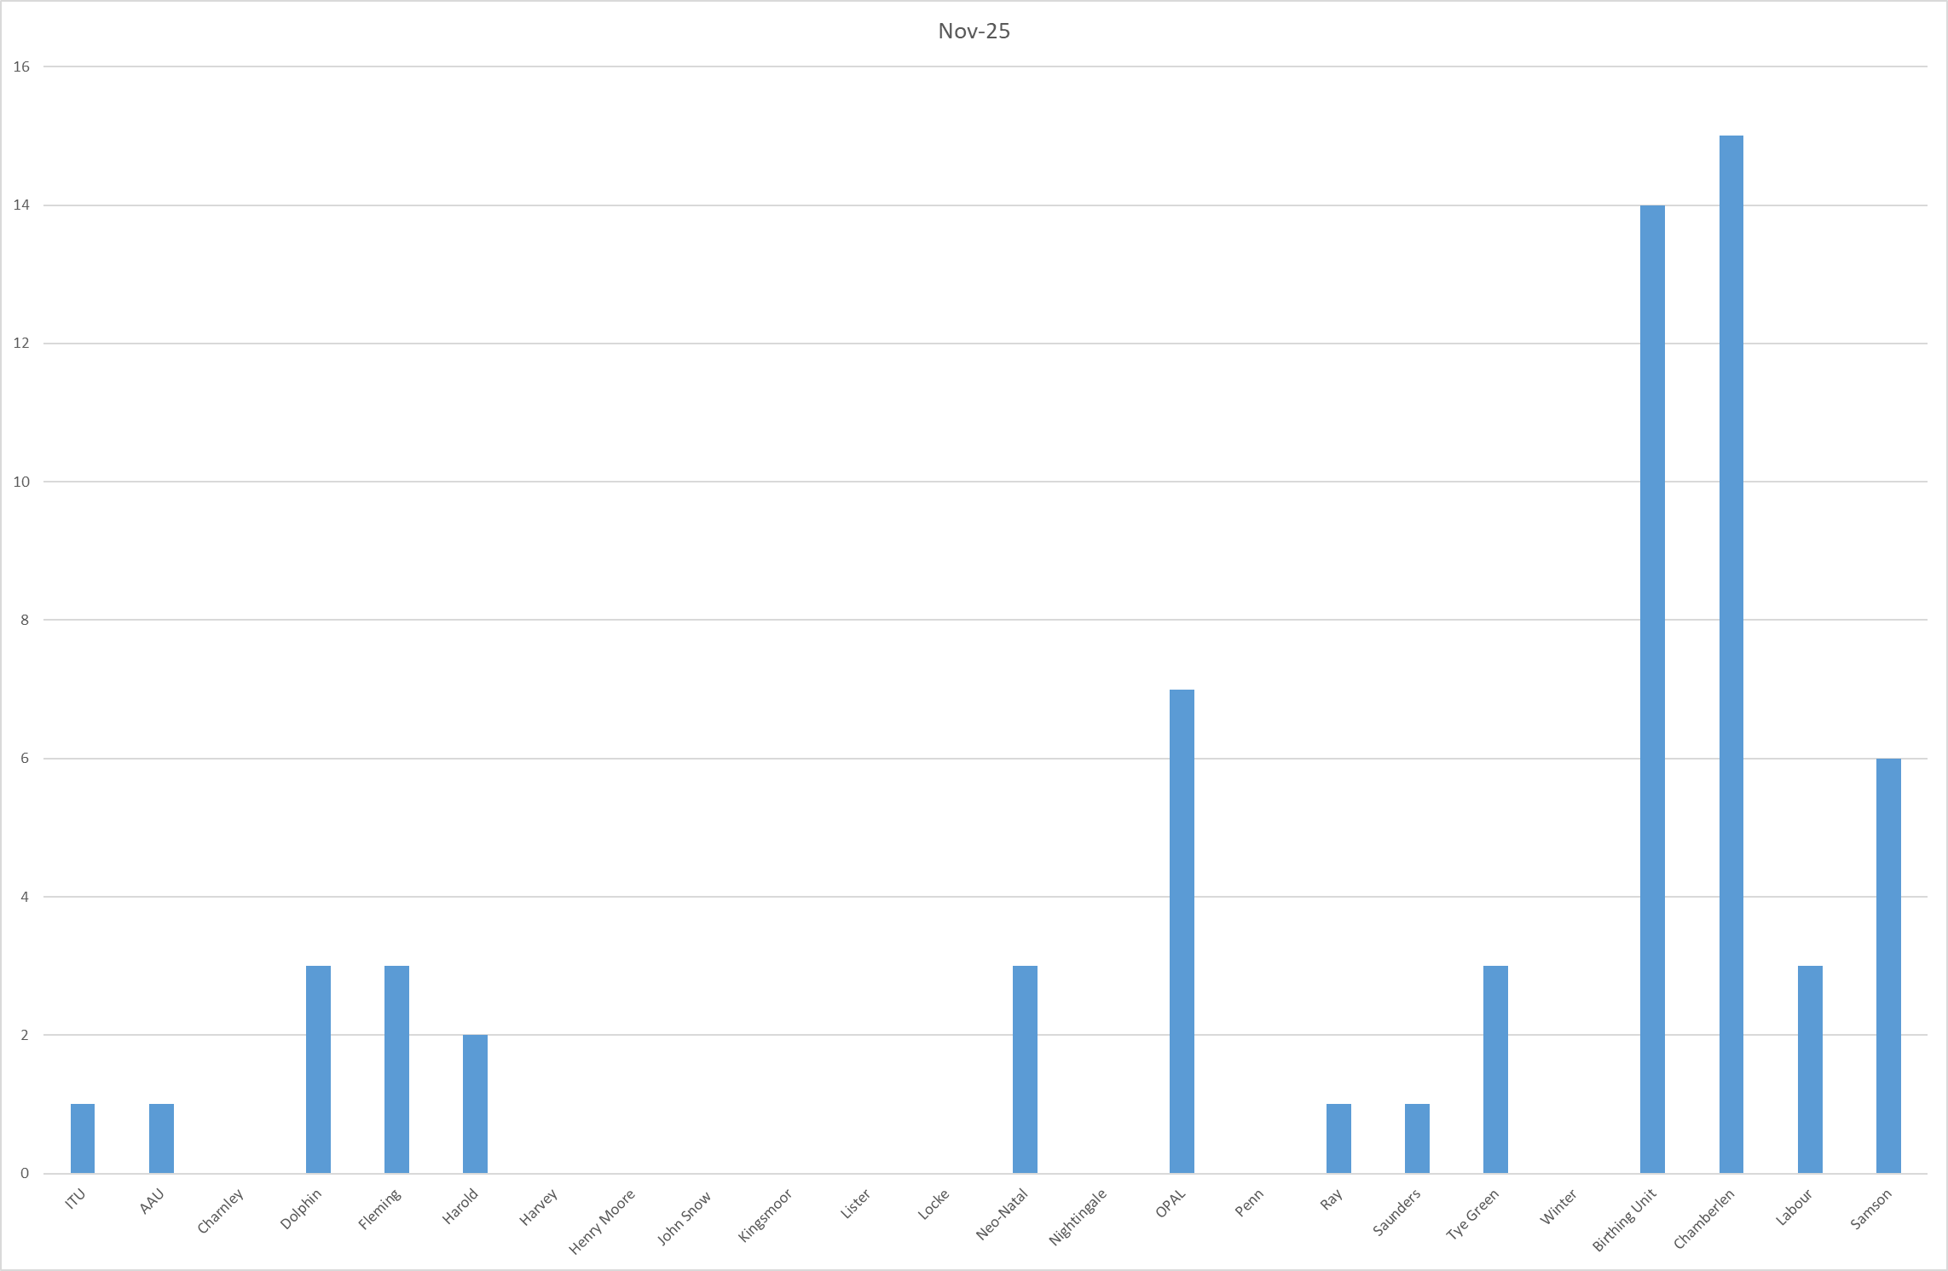

Table 2a. Occasions when all registered staffing fell below 75% of standard template.
Trend Data Dec-24 – Nov-25
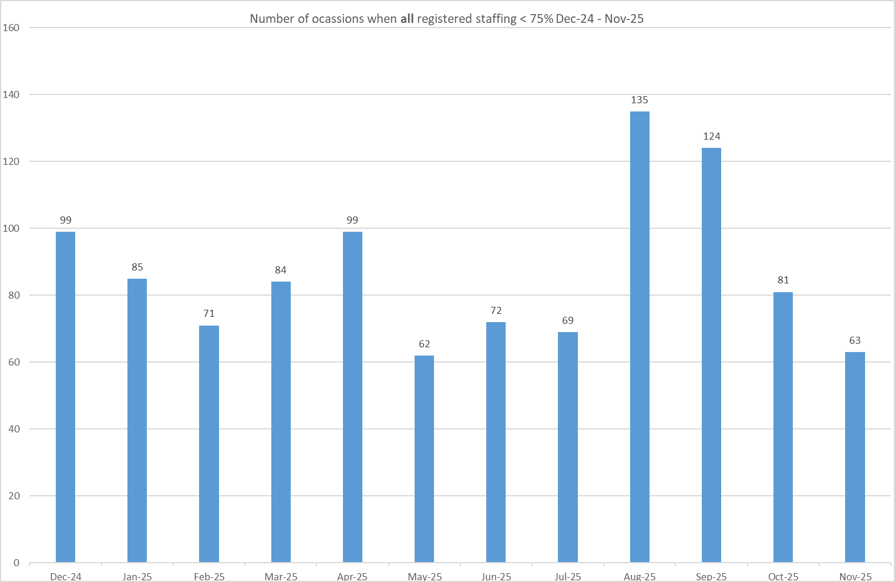

Table 2b. Occasions when registered maternity staffing fell below 75% of standard template. Trend Data Dec-24 – Nov-25

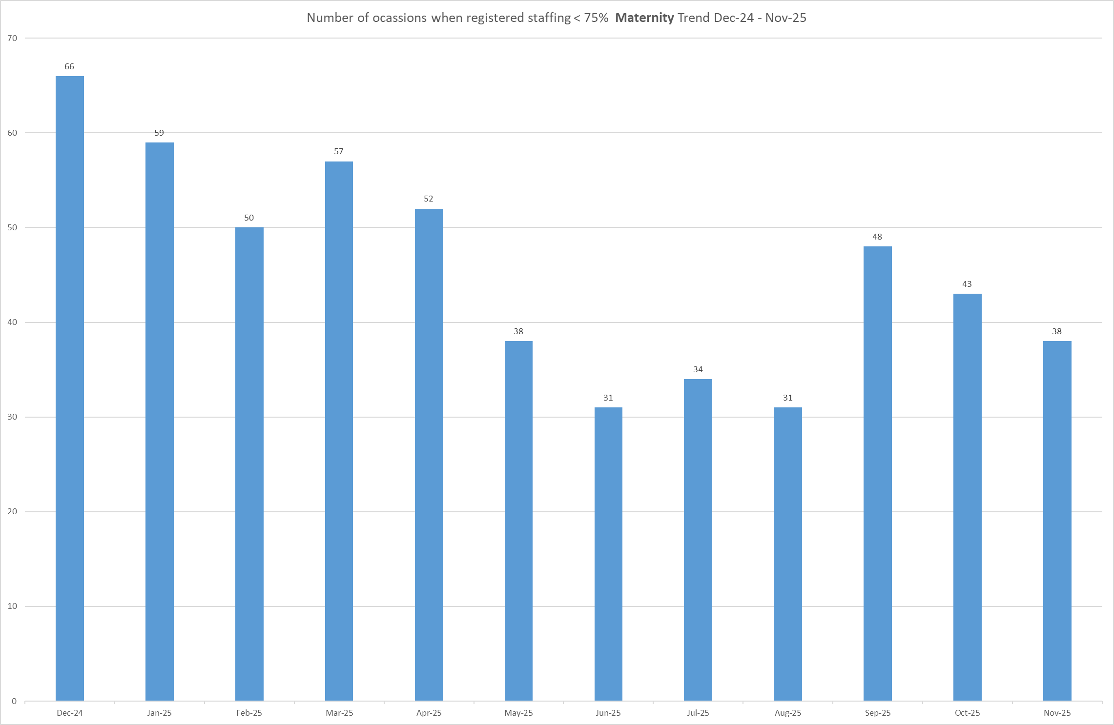

Table 3a. Red Flags raised via SafeCare Nov-25

Table 3b. Red Flags raised via SafeCare trend Dec-24 – Nov-25

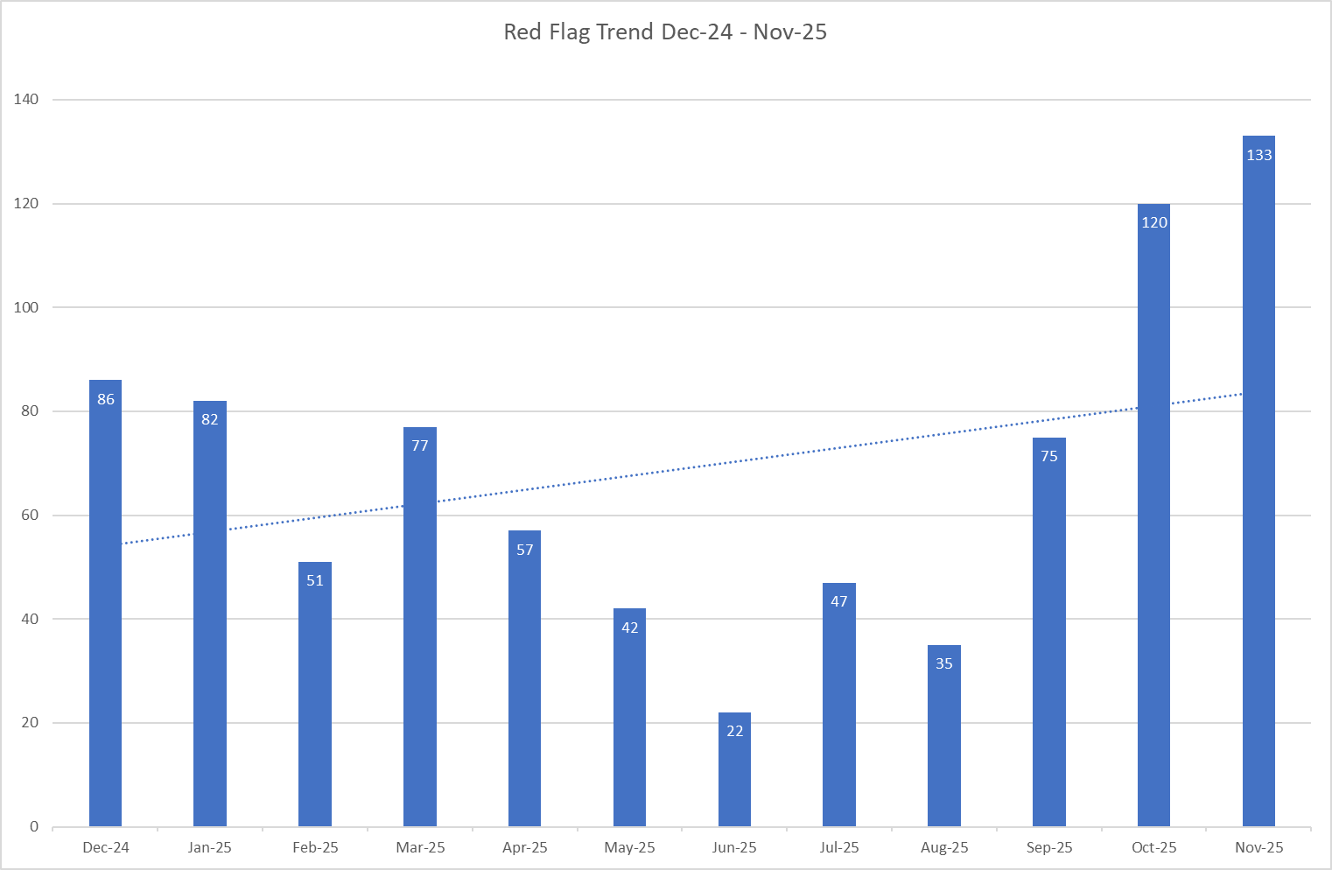

Table 3c. Datix for lack of suitably trained / skilled staff
In November, 48 staffing-related incidents were reported (45 nursing, 3 maternity). The highest reporting areas were Tye Green (11), Winter (6), and Ray and Fleming (4 each). Collectively, these three areas account for nearly half of all staffing-related incident reports, indicating concentrated pressure points requiring continued oversight and targeted support.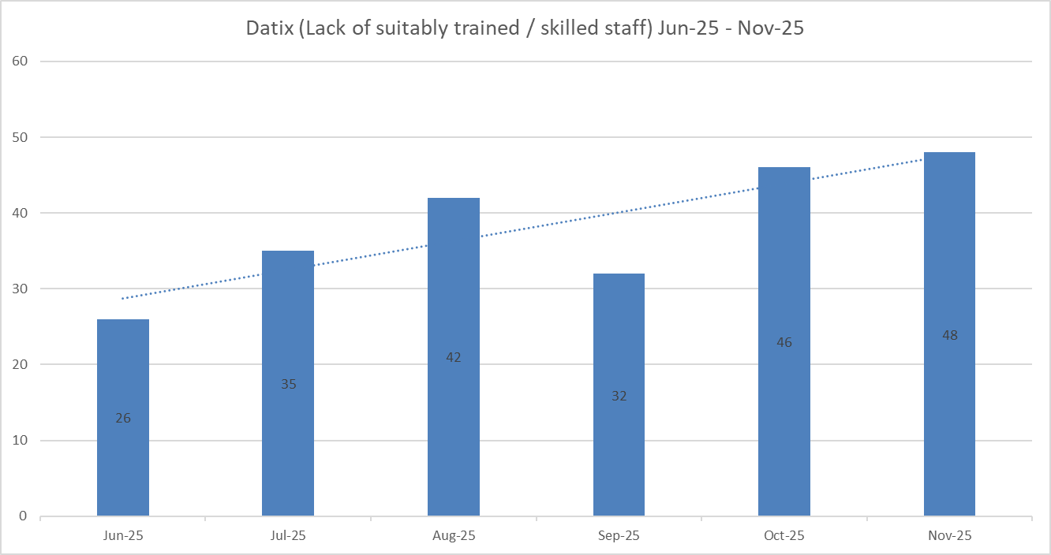

Redeployment
Redeployment continues to support safe staffing through daily safety huddles. In November, 148 substantive redeployments were recorded, a reduction of 10 compared to October, and a continued downward trend from 281 in August and 286 in September (Table 5). This represents a 47% reduction since September, suggesting improved roster alignment and reduced reliance on cross-cover.
Tye Green, John Snow and AAU were the highest redeploying wards, while Nightingale and the Emergency Department were the largest net receivers (Table 4). Redeployed hours accounted for 1.06% of substantive hours and 1.87% of total hours worked (Tables 6 and 7), excluding agency, bank and multi-post holders.
Governance remains robust, with all redeployments clinically risk-assessed and recorded in SafeCare. Further reductions are anticipated as establishment review changes are embedded within roster templates.
Table 4. Hours of substantive staff redeployed November 2025

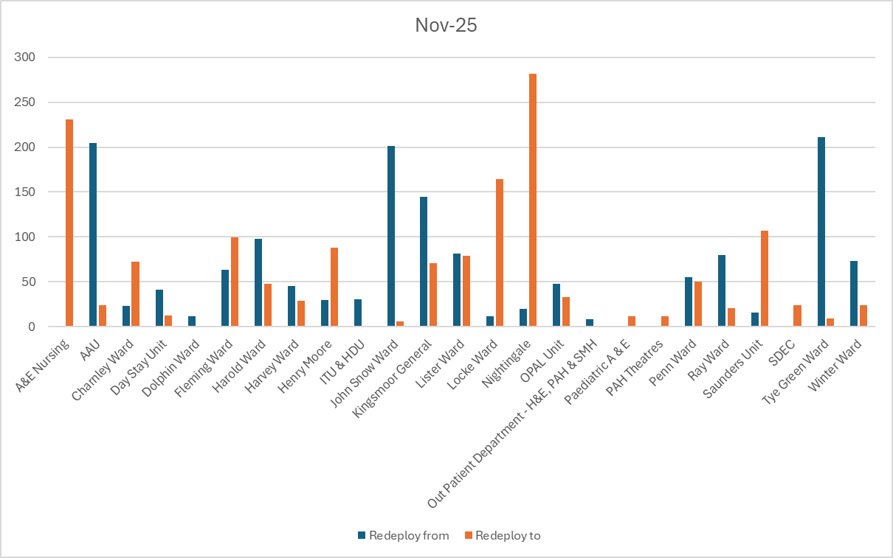

Table 5. Substantive staff redeployment trend

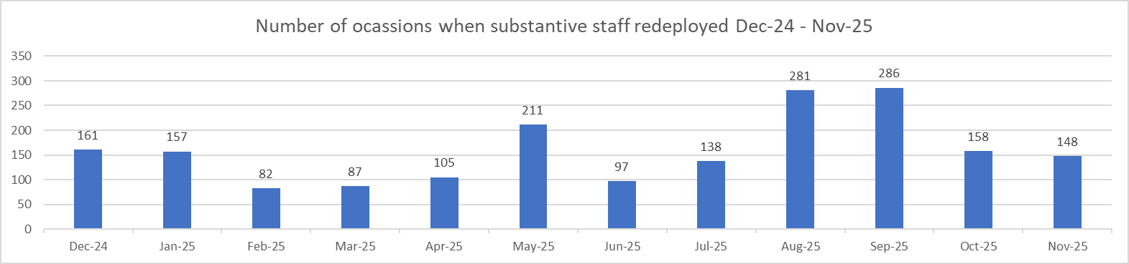
Table 6. % of substantive staff redeployed as % of total hours worked

Substantive staff hours redeployed | Total hours worked (inc. bank and agency) | % of total hours worked / substantive staff redeployed
1496.1 | 140763 | 1.06%

Table 7. % of staff redeployed as % of total hours worked

All staff hours redeployed (including bank and agency but excluding Enhanced Care Team, Bank Pool and Rapid Response Pool) | Total hours worked (inc. bank and agency) | % of total hours worked / staff redeployed (including bank and agency but excluding Enhanced Care Team, Bank Pool and Rapid Response Pool)
2641.1 | 140763 | 1.87%

Appendix 3 Summary
November data demonstrates improving workforce flexibility alongside ongoing pressures:
- Nursing Red Flags: 133 raised (+13 compared to October), predominantly related to registered nurse shortfalls and enhanced care demand. The majority remain open, indicating a need to strengthen closure compliance and follow-up.
- Datix incidents: 48 staffing-related reports, concentrated in a small number of wards, reflecting appropriate escalation and a strengthening safety culture.
- Redeployment: 148 occasions, continuing a sustained reduction from earlier peaks, suggesting improved roster alignment and workforce planning.
Overall assurance: Safe staffing was maintained through daily safety huddles and robust governance controls. While continued reliance on temporary staffing and open Red Flags highlights a safe but fragile position, improving redeployment trends and proactive escalation provide confidence that staffing risks are being actively identified and managed.
Appendix 4: Nursing quality indicators

Table 1. Number of falls, unwitnessed falls and falls with harm in November 2025, with the top 3 wards being highlighted.
 | Total falls in month | Top 3 wards
Total falls | 80 | Winter – 11 |  | Lister – 10 |  | Charnley, Kingsmoor, Penn – 7
Unwitnessed falls | 53 | Winter – 9 |  | Charnley – 7 |  | Lister, Penn, Locke – 5
Falls with harm * | 17 | Winter – 4 | Charnley – 3 |  | Ray, AAU – 2
*Subject to change following review at Falls Incident Oversight Group

Falls increased slightly to 80 (+2), with harm-related falls rising to 17 (+3). Unwitnessed falls reduced to 53 (−4), indicating some improvement in observation and supervision. Training compliance remains high at >97%, with targeted support continuing in Kingsmoor and Harold to address residual risk.

Falls Rate per 1000 bed days November 2025 data

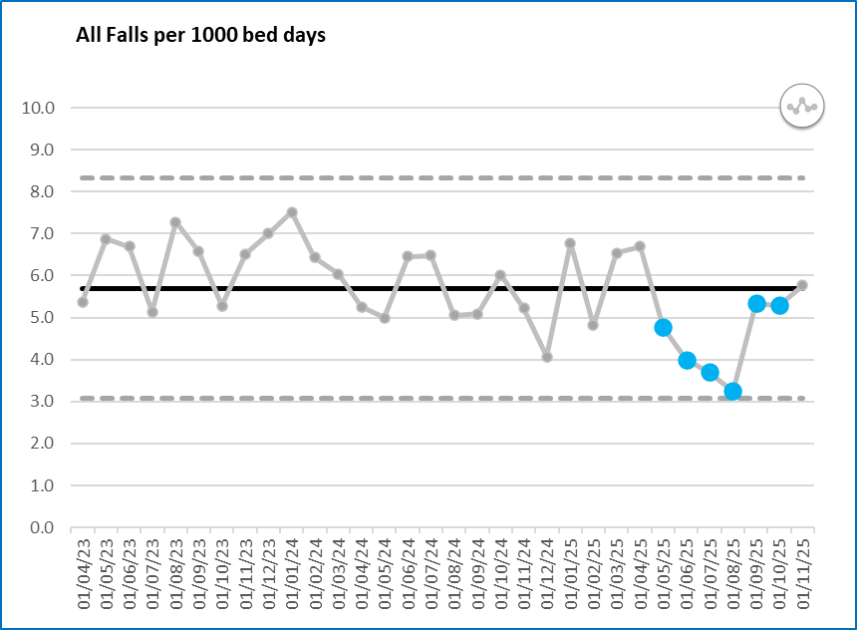

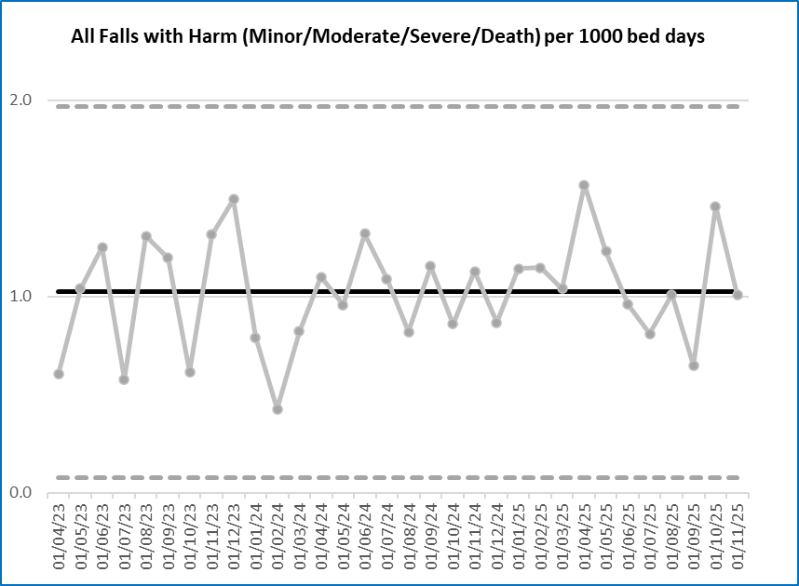

Pressure Ulcers

Table 2a. Number of Hospital Acquired Pressure Ulcers (HAPU) Cat 2 and Cat 3 Pressure Ulcers
Reportable hospital-acquired pressure ulcers (HAPUs) increased to 41 (+11), with non-reportable skin changes rising to 78 (+3). Tye Green and Kingsmoor remain under enhanced surveillance, with targeted improvement actions in progress.
Current reporting draws on multiple data sources, resulting in some inconsistency; therefore, rates per 1,000 bed days are not yet available. In addition, reported incidents may include more than one HAPU per patient, reflecting increased vulnerability rather than isolated events.
To strengthen assurance, the Tissue Viability Team will introduce a unified monitoring system covering all Category 1 pressure damage and vulnerable skin, enabling earlier intervention, timely pressure care and improved capture of resolved damage. The Trust also launched the ‘All you have to do is ASK’ campaign in November, aligned to Stop the Pressure Day, to reinforce prevention and staff awareness.
.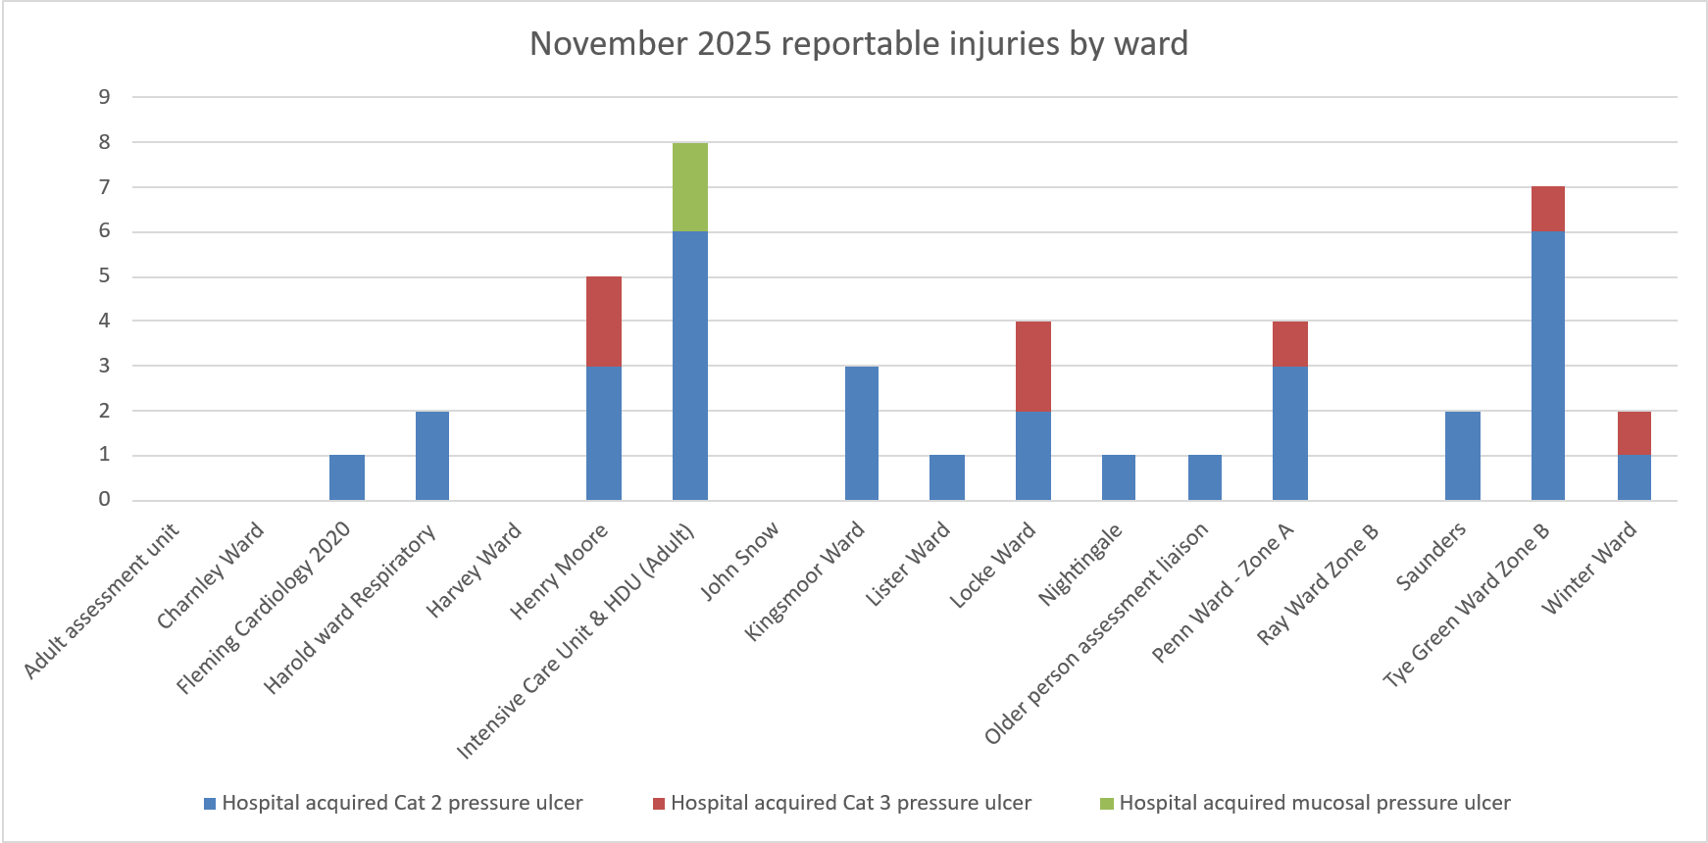

Total in month | Top 3 wards
41 | ITU – 8 | Tye Green – 7 | Henry Moore – 5

Table 2b. Reported Incidents and Actual Hospital Acquired Pressure Ulcers November 2025
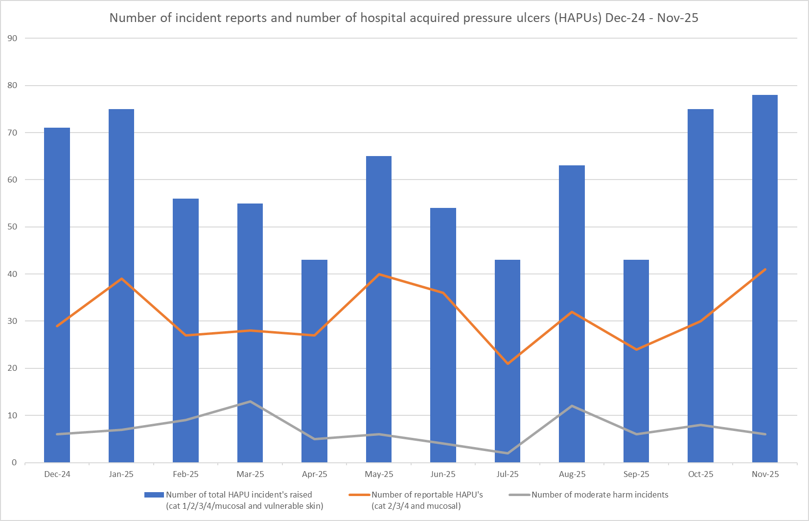

Complaints, PALS and Compliments Trend Data February 2025 – November 2025

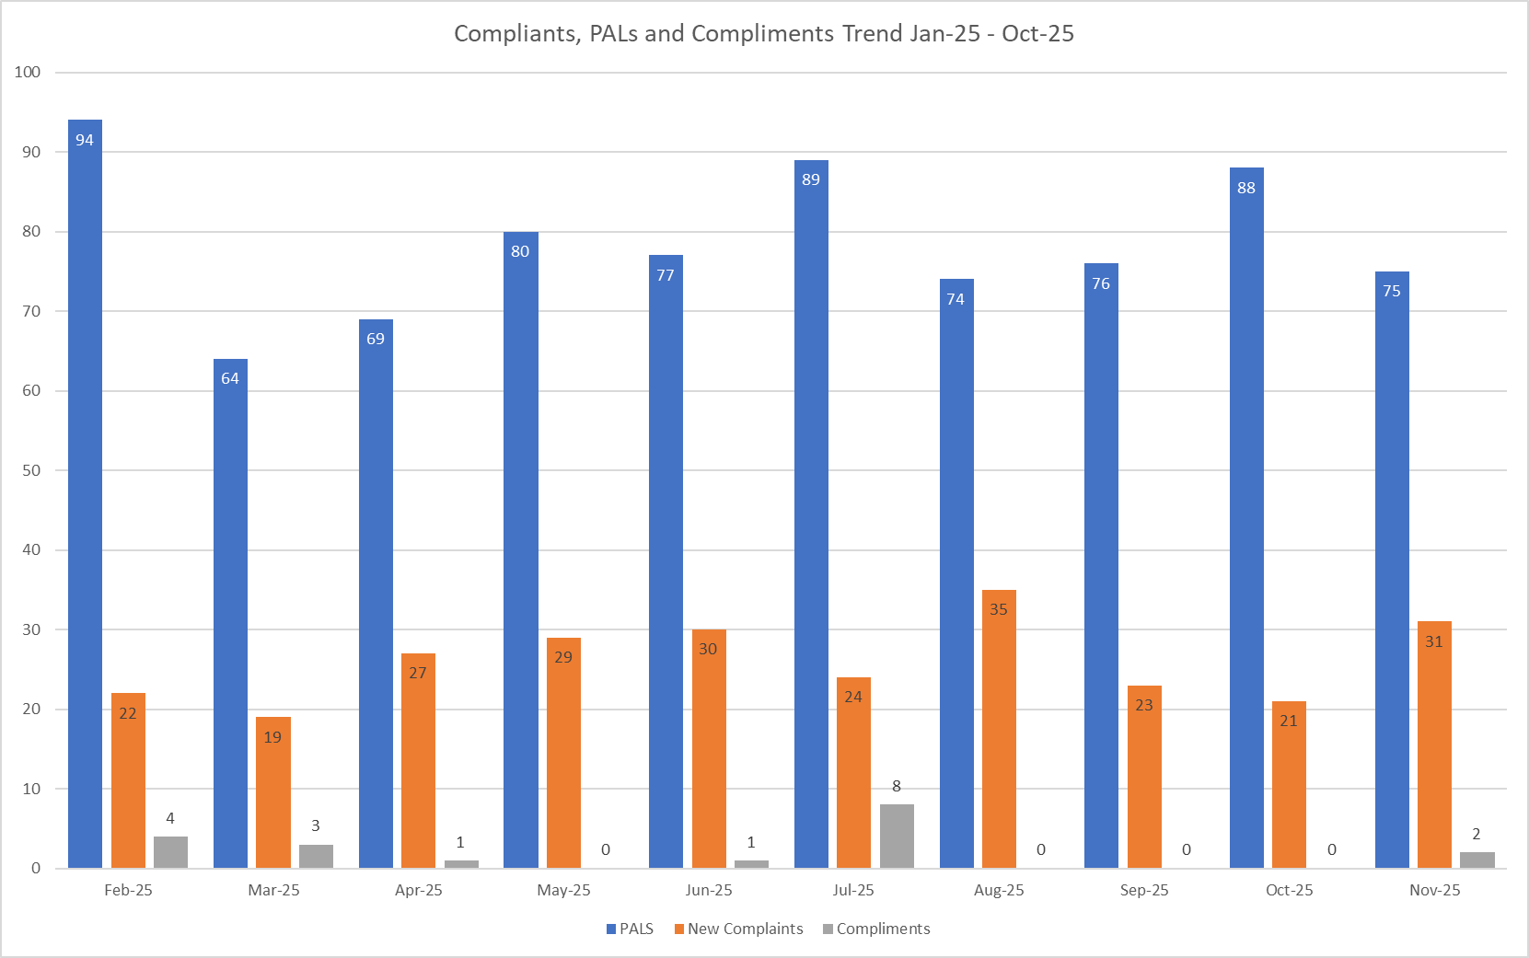

Table 3. Number of new Complaints, PALS and Compliments in November 2025 with top three wards highlighted
 | Total in month | Top Departments
New complaints | 31 | A&E – 8 | Harold – 3
PALs | 75 | A&E – 21 | Lister – 7
Compliments | 2 | A&E – 2

Complaints: 31 (main themes: medical care 26%, delay 16%, communication 16%).
PALS: 75 (themes: delay 36%, communication 25%, appointments 10%).
Compliments: Only 2 recorded; themes not provided—data capture remains inconsistent.
Appendix 4 Summary
Quality indicators for November present a mixed picture. Falls increased slightly, with a corresponding rise in harm-related cases, and pressure ulcers demonstrated a notable upward trend, indicating ongoing fragility in pressure care. Patient experience data continues to highlight recurring themes of delays and communication within complaints and PALS, alongside very low capture of compliments, limiting visibility of positive patient experiences.
Despite these concerns, assurance is supported by high mandatory training compliance (>97%) and active improvement actions, including the introduction of a new tissue viability monitoring system and the launch of the “All you have to do is ASK” campaign.
Overall assessment: Quality remains under close review, with mitigating actions in place; however, upward harm trends require sustained leadership focus and continued oversight to ensure improvement is embedded.

