|  |  |  |  |  |  |  |  |  |  |  |  |
| --- | --- | --- | --- | --- | --- | --- | --- | --- | --- | --- | --- |
| **Agenda item:**  **Presented by:**  **Prepared by:**  **Date prepared:**  **Subject / title:** | Giuseppe Labriola – Deputy Chief Nurse  David Dellow – Safe Staffing Lead and Giuseppe Labriola – Deputy Chief Nurse    17.12 2024  Report on Nursing and Midwifery staff levels for November 2024. | | | | | | | | | | |
| **Purpose:** | **Approval** |  | **Decision** | |  | **Information** | | **x** | **Assurance** | | **x** |
| **Key issues:** | There has been a sustained Registered Nurse overall fill of > 95%. Wards achieving < 75% overall fill rate are included under section 3. The increase in overall fill rates is multifaced with a combination of enhanced care needs and supernumerary time driving this. The results of the full year establishment review (which underpins the rota templates) is due to report to Board in February 2025.  practice. | | | | | | | | | | |
| **Recommendation:** | The committee are asked to note the information within this report. | | | | | | | | | | |
| **Trust strategic objectives:** | Princess Alexandra_strap line blocks NHS blue text  **Patients** | Princess Alexandra_strap line blocks NHS blue text  **People** | | **Performance** | | | **Places** | | | Princess Alexandra_strap line blocks NHS blue text  **Pounds** | |
| x | x | | x | | |  | | | x | |
|  |  | | | | | | | | | | |
| **Previously considered by:** | NA | | | | | | | | | | |
| **Risk / links with the BAF:** | BAF: 2.1 Workforce capacity | | | | | | | | | | |
| **Legislation, regulatory, equality, diversity and dignity implications:** | NHS England and CQC letter to NHSFT CEOs (31.3.14): Hard Truths Commitment regarding publishing of staffing data.  NHS Improvement letter: 22.4.16  NHS Improvement letter re CHPPD: 29/6/18 | | | | | | | | | | |
| **Appendices:** | **Appendix 1:** Ward and divisional fill rates by month against adjusted standard planned template.  **Appendix 2**: Ward and divisional CHPPD data  **Appendix 3:** Nursing red flags  **Appendix 4:** Nursing quality indicators | | | | | | | | | | |

**1.0 Introduction**

This paper illustrates how PAHT’s nursing and midwifery staffing has been deployed for the month of November 2024. It evidences how planned staffing has been successfully achieved and how this is supported by nursing and midwifery recruitment and deployment.

**2.0 Background**

The National Quality Board (NQB 2016) recommend that monthly, actual staffing data is compared with expected staffing and reviewed alongside quality of care, patient safety, and patient and staff experience data. The Trust is committed to ensuring that improvements are learned from and celebrated, and areas of emerging concern are identified and addressed promptly. This paper will identify safe staffing and actions taken in November 2024. The following sections identify the processes in place to demonstrate that the Trust proactively manages nursing and midwifery staffing to support patient safety.

**3.0 Inpatient wards fill rate**

The Trust’s safer staffing submission has been submitted to NHS Digital for November 2024 within the data submission deadline. Table 1 shows the summary of the overall fill rate for this month. Table 2 shows a summary of overall fill rate percentages for a rolling 12-month period.

Appendix 1 illustrates a ward-by-ward breakdown for this period.

**3.1 Wards with < 75% average fill rate**

One ward that had a fill rate of < 75%:

**John Snow Ward**

This is our elective orthopaedic ward and has fluctuating capacity. There were no concerns that are identifiable from the quality metrics or red flags.

**3.2 Wards with > 100% average fill rate**

Henry Moore Ward has an increased fill rate due to fluctuating capacity and opening of additional surgical beds and a Level 1 area for post-operative patients, the Level 1 bay is staffed by ITU and the staffing is reflected in their numbers. Therefore, the additional staff are reflective of the required workforce to meet the activity demands.

The impact of staffing requirements for patients requiring enhanced care is shown in the number of wards which continue to have greater than 100% fillrate, this is especially demonstrated in wards such as Penn, Saunders and AAU night fill rate for Healthcare support workers (HCSWs). The fill rate is based against the standard ward template

Greater than 100% fill rate for Registered Nurse (RN) shifts are attributable to Registered Mental Health (RMN) 1:1 requirements or supporting the induction of newly qualified/registered RNs.

We continue to utilise NHS Professionals and agency to mitigate vacant shifts, though continue to reduce our temporary staffing pools. Additional control measures have been put in place regarding the creation of additional duties. Furthermore, our senior nurses and midwives are also supporting individual area when required. SafeCare data continues to be collected three times a day to enhance staffing governance across the organisation.

Further detail can be found in Appendix 1

**Table 1. Overall fill rate**

|  |  |  |  |  |  |  |
| --- | --- | --- | --- | --- | --- | --- |
| **Average day fill rate - registered nurses/midwives** | **Average day fill rate - care staff** | **Average night fill rate - registered nurses/midwives** | **Average night fill rate - care staff** | **% Registered overall fill rate** | **% HCSW overall fill rate** | **% Overall fill rate** |
| **95.7%** | **103.8%** | **103.5%** | **123.7%** | **99.1%** | **112.7%** | **103.6%** |

**Table 2. Inpatient fill rate including Maternity Wards Trend**

**4.0 Care Hours Per Patient Day (CHPPD)**

CHPPD allows comparison of a ward’s CHPPD figure with that of other wards in the hospital, or with similar wards in other hospitals. It can be used to look at variation between similar wards to ensure the right staff are being used in the right way and in the right numbers.

The hours worked during day and night shifts by registered nurses and midwives and healthcare assistants are added together. This figure is then divided by the number of patients at midnight, this then gives the total CHPPD

By itself, the CHPPD does not reflect the total amount of care provided on a ward nor does it directly show whether care is safe, effective or responsive. It should therefore be considered alongside measures of quality and safety.

**Table 3. Overall Care Hours Per Patient Day (CHPPD) November 2024**

|  |  |  |
| --- | --- | --- |
| Registered CHPPD | Unregistered CHPPD | Total CHPPD |
| 5.0 | 2.7 | 7.7 |

The Model Hospital data for September 2024 shows the Trust with a CHPPD of 7.4 against the national median of 8.6**.** Table 4 also now shows the Trusts total CHPPD against our peers (East and North Hertfordshire NHS Trust and West Hertfordshire Teaching Hospitals NHS Trust)

Appendix 2 shows the individual ward and divisional CHPPD for November 2024

**Table 4. CHPPD Trend**

**5.0 Quality Indicators**

**5.1 Nursing Red Flags**

Nursing red flags prompt an immediate response by the registered nurse in charge of the ward. The response may include allocating additional nursing staff to the ward or other appropriate responses. Appendix 3 details the NICE (2014) definition of Nursing Red Flags and the number of occasions when registered staffing fell below 75% of the standard template and trend. Currently, this information cannot be monitored for all nursing red flags on the DATIX and a system has been developed on SafeCare. This data will be provided in subsequent papers.

**5.2 Quality indicators (Falls, pressure ulcers and complaints, PALS and compliments)**

Nursing quality indicators have been reviewed and there is no correlation between these, fill rates or red flags which are a cause of concern. A review of quality indicators can be found in Appendix 4

**6.0 Conclusion**

There has been a sustained RN overall fill of > 95%. The increase in overall fill rates is multifaced with a combination of enhanced care needs and supernumerary time driving this. Wards achieving < 75% overall fill rate are included under section 3. Nursing quality indicators have been reviewed and there is no correlation with <75% fill rates and nursing red flags which are a cause of concern. The results of the full year establishment review, which underpins the ward establishment, is due to report to Board in February 2025.

**7.0 Recommendation**

The committee are asked to note the information in this report to provide assurance on the daily mitigation of nursing and midwifery staffing.

**Appendix 1:** **Ward level data and narrative: fill rates November 2024*(Adjusted Standard Planned Ward Demand)***

|  |  |  |  |
| --- | --- | --- | --- |
| >100% | 95 – 100% | 75-95% | <75% |

|  |  |  |  |  |  |  |  |
| --- | --- | --- | --- | --- | --- | --- | --- |
|  | **Day** | | **Night** | |  | | |
| **Ward name** | **Average fill rate - registered nurses/midwives (%)** | **Average fill rate - care staff (%)** | **Average fill rate - registered nurses/midwives (%)** | **Average fill rate - care staff (%)** | **% Registered overall fill rate** | **% HCSW overall fill rate** | **% Overall fill rate** |
| Harvey | **85.9%** | **113.6%** | **96.4%** | **114.9%** | **90.1%** | **114.2%** | **98.9%** |
| Henry Moore | **108.8%** | **139.0%** | **149.5%** | **140.1%** | **125.1%** | **139.5%** | **131.4%** |
| ITU & HDU | **107.4%** | **56.7%** | **110.3%** | **116.7%** | **108.9%** | **86.7%** | **106.8%** |
| John Snow | **95.5%** | **35.6%** | **93.3%** | **56.7%** | **94.5%** | **42.2%** | **71.9%** |
| Penn | **107.1%** | **118.1%** | **116.3%** | **167.9%** | **111.0%** | **137.0%** | **120.3%** |
| Saunders | **82.8%** | **114.8%** | **125.5%** | **156.0%** | **98.8%** | **130.5%** | **110.7%** |
| ***Surgery Total*** | **99.3%** | **102.6%** | **113.7%** | **133.0%** | **105.7%** | **115.2%** | **108.6%** |
| Fleming | **81.1%** | **105.1%** | **98.6%** | **131.2%** | **88.5%** | **117.6%** | **97.4%** |
| Harold | **94.7%** | **106.3%** | **105.0%** | **111.1%** | **99.2%** | **108.6%** | **102.2%** |
| Kingsmoor | **87.8%** | **122.8%** | **102.7%** | **147.1%** | **93.5%** | **134.4%** | **108.7%** |
| Lister | **98.1%** | **109.3%** | **107.5%** | **131.6%** | **102.1%** | **120.0%** | **109.2%** |
| Locke | **92.3%** | **118.3%** | **100.0%** | **136.5%** | **95.5%** | **127.0%** | **108.1%** |
| Nightingale | **115.8%** | **88.3%** | **105.2%** | **199.8%** | **110.7%** | **123.3%** | **116.1%** |
| Opal | **105.3%** | **108.8%** | **101.5%** | **129.5%** | **103.5%** | **118.7%** | **109.6%** |
| Ray | **119.1%** | **88.1%** | **137.5%** | **127.8%** | **126.9%** | **103.2%** | **118.4%** |
| Tye Green | **89.2%** | **105.6%** | **98.3%** | **127.8%** | **93.1%** | **114.7%** | **101.5%** |
| Winter | **99.5%** | **112.8%** | **106.7%** | **113.9%** | **102.6%** | **113.3%** | **106.9%** |
| ***Medicine Total*** | **96.4%** | **107.1%** | **106.2%** | **131.2%** | **100.6%** | **118.0%** | **107.1%** |
| AAU | **88.4%** | **131.6%** | **97.2%** | **140.5%** | **92.3%** | **135.8%** | **101.5%** |
| Charnley | **101.0%** | **141.5%** | **101.6%** | **149.6%** | **101.3%** | **145.4%** | **113.9%** |
| ***UEC Total*** | **93.3%** | **136.5%** | **99.0%** | **145.0%** | **95.9%** | **140.6%** | **106.7%** |
| Birthing | **122.1%** | **84.9%** | **79.7%** | **93.3%** | **101.8%** | **88.9%** | **97.5%** |
| Chamberlen | **87.8%** | **68.6%** | **95.7%** | **86.7%** | **91.5%** | **77.2%** | **88.0%** |
| Dolphin | **84.5%** | **76.7%** | **88.6%** | **98.7%** | **86.3%** | **84.1%** | **85.7%** |
| Labour | **97.2%** | **85.6%** | **94.0%** | **94.1%** | **95.7%** | **89.7%** | **94.3%** |
| Neo-Natal Unit | **86.1%** | **102.9%** | **94.3%** | **76.8%** | **90.2%** | **89.9%** | **90.1%** |
| Samson | **78.8%** | **86.9%** | **82.6%** | **82.2%** | **80.6%** | **84.7%** | **82.9%** |
| ***CHAWS Total*** | **91.2%** | **84.4%** | **90.8%** | **87.3%** | **91.0%** | **85.7%** | **89.4%** |
| ***Total*** | **95.7%** | **103.8%** | **103.5%** | **123.7%** | **99.1%** | **112.7%** | **103.6%** |

**John Snow Ward** - continues to have fluctuating capacity and has not consistently been sending 1 of the 2-day HCSW shifts to NHS Professionals (NHSP). The HCSW night shift is being filled, though depending on overnight patient numbers and acuity these staff may be redeployed to other areas. These factors continue to impact on the number of HCSW shifts being redeployed from the ward during November, and continue to impact on the HCSW fill rate for day and night. This will be reviewed as part of the full year establishment review and a recommendation made based on predicted activity for in-patient elective orthopaedic surgery.

**Henry Moore Ward** - if the Level one bay is not required then it is opened up to all patients to ease site pressures and additional staff booked if required via additional duties. This is being reviewed as part of the full year establishment review.

**Critical Care** - it has been identified in the divisional roster reviews that critical care are not consistently sending all HCSW shifts out to NHSP. An improvement plan has been requested and a recruitment campaign for support workers will commence centrally in January, for surgery and critical care.

**Maternity** - the service continue to robustly review staffing through twice weekly staffing reviews and the use of Birthrate Plus. Safety is maintained by daily staffing huddles and staff deployment according to acuity, while support is provided by specialist midwives and matrons being redeployed as required. Maternity have a HCSW recruitment event planned for January to improve vacancies throughout all maternity areas. Midwifery vacancies are now at zero.

The Trust is part of an Enhanced Care Collaborative working group supported by NHS England that is reviewing the provision of Enhanced Care including the workforce and training requirements to sustainably manage this demand. The full year establishment review completed in October 2024, with consideration of the Enhanced Care Collaborative findings, will review the continued demand above established templates for enhanced care needs and will make a recommendation for how this demand is planned for.

**Appendix 2: Ward level data: CHPPD November 2024**

|  |  |  |  |
| --- | --- | --- | --- |
| Care Hours Per Patient Day (CHPPD) | | | |
| Ward | Registered Nurses/Midwives | Non-registered Nurses/Midwives | Overall |
| ***Trust Total*** | ***5.0*** | ***2.7*** | ***7.7*** |
| Harvey Ward | 3.7 | 2.7 | 6.4 |
| Henry Moore Ward | 3.7 | 3.1 | 6.8 |
| ITU & HDU | 20.6 | 1.6 | 22.2 |
| John Snow Ward | 7.5 | 2.5 | 10.0 |
| Penn Ward | 4.5 | 3.1 | 7.6 |
| Saunders Unit | 3.5 | 2.8 | 6.4 |
| **Surgery Total** | ***5.9*** | ***2.8*** | ***8.7*** |
| Fleming Ward | 3.6 | 2.1 | 5.7 |
| Harold Ward | 4.8 | 2.4 | 7.2 |
| Kingsmoor General | 3.4 | 2.9 | 6.3 |
| Lister Ward | 3.9 | 3.0 | 6.9 |
| Locke Ward | 3.6 | 3.2 | 6.7 |
| Nightingale Ward | 3.3 | 2.8 | 6.0 |
| Opal Unit | 4.8 | 3.6 | 8.4 |
| Ray Ward | 4.8 | 2.2 | 6.9 |
| Tye Green Ward | 4.0 | 3.1 | 7.1 |
| Winter Ward | 3.8 | 2.8 | 6.6 |
| ***Medicine Total*** | ***4.0*** | ***2.8*** | ***6.8*** |
| AAU | 6.3 | 2.4 | 8.7 |
| Charnley Ward | 4.5 | 2.6 | 7.1 |
| ***UEC Total*** | ***5.4*** | ***2.5*** | ***7.9*** |
| Birthing Unit | 11.3 | 4.9 | 16.3 |
| Chamberlen Ward | 6.1 | 1.7 | 7.8 |
| Dolphin Ward | 5.9 | 1.9 | 7.9 |
| Labour Ward | 21.3 | 5.7 | 27.0 |
| Neo-Natal Unit | 7.8 | 1.6 | 9.4 |
| Samson Ward | 2.0 | 2.8 | 4.8 |
| ***CHAWS Total*** | ***6.6*** | ***2.7*** | ***9.2*** |

**Appendix 3. Nursing Red Flags (NICE 2014)and trend data**

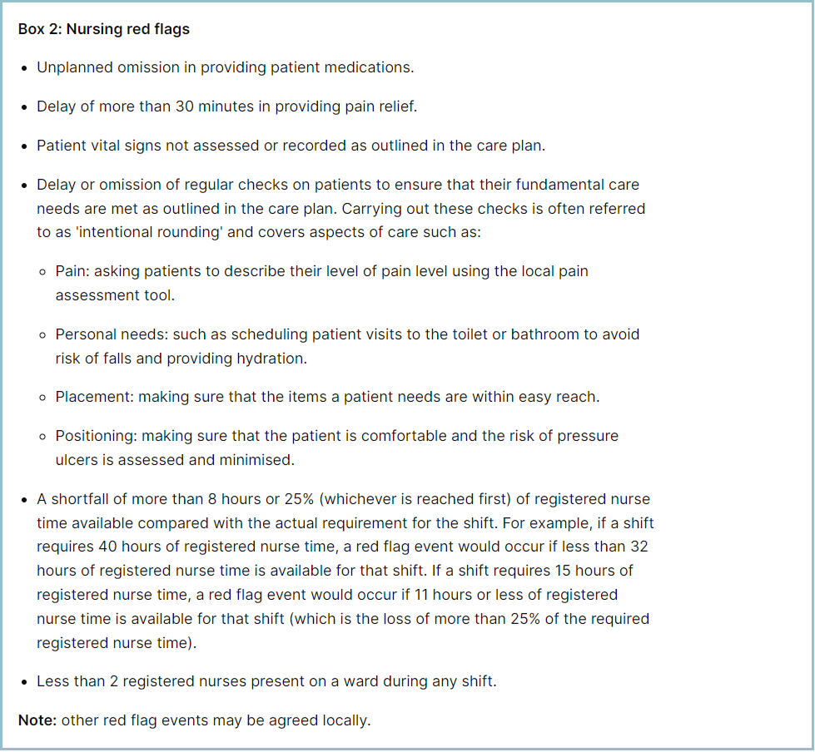

**Staffing red flags and trend data**

The number of occasions/shifts where the reported fill rate has fallen below 75% across the wards is available in Table 1. This increased by 25 occasions in November to 126. The majority of these shortfalls were in Maternity, which had 63.

**Table 1. Occasions when registered staffing fell below 75% of standard template**

**Table 2. Staffing Red Flags Trend Data**

**Redeployment**

Redeployment of staff continues to be undertaken to support safe staffing as part of the daily staffing huddles. Table 3 details the trend in November with John Snow redeploying the highest number of substantive staff with Day Stay and AAU being the next highest. The highest net receiver of staff was Henry Moore followed by A&E, Penn and Nightingale Ward.Table 4 demonstrates the number of substantive staff redeployments per month trend

**Table 4. Substantive staff redeployment trend**

This reports looks at the number of shifts substantive staff working a shift are redployed, it does not include the shifts when agency, bank or multi post holders are redeployed.

Table 5 shows the hours of substantive staff moved as a percentage of total hours worked.

Table 6 shows the hours of all staff including bank and agency, excluding the Enhanced Care Team, Bank Pool and Rapid Response Pool staff.

**Table 5. % of substantive staff redeployed as % of total hours worked**

|  |  |  |
| --- | --- | --- |
| Substantive staff hours redeployed | Total hours worked (inc bank and agency) | % of total hours worked / substantive staff redeployed |
| 1053 | 136898 | 0.77% |

**Table 6. % of staff redeployed as % of total hours worked**

|  |  |  |
| --- | --- | --- |
| All staff hours redeployed (including bank and agency but excluding Enhanced Care Team, Bank Pool and Rapid Response Pool) | Total hours worked (inc bank and agency) | % of total hours worked / staff redeployed (including bank and agency but excluding Enhanced Care Team, Bank Pool and Rapid Response Pool) |
| 2011 | 136898 | 1.47% |

The data detailing nurse redeployment indicates that the numbers of staff reassigned are minimal and continues to not be a cause of concern. The redeployment process is efficiently managed with improved governance and oversight.

**Appendix 4: Nursing quality indicators**

**Table 1. Number of falls, unwitnessed falls and falls with harm in November, with the top 3 wards being highlighted**

|  |  |  |  |
| --- | --- | --- | --- |
|  | Total falls in month | Top 3 wards | |
| Total falls | 75 | A&E 8 | Fleming, Lister & Tye Green 7 each |
| Unwitnessed falls | 61 | A&E , Fleming, Harold, Lister & Tye Green 6 each | |
| Falls with harm \* | 15 | Lister 4 | A&E, Locke & Tye Green 2 each |

*\*subject to change following review at Falls Incident Oversight Group*

The Trust falls reduction strategy and workplan (2024/2025) remains in place and mandatory falls training has increased to 94%.

**Falls Rate per 1000 bed days**

**Pressure Ulcers**

**Table 2. Number of Hospital Acquired Pressure Ulcers (HAPU) Cat 2 and Cat 3 Pressure Ulcers (including unstageable)**

In November there was an increase in HAPU, with 25 HAPU’s in November compared to 21 last month.

|  |  |  |  |
| --- | --- | --- | --- |
| Total in month | Top 3 wards | | |
| 25 | Tye Green 6 | ITU 5 | Harold 4 |

**Total Pressure Ulcer Rate per 1000 bed days and Moderate Harm Pressure Ulcer Rate per 1000 bed days trend.**

**Complaints, PALS and Compliments Trend Data**

**Complaints, PALS and Compliments**

**Table 8. Number of new Complaints, PALS and Compliments in November with top three wards highlighted**

|  |  |  |  |  |
| --- | --- | --- | --- | --- |
|  | Total in month | Top 3 wards | | |
| New complaints | 10 | Paeds A&E 3 | A&E, Harold & Saunders 2 each | Kingsmoor 1 |
| PALs | 105 | A&E 21 | Lister 8 | Charnley 7 |
| Compliments | 20 | A&E 5 | Fleming, Penn & Theatres 2 each | |

The 3 main PALS themes for November were:

* Delay – 33.4%%, Communication – 29.0%, Cancellations – 7.9%

Complaints themes for November were as follows

* Medical Care – 35.3% Attitude – 14.7% and Communication and Privacy and Dignity 8.8% each