Meeting Title
Date Agenda item:
Report Title: Safer Staffing Monthly Report – May 2026
Presented by: Jo Ward – Interim Chief Nurse
Prepared by: Charlotte Collings – Lead Nurse for Safer Staffing and Workforce
Purpose: (please tick) | Approval/Decision |  |  | Information/Assurance |  |  | √
Executive Summary
This report provides assurance on nursing and midwifery staffing for May 2026. Overall, staffing levels were maintained and safely delivered against planned establishment.
However, analysis including additional demand demonstrates variation between planned and required staffing, with continued reliance on redeployment and temporary staffing to respond to patient need. Quality indicators remain stable overall, with some improvement noted; however, ongoing pressures are evident in areas of higher demand and variation persists in the consistent use of red flag reporting.
Risks and Issues (including links to BAF/Corporate Risk Register/Other risk registers)
BAF: 2.3 Workforce capacity

Recommendation
The Committee is asked to:
- Note the information of the May 2026 safer staffing report.

Strategic Objectives
 |  |  |  |  |  | 
√ |  | √ |  |  |  | √
Relevant legal/statutory issues
National Quality Board (NQB) Supporting NHS providers to deliver the right staff, with the right skills, in the right place at the right time; NHS Improvement Developing Workforce Safeguards; NHS England safe staffing guidance; NIHR Professional Judgement Framework: A guide to applying professional judgement in nurse staffing reviews
Impact Assessments
Quality |  |  |  |  | Positive impact through continued assurance of safe staffing and workforce planning.
Equality, Diversity and Inclusion |  |  |  |  | No adverse equality impacts identified.
Health inequalities |  |  |  |  | No direct impact identified.
Previously Considered By |  |  |  |  | N/A
Appendices |  |  |  |  | Appendix 1: Fill Rates  Appendix 2: Redeployment and trend data  Appendix 3: CHPPD  Appendix 4. Nursing Red Flags (NICE 2014), Incident Reports and Trend Data  Appendix 5: Nursing quality indicators

1.0 Introduction
This report supports Board oversight of safe nursing and midwifery staffing in line with National Quality Board and Developing Workforce Safeguards guidance. It provides assurance through triangulated review of evidence-based data, patient outcomes and professional judgement to assess whether staffing levels are safe and effective and that risks are identified and appropriately managed.
2.0 Evidence-Based Data: Workforce and Demand
2.1 Workforce Supply
Workforce supply continues to present challenges across inpatient services, with vacancy rates of 8.0% for registered nurses (including 39.96 WTE at Band 5), 14.5% for healthcare support workers and 4.2% for registered midwives. This impacts the ability to meet patient demand through substantive staffing alone and contributing to reliance on temporary staffing and workforce flexibility, including redeployment, to maintain safe staffing levels to maintain safe staffing levels (Appendix 5, Table 4).
Planned recruitment of newly qualified nurses is expected to strengthen the Band 5 workforce pipeline from the autumn; however, this does not mitigate current summer staffing levels, and preceptorship requirements will need to be managed to support safe skill mix during the winter months.
2.2 Staffing Delivery Against Planned Establishment
Overall fill rates remained strong in May 2026, with registered staffing at 98.0% and total staffing at 103.0%, indicating delivery against planned establishment. No wards fell below the 75% threshold. (Appendix 1, Table 1A). This demonstrates that core staffing requirements were consistently met across all inpatient areas.
However, fill rates reflect staffing against planned templates based on average demand and do not fully account for real-time patient acuity, dependency or enhanced care requirements.
Table 1. Overall fill rate
Average day fill rate – registered | Average day fill rate - care staff | Average night fill rate - registered | Average night fill rate - care staff | % Registered overall fill rate | % HCSW overall fill rate | % Overall fill rate
94.4% | 106.5% | 102.6% | 121.1% | 98.0% | 113.2% | 103.0%
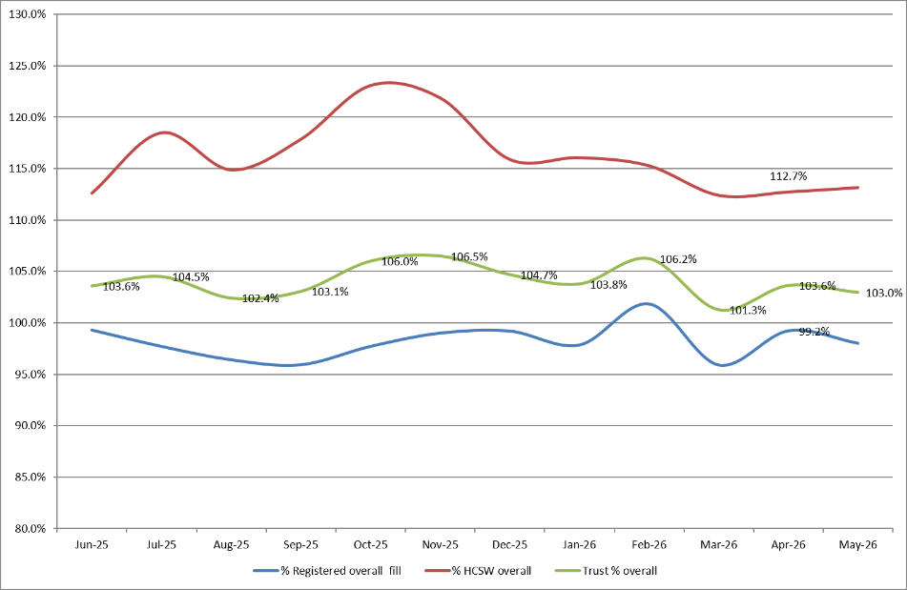
Table 2. Inpatient fill rate inc. Maternity Trend

2.3 Staffing Delivery Against Actual Demand
Analysis of total demand, including additional shifts created to meet increased activity (Appendix 1, Table 1e), demonstrates variation between planned staffing and total demand. While staffing meets the planned template, it reflects increased patient demand beyond planned levels.
This variation reflects responsiveness to increased acuity and enhanced care requirements rather than a failure to meet baseline staffing levels.
2.4 Key Drivers of Workforce Demand
Emergency Departments
Although Emergency Departments are excluded from national safer staffing reporting, local data continues to be reviewed for assurance (Appendix 1, Tables 1B and 1C).
Paediatric Emergency Department has recently reopened following refurbishment, providing an opportunity to review and optimise staffing models. Work is underway to improve alignment between staffing templates and demand and to support more effective workforce deployment.
Enhanced Care
Enhanced care remains a key contributor to workforce demand, with a limited substantive workforce available to meet this activity. As a result, demand is primarily met through temporary staffing, with a continued gap between required and delivered hours. (Appendix 1, Table 1D).
2.5 Workforce Utilisation (CHPPD Context)
Care Hours Per Patient Day (CHPPD) provides a measure of staffing input and supports assessment of workforce utilisation. The Trust reports CHPPD against both national peer comparisons and locally agreed benchmarks, reflecting differences in service configuration and patient population. It should not be used in isolation as a measure of safety.
While CHPPD remains consistent, the Trust continues to sit within the lower quartile when compared to national peers. This does not reflect patient acuity or demand and should be interpreted alongside local data.
When considered with planned staffing and demand indicators, this position is consistent with the variance observed between planned establishment and actual patient need, as outlined in Section 2.3 (Appendix 3).
Table 3. Overall Care Hours Per Patient Day (CHPPD) May 2026
Registered CHPPD | Unregistered CHPPD | Total CHPPD
5.2 | 2.9 | 8.1
Table 4. CHPPD Trend and benchmarking with peer and national data
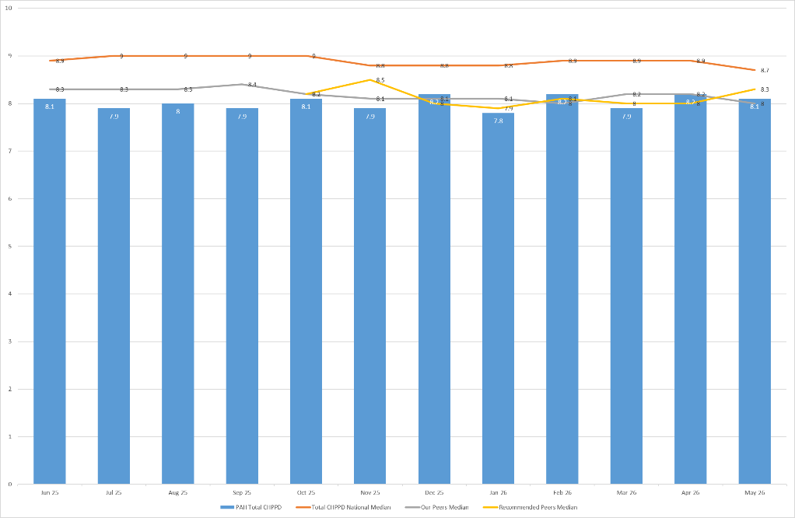
2.6 Variation in Fill Rates
No wards recorded an average fill rate below 75% during May 2026.
A number of areas reported fill rates above 100%, reflecting staffing delivered above planned establishment to respond to increased patient acuity, dependency and enhanced care requirements. This does not indicate overstaffing but reflects necessary operational flexibility.
3.0 Outcomes: Quality and Patient Safety Indicators
Quality indicators for May 2026 demonstrate a stable position overall, with some variation across clinical areas. While there are locally higher levels of activity in specific wards, there is no evidence of sustained deterioration in patient safety indicators at a whole-system level. Continued monitoring is required to ensure that areas experiencing higher demand are appropriately supported (Appendix 5).
3.1 Patient Safety Indicators
Falls activity remains broadly consistent, with variation observed in specific clinical areas. This reflects differences in patient need and case mix rather than a system-wide change in performance.
Pressure ulcer incidence shows a continued improvement compared to previous months, indicating effective prevention and management despite ongoing operational pressures.
3.2 Patient Experience
Patient experience indicators remain stable, with complaints and PALS activity consistent with previous months. Themes relating to delays and communication continue to be reported, reflecting wider system pressures rather than specific concerns regarding staffing levels.
Compliment data is now being recorded more consistently; however, volumes remain low and thematic analysis is not yet established, limiting the ability to draw meaningful insight at this stage.
3.3 Red Flags and Incident reports
Red flag reporting demonstrates a stabilising position, with improved consistency in review and resolution processes at matron level (Appendix 4, table 3a and 3b).
Variation remains in the consistent use of red flag reporting across some areas, and continued focus is required to ensure reporting is embedded and used effectively to support real-time decision making.
Datix reporting relating to staffing and skill mix provides additional context, with incidents reflecting occasions where staffing has not aligned to patient need (Appendix 4, Table 3c). These reports support triangulation of workforce and safety data and are reviewed alongside red flags to inform oversight and escalation where required.
4.0 Professional Judgement
Professional judgement remains central to the day-to-day management of safe staffing, supporting real-time decision making alongside workforce data and patient outcomes. This includes daily staffing huddles, matron review and escalation processes to ensure staffing is responsive to changes in demand and patient need.
4.1 Key Themes Identified
Professional judgement identifies several consistent themes across services:
- Variation between planned staffing and actual demand, requiring ongoing workforce adjustment despite delivery against establishment
- Continued reliance on temporary staffing and redeployment, particularly to support enhanced care activity
- Variation in the consistency and use of red flag reporting across clinical areas
- Workforce pressures within the unregistered workforce, impacting skill mix and flexibility
4.2 Actions and Escalation
In response to these themes, a range of actions continue to support safe staffing:
- Daily review of staffing levels through site management and divisional oversight
- Targeted use of redeployment and temporary staffing to respond to areas of increased demand (Appendix 2)
- Continued focus on strengthening the use of red flag reporting to support real-time decision making
- Ongoing review of staffing models and alignment to demand, including enhanced care and Emergency Departments
Overall, professional judgement supports that staffing aligns with planned establishment, with ongoing operational management ensuring safe care delivery in response to changes in demand.
Appendix 1: Fill Rates
Table 1a: Ward level data – Average fill rates against Standard Template (%) May 2026
 | >100% |  | 95 - 100% |  | 75 - 95% |  | <75%
 |  | Day |  | Night
Ward name |  | registered (%) | Unregistered (%) | registered (%) | Unregistered (%) | % Registered Overall | % Unregistered Overall | % Overall fill rate
Harvey |  | 89.6% | 127.3% | 102.2% | 128.8% | 94.7% | 128.0% | 106.8%
Henry Moore |  | 94.7% | 104.5% | 147.7% | 108.6% | 114.5% | 106.5% | 111.2%
ITU & HDU |  | 91.7% | 94.6% | 97.5% | 80.9% | 94.6% | 88.1% | 94.0%
John Snow |  | 100.1% | 72.4% | 96.8% | 35.9% | 98.5% | 55.1% | 84.0%
Penn |  | 95.3% | 118.6% | 100.8% | 161.8% | 97.7% | 135.0% | 111.0%
Saunders |  | 95.9% | 111.2% | 123.2% | 159.6% | 106.2% | 129.6% | 115.0%
PP Total |  | 93.8% | 109.5% | 108.0% | 122.1% | 100.0% | 115.0% | 104.5%
Fleming |  | 88.3% | 104.5% | 100.0% | 114.5% | 93.3% | 109.3% | 98.2%
Harold |  | 97.0% | 97.4% | 104.8% | 107.4% | 100.5% | 102.2% | 101.0%
Kingsmoor |  | 94.8% | 136.1% | 112.2% | 171.7% | 101.4% | 153.1% | 120.7%
Lister |  | 95.4% | 123.7% | 103.4% | 135.6% | 98.8% | 129.4% | 111.0%
Locke |  | 94.9% | 111.2% | 102.4% | 125.7% | 98.1% | 118.1% | 106.1%
Nightingale |  | 100.6% | 70.3% | 100.1% | 91.1% | 100.4% | 80.3% | 90.3%
Opal |  | 102.3% | 101.2% | 98.4% | 109.6% | 100.4% | 105.2% | 102.3%
Ray |  | 98.1% | 104.6% | 104.0% | 156.9% | 100.6% | 124.4% | 109.2%
Tye Green |  | 89.5% | 113.7% | 97.5% | 142.8% | 93.0% | 125.5% | 105.6%
Winter |  | 92.9% | 120.4% | 100.0% | 128.2% | 95.9% | 124.1% | 107.2%
AAU |  | 89.1% | 121.2% | 103.8% | 143.0% | 95.6% | 131.6% | 103.2%
Charnley |  | 89.6% | 142.4% | 96.0% | 154.7% | 92.7% | 148.3% | 108.6%
IEMP Total |  | 93.6% | 112.9% | 102.1% | 132.5% | 97.3% | 122.0% | 105.9%
Birthing |  | 113.5% | 93.7% | 110.3% | 72.3% | 112.0% | 83.5% | 102.5%
Chamberlen |  | 88.1% | 58.1% | 96.9% | 80.6% | 92.3% | 68.9% | 86.4%
Dolphin |  | 99.4% | 81.2% | 111.3% | 99.4% | 104.7% | 87.3% | 100.3%
Labour |  | 95.3% | 83.9% | 88.1% | 75.4% | 91.9% | 79.8% | 89.2%
Neo-Natal Unit |  | 97.3% | 87.7% | 98.0% | 93.5% | 97.6% | 90.6% | 96.4%
Samson |  | 95.1% | 88.5% | 94.6% | 91.1% | 94.9% | 89.8% | 91.9%
FDC Total |  | 97.1% | 84.0% | 97.9% | 86.2% | 97.4% | 85.0% | 93.7%
Total |  | 94.4% | 106.5% | 102.6% | 121.1% | 98.0% | 113.2% | 103.0%

Table 1b: ED data – Average fill rates against Standard Template (%) May 2026
Average day fill rate - registered | Average day fill rate - care staff | Average night fill rate - registered | Average night fill rate - care staff | % Registered overall fill rate | % HCSW overall fill rate | % Overall fill rate
105.9% | 101.8% | 117.1% | 116.9% | 110.9% | 108.5% | 110.2%
Table 1c: Paediatric ED data – Average fill rates against Standard Template (%) May 2026
Average day fill rate - registered | Average day fill rate - care staff | Average night fill rate - registered | Average night fill rate - care staff | % Registered overall fill rate | % HCSW overall fill rate | % Overall fill rate
111.1% | 66.8% | 141.2% | 88.1% | 124.5% | 77.4% | 110.0%

Table 1d: Enhanced Care Data Demand Vs. Fill Rates May 2026

Registered | Hours
Overall number of ETOC hours provided in month | 371
Number of ETOC hours provided by substantive staff | 0
Number of ETOC hours provided by bank staff | 371
Number of ETOC hours provided by agency staff | 0
Number of unfilled hours for staff relating to ETOC | 127
Unregistered
Overall number of ETOC hours provided in month | 7697
Number of ETOC hours provided by substantive staff | 1004
Number of ETOC hours provided by bank staff | 6693
Number of ETOC hours provided by agency staff | 0
Number of unfilled hours for staff relating to ETOC | 9034

Table 1e: Average Fill Rate % - Standard Template and All Demands with Associated Variances – May 2026

Appendix 2: Redeployment and trend data

Table 1. Hours of substantive staff redeployed May-26
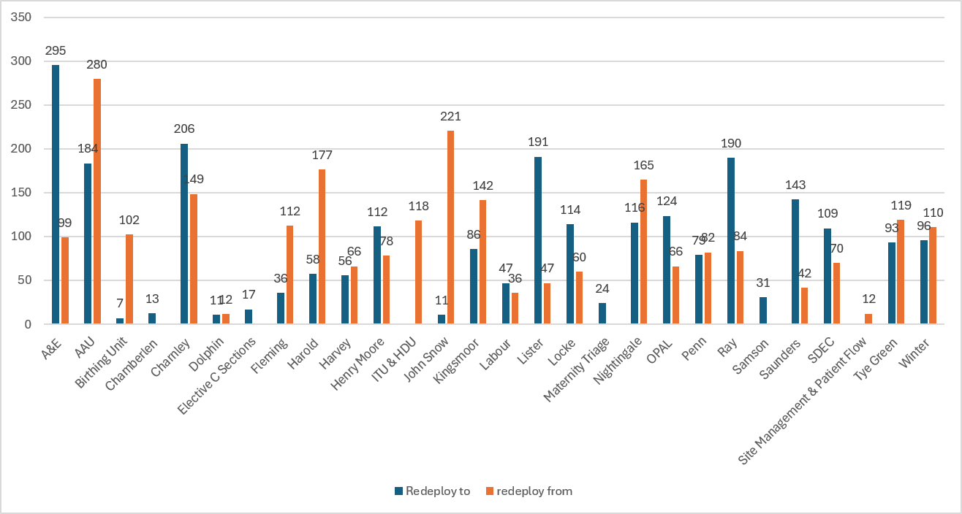

Table 2. Substantive staff redeployment ocasions trend Apr-25 –May-26
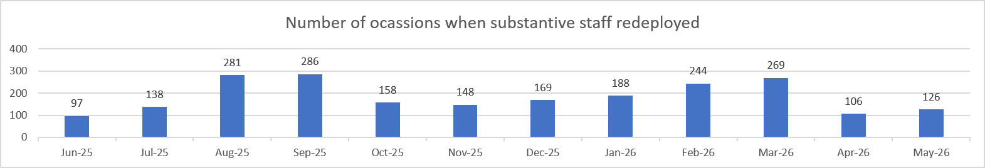

Table 3. % of substantive staff redeployed as % of total hours worked
Substantive staff hours redeployed | Total hours worked (inc. bank and agency) | % of total hours worked / substantive staff redeployed
2207.90 | 143867 | 1.53% (Apr: 1.44%)
Table 4. % of staff redeployed as % of total hours worked
All staff hours redeployed (including bank and agency but excluding Enhanced Care Team, Bank Pool and Rapid Response Pool) | Total hours worked (inc. bank and agency) | % of total hours worked / staff redeployed (including bank and agency but excluding Enhanced Care Team, Bank Pool and Rapid Response Pool)
2444.90 | 143867 | 1.69% (Apr: 1.53%)

Appendix 3: CHPPD

Table 1. Ward level data: CHPPD May 2026
Care Hours Per Patient Day (CHPPD)
Ward/Unit | Registered Nurses/Midwives | Non-registered Nurses/Midwives | Overall
Trust Total | 5.2 | 2.9 | 8.1
Harvey | 3.9 | 3.0 | 6.8
Henry Moore | 4.4 | 2.9 | 7.3
ITU & HDU | 26.4 | 2.5 | 28.9
John Snow | 5.8 | 1.6 | 7.4
Penn | 3.7 | 2.8 | 6.5
Saunders | 3.8 | 2.8 | 6.6
Planned Pathways Total | 5.7 | 2.8 | 8.4
Fleming | 3.8 | 2.0 | 5.7
Harold | 4.8 | 2.3 | 7.1
Kingsmoor | 3.7 | 3.3 | 7.0
Lister | 3.7 | 3.3 | 7.0
Locke | 3.7 | 2.9 | 6.6
Nightingale | 4.0 | 3.2 | 7.2
Opal | 4.9 | 3.4 | 8.4
Ray | 3.8 | 2.6 | 6.4
Tye Green | 3.9 | 3.4 | 7.3
Winter | 3.6 | 3.1 | 6.7
AAU | 6.1 | 2.2 | 8.3
Charnley | 4.1 | 2.6 | 6.7
Integrated Emergency and Medical Pathways Total | 4.2 | 2.8 | 7.0
Birthing Unit | 20.7 | 7.7 | 28.5
Chamberlen | 6.3 | 1.6 | 7.9
Dolphin | 13.4 | 3.7 | 17.2
Labour | 22.0 | 5.5 | 27.5
Neo-Natal | 10.9 | 2.0 | 12.9
Samson | 3.9 | 4.9 | 8.7
Family, Diagnostics and community Total | 10.1 | 3.8 | 13.8

Appendix 4. Nursing Red Flags (NICE 2014), Incident Reports and
Trend Data

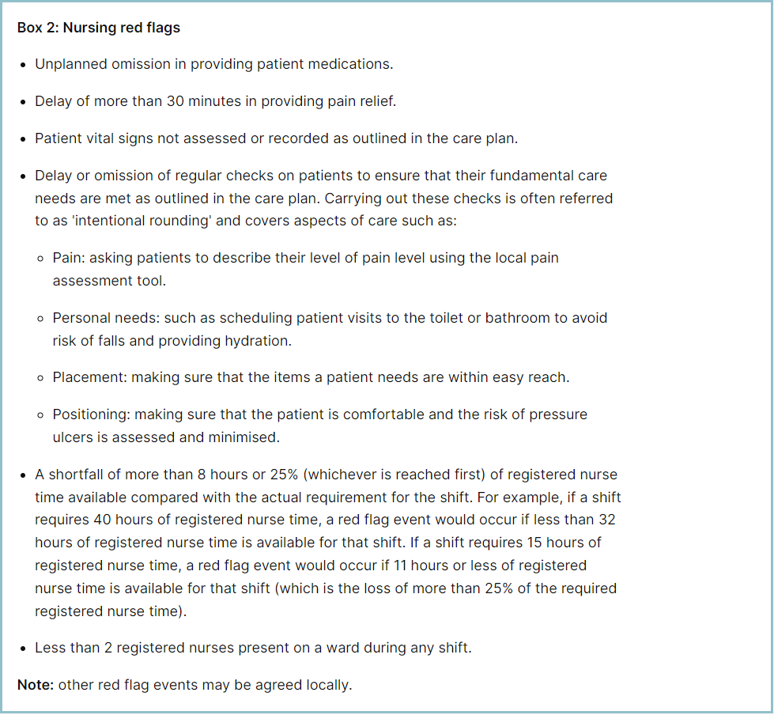 Table 1. Occasions registered staffing fell below 75% of standard template – May 2026
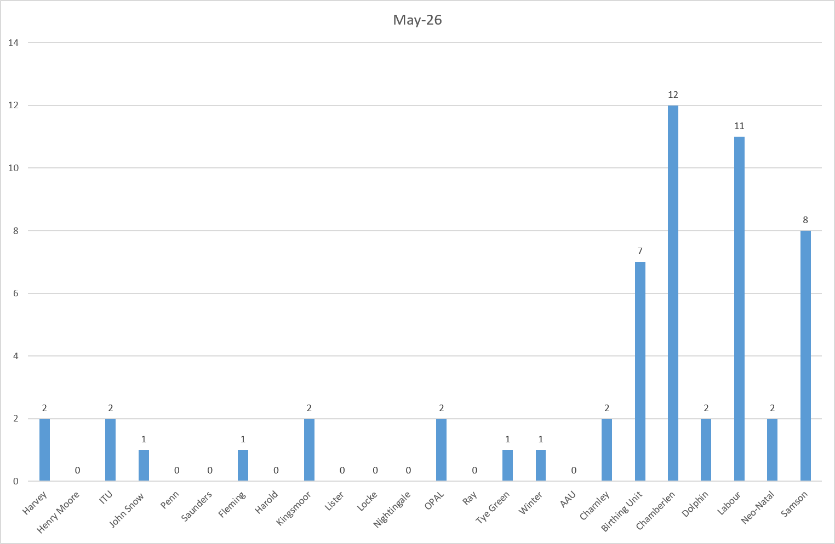
Table 2a. Occasions when registered staffing fell below 75% of standard template. Trend Data Jun-25 –May-26

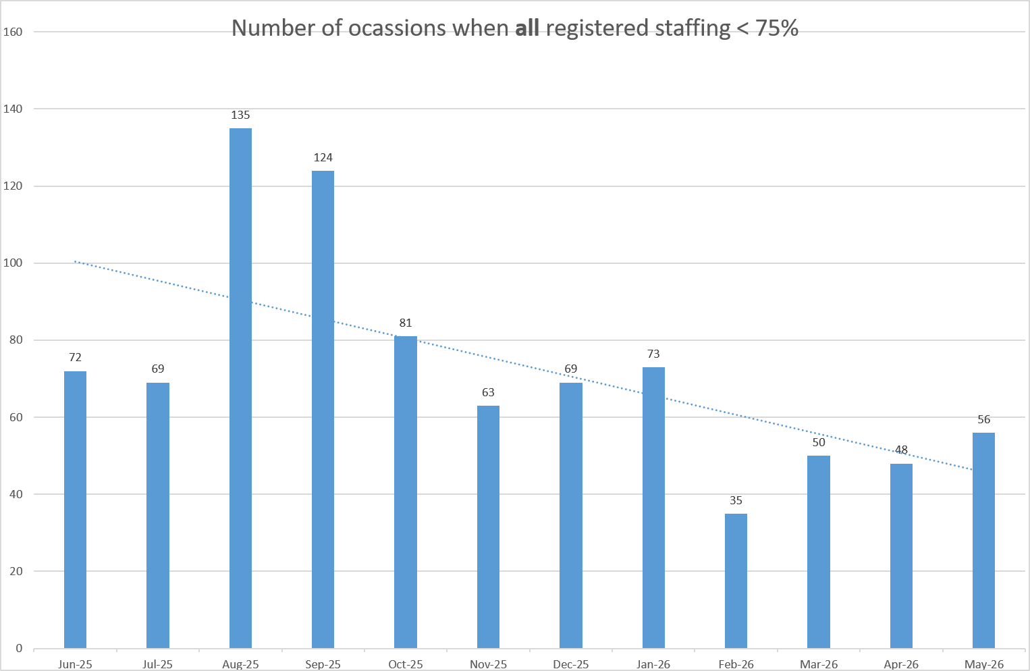
Table 2b. Occasions when registered maternity staffing fell below 75% of standard template. Trend Data Jun-25 – May-26

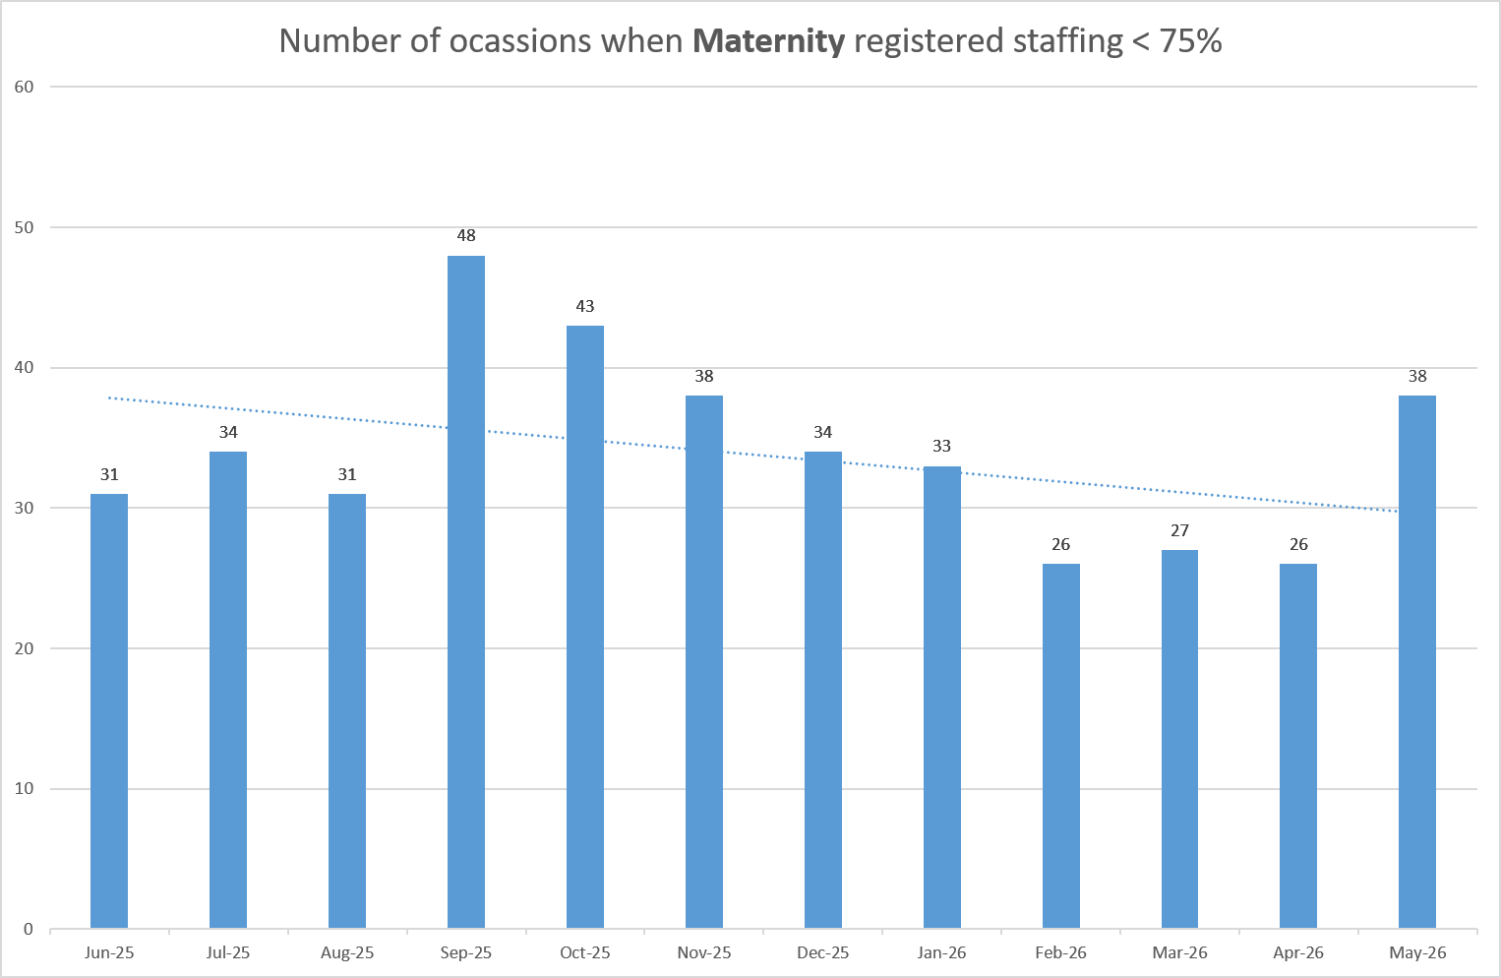
Table 3a. Red Flags raised via SafeCare May-26

Table 3b. Red Flags raised via SafeCare trend Jun-25 – May-26

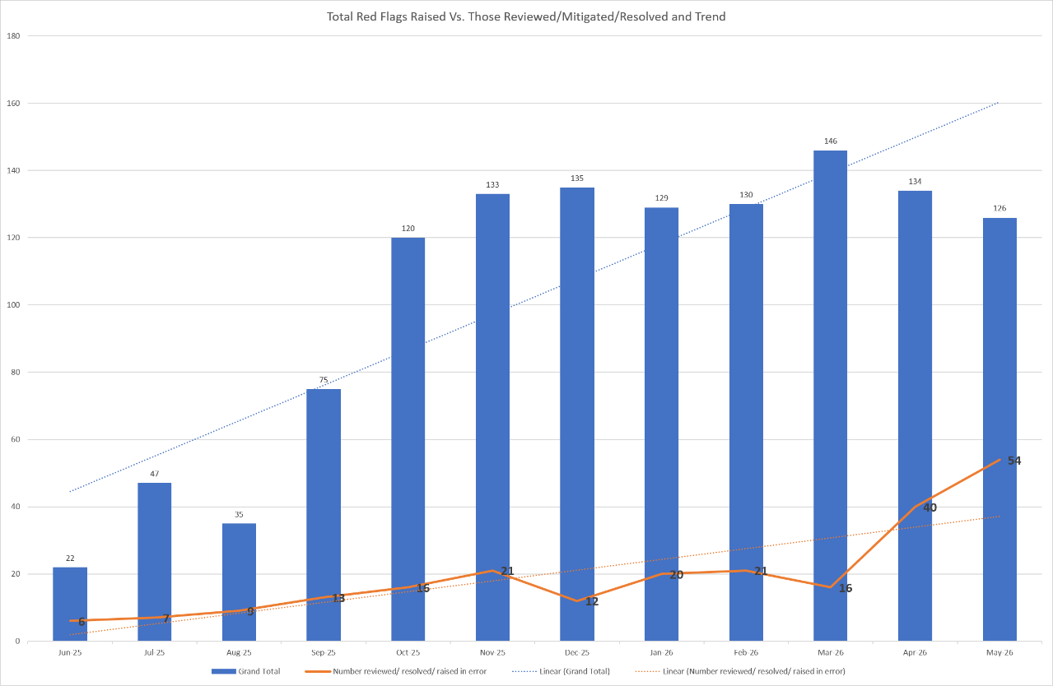

Table 3c. Datix for lack of suitably trained / skilled staff Jun-25 – May-26

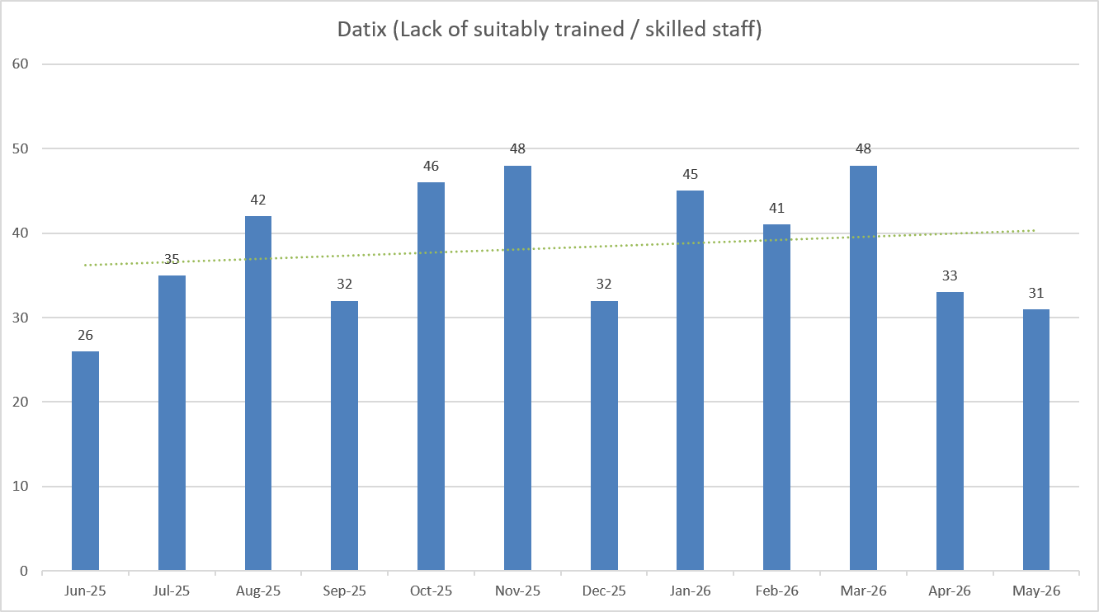

Appendix 5: Nursing quality indicators

Falls

Table 1. Number of falls and categories in May 2026, with the top 3 wards highlighted.
 | Total falls in month | Top 3 wards
Total falls | 90 | Winter – 14 | AAU – 9 | Charnley – 8
Unwitnessed falls | 63 | Winter – 9 | Charnley – 7 | AAU – 6
Falls with harm * | 19 | Winter – 4 | Henry Moore – 3 | AAU – 2
*Subject to change following review at Falls Incident Oversight Group

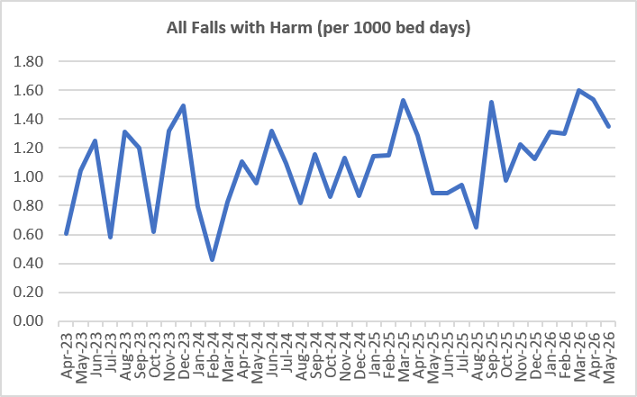

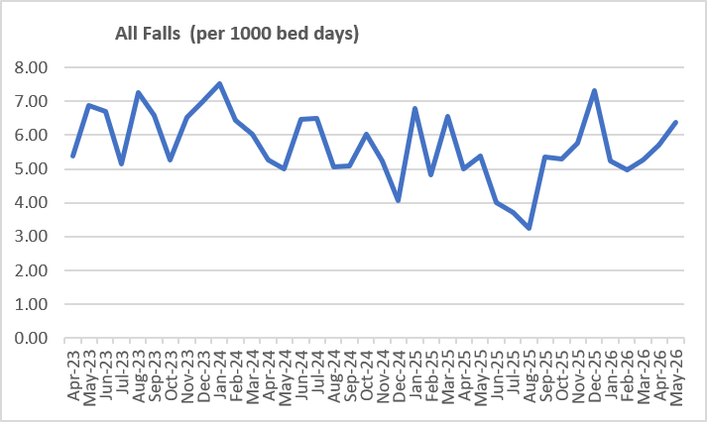
Falls Rate per 1000 bed days May 2026

Pressure Ulcers

Table 2: Number of Hospital Acquired Pressure Ulcers (HAPU)
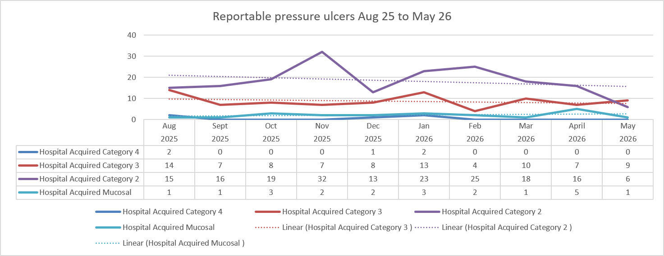

 | Total in month | Top Departments
Total skin changes | 70 | ITU & HDU – 13 |  | Tye Green – 9 | Winter – 8
Reportable HAPU’s | 16 | Ray & Winter - 3 | Henry Moore, ITU/HDU, Lister, Saunders and Tye Green - 2

Complaints, PALS and Compliments Trend Data Jun-25 – May-26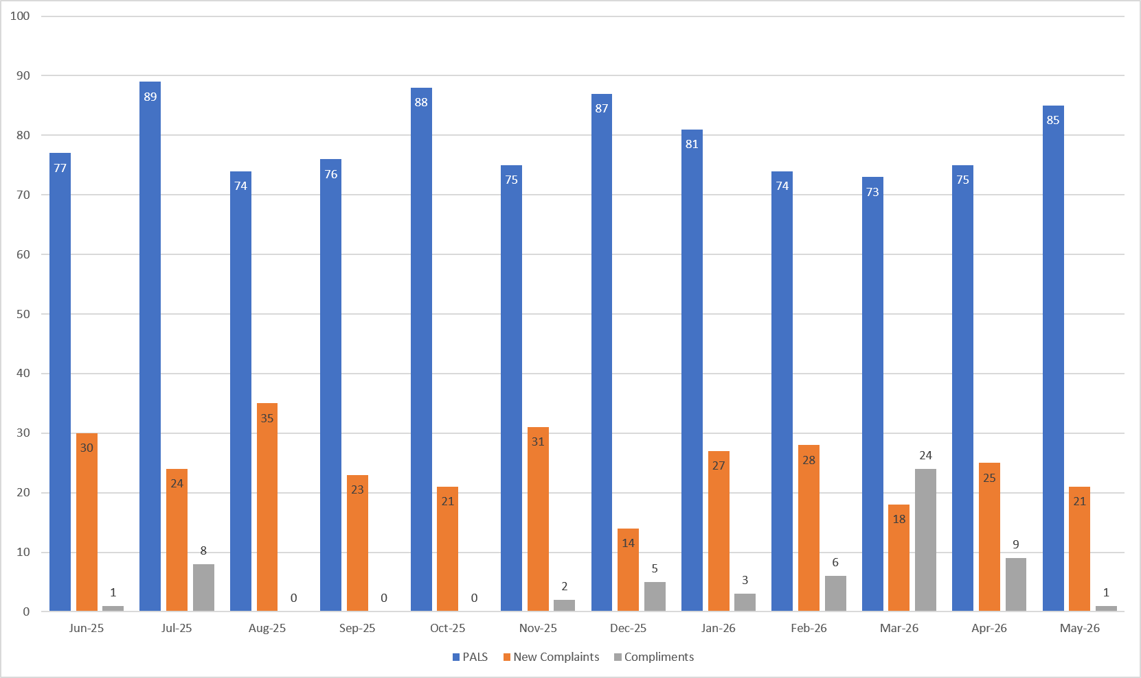

Table 3. Number of new Complaints, PALS and Compliments in May 2026 with top three wards highlighted
 | Total in month | Top Departments
New complaints | 21 | A&E – 3 | Labour, Henry Moore, Theatres – 2
PALs | 85 | A&E – 19 | Nightingale – 8 | Kingsmoor – 7
Compliments | 1 | Harvey – 1

Complaints: main themes: Communications – 22.94%, Medical care – 17.75%, Nursing care – 14.68%, Delay – 14.68%

PALS: main themes: Delay – 37.43%, Communication – 27.3%, Appointments – 10.95%
Compliments: themes not provided.

Table 4: Nursing and Midwifery Staffing and Quality data Triangulation – May 2026

