Meeting Title
Date Agenda item:
Report Title: Safer Staffing Monthly Report – July 2026
Presented by: Jo Ward – Interim Chief Nurse
Prepared by: Charlotte Collings – Lead Nurse for Safer Staffing and Workforce
Purpose: (please tick) | Approval/Decision |  |  | Information/Assurance |  |  | √
Executive Summary
Overall, nursing and midwifery staffing remains stable, with workforce, quality and staffing indicators providing assurance that safe care is being maintained across the Trust. Redeployment continues to be used to manage operational pressures and fluctuating demand, with no significant concerns identified through quality or patient safety metrics. While some workforce challenges remain, the data does not indicate any deterioration in the overall staffing position.
Risks and Issues (including links to BAF/Corporate Risk Register/Other risk registers)
BAF: 2.3 Workforce capacity

Recommendation
The Committee is asked to:
- Note the information of the July 2026 safer staffing report.

Strategic Objectives
 |  |  |  |  |  | 
√ |  | √ |  |  |  | √
Relevant legal/statutory issues
National Quality Board (NQB) Supporting NHS providers to deliver the right staff, with the right skills, in the right place at the right time; NHS Improvement Developing Workforce Safeguards; NHS England safe staffing guidance; NIHR Professional Judgement Framework: A guide to applying professional judgement in nurse staffing reviews
Impact Assessments
Quality |  |  |  |  | Positive impact through continued assurance of safe staffing and workforce planning.
Equality, Diversity and Inclusion |  |  |  |  | No adverse equality impacts identified.
Health inequalities |  |  |  |  | No direct impact identified.
Previously Considered By |  |  |  |  | N/A
Appendices |  |  |  |  | Appendix 1: Fill Rates  Appendix 2: Redeployment and trend data  Appendix 3: CHPPD  Appendix 4. Nursing Red Flags (NICE 2014), Incident Reports and Trend Data  Appendix 5: Nursing quality indicators

1.0 Introduction
This report outlines nursing and midwifery staffing across the Trust and has been prepared in accordance with National Quality Board (NQB) Guidance and NHS England's Developing Workforce Safeguards (DWS). The report presents workforce, staffing and quality indicators, together with professional judgement, to support oversight of safe staffing and inform any actions required in response to identified risks or pressures
2.0 Evidence-Based Data: Workforce and Demand
2.1 Workforce Supply
Vacancies continue to be present across a number of staff groups, although the registered nursing vacancy rate reduced during July. Vacancy rates at month-end were 6.79% for registered nurses, 0% for registered midwives and 13.80% for healthcare and maternity support workers.
Workforce gaps continue to be managed through a combination of temporary staffing, workforce flexibility and redeployment to support safe staffing levels and respond to fluctuations in patient demand. (Appendix 5, Table 4).
Planned recruitment of newly qualified nurses later in the year is expected to strengthen the registered nursing workforce, with preceptorship arrangements and workforce planning supporting the transition into practice.
2.2 Staffing Delivery Against Planned Establishment
Overall staffing delivery remained stable during July, with an overall fill rate of 101.4%. A small number of clinical areas fell below the 75% registered staffing threshold on occasion, most notably Birthing Unit and Nightingale Ward. These results should be considered within the context of operational service changes, including temporary ward closures, redeployment of staff and subsequent reopening of services in response to demand. (Appendix 1, Table 1a).
During July, OPAL implemented a revised staffing model to support frailty assessment and patient flow, increasing registered nurse staffing during the day and reducing it overnight, as a trial. This has resulted in lower night fill rates and an increase in occasions where registered staffing fell below the 75% threshold and should be considered when interpreting the data.
Fill rates are measured against planned staffing templates and provide only one measure of staffing delivery. They should be considered alongside patient acuity, dependency, enhanced care requirements and professional judgement when assessing whether staffing levels remain safe and effective.
Table 1. Overall fill rate
Average day fill rate – registered | Average day fill rate - care staff | Average night fill rate - registered | Average night fill rate - care staff | % Registered overall fill rate | % HCSW overall fill rate | % Overall fill rate
96.1% | 102.0% | 97.7% | 121.9% | 96.8% | 111.1% | 101.4%

Table 2. Inpatient fill rate inc. Maternity Trend

2.3 Staffing Delivery Against Actual Demand
Actual demand varied throughout July and reflects not only planned staffing establishments, but also additional duties required to support patient care. For areas using SafeCare, patient acuity and dependency data provides additional insight into workforce requirements. Variances between planned establishment and actual demand are often driven by additional staffing requirements, including enhanced care and other patient-specific needs, which sit outside the standard staffing template. Actual demand should therefore be considered alongside fill rates, quality indicators and professional judgement when assessing staffing effectiveness and workforce deployment (Appendix 1, Table 1e). Weekly scrutiny of additional duties has provided assurance that the majority continue to reflect identified patient need, particularly enhanced care requirements, whilst supporting the identification and correction of duties created outside agreed staffing templates in real time with the e-Rostering team.
2.4 Key Drivers of Workforce Demand
Emergency Departments
Although Emergency Departments are excluded from national safer staffing reporting, local staffing data continues to be reviewed for assurance (Appendix 1, Tables 1B and 1C).
Adult Emergency Department remained the largest recipient of redeployed staff during July, reflecting ongoing demand associated with ambulance cohort areas and patient flow. Workforce pressures continued to be managed through local escalation processes and workforce flexibility, including redeployment where required. Recruitment to recently approved additional substantive nursing posts for the ambulance cohort areas is now underway and is expected to strengthen staffing capacity during the autumn.

Within Children's Emergency Department, a revised shift pattern has recently been introduced to increase staffing availability during periods of peak demand, as per SNCT recommendations. The effectiveness of this approach, alongside future workforce requirements, will be considered as part of the forthcoming SNCT review in September.
Enhanced Care
Enhanced care continued to be a significant driver of workforce demand during July, with additional staffing required to support patients requiring enhanced observation and specialist care. Enhanced care requirements are reviewed through daily staffing huddles, SafeCare reporting, matron verification, red flag monitoring and professional judgement to support workforce planning, deployment and escalation where required.
Alongside operational oversight, work has continued to strengthen the consistency of enhanced care assessments through targeted education and training. This has included refresher training on SNCT levels of care, enhanced care requirements and the role of senior nurses in safer staffing decision-making. A monthly multidisciplinary enhanced care study day for registered and unregistered nursing staff will commence in October, supporting a consistent approach to the assessment, planning and delivery of enhanced care, whilst improving the accuracy and consistency of recording enhanced care requirements across the Trust (Appendix 1, Table 1D).
2.5 Workforce Utilisation (CHPPD Context)
Care Hours Per Patient Day (CHPPD) provides an indication of workforce utilisation and is reported against both national benchmarking and locally agreed expectations. During July, Trust CHPPD remained broadly stable (Appendix 3).
Model Hospital benchmarking continues to demonstrate a workforce profile with proportionally higher registered nursing hours and lower support worker hours when compared to some peer organisations. As CHPPD does not account for patient acuity, dependency, enhanced care requirements or ward configuration, it should be considered alongside workforce, demand, quality and professional judgement indicators when assessing staffing effectiveness and patient safety (Table 3).
Table 3. Overall Care Hours Per Patient Day (CHPPD) July 2026
Registered CHPPD | Unregistered CHPPD | Total CHPPD
5.1 | 2.8 | 8.0
3.0 Outcomes: Quality and Patient Safety Indicators
Quality and patient safety indicators remained broadly stable during July 2026. Whilst variation was observed across individual measures, triangulation of workforce, patient safety and patient experience data has not identified a consistent pattern to suggest staffing pressures are adversely impacting patient outcomes. Falls resulting in harm and overall skin changes reduced during the month, although a small increase in reportable pressure ulcers was observed. Continued monitoring is undertaken to identify emerging themes and ensure areas experiencing higher demand remain appropriately supported (Appendices 4 and 5).
3.1 Patient Safety Indicators
Falls activity reduced during July, with reductions seen in both overall falls and falls resulting in harm. Total skin changes also reduced compared to the previous month, although a small increase in reportable hospital-acquired pressure ulcers was observed. Overall, patient safety indicators do not demonstrate a consistent pattern of deterioration and continue to be reviewed alongside workforce and staffing data.
3.2 Patient Experience
Patient experience themes remained broadly consistent during July, with delays and communication continuing to account for the majority of complaints and PALS contacts. These indicators continue to be reviewed alongside workforce, patient safety and staffing data to support identification of any emerging themes or areas requiring additional support (Appendix 5).
3.3 Red Flags and Incident reports
Red flag reporting continues to support real-time oversight of staffing and patient care. Whilst utilisation remains variable across some clinical areas, red flags are routinely reviewed through daily staffing huddles and inform operational decision-making regarding workforce deployment, escalation and mitigation where required. A proportion of the increase in occasions where registered staffing fell below the 75% threshold relates to the revised staffing model within OPAL, which increased registered nurse staffing during the day to support frailty assessment and patient flow and should therefore be considered when interpreting red flag trends. (Appendix 4, Tables 3a and 3b)
Staffing-related incident reports continue to provide additional context when triangulating workforce and quality indicators. No organisation-wide themes were identified during July and, recognising that incident reporting is influenced by local reporting practices, these data continue to be reviewed alongside red flags, workforce and quality metrics to support a comprehensive assessment of staffing-related risks and patient outcomes. (Appendix 4 and 5).
4.0 Professional Judgement
Professional judgement continues to play a key role in safe staffing decision-making. Daily staffing huddles, matron oversight, red flag reviews and escalation processes are used alongside workforce, demand and quality indicators to support staff deployment and respond to changes in patient need and service pressures.
4.1 Key Themes Identified
Professional judgement identifies several consistent themes across services:
- Variations between planned staffing establishments and actual demand continue to be influenced by patient acuity, dependency, enhanced care requirements and other patient-specific needs.
- Workforce flexibility, including redeployment and temporary staffing, remains an important mechanism for responding to fluctuations in demand and maintaining safe staffing levels (Appendix 2).
- Enhanced care continues to be a significant driver of workforce demand across inpatient services.
- Staffing governance processes continue to mature through the use of SafeCare, red flag reporting, daily staffing huddles and professional oversight.
- Workforce vacancies remain most evident within healthcare and maternity support worker roles, although overall workforce supply remains stable, with improvement seen in registered nursing vacancies.
4.2 Actions and Escalation
In response to these themes, a range of actions continue to support safe staffing:
- Daily review of staffing levels through Trust-wide staffing huddles and divisional oversight.
- Targeted use of redeployment and temporary staffing to respond to changes in patient acuity, dependency and demand (Appendix 2).
- Ongoing review of enhanced care requirements through SafeCare, professional judgement and escalation processes.
- Continued scrutiny of additional duties to support appropriate workforce utilisation and oversight of demand.
- Delivery of safer staffing education to support consistent application of levels of care descriptors, escalation processes and reporting arrangements.
- Refresher training for staff undertaking SNCT reviews in preparation for the September 2026 data collection, which will inform the year-end establishment review.
- Implementation of a revised daily staffing huddle record to strengthen governance, improve visibility of staffing decisions and support consistency in escalation and mitigation processes.
Overall, professional judgement supports that staffing remained responsive to patient need during July, with workforce, quality and demand indicators continuing to provide assurance that safe care was maintained across the Trust.
5.0 Overall Interpretation
Triangulation of workforce, demand, quality and professional judgement indicators provides assurance that safe care was maintained throughout July 2026. Workforce supply remained stable, with a reduction in registered nursing vacancies, whilst staffing delivery continued to meet planned establishment overall.
Enhanced care continued to be the most significant driver of additional workforce demand, with workforce flexibility, redeployment and operational staffing processes supporting services in responding to changing patient need. Quality, patient experience, incident and red flag data have not identified a consistent pattern suggesting staffing levels adversely impacted patient outcomes during the reporting period.
Preparations are underway for the September 2026 SNCT data collection, which will contribute to the Trust's year-end establishment review and provide a further opportunity to assess whether nursing and midwifery establishments remain aligned to patient demand. Overall, the available evidence provides assurance that nursing and midwifery staffing remained safe and effective throughout July 2026.

Appendix 1: Fill Rates
Table 1a: Ward level data – Average fill rates against Standard Template (%) July 2026
 | >100% |  | 95 - 100% |  | 75 - 95% |  | <75%
 |  | Day |  | Night
Ward name |  | registered (%) | Unregistered (%) | registered (%) | Unregistered (%) | % Registered Overall | % Unregistered Overall | % Overall fill rate
Harvey |  | 96.9% | 126.6% | 132.3% | 119.2% | 111.3% | 123.1% | 115.6%
Henry Moore |  | 97.0% | 91.7% | 97.4% | 99.3% | 97.2% | 95.4% | 96.5%
ITU & HDU |  | 88.9% | 71.4% | 91.8% | 90.3% | 90.3% | 80.9% | 89.5%
John Snow |  | 101.1% | 73.3% | 100.0% | 49.6% | 100.6% | 61.9% | 87.7%
Penn |  | 93.8% | 128.9% | 97.6% | 170.3% | 95.4% | 144.6% | 113.0%
Saunders |  | 90.7% | 115.1% | 100.0% | 154.8% | 94.7% | 130.1% | 107.4%
PP Total |  | 93.2% | 108.2% | 99.6% | 120.5% | 96.1% | 113.6% | 101.2%
Fleming |  | 88.5% | 92.1% | 100.8% | 99.9% | 93.7% | 95.8% | 94.3%
Harold |  | 92.2% | 90.0% | 100.5% | 103.2% | 95.8% | 96.3% | 96.0%
Kingsmoor |  | 93.8% | 128.4% | 103.6% | 145.7% | 97.5% | 136.7% | 112.1%
Lister |  | 97.4% | 110.5% | 99.3% | 133.3% | 98.2% | 121.4% | 107.4%
Locke |  | 92.8% | 111.8% | 100.9% | 142.6% | 96.2% | 126.5% | 108.3%
Nightingale |  | 98.6% | 61.5% | 100.2% | 92.7% | 99.4% | 76.5% | 87.9%
Opal |  | 123.0% | 93.8% | 74.6% | 124.0% | 99.8% | 108.3% | 103.2%
Ray |  | 107.9% | 116.4% | 120.2% | 178.4% | 113.1% | 140.0% | 122.7%
Tye Green |  | 91.2% | 118.0% | 94.5% | 157.4% | 92.6% | 134.1% | 108.7%
Winter |  | 98.7% | 112.5% | 99.9% | 137.5% | 99.2% | 124.4% | 109.3%
AAU |  | 86.0% | 114.7% | 95.9% | 134.7% | 90.4% | 124.3% | 97.5%
Charnley |  | 95.9% | 118.0% | 93.6% | 155.6% | 94.8% | 136.0% | 106.6%
IEMP Total |  | 95.4% | 107.5% | 98.8% | 134.3% | 96.9% | 119.9% | 105.0%
Birthing |  | 83.5% | 78.4% | 81.5% | 85.5% | 82.6% | 81.8% | 82.3%
Chamberlen |  | 96.7% | 77.0% | 92.7% | 87.1% | 94.8% | 81.8% | 91.5%
Dolphin |  | 92.3% | 66.0% | 90.6% | 86.3% | 91.5% | 72.7% | 86.8%
Labour |  | 122.7% | 71.3% | 92.4% | 78.7% | 108.2% | 74.9% | 100.8%
Neo-Natal Unit |  | 90.2% | 86.8% | 96.1% | 80.2% | 93.2% | 83.5% | 91.6%
Samson |  | 100.3% | 86.0% | 100.0% | 91.9% | 100.1% | 88.8% | 93.7%
FDC Total |  | 101.3% | 78.3% | 93.0% | 86.4% | 97.3% | 82.0% | 92.7%
Total |  | 95.3% | 103.5% | 99.3% | 122.3% | 97.1% | 112.1% | 102.0%

Table 1b: ED data – Average fill rates against Standard Template (%) July 2026
Average day fill rate - registered | Average day fill rate - care staff | Average night fill rate - registered | Average night fill rate - care staff | % Registered overall fill rate | % HCSW overall fill rate | % Overall fill rate
105.1% | 87.8% | 114.3% | 112.0% | 109.2% | 98.6% | 105.8%
Table 1c: Childrens ED data – Average fill rates against Standard Template (%) July 2026
Average day fill rate - registered | Average day fill rate - care staff | Average night fill rate - registered | Average night fill rate - care staff | % Registered overall fill rate | % HCSW overall fill rate | % Overall fill rate
100.8% | 40.5% | 120.9% | 88.6% | 109.7% | 64.6% | 95.8%

Table 1d: Enhanced Care Data Demand Vs. Fill Rates July 2026

Registered | Hours
Overall number of ETOC hours provided in month | 1168
Number of ETOC hours provided by substantive staff | 0
Number of ETOC hours provided by bank staff | 1168
Number of ETOC hours provided by agency staff | 0
Number of unfilled hours for staff relating to ETOC | 4119
Unregistered
Overall number of ETOC hours provided in month | 7107
Number of ETOC hours provided by substantive staff | 1019
Number of ETOC hours provided by bank staff | 6088
Number of ETOC hours provided by agency staff | 0
Number of unfilled hours for staff relating to ETOC | 23342

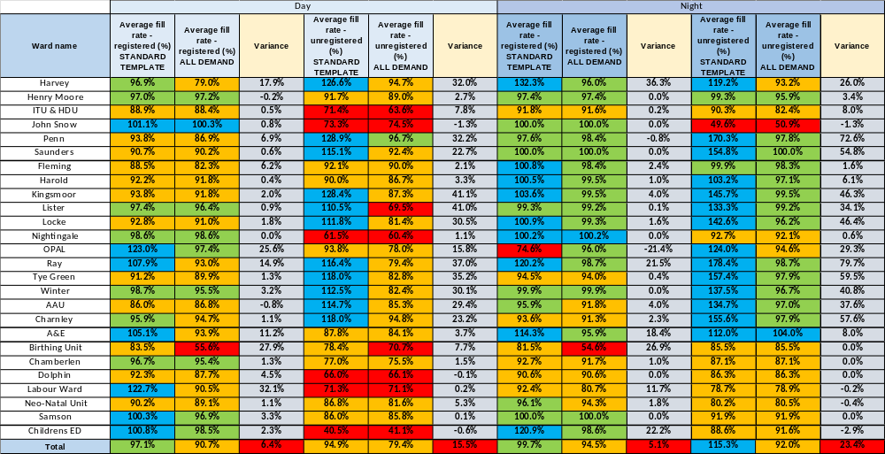
Table 1e: Average Fill Rate % - Standard Template and All Demands with Associated Variances – July 2026

Appendix 2: Redeployment and trend data
Table 1. Hours of substantive staff redeployed Jul-26

Table 2. Substantive staff redeployment ocasions trend

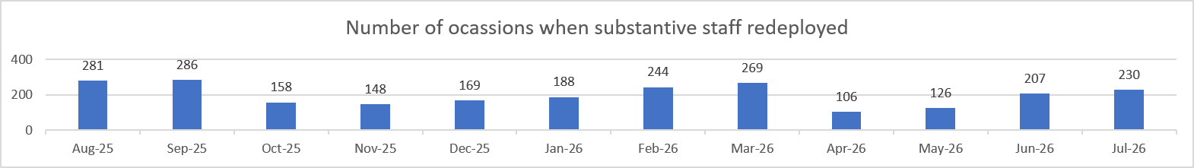

Table 3. % of substantive staff redeployed as % of total hours worked
Substantive staff hours redeployed | Total hours worked (inc. bank and agency) | % of total hours worked / substantive staff redeployed
3264.51 | 141517 | 2.31% (Jun: 2.29%)
Table 4. % of staff redeployed as % of total hours worked
All staff hours redeployed (including bank and agency but excluding Enhanced Care Team, Bank Pool and Rapid Response Pool) | Total hours worked (inc. bank and agency) | % of total hours worked / staff redeployed (including bank and agency but excluding Enhanced Care Team, Bank Pool and Rapid Response Pool)
3540.86 | 141517 | 2.50% (Jun: 2.44%)

Appendix 3: CHPPD
Table 1. Ward level data: CHPPD July 2026
Care Hours Per Patient Day (CHPPD)
Ward/Unit | Registered Nurses/Midwives | Non-registered Nurses/Midwives | Overall
Trust Total | 5.1 | 2.8 | 8.0
Harvey | 4.6 | 2.9 | 7.4
Henry Moore | 4.4 | 2.6 | 7.0
ITU & HDU | 24.5 | 2.2 | 26.7
John Snow | 5.1 | 1.6 | 6.6
Penn | 3.6 | 3.1 | 6.7
Saunders | 3.7 | 2.8 | 6.5
Planned Pathways Total | 5.6 | 2.7 | 8.3
Fleming | 3.8 | 1.7 | 5.5
Harold | 4.6 | 2.1 | 6.8
Kingsmoor | 3.6 | 3.0 | 6.5
Lister | 3.7 | 3.1 | 6.8
Locke | 3.6 | 3.2 | 6.8
Nightingale | 2.9 | 2.2 | 5.2
Opal | 4.7 | 3.4 | 8.0
Ray | 4.3 | 3.0 | 7.2
Tye Green | 4.0 | 3.7 | 7.7
Winter | 3.7 | 3.1 | 6.8
AAU | 5.9 | 2.1 | 8.0
Charnley | 4.2 | 2.4 | 6.5
Integrated Emergency and Medical Pathways Total | 4.1 | 2.7 | 6.8
Birthing Unit | 7.6 | 3.8 | 11.4
Chamberlen | 7.9 | 2.3 | 10.2
Dolphin | 11.8 | 3.1 | 14.9
Labour | 34.0 | 6.7 | 40.7
Neo-Natal | 9.9 | 1.8 | 11.7
Samson | 4.3 | 5.1 | 9.5
Family, Diagnostics and community Total | 10.3 | 3.7 | 14.0

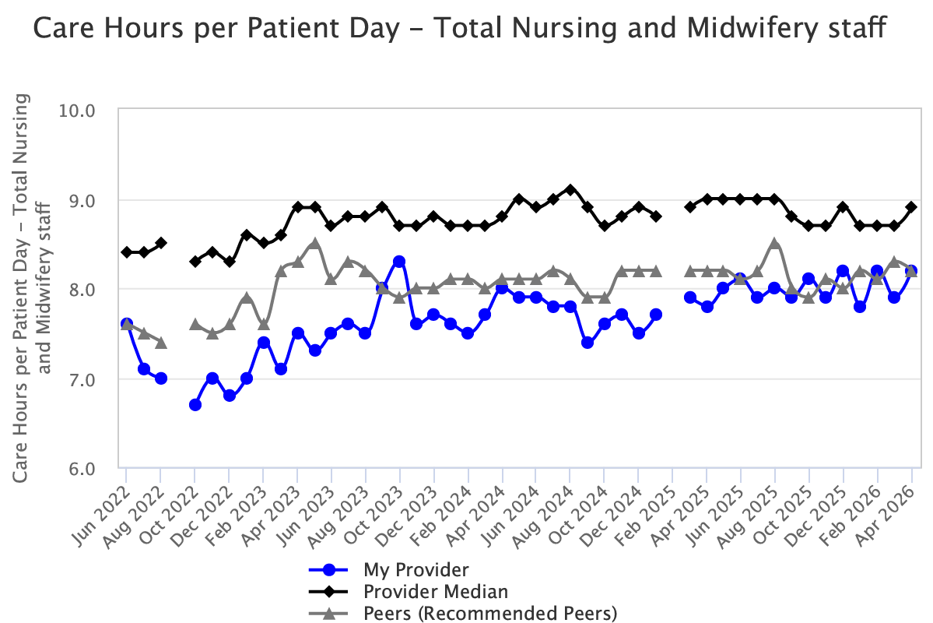
Table 2 – Total CHPPD trend Nursing and Midwifery Staff

Appendix 4. Nursing Red Flags (NICE 2014), Incident Reports and

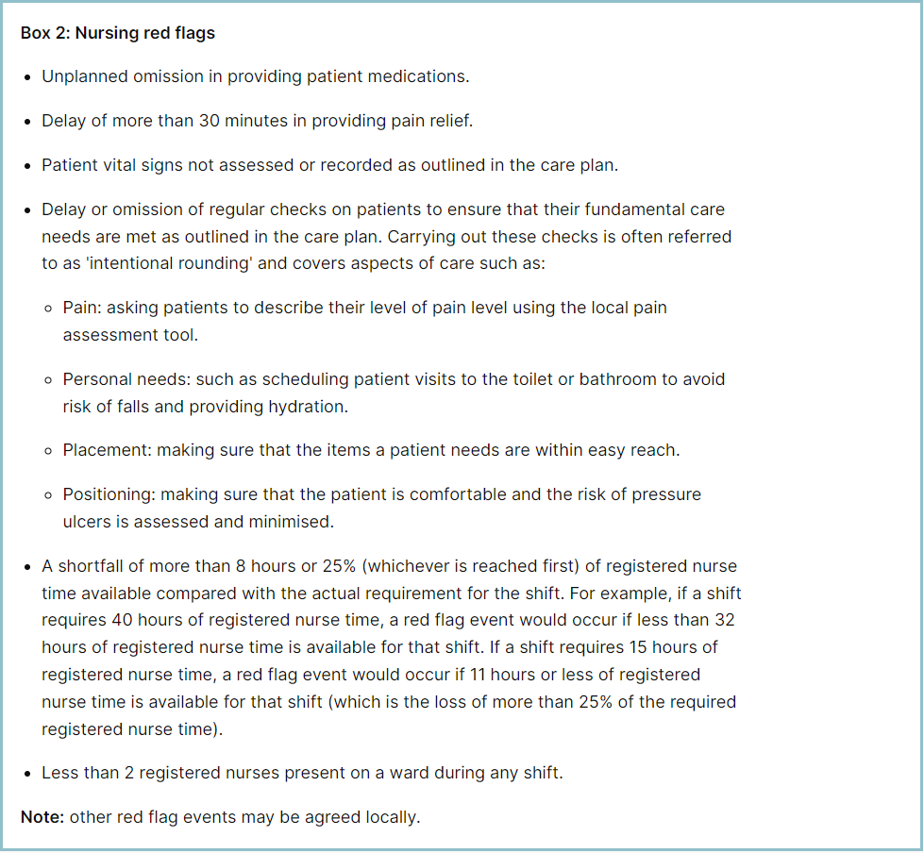 Table 1. Occasions registered staffing fell below 75% of standard template – July 2026
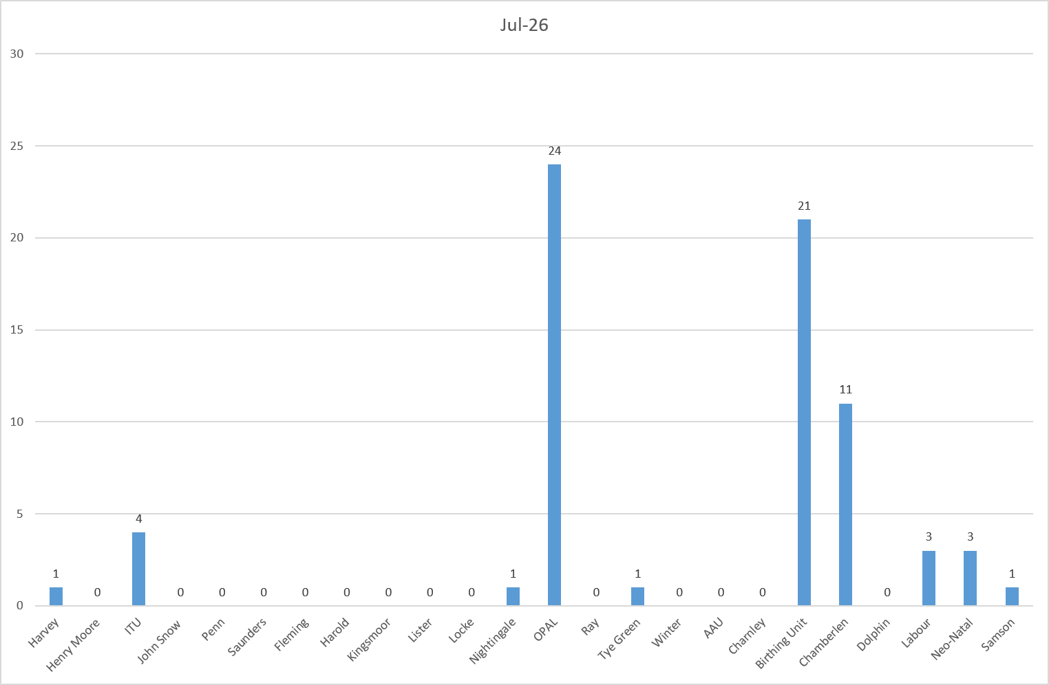
Table 2a. Occasions when registered staffing fell below 75% of standard template. Trend Data Aug-25 –Jul-26
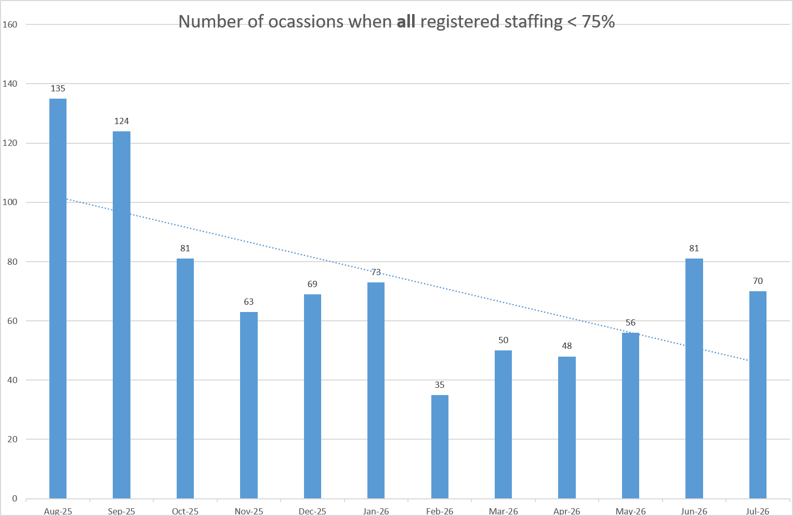
Table 2b. Occasions when registered maternity staffing fell below 75% of standard template. Trend Data Aug-25 –Jul-26
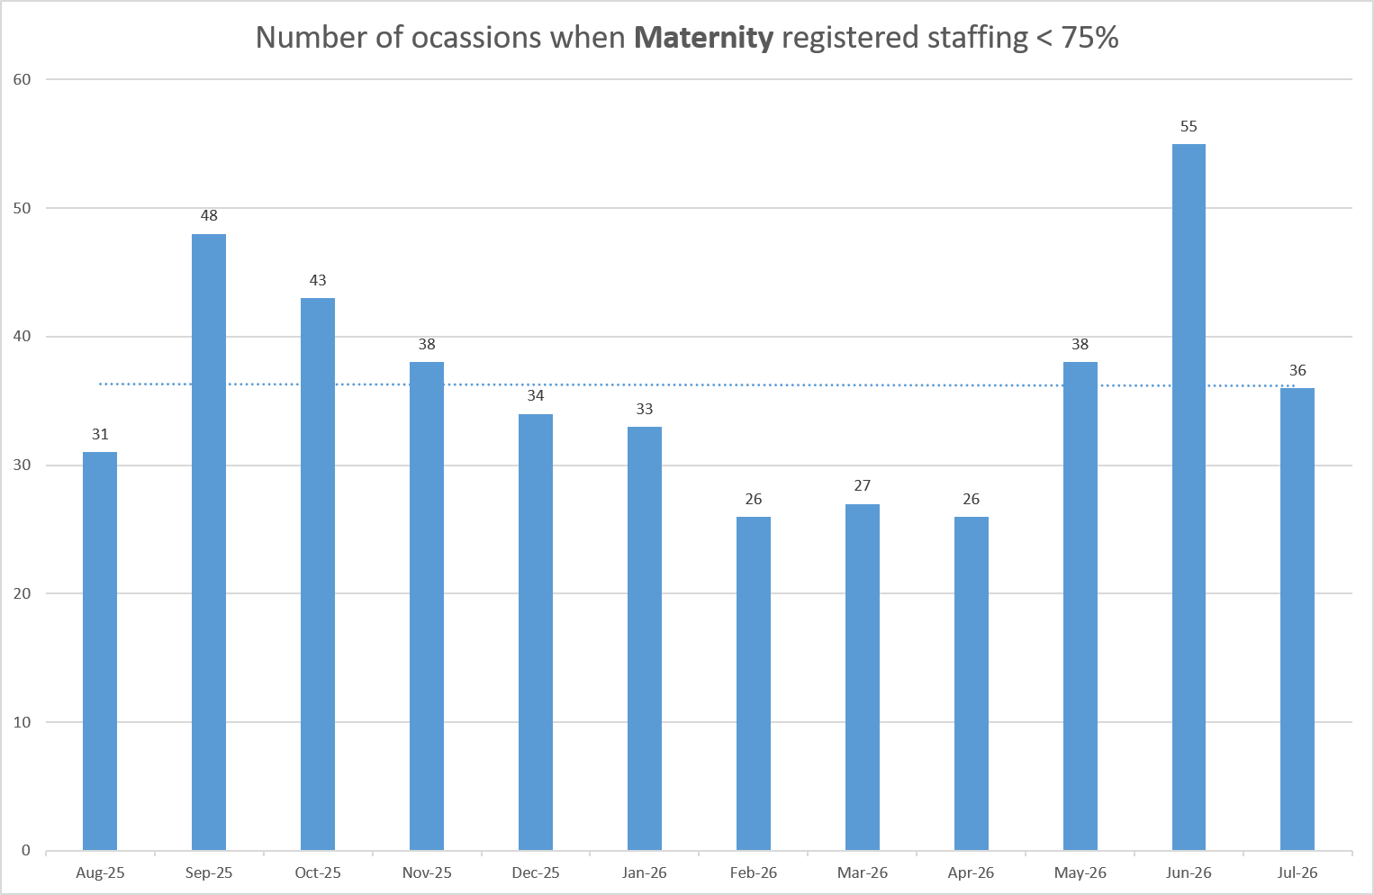
Table 3a. Red Flags raised via SafeCare Jul-26
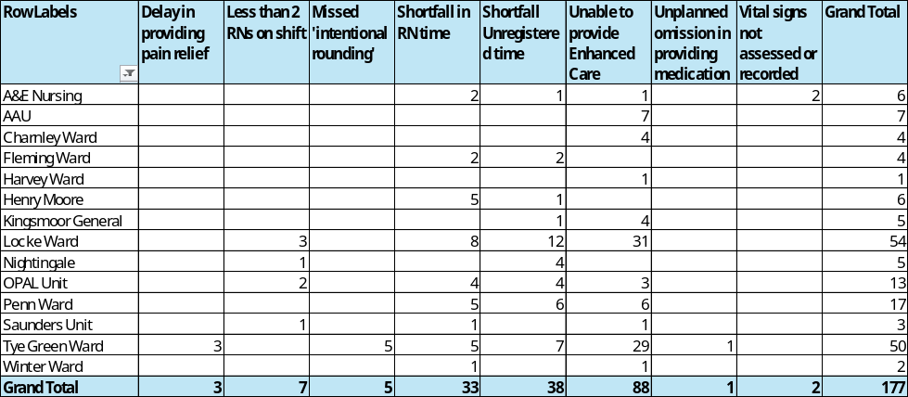
Table 3b. Red Flags raised via SafeCare trend Aug-25 – Jul-26
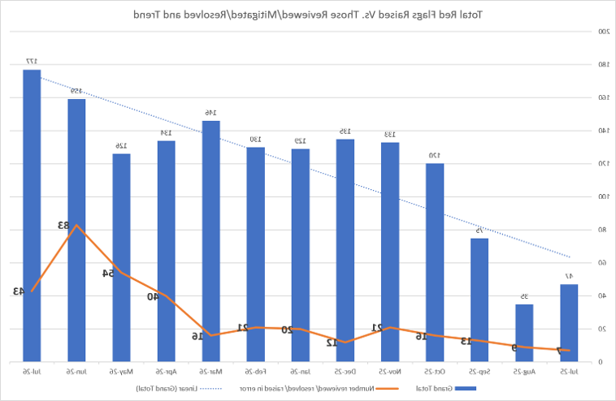
Table 3c. Datix for lack of suitably trained / skilled staff

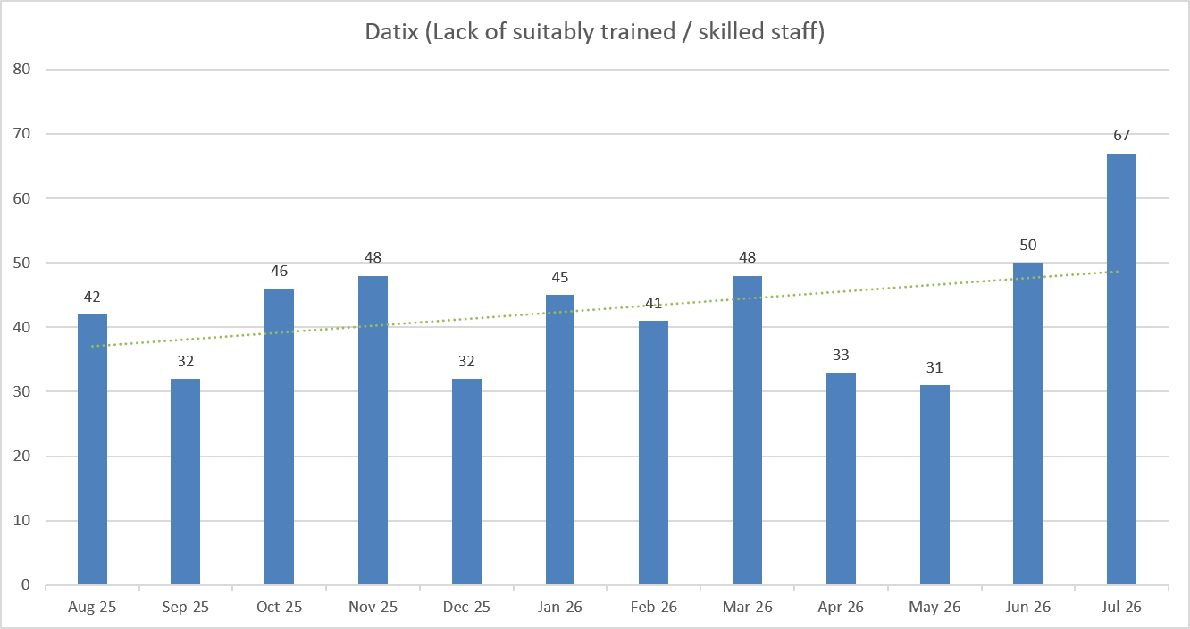

Appendix 5: Nursing quality indicators
Falls
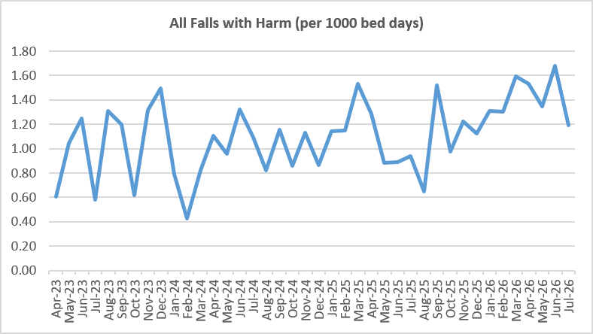
Table 1: Falls Rate per 1000 bed days June 2026
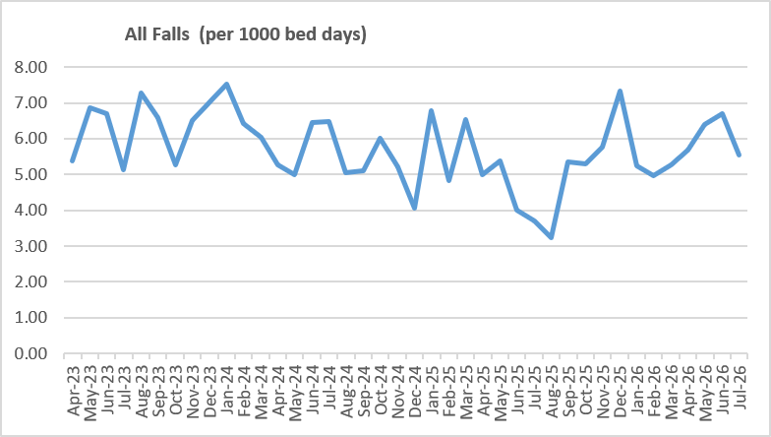

Table 2: Number of falls and categories in July 2026
 | Total falls in month | Top 3 wards
Total falls | 79 ↓ | A&E – 9 | Charnley – 8 | Lister & Tye Green – 7
Unwitnessed falls | 56 ↓ | A&E – 8 | Charnley – 8 | Lister – 6
Falls with harm * | 17 ↓ | A&E – 5 | Charnley – 4 | Lister – 2
*Subject to change following review at Falls Incident Oversight Group

Pressure Ulcers
Table 2: Number of Hospital Acquired Pressure Ulcers (HAPU)
 | Total in month | Top Departments
Total skin changes | 54↓ | AAU – 6 | Kingsmoor – 6 | Tye Green – 6
Reportable HAPU’s | 12↓ | Harvey – 3 | Lister – 3 | Kingsmoor – 2
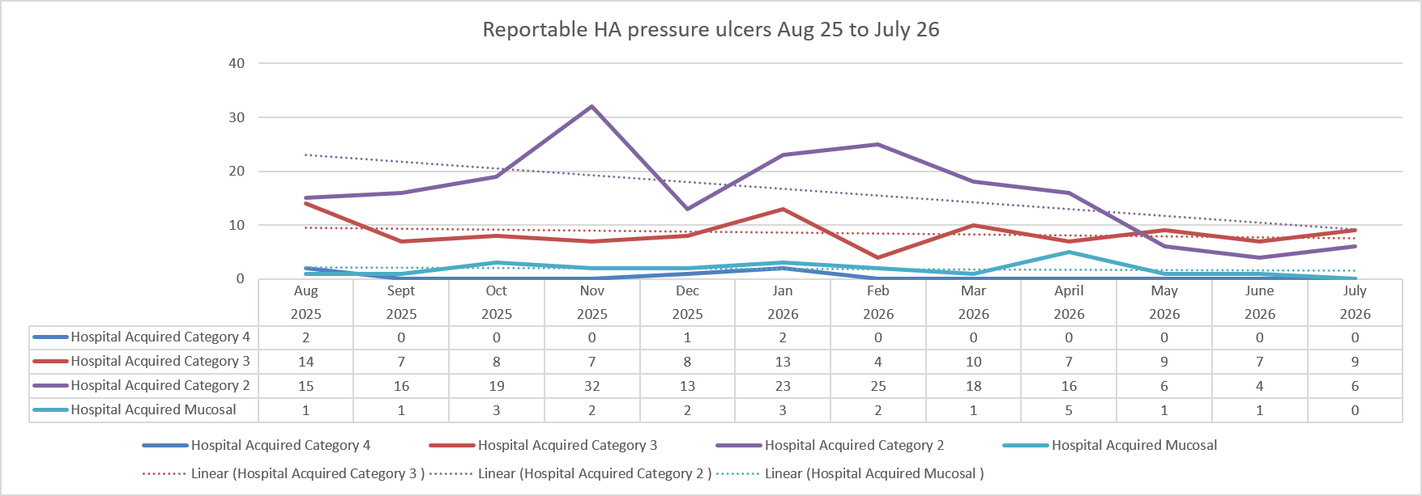

Complaints, PALS and Compliments Trend Data Aug-25 – Jul-26
Table 3. Number of new Complaints, PALS and Compliments in June 2026 with top three wards highlighted

 | Total in month | Top Departments
New complaints | 33 ↑ | A&E – 14 | Lister – 3 | Labour, Childrens ED and Harold – 2
PALs | 85 ↓ | A&E – 19 | NICU – 10 | Labour – 7
Compliments | 5 ↓ | Fleming – 2 | Lister, Dolphin, Henry Moore – 1
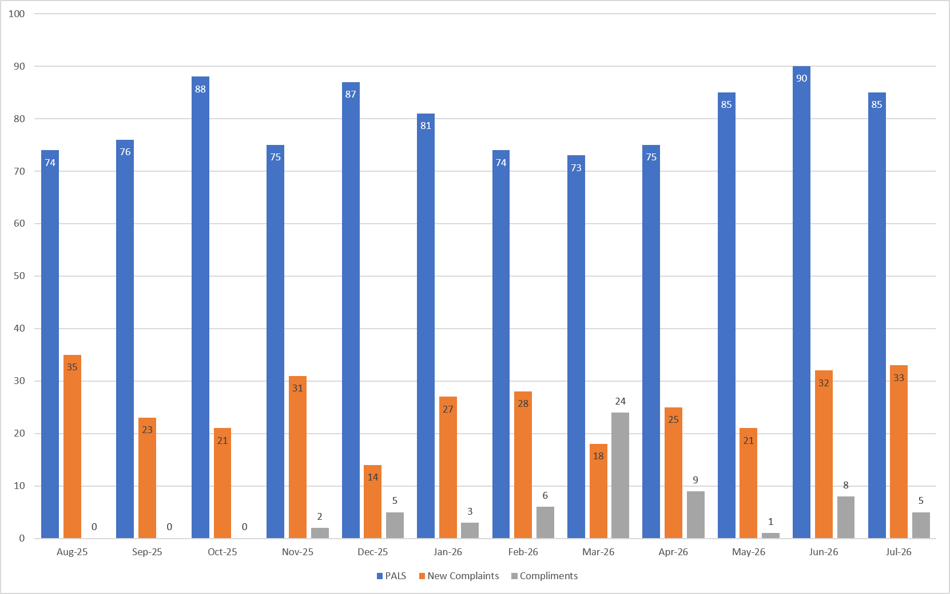

Complaints: main themes: Delay – 25.9%, Medical care – 21.08%, Communications – 15.66%,
PALS: main themes: Delay – 34.9%, Communication – 20.5%, Appointments – 15.14%
Compliments: themes not provided.

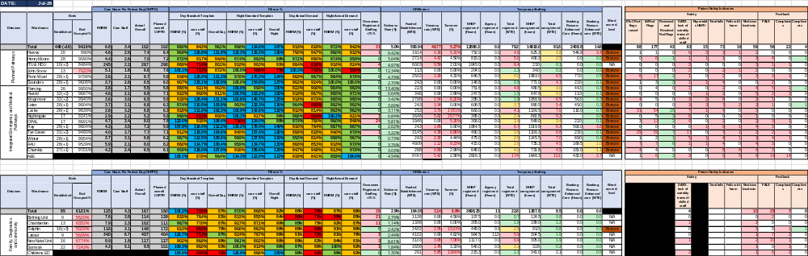
Table 4: Nursing and Midwifery Staffing and Quality data Triangulation – July 2026

