|  |  |  |  |  |  |  |  |  |  |  |  |
| --- | --- | --- | --- | --- | --- | --- | --- | --- | --- | --- | --- |
| **Agenda item:**  **Presented by:**  **Prepared by:**  **Date prepared:**  **Subject / title:** | Safe Staffing Monthly report  Giuseppe Labriola – Deputy Chief Nurse  Charlotte Collings, Lead Nurse for Staffing and Workforce and Giuseppe Labriola – Deputy Chief Nurse  15 August 2025  Report on Nursing and Midwifery staff levels for July 2025. | | | | | | | | | | |
| **Purpose:** | **Approval** |  | **Decision** | |  | **Information** | | **x** | **Assurance** | | **x** |
| **Key issues:** | There has been a sustained overall registered fill of > 95%.  No wards achieved < 75% overall fill rate in month. The increase in overall fill rates continue to be multifaced with an increase of enhanced care needs  The mid-year nursing and midwifery establishment review is currently following the governance processes and will be approved at board in October 2025 | | | | | | | | | | |
| **Recommendation:** | The committee are asked to note the information within this report. | | | | | | | | | | |
| **Trust strategic objectives:** | Princess Alexandra_strap line blocks NHS blue text  **Patients** | **People** | | **Performance** | | | **Places** | | | **Pounds** | |
| x | x | | x | | |  | | | x | |
|  |  | | | | | | | | | | |
| **Previously considered by:** | NA | | | | | | | | | | |
| **Risk / links with the BAF:** | BAF: 2.3 Workforce capacity | | | | | | | | | | |
| **Legislation, regulatory, equality, diversity and dignity implications:** | NHS England and CQC letter to NHSFT CEOs (31.3.14): Hard Truths Commitment regarding publishing of staffing data.  NHS Improvement letter: 22.4.16  NHS Improvement letter re CHPPD: 29/6/18 | | | | | | | | | | |
| **Appendices:** | **Appendix 1:** Ward and divisional fill rates by month against adjusted standard planned template.  **Appendix 2**: Ward and divisional CHPPD data  **Appendix 3:** Nursing red flags  **Appendix 4:** Nursing quality indicators | | | | | | | | | | |

**1.0 Introduction**

This paper illustrates how PAHT’s nursing and midwifery staffing has been deployed for the month of July 2025. It evidences how planned staffing has been successfully achieved and how this is supported by nursing and midwifery recruitment and deployment.

**2.0 Background**

The National Quality Board (NQB 2016) recommend that monthly, actual staffing data is compared with expected staffing and reviewed alongside quality of care, patient safety, and patient and staff experience data. The Trust is committed to ensuring that improvements are learned from and celebrated, and areas of emerging concern are identified and addressed promptly. This paper will identify safe staffing and actions taken in July 2025. The following sections identify the processes in place to demonstrate that the Trust proactively manages nursing and midwifery staffing to support patient safety.

**3.0 Inpatient wards fill rate**

The Trust’s safer staffing submission has been submitted to NHS Digital for July 2025 within the data submission deadline. Table 1 shows the summary of the overall fill rate for this month. Table 2 shows a summary of overall fill rate percentages for a rolling 12-month period.

Appendix 1 illustrates a ward-by-ward breakdown for this period.

**3.1 Wards with < 75% average fill rate**

No wards had an overall fill rate of <75%

**3.2 Wards with > 100% average fill rate**

Henry Moore Ward continues to have an increased fill rate due to fluctuating capacity and opening of additional surgical beds and a Level 1 area for post-operative patients, the Level 1 bay is staffed by ITU and the staffing is reflected in their numbers. Therefore, the additional staff are reflective of the required workforce to meet the activity demands. As part of the mid-year nursing and midwifery establishment review, there are proposed changes to the workforce model which will inform the required establishment for Henry Moore ward.

Greater than 100% fill rate for Registered Nurse (RN) shifts continues to be mainly attributable to enhanced care requirements, a task and finish group is now in place reviewing enhanced care requirements.

The Trust continues to utilise NHS Professionals to mitigate vacant shifts and in addition agency nursing to support patients that require Registered Mental Health Nurse’s. Additional control measures continue to be in place regarding the creation of additional duties.

Furthermore, our senior nurses and midwives are also supporting individual areas when required. SafeCare data continues to be collected three times a day to enhance staffing governance across the organisation.

Further detail can be found in Appendix 1

**Table 1. Overall fill rate**

|  |  |  |  |  |  |  |
| --- | --- | --- | --- | --- | --- | --- |
| **Average day fill rate - registered nurses/midwives** | **Average day fill rate - care staff** | **Average night fill rate - registered nurses/midwives** | **Average night fill rate - care staff** | **% Registered overall fill rate** | **% HCSW overall fill rate** | **% Overall fill rate** |
| **95.3%** | **112.3%** | **100.6%** | **126.0%** | **97.7%** | **118.5%** | **104.5%** |

**Table 2. Inpatient fill rate including Maternity Wards Trend**

**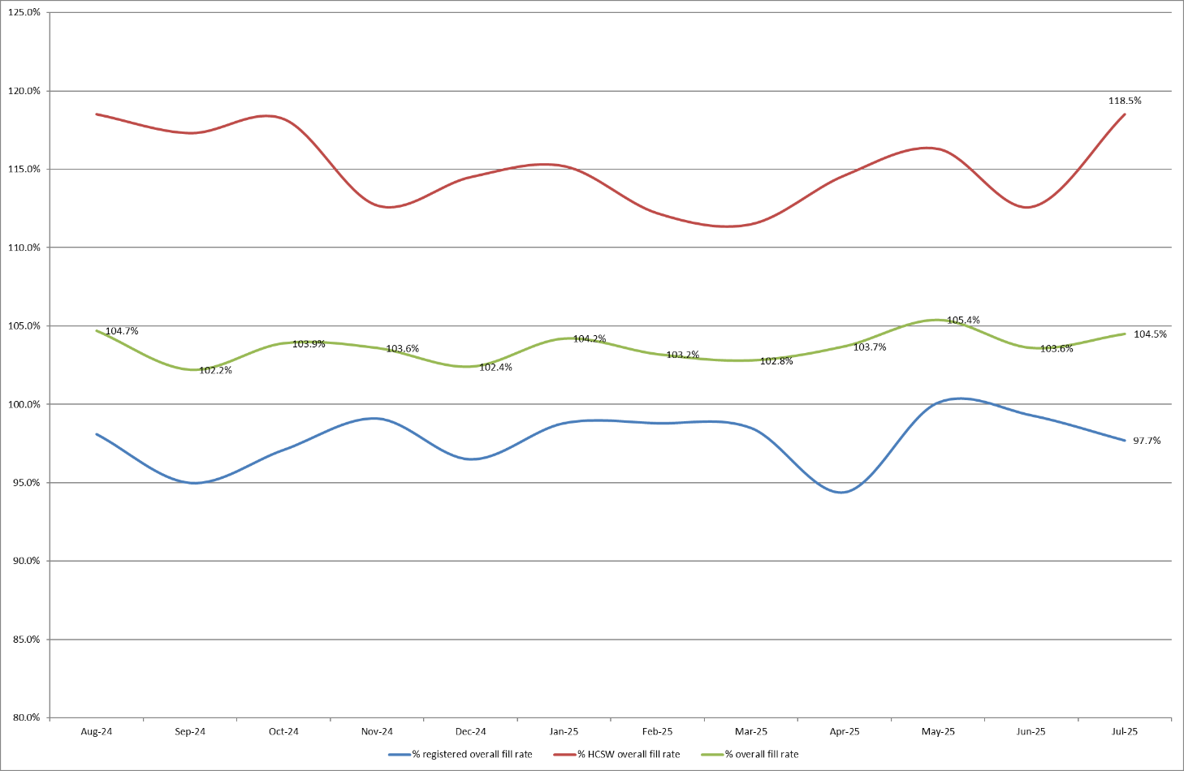**

**4.0 Care Hours Per Patient Day (CHPPD)**

CHPPD allows comparison and benchmarking of a ward’s CHPPD figure with that of other wards in the hospital, or with similar wards in other hospitals. It can be used to look at variation between similar wards to ensure the right staff are being used in the right way and in the right numbers.

The hours worked during day and night shifts by registered nurses and midwives and healthcare assistants are added together. This figure is then divided by the number of patients at midnight, this then gives the total CHPPD

By itself, the CHPPD does not reflect the total amount of care provided on a ward nor does it directly show whether care is safe, effective or responsive. It should therefore be considered alongside measures of quality and safety.

**Table 3. Overall Care Hours Per Patient Day (CHPPD) July 2025**

|  |  |  |
| --- | --- | --- |
| Registered CHPPD | Unregistered CHPPD | Total CHPPD |
| 5.0 | 2.9 | 7.9 |

The Model Hospital data (May 2025) shows the Trust with a CHPPD of 8.0 against the national median of 9.0**.** Table 4 also shows the Trusts total CHPPD against our peers (East and North Hertfordshire NHS Trust and West Hertfordshire Teaching Hospitals NHS Trust).

Appendix 2 shows the individual ward and divisional CHPPD for June 2025

**Table 4. CHPPD Trend**

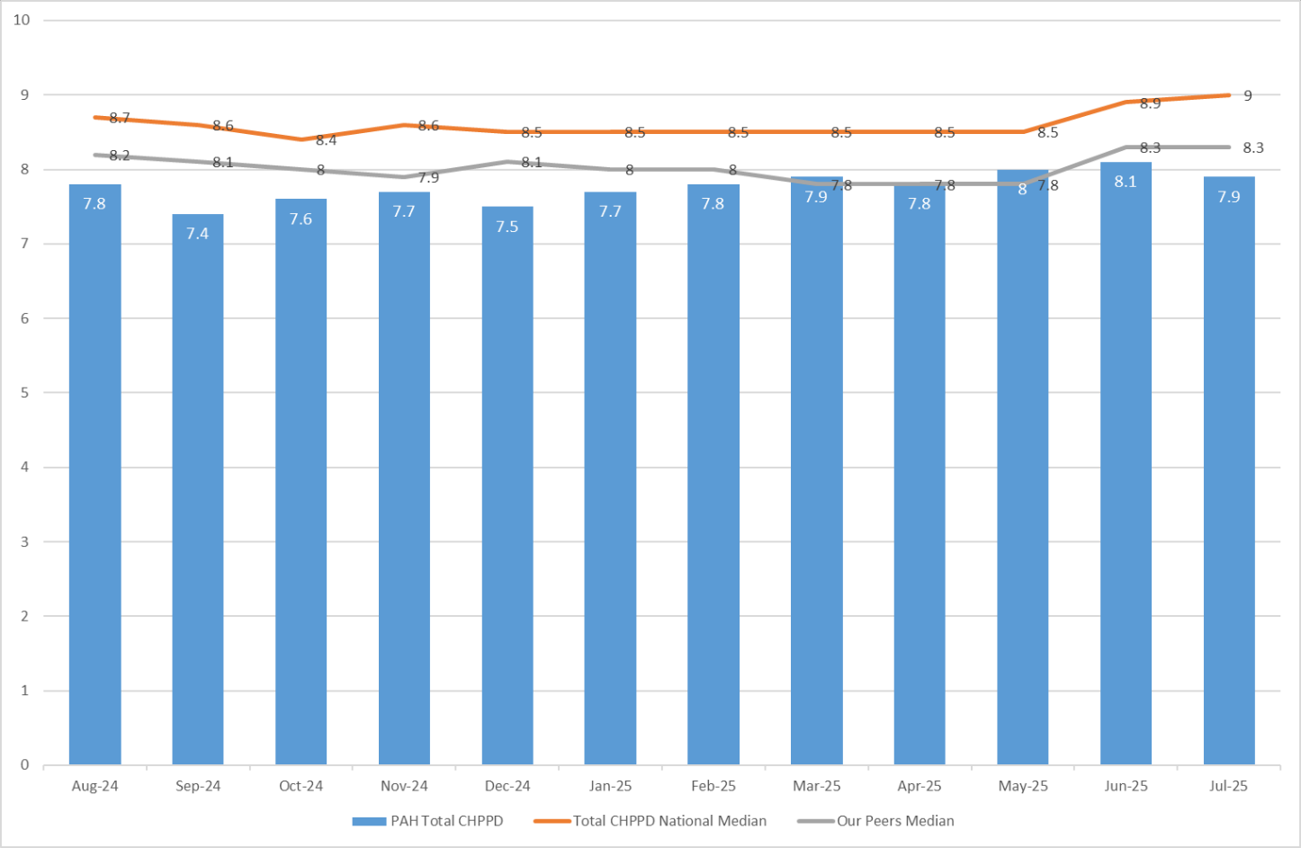

**5.0 Quality Indicators**

**5.1 Nursing Red Flags**

Nursing red flags prompt an immediate response by the registered nurse in charge of the ward. The response may include allocating additional nursing staff to the ward or other appropriate responses. Appendix 3 details the NICE (2014) definition of Nursing Red Flags. This includes the number of occasions when registered staffing fell below 75% of the standard template with trend, and the number of Red Flags raised in SafeCare.

**5.2 Quality indicators (Falls, pressure ulcers and complaints, PALS and compliments)**

Nursing quality indicators have been reviewed and there is no correlation between these, fill rates or red flags which are a cause of concern. A review of quality indicators can be found in Appendix 4.

**6.0 Conclusion**

The Trust continues to achieve a sustained overall registered fill of > 95%. The increase in overall fill rates for support workers is due to enhanced care needs.

**7.0 Recommendation**

The board are asked to note the information in this report to provide assurance on the daily mitigation of nursing and midwifery staffing.

**Appendix 1:** **Ward level data and narrative: fill rates July 2025 *(Adjusted Standard Planned Ward Demand)***

|  |  |  |  |
| --- | --- | --- | --- |
| >100% | 95 – 100% | 75-95% | <75% |

|  |  |  |  |  |  |  |  |
| --- | --- | --- | --- | --- | --- | --- | --- |
|  | **Day** | | **Night** | |  | | |
| **Ward name** | **Average fill rate - registered nurses/midwives (%)** | **Average fill rate - care staff (%)** | **Average fill rate - registered nurses/midwives (%)** | **Average fill rate - care staff (%)** | **% Registered overall fill rate** | **% HCSW overall fill rate** | **% Overall fill rate** |
| Harvey | **87.8%** | **124.5%** | **98.8%** | **127.2%** | **92.3%** | **125.8%** | **104.4%** |
| Henry Moore | **134.0%** | **142.1%** | **183.3%** | **146.8%** | **153.7%** | **144.3%** | **149.7%** |
| ITU & HDU | **95.8%** | **94.4%** | **101.2%** | **107.9%** | **98.5%** | **100.8%** | **98.7%** |
| John Snow | **100.1%** | **83.1%** | **100.1%** | **41.9%** | **100.1%** | **63.4%** | **87.9%** |
| Penn | **97.8%** | **126.8%** | **100.0%** | **180.3%** | **98.8%** | **147.1%** | **116.1%** |
| Saunders | **92.2%** | **138.8%** | **122.2%** | **200.3%** | **103.5%** | **162.1%** | **125.6%** |
| ***Surgery Total*** | **98.7%** | **125.6%** | **110.6%** | **145.9%** | **104.0%** | **134.4%** | **112.9%** |
| Fleming | **85.0%** | **101.9%** | **98.4%** | **104.8%** | **90.7%** | **103.3%** | **94.5%** |
| Harold | **92.0%** | **111.2%** | **101.1%** | **118.2%** | **96.0%** | **114.5%** | **101.8%** |
| Kingsmoor | **96.2%** | **129.1%** | **111.1%** | **149.0%** | **101.9%** | **138.6%** | **115.6%** |
| Lister | **95.8%** | **124.5%** | **100.0%** | **146.5%** | **97.6%** | **135.0%** | **112.5%** |
| Locke | **95.0%** | **124.4%** | **100.0%** | **133.3%** | **97.1%** | **128.7%** | **109.7%** |
| Nightingale | **100.1%** | **70.8%** | **96.8%** | **79.8%** | **98.5%** | **75.1%** | **86.8%** |
| Opal | **115.5%** | **122.1%** | **71.9%** | **126.4%** | **94.7%** | **124.2%** | **106.5%** |
| Ray | **96.4%** | **103.9%** | **101.7%** | **142.8%** | **98.7%** | **118.7%** | **105.8%** |
| Tye Green | **94.0%** | **118.5%** | **96.3%** | **148.2%** | **95.0%** | **130.6%** | **108.9%** |
| Winter | **98.4%** | **118.7%** | **99.2%** | **129.3%** | **98.8%** | **123.7%** | **108.7%** |
| ***Medicine Total*** | **95.6%** | **114.2%** | **98.5%** | **130.0%** | **96.8%** | **121.5%** | **106.1%** |
| AAU | **86.2%** | **136.7%** | **97.8%** | **155.2%** | **91.4%** | **145.5%** | **102.7%** |
| Charnley | **95.7%** | **152.4%** | **96.2%** | **171.2%** | **96.0%** | **161.4%** | **114.7%** |
| ***UEC Total*** | **89.8%** | **144.6%** | **97.2%** | **163.2%** | **93.2%** | **153.5%** | **107.8%** |
| Birthing | **92.5%** | **97.0%** | **79.5%** | **77.4%** | **86.3%** | **87.7%** | **86.8%** |
| Chamberlen | **101.8%** | **94.5%** | **99.3%** | **71.6%** | **100.6%** | **83.5%** | **96.4%** |
| Dolphin | **101.4%** | **65.5%** | **107.8%** | **92.8%** | **104.3%** | **74.6%** | **96.8%** |
| Labour | **85.1%** | **89.0%** | **92.9%** | **85.0%** | **88.9%** | **87.1%** | **88.5%** |
| Neo-Natal Unit | **90.5%** | **58.1%** | **92.1%** | **93.8%** | **91.3%** | **75.9%** | **88.7%** |
| Samson | **97.9%** | **81.5%** | **97.3%** | **76.7%** | **97.6%** | **79.2%** | **87.1%** |
| ***CHAWS Total*** | **93.5%** | **80.6%** | **95.5%** | **81.4%** | **94.5%** | **81.0%** | **90.4%** |
| ***Total*** | **95.3%** | **112.3%** | **100.6%** | **126.0%** | **97.7%** | **118.5%** | **104.5%** |

**Trust wide** – there has been a successful recruitment event for newly qualified nurses to join trust wide positions, offers were made for 6 children’s nurses, 28 adult nurses and 2 dual-registered adult/mental health nurses. It is expected they will join teams throughout the Autumn.

**John Snow Ward** – the HCSW shifts are often under template by 1 WTE, this is due to fluctuating ward capacity throughout the month in addition to the HCSW being re-deployed to other areas through the daily safe staffing meetings.

**OPAL Unit** – have been trialling a new shift pattern which isn’t currently reflected in their template, this accounts for the over fill for RN’s on a day shift, and under fill for the Night shift. They now staff 4 RN’s for the day and 2 at Night if assessment beds remain closed through the night. This will be formally reviewed with SNCT.

**Dolphin and Neonatal Unit** – low fill rates on day shifts for HCSW and nursery nurse shifts, both areas have vacancies and have recently recruited into these, this should be reflected in future data collections.

**Maternity** – the service continues to robustly review staffing through twice weekly staffing reviews and the use of BirthRate Plus. Safety is maintained by daily staffing huddles and staff deployment according to acuity, support continues to be provided by specialist midwives and matrons being redeployed as required. Birthrate Plus have been commissioned to review the workforce and the workforce intentions will be available within the full year nursing and midwifery establishment review starting in September 2025.

**Emergency Departments** – national reporting is currently for inpatient areas and therefore does not include areas including the emergency department. To ensure the Board is sighted to staffing in these areas, the data for both adult ED and Paediatric ED is included below (Appendix 1a and 1b) using the same methodology as the full UNIFY report.

**Paediatric Emergency Department** – Shows a low overall fill rate for HCSW’s and higher than template for RN’s in ED. Following discussions with the divisional team and reviewing SNCT data, it has been identified that creating a middle shift should mitigate some of these figures as the key driver is improving the workforce efficiency, this is under review.

The Trust continues as part of an Enhanced Care Collaborative working group supported by NHS England that is reviewing the provision of Enhanced Care including the workforce and training requirements to sustainably manage this demand.

The interim establishment review (which underpins the rota templates) commenced in March 2025 and finished 1st April 2025 This is for adult and paediatric inpatient wards and assessment units along with main and paediatric emergency departments.

**Appendix 1a: ED data and narrative: fill rates July 2025 *(Standard Planned Demand)***

|  |  |  |  |  |  |  |
| --- | --- | --- | --- | --- | --- | --- |
| **Average day fill rate - registered nurses/midwives** | **Average day fill rate - care staff** | **Average night fill rate - registered nurses/midwives** | **Average night fill rate - care staff** | **% Registered overall fill rate** | **% HCSW overall fill rate** | **% Overall fill rate** |
| **96.9%** | **94.8%** | **111.7%** | **108.0%** | **103.5%** | **100.6%** | **102.6%** |

**Appendix 1b: Paediatric ED data and narrative: fill rates July 2025 *(Standard Planned Demand)***

|  |  |  |  |  |  |  |
| --- | --- | --- | --- | --- | --- | --- |
| **Average day fill rate - registered nurses/midwives** | **Average day fill rate - care staff** | **Average night fill rate - registered nurses/midwives** | **Average night fill rate - care staff** | **% Registered overall fill rate** | **% HCSW overall fill rate** | **% Overall fill rate** |
| **108.3%** | **81.2%** | **147.3%** | **95.4%** | **125.7%** | **88.3%** | **114.2%** |

**Appendix 2: Ward level data: CHPPD July 2025**

|  |  |  |  |
| --- | --- | --- | --- |
| Care Hours Per Patient Day (CHPPD) | | | |
| Ward | Registered Nurses/Midwives | Non-registered Nurses/Midwives | Overall |
| ***Trust Total*** | **5.0** | **2.9** | **7.9** |
| Harvey Ward | 3.7 | 2.9 | 6.6 |
| Henry Moore Ward | 3.9 | 2.8 | 6.7 |
| ITU & HDU | 18.9 | 1.9 | 20.8 |
| John Snow Ward | 5.7 | 1.8 | 7.6 |
| Penn Ward | 3.8 | 3.2 | 7.0 |
| Saunders Unit | 3.7 | 3.5 | 7.1 |
| ***Surgery Total*** | **5.5** | **2.9** | **8.4** |
| Fleming Ward | 3.8 | 1.9 | 5.7 |
| Harold Ward | 4.6 | 2.5 | 7.1 |
| Kingsmoor General | 3.7 | 3.0 | 6.8 |
| Lister Ward | 3.7 | 3.4 | 7.1 |
| Locke Ward | 3.7 | 3.3 | 7.0 |
| Nightingale Ward | 3.0 | 2.3 | 5.2 |
| Opal Unit | 5.3 | 4.7 | 10.0 |
| Ray Ward | 3.8 | 2.6 | 6.4 |
| Tye Green Ward | 4.0 | 3.5 | 7.5 |
| Winter Ward | 3.7 | 3.1 | 6.8 |
| ***Medicine Total*** | **3.9** | **3.0** | **6.9** |
| AAU | 6.4 | 2.7 | 9.0 |
| Charnley Ward | 4.2 | 2.8 | 7.0 |
| ***UEC Total*** | **5.3** | **2.8** | **8.0** |
| Birthing Unit | 10.3 | 5.2 | 15.5 |
| Chamberlen Ward | 6.6 | 1.8 | 8.4 |
| Dolphin Ward | 9.9 | 2.4 | 12.2 |
| Labour Ward | 20.9 | 5.9 | 26.8 |
| Neo-Natal Unit | 9.6 | 1.6 | 11.2 |
| Samson Ward | 3.1 | 3.3 | 6.4 |
| ***CHAWS Total*** | **8.2** | **3.0** | **11.2** |

**Appendix 3. Nursing Red Flags (NICE 2014)and trend data**

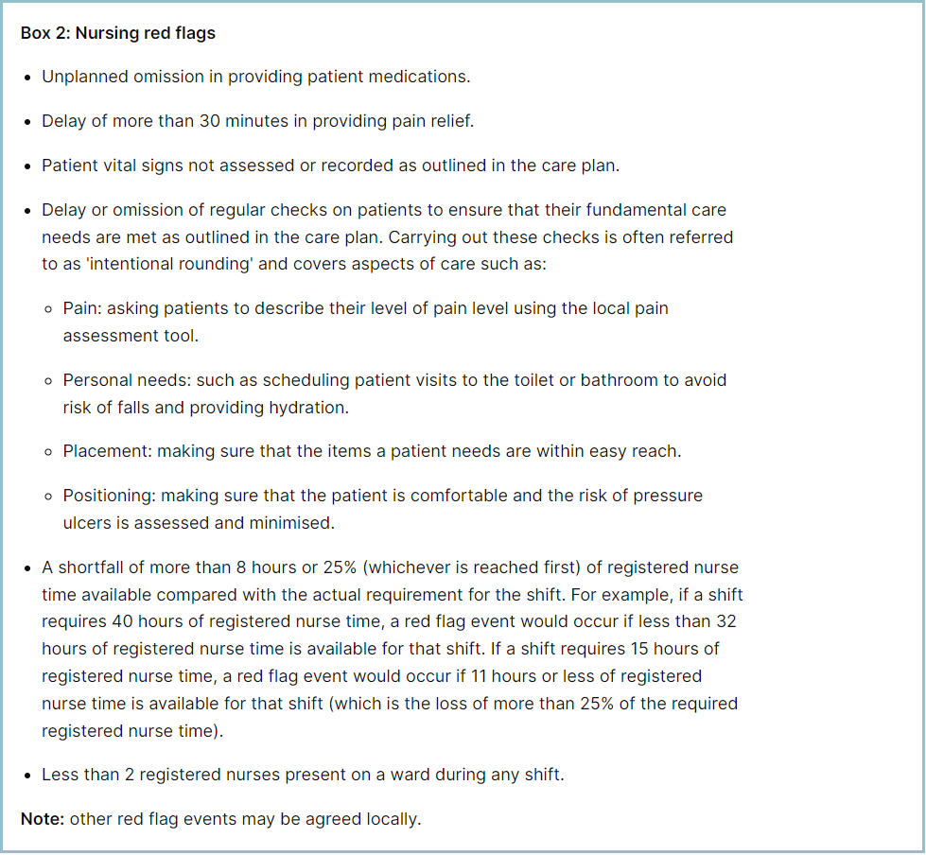

**Staffing red flags and trend data**

The number of occasions / shifts where the reported fill rate has fallen below 75% across the wards is available in Table 1. This decreased by 3 occasions in July 2025 to 69. The majority of these shortfalls continue to be in Maternity, which had 34, an increase of 3 from last month. Table 2 shows the trend for when registered staffing fell below 75% of standard template.

**Table 1. Occasions when registered staffing fell below 75% of standard template July 2025**

**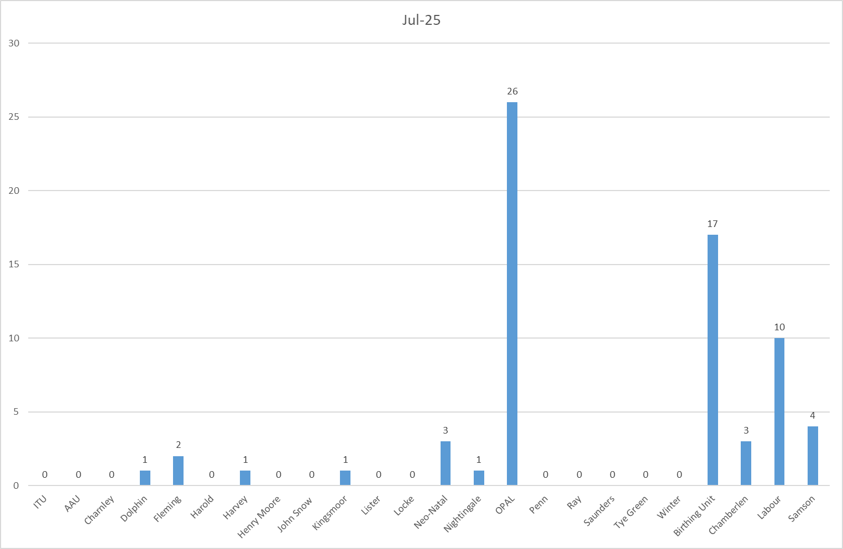**

**Table 2. Occasions when registered staffing fell below 75% of standard template**

**Trend Data August 2024 – July 2025**

**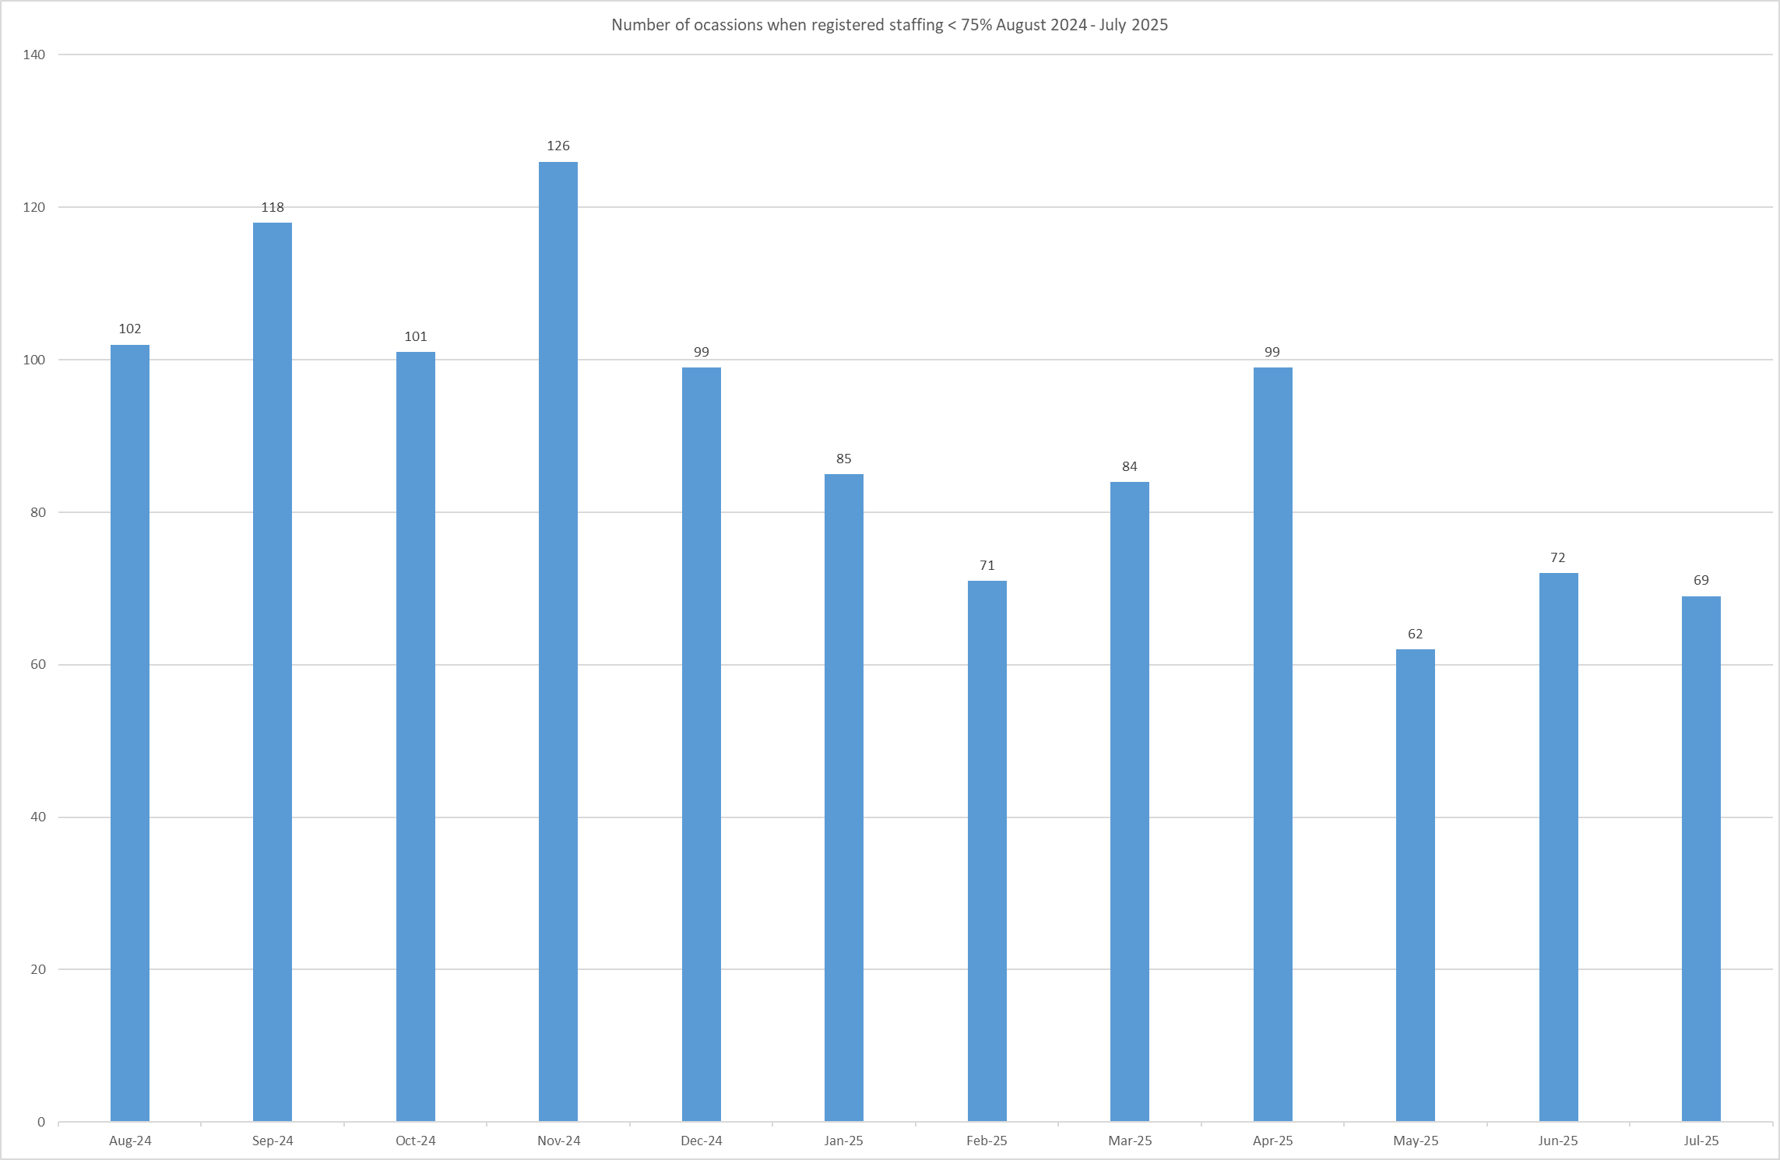**

All adult inpatient areas capture staffing shortfalls on SafeCare by raising a Red Flag on the system. Table 3a shows the Red Flags raised through SafeCare in July 2025. Table 3b shows the number of Red Flags raised for adult inpatient wards has increased with 47 raised in July against 22 for June.

To improve oversight into how many incidents relating to when Enhanced Care could not be provided, the Trust has also added a local Red Flag highlighting when this occurs in SafeCare. This and the addition of Enhanced Care Level 3 Patient task will also enable the Trust to provide data to the Enhanced Care Collaborative and ensure staffing is appropriately deployed. These have now been rolled out across all adult inpatient wards.

There needs to be robust validation of the red flags by managers and matrons to understand which have been mitigated and closed, which is not currently demonstrated in Table 3a below. This will be a focused aspect of work with the divisions.

**Table 3a. Red Flags raised via SafeCare July 2025**



**Table 3b. Red Flags raised via SafeCare Trend**

**Redeployment**

Redeployment of staff continues to be undertaken to support safe staffing as part of the daily staffing huddles. Table 4 details the trend in July 2025 with Nightingale redeploying the highest number of substantive staff with John Snow being the next highest. The highest net receiver of staff was A&E followed by Charnley.Table 5 demonstrates the number of substantive staff redeployments per month trend

**Table 4. Hours of substantive staff redeployed July 2025**

**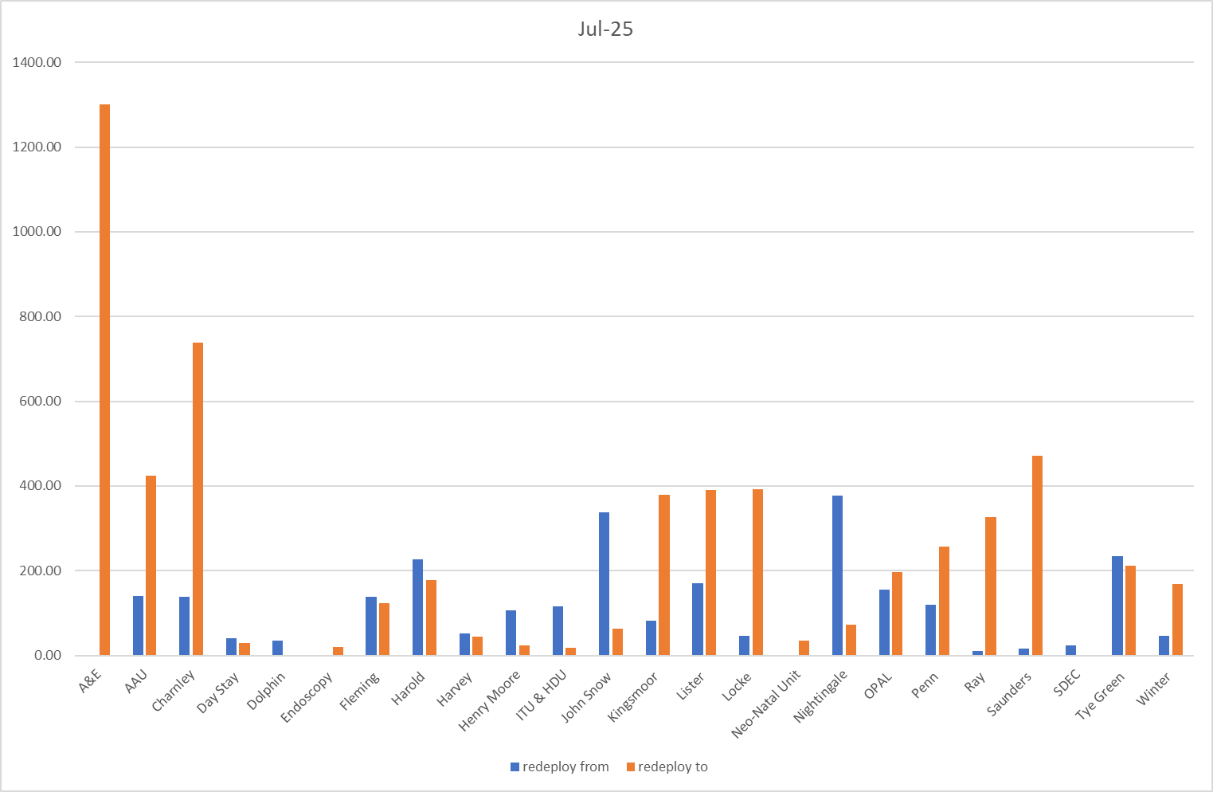**

**Table 5. Substantive staff redeployment trend**

This reports looks at the number of shifts substantive staff working are redeployed, it does not include the shifts when agency, bank or multi-post holders are redeployed.

**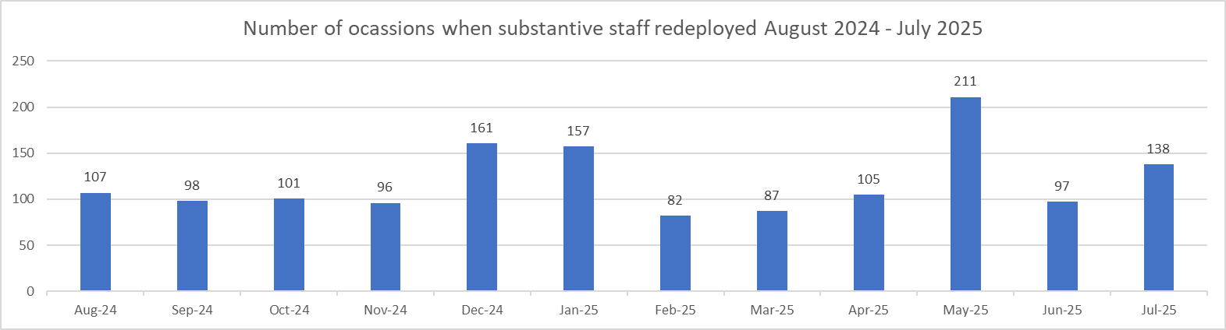**

Table 6 shows the hours of substantive staff moved as a percentage of total hours worked.

Table 7 shows the hours of all staff including bank and agency, excluding the Enhanced Care Team, Bank Pool and Rapid Response Pool staff.

**Table 6. % of substantive staff redeployed as % of total hours worked**

|  |  |  |
| --- | --- | --- |
| Substantive staff hours redeployed | Total hours worked (inc bank and agency) | % of total hours worked / substantive staff redeployed |
| 2310 | 142620 | 1.62% |

**Table 7. % of staff redeployed as % of total hours worked**

|  |  |  |
| --- | --- | --- |
| All staff hours redeployed (including bank and agency but excluding Enhanced Care Team, Bank Pool and Rapid Response Pool) | Total hours worked (inc bank and agency) | % of total hours worked / staff redeployed (including bank and agency but excluding Enhanced Care Team, Bank Pool and Rapid Response Pool) |
| 2650 | 142620 | 1.86% |

The data detailing nurse redeployment indicates that the numbers of staff reassigned are minimal and continues to not be a cause of concern, however has increased marginally from last month. The redeployment process is efficiently managed with improved governance and oversight.

**Appendix 4: Nursing quality indicators**

**Table 1. Number of falls, unwitnessed falls and falls with harm in July 2025, with the top 3 wards being highlighted**

|  |  |  |  |  |
| --- | --- | --- | --- | --- |
|  | Total falls in month | Top 3 wards | | |
| Total falls | 63 | Kingsmoor – 8 | Locke – 5 | Saunders – 5 |
| Unwitnessed falls | 49 | Kingsmoor – 7 | Locke – 5 | Harvey, OPAL, Saunders – 4 |
| Falls with harm \* | 17 | Harvey - 5 | Charnley, Kingsmoor, Saunders - 2 | |

*\*subject to change following review at Falls Incident Oversight Group*

July’s data sees an overall decrease in total falls from 68 in June to 63 in July, an increase of unwitnessed falls to (49 to 41) and increase of falls with harm from (10 to 17).

The Trust falls reduction strategy and workplan (2025/2026) remains in place and mandatory falls training has increased to 97%. Matron for Kingsmoor and Harold is doing targeted work to support reducing unwitnessed falls in these areas.

**Falls Rate per 1000 bed days July 2025 data**

**Pressure Ulcers**

**Table 2a. Number of Hospital Acquired Pressure Ulcers (HAPU) Cat 2 and Cat 3 Pressure Ulcers**

July showed a decrease in reportable HAPUs (21) compared to last month (36), there were 4 category 3 HAPU’s, a decrease of 3 and 16 category 2, a decrease of 7 from June’s data.

“Pressure Ulcer Prevention Wednesdays” commenced in May and will continue. The focus for August is Moisture Associated Skin Damage.

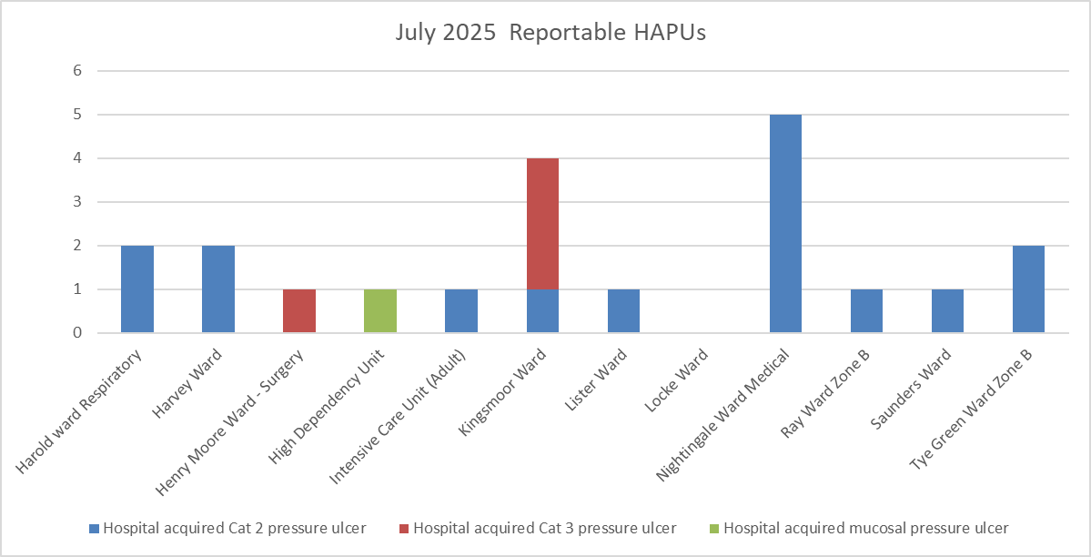

|  |  |  |  |
| --- | --- | --- | --- |
| Total in month | Top 3 wards | | |
| 21 | Nightingale - 5 | Kingsmoor - 4 | Tye Green, Harold and Harvey - 2 |

**Table 2b. Reported Incidents and Actual Hospital Acquired Pressure Ulcers July 2025**

**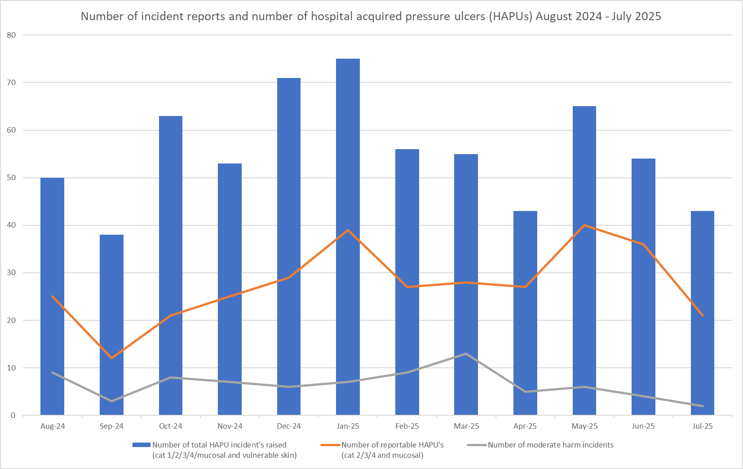**

Hospital acquired pressure ulcer data taken from different sources can be inconsistent and not comparable. Due to these variables a more unified approach to data capture and data reporting is underway and therefore the rate per 1000 occupied bed days is currently not being completed. As a consequence the footfall is not reflected in the graph.

The above chart captures:

* The number of incident forms completed per month relating to total number of skin changes (category 1,2,3,4, mucosal and vulnerable skin/deep tissue injury)
* The actual number of reportable pressure ulcers per month
* The number of moderate harm incidents validated.

The number of reportable HAPU’s has reduced again this month, as have the number of validated moderate harm incidents.

It is important to note that the number of incidents reported does not equal the number of HAPUs. Multiple incidents reported in the year will have included more than one HAPU per incident due to the patient's skin being vulnerable.

**Complaints, PALS and Compliments Trend Data January 2025 – July 2025**

*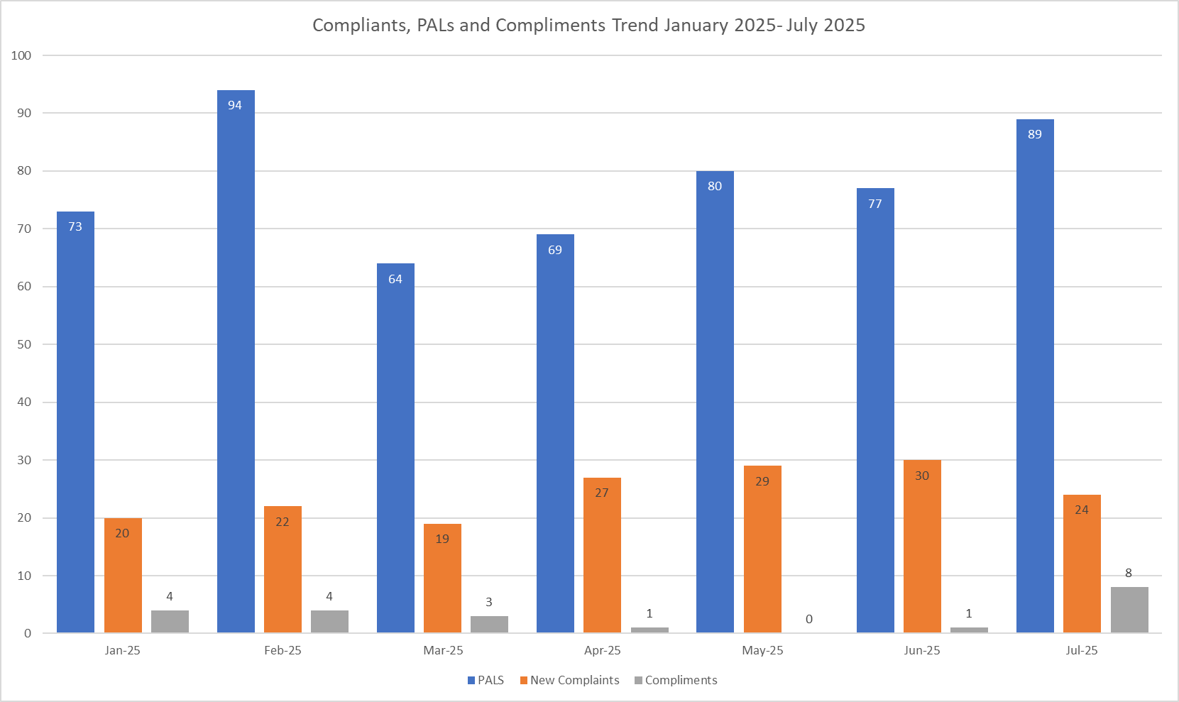*

**Table 3. Number of new Complaints, PALS and Compliments in July 2025 with top three wards highlighted**

|  |  |  |  |  |
| --- | --- | --- | --- | --- |
|  | Total in month | Top Departments | | |
| New complaints | 24 | A&E - 5 | Paeds A&E - 4 | Winter - 3 |
| PALs | 89 | A&E - 24 | Saunders - 6 | Winter - 6 |
| Compliments | 8 | Harvey - 4 | Kingsmoor, Lister, Birthing Unit and Dolphin - 1 | |

The main themes for PALS concerns received in July 2025 are as follows:

* Delay – 36.45%
* Communication – 23.11%
* Cancellations – 10.96%

The main themes for Complaints received in July 2025 are as follows:

* Communication – 24.02%
* Medical care – 21.23%
* Delay – 13.41%

The main themes for Compliments received in July 2025 are as follows:

* Everything Amazing – 28.57%
* Efficient – 28.57%
* Feedback – 42.86%