Agenda item:  Presented by:  Prepared by:  Date prepared:  Subject / title: | Jo Ward - Interim Chief Nurse  Charlotte Collings – Lead Nurse for Safe Staffing and Workforce  Polly Read – Interim Deputy Chief Nurse  February 2026  Safe Staffing Monthly report – January 2026
Purpose: | Approval |  | Decision |  |  | Information |  | x | Assurance |  | x
Key issues: | - A sustained overall registered staffing fill rate of >95% has been maintained.  - No wards recorded an overall fill rate below 75% during the reporting month.  - The continued increase in overall fill rates is multifactorial, including a rise in enhanced care requirements.  - The full year nursing and midwifery establishment review was completed in September 2025 and is progressing through the agreed governance processes, with submission to the People Committee in January 2026 and the Trust Board in February 2026.
Recommendation: | The committee are asked to note the information within this report.
Trust strategic objectives: |   Patients |   People |  |   Performance |  |  |   Places |  |  |   Pounds
Trust strategic objectives: | x | x |  | x |  |  |  |  |  | x
Previously considered by: | NA
Risk / links with the BAF: | BAF: 2.3 Workforce capacity
Legislation, regulatory, equality, diversity and dignity implications: | NHS England and CQC letter to NHSFT CEOs (31.3.14): Hard Truths Commitment regarding publishing of staffing data.  NHS Improvement letter: 22.4.16  NHS Improvement letter re CHPPD: 29/6/18
Appendices: | Appendix 1: Ward and divisional fill rates by month against adjusted standard planned template.  Appendix 2: Ward and divisional CHPPD data  Appendix 3: Nursing red flags  Appendix 4: Nursing quality indicators

Executive Summary
Safe staffing was maintained in January with reasonable assurance. Enhanced Care (ETOC) remains the primary workforce risk due to heavy reliance on temporary staffing and unfilled unregistered hours; a sustainable model is being finalised. Registered nurse fill rates averaged 97.8%, and no wards fell below the 75% threshold. However, the position remains safe but fragile due to persistent pressures: enhanced care demand, CHPPD below national benchmarks (7.8 vs 8.8), and steady volumes of Red Flags (129, -4), mainly linked to RN shortfalls and unmet enhanced care needs.
Quality indicators show falls reduced to 76 (-29), with unwitnessed falls decreasing significantly (-38), though harm-related falls remain similar. Pressure ulcers increased to 40 from 23; five wards reported zero HAPUs. Complaints and PALS activity remain concentrated in ED and Lister Ward, with recurring themes of delays and communication, while compliment capture is inconsistent.
Positive developments include sustained registered fill rates >95%, improved redeployment governance, new starters in both registered and unregistered roles and completion of the establishment review for Board approval in February 2026. Mandatory training compliance remains >97%.
Overall judgement: Staffing was safe in January, but resilience is challenged by acuity-driven demand and structural gaps in enhanced care provision. Continued oversight and proactive workforce planning are essential.
1.0 Introduction
This report outlines nursing and midwifery staffing deployment at PAHT during January 2026, demonstrating how safe staffing levels were achieved and maintained. It also sets out governance and workforce management arrangements supporting this position.
2.0 Background
Monthly staffing data is reviewed against expected levels and quality indicators in line with National Quality Board (NQB, 2016) guidance. The Trust remains committed to identifying improvements, addressing risks promptly, and sustaining high-quality patient care.
3.0 Inpatient Wards Fill Rate and Redeployment
The Trust’s safer staffing submission for January 2026 was submitted to NHS Digital within the required data submission timeframe. Table 1 presents a summary of the overall fill rate for the month, while Table 2 provides the overall fill rate percentages across a rolling 12-month period.
Table 1. Overall fill rate
Average day fill rate - registered nurses/midwives | Average day fill rate - care staff | Average night fill rate - registered nurses/midwives | Average night fill rate - care staff | % Registered overall fill rate | % HCSW overall fill rate | % Overall fill rate
93.2% | 104.8% | 100.5% | 124.8% | 96.4% | 113.9% | 102.2%

Table 2. Inpatient fill rate including Maternity Wards Trend

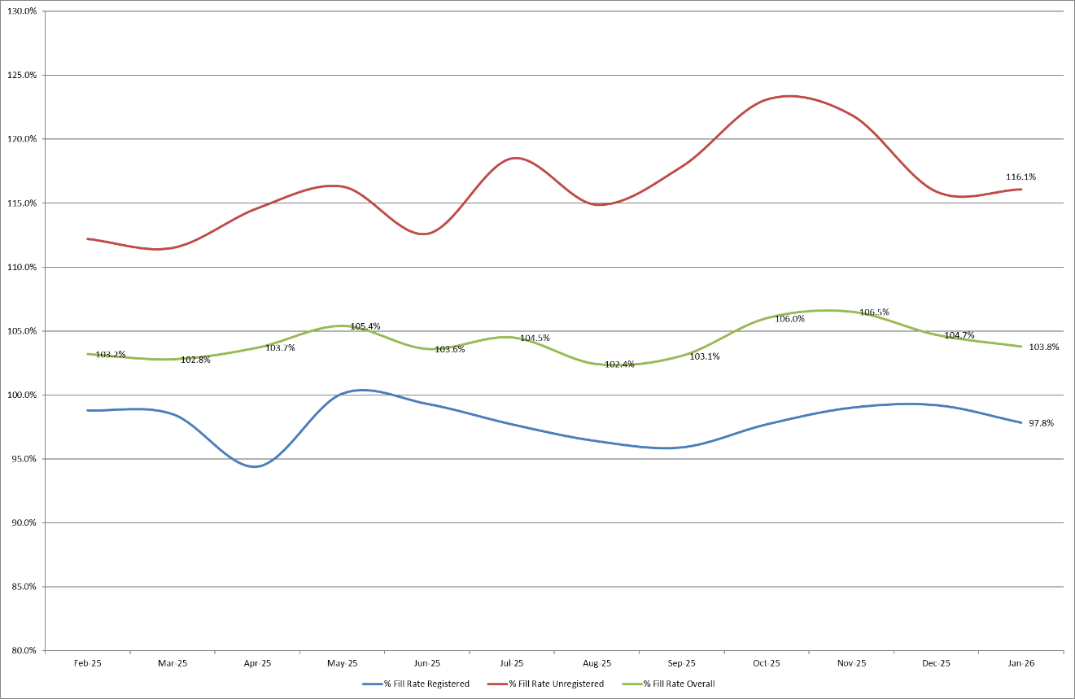
Appendix 1 sets out a ward-by-ward breakdown for the same period.
Trust wide – Recruitment continues to be positive, with 11 newly qualified nurses and 6 HCSW’s joining in January 2026 with a further 11 in the pipeline for RNs, and 9 for HCAs. A further recruitment event is planned for Spring and Summer 2026, targeting newly qualified graduates, including five internal apprentices who are due to complete their programmes. In addition, a programme of Healthcare Support Worker (HCSW) recruitment events has been scheduled throughout the year, with the first event taking place in March.
The end-of-year establishment review covering adult and paediatric inpatient wards, assessment units and the Emergency Department concluded on 14 October 2025 and is scheduled for Board approval in February 2026. This review will inform future roster templates and is intended to address acuity-driven pressures, including those identified through CHPPD benchmarking and enhanced care demand.
John Snow Ward – HCSW shifts were delivered below template, based on real-time assessment of patient capacity and acuity and driven by vacancies. Redeployment decisions were agreed through daily safety huddles to maintain safe staffing. This position was formally reviewed and captured in the September 2025 SNCT submission.
Maternity – Fill rates improved across the division in January, though some areas remain amber due to vacancies and sickness absence. Twice-weekly staffing reviews and deployment adjustments continue to maintain safety, supported by matrons and specialist midwives.
Emergency Departments – While national safer staffing reporting excludes Emergency Departments, local data for Adult and Paediatric ED’s is included for assurance (Appendix 1, Table 1b and 1c). Both EDs maintained stable overall and RN fill rates in January. However, Paediatric ED saw a further approximate 1% drop in HCSW fill, highlighting ongoing fragility. Shift profiling changes introduced in December are expected to improve resilience.
Enhanced Care – ETOC delivery in January relied entirely on temporary staffing for registered hours, with no substantive registered establishment aligned to this activity. Unregistered ETOC hours were largely delivered by bank staff, with only limited substantive contribution.
Despite this, there was a significant shortfall in unregistered ETOC hours. In practice, these unmet hours are absorbed by substantive ward teams, who flex to provide enhanced care alongside their allocated patient workload. This creates a hidden redistribution of risk, reducing available care time for other patients and increasing workload intensity across the ward.
The data evidences a structural establishment gap. ETOC demand is recurrent but not embedded within substantive workforce modelling, resulting in sustained bank reliance, continued cost pressure, and reduced operational resilience. While care continues to be delivered, this is achieved through internal workforce displacement rather than funded capacity, with associated patient safety and staff wellbeing implications. (Appendix 1, Table 1d)
Actions: A Task and Finish Group will finalise a sustainable ETOC model – shifting capacity to substantive roles, tightening governance around request/approval and closure, and reducing reliance on bank/agency through clearer risk criteria, training, and improved rostering.
3.1 Wards with < 75% average fill rate
No wards recorded an average fill rate below 75% during January 2026.
3.2 Wards with > 100% average fill rate
Harvey and Ray fill rates remain over 100% for registered staff during January 2026 because of needing prolonged registered mental health nurses and is therefore not concerning.
4.0 Redeployment
Appendix 2 outlines the data and trends for this month.
Redeployment continued to support safe staffing through daily safety huddles. In January, substantive redeployment remained broadly consistent with the previous three months, with only a marginal increase of 0.1%, suggesting overall staffing stability.
John Snow consistently flags as the ward most likely to redeploy staff, while the Adult Emergency Department remained the largest net receiver. Outpatient departments across HEH, PAH and SMH were redeployed 253 occasions to support staffing in inpatient areas. Governance remains robust, with all redeployments clinically risk-assessed and recorded in SafeCare.
5.0 Care Hours Per Patient Day (CHPPD)
CHPPD benchmarks staffing levels within the Trust and against peers, helping ensure the right numbers and skill mix. It is calculated by dividing total worked hours (registered and unregistered staff) by the midnight patient count. While a useful indicator of staffing input, CHPPD does not measure care quality or safety and should be considered alongside other quality and patient experience metrics for assurance. Appendix 3 has an additional table to review planned vs. actual CHPPD to establish any trends with excess fill rate of unregistered staff in Penn, OPAL, Tye Green and Charnley Wards.

Table 3. Overall Care Hours Per Patient Day (CHPPD) January 2026
Registered CHPPD | Unregistered CHPPD | Total CHPPD
4.9 | 2.8 | 7.8
Appendix 3 provides a detailed breakdown of CHPPD by ward and division for January 2026.
Table 4. CHPPD Trend and benchmarking with peer and national data
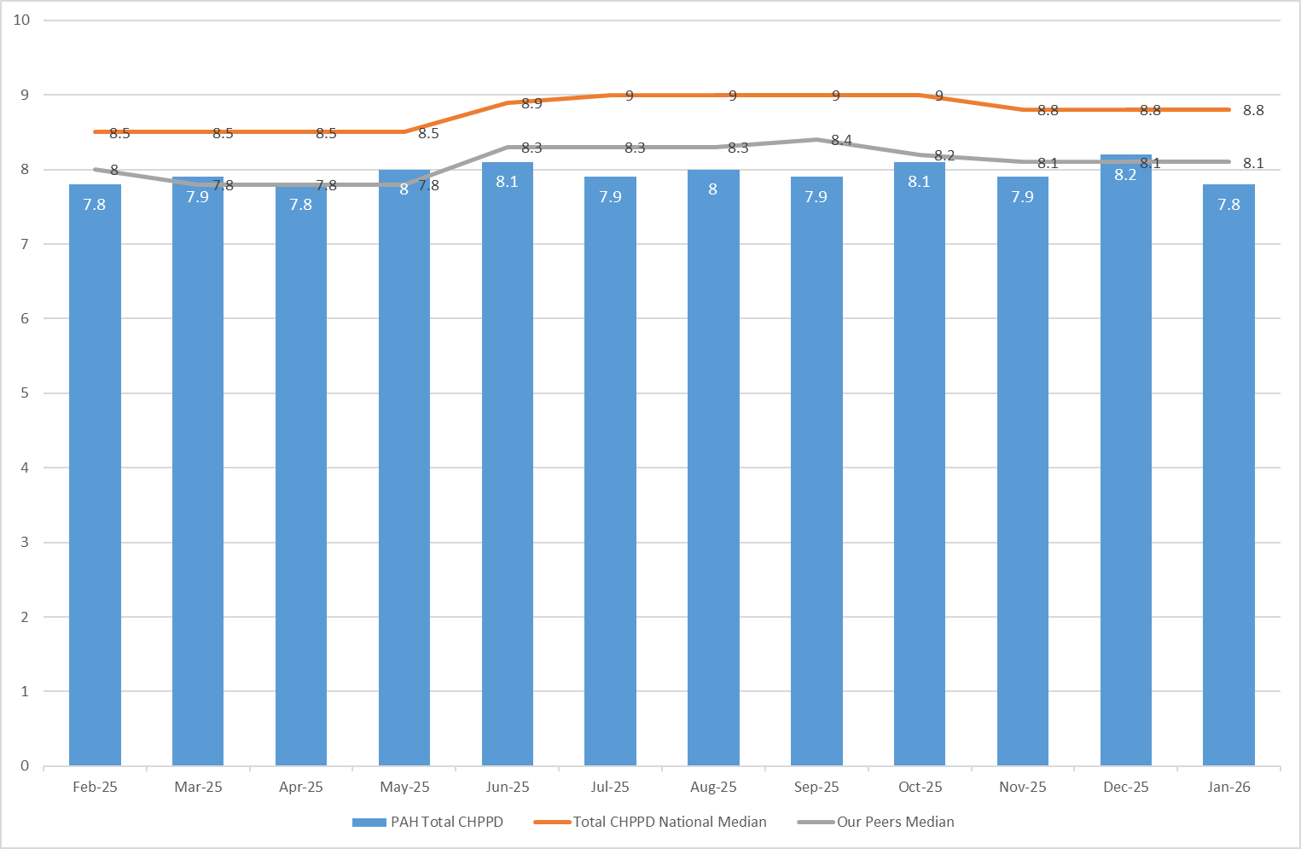
Peer organisations are: East and North Hertfordshire NHS Trust and West Hertfordshire Teaching Hospitals NHS Trust. The Trust’s CHPPD remains similar to peers but below national median benchmarks. The value has dropped in January 2026, our lowest since April 2025.
6.0 Quality Indicators
6.1 Red Flags and Incident Reports Relating to Staffing
Appendix 4 outlines data and trends for red flags and staffing incidents.
Staffing Red Flags are automatically generated when registered staffing falls below 75% of template, these prompt immediate action by the nurse in charge. In January, 73 shifts triggered Nursing Red Flags (+4), with maternity contributing 33 (-1). Hotspots included Birthing Unit, OPAL, and John Snow.
Across adult inpatient areas, 129 Red Flags were raised via SafeCare (-6), mainly due to RN shortfalls (57) and unmet enhanced care needs (57). Closure compliance remains poor: 123 remain open and only 16 resolved, despite improved reporting. Oversight has been strengthened through daily huddles and training, with closure compliance embedded in preceptorship and Band 6 development programmes.
45 staffing-related incidents were reported via Datix (43 nursing, 2 maternity), an increase (+13) compared to last month. The highest reporting areas were SDEC, Kingsmoor and Ray, accounting for 20 of all incident reports.
6.2 Falls, pressure ulcers and complaints, PALS and compliments
January data shows mixed trends across quality measures.
Falls decreased to 76 (-29), with unwitnessed falls dropping significantly to 54 (-38), though harm-related falls increased slightly to 19 (+5). Training compliance remains high (>97%), with focused support continuing in Kingsmoor and Harold.
Pressure ulcers increased overall, with reportable HAPUs jumping to 40 (+16) and non-reportable skin changes increasing to 39 (+5). ITU/HDU, Tye Green, and Kingsmoor remain under enhanced surveillance, while five wards reported zero HAPUs, several sustaining this for four months. Assurance is strengthened by the launch of a new tissue viability quality surveliance on 1 January 2026 and ongoing review of investigation processes.
Patient experience data highlights recurring themes of delays and communication. Complaints totalled 27 (mainly medical care and appointment delays), and PALS contacts reached 81, with similar themes, most centralised within ED. Only 3 compliments were recorded, reflecting inconsistent capture and limiting opportunities to share positive feedback.
Overall, quality indicators remain under close review. While harm trends show improvement in some areas, fragility persists, requiring sustained leadership focus and continued oversight to embed improvement.
Data and trends of quality indicators is provided in Appendix 5.
7.0 Conclusion: Assurance and Governance
The Trust maintained a sustained registered fill rate above 95%, providing assurance that staffing levels remained safe. However, acuity-driven pressures persisted, particularly enhanced care demand, continuing to challenge workforce resilience.
To mitigate these risks, the following governance controls were applied throughout January:
- Real-time oversight: Daily SafeCare huddles and three-times-daily acuity reviews supported informed redeployment decisions.
- Senior clinical support: Senior nurses and midwives provided direct support to high-risk areas.
- Temporary staffing: NHSP supported filling vacant shifts, including RMNs for patients with mental health needs.
- Enhanced care oversight: Local Red Flags for unmet enhanced care improved visibility, with data shared through the Enhanced Care Collaborative.
- SafeCare governance: Red Flags were reviewed daily and informed deployment decisions; training on reporting and closure remains embedded in daily huddles, preceptorship and Band 6 development programmes with local support provided.
- Redeployment governance: 188 substantive redeployments (1.17% of substantive hours) were recorded, monitored through daily huddles and monthly reporting.
- Escalation and assurance: Risks were escalated via divisional leadership and monitored through twice-daily compliance checks, weekly SafeCare reports, and monthly Board reporting.

8.0 Recommendation
The Board is asked to note the contents of this report, which provide assurance on the daily management and mitigation of nursing and midwifery staffing risks.

Appendix 1: Fill Rates
Table 1a: Ward level data – fill rates January 2026 (Adjusted Standard Planned Ward Demand)
 | >100% |  | 95 – 100% |  |  | 75-95% |  |  | <75%
 |  | Day |  |  | Night
Ward name |  | Average fill rate - registered nurses/midwives (%) |  | Average fill rate - care staff (%) | Average fill rate - registered nurses/midwives (%) |  | Average fill rate - care staff (%) | % Registered overall fill rate |  | % HCSW overall fill rate | % Overall fill rate
Harvey |  | 101.1% |  | 128.2% | 130.8% |  | 124.1% | 113.2% |  | 126.2% | 117.9%
Henry Moore |  | 82.8% |  | 97.1% | 129.7% |  | 101.0% | 100.4% |  | 99.0% | 99.8%
ITU & HDU |  | 94.0% |  | 111.2% | 97.6% |  | 114.8% | 95.8% |  | 112.9% | 97.4%
John Snow |  | 86.3% |  | 73.9% | 80.7% |  | 70.9% | 83.6% |  | 72.5% | 79.9%
Penn |  | 92.9% |  | 114.9% | 97.6% |  | 175.4% | 94.9% |  | 137.9% | 110.3%
Saunders |  | 86.9% |  | 108.5% | 117.6% |  | 164.1% | 98.4% |  | 129.6% | 110.1%
Surgery Total |  | 91.3% |  | 107.9% | 106.7% |  | 128.7% | 98.0% |  | 117.0% | 103.7%
Fleming |  | 85.3% |  | 98.3% | 98.5% |  | 114.8% | 90.9% |  | 106.2% | 95.6%
Harold |  | 92.0% |  | 104.7% | 101.1% |  | 130.0% | 96.0% |  | 116.8% | 102.6%
Kingsmoor |  | 85.0% |  | 122.2% | 103.8% |  | 136.4% | 92.1% |  | 129.0% | 105.9%
Lister |  | 97.0% |  | 106.6% | 99.3% |  | 135.1% | 97.9% |  | 120.2% | 106.8%
Locke |  | 94.2% |  | 106.7% | 98.4% |  | 126.8% | 96.0% |  | 116.3% | 104.1%
Nightingale |  | 100.5% |  | 66.5% | 97.0% |  | 107.0% | 98.8% |  | 85.9% | 92.3%
Opal |  | 100.8% |  | 128.2% | 89.8% |  | 153.0% | 95.6% |  | 140.1% | 113.4%
Ray |  | 109.5% |  | 106.5% | 125.8% |  | 139.6% | 116.4% |  | 119.0% | 117.3%
Tye Green |  | 87.3% |  | 107.6% | 95.5% |  | 136.4% | 90.9% |  | 119.3% | 102.0%
Winter |  | 90.6% |  | 109.2% | 100.0% |  | 127.7% | 94.6% |  | 118.1% | 103.9%
Medicine Total |  | 93.2% |  | 106.6% | 101.3% |  | 131.0% | 96.6% |  | 117.8% | 104.6%
AAU |  | 85.1% |  | 138.5% | 97.7% |  | 146.0% | 90.7% |  | 142.1% | 101.5%
Charnley |  | 93.7% |  | 143.2% | 94.2% |  | 172.6% | 94.0% |  | 157.2% | 112.0%
UEC Total |  | 88.4% |  | 140.8% | 96.2% |  | 159.3% | 92.0% |  | 149.7% | 106.0%
Birthing |  | 83.6% |  | 89.0% | 76.7% |  | 90.3% | 80.3% |  | 89.6% | 83.4%
Chamberlen |  | 100.8% |  | 78.0% | 96.1% |  | 96.8% | 98.6% |  | 87.0% | 95.7%
Dolphin |  | 98.1% |  | 81.0% | 104.8% |  | 94.7% | 101.1% |  | 85.6% | 97.2%
Labour |  | 101.4% |  | 83.4% | 93.7% |  | 86.4% | 97.7% |  | 84.8% | 94.9%
Neo-Natal Unit |  | 95.3% |  | 109.7% | 92.5% |  | 103.2% | 93.9% |  | 106.5% | 96.0%
Samson |  | 102.5% |  | 77.3% | 98.1% |  | 87.9% | 100.4% |  | 82.4% | 90.1%
CHAWS Total |  | 98.2% |  | 83.1% | 94.8% |  | 91.0% | 96.6% |  | 86.7% | 93.6%
Total |  | 94.8% |  | 106.7% | 101.6% |  | 127.3% | 97.8% |  | 116.1% | 103.8%
Table 1b: ED data – fill rates January 2026 (Standard Planned Demand)
Average day fill rate - registered nurses/midwives | Average day fill rate - care staff | Average night fill rate - registered nurses/midwives | Average night fill rate - care staff | % Registered overall fill rate | % HCSW overall fill rate | % Overall fill rate
104.3% | 105.6% | 119.9% | 129.9% | 111.3% | 116.4% | 112.9%

Table 1c: Paediatric ED data – fill rates January 2026 (Standard Planned Demand)
Average day fill rate - registered nurses/midwives | Average day fill rate - care staff | Average night fill rate - registered nurses/midwives | Average night fill rate - care staff | % Registered overall fill rate | % HCSW overall fill rate | % Overall fill rate
124.1% | 57.1% | 149.8% | 89.0% | 135.5% | 73.0% | 116.3%

Table 1d: Enhanced Care Data Demand Vs. Fill Rates January 2026

Appendix 2: Redeployment and trend data
Table 1. Hours of substantive staff redeployed January 2026
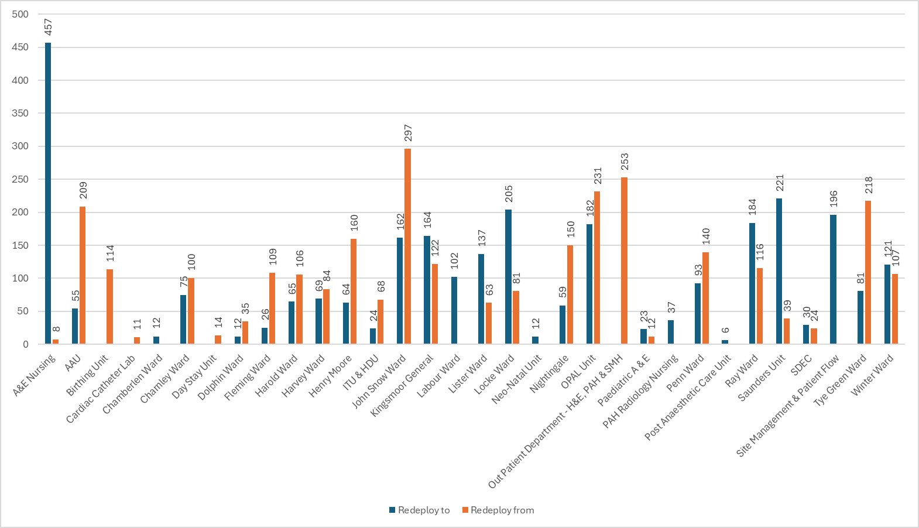

Table 2. Substantive staff redeployment ocasions trend Feb-25 – Jan-26
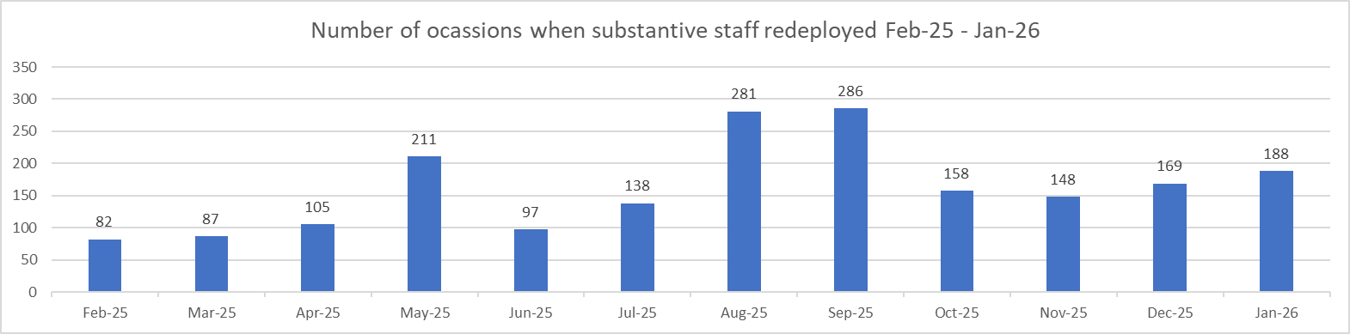

Table 3. % of substantive staff redeployed as % of total hours worked
Substantive staff hours redeployed | Total hours worked (inc. bank and agency) | % of total hours worked / substantive staff redeployed
1691.92 | 143671 | 1.17% (Dec- 1.16%)

Table 4. % of staff redeployed as % of total hours worked
All staff hours redeployed (including bank and agency but excluding Enhanced Care Team, Bank Pool and Rapid Response Pool) | Total hours worked (inc. bank and agency) | % of total hours worked / staff redeployed (including bank and agency but excluding Enhanced Care Team, Bank Pool and Rapid Response Pool)
2868.23 | 143671 | 1.99% (Dec- 2.2%)

Appendix 3: CHPPD

Table 1. Ward level data: CHPPD January 2026
Care Hours Per Patient Day (CHPPD)
Ward/Unit | Registered Nurses/Midwives | Non-registered Nurses/Midwives | Overall
Trust Total | 4.9 | 2.8 | 7.8
Harvey | 4.7 | 3.0 | 7.6
Henry Moore | 3.7 | 2.6 | 6.3
ITU & HDU | 18.5 | 2.2 | 20.6
John Snow | 5.1 | 2.2 | 7.3
Penn | 3.6 | 3.0 | 6.6
Saunders | 3.5 | 2.8 | 6.3
Surgery Total | 5.4 | 2.7 | 8.1
Fleming | 3.7 | 1.9 | 5.6
Harold | 4.5 | 2.5 | 7.1
Kingsmoor | 3.3 | 2.8 | 6.1
Lister | 3.7 | 3.0 | 6.8
Locke | 3.6 | 2.9 | 6.5
Nightingale | 3.4 | 3.0 | 6.4
Opal | 4.2 | 4.1 | 8.2
Ray | 4.4 | 2.5 | 6.9
Tye Green | 3.8 | 3.2 | 7.0
Winter | 3.5 | 2.9 | 6.5
Medicine Total | 3.8 | 2.8 | 6.7
AAU | 5.9 | 2.5 | 8.4
Charnley | 4.1 | 2.8 | 6.9
UEC Total | 5.0 | 2.6 | 7.7
Birthing Unit | 14.1 | 7.9 | 22.0
Chamberlen | 8.6 | 2.5 | 11.1
Dolphin | 9.6 | 2.7 | 12.3
Labour | 27.6 | 6.8 | 34.4
Neo-Natal | 9.5 | 2.1 | 11.6
Samson | 2.8 | 3.1 | 5.8
CHAWS Total | 8.6 | 3.3 | 11.9

Table 2. Planned Vs. Actual CHPPD needs 1.1.26 – 31.1.26

Charnley
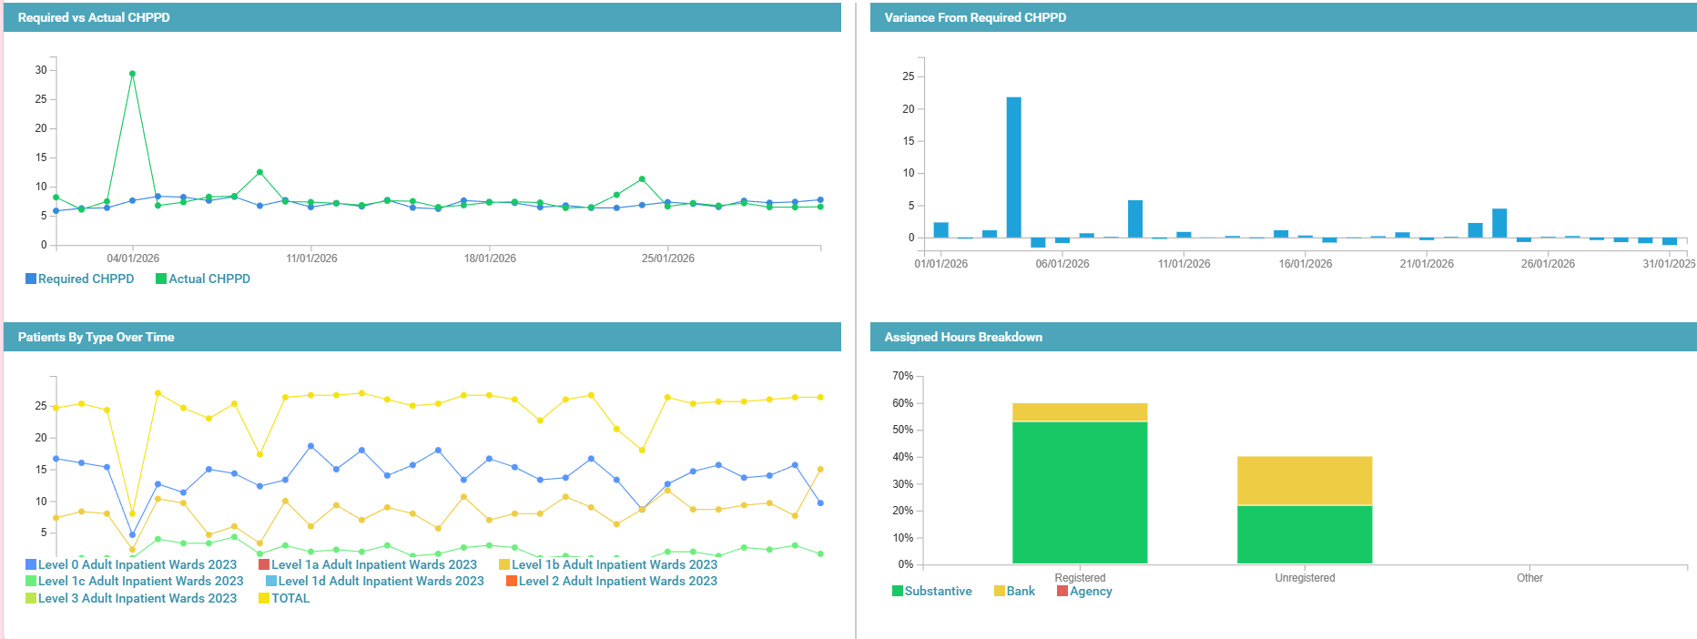

Penn Ward
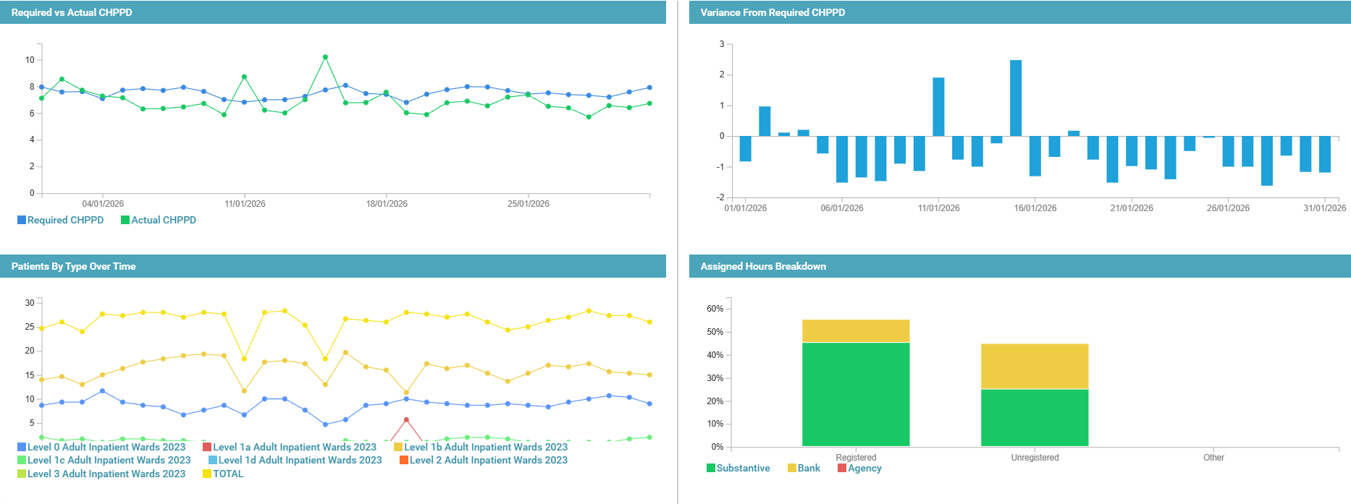

OPAL
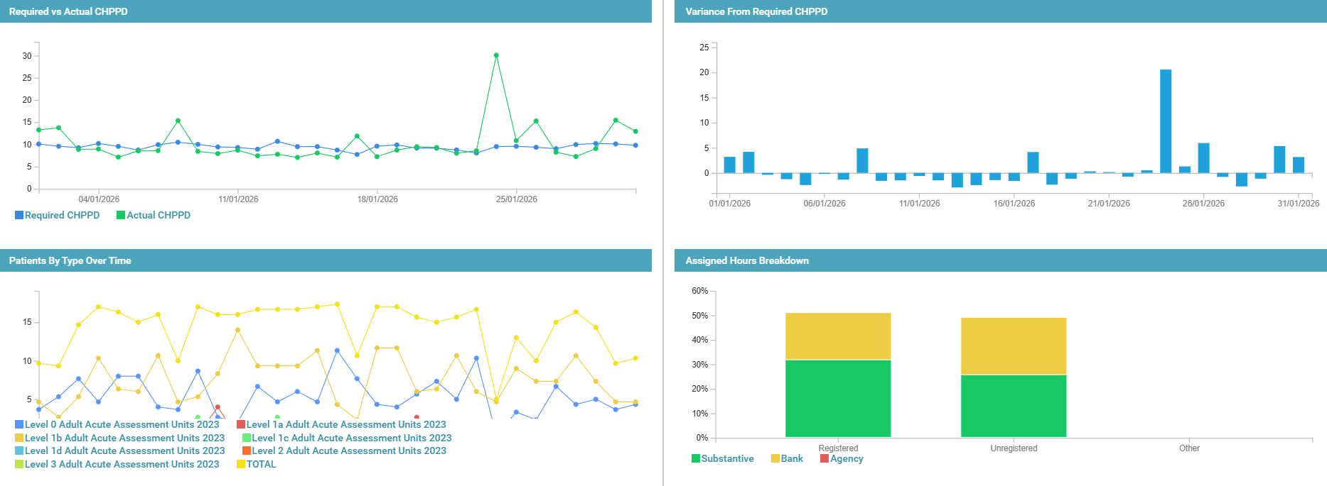

Tye Green

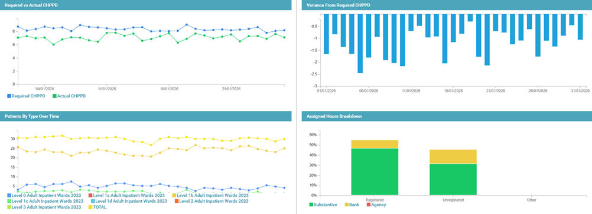

This data indicates that despite elevated HCA levels, required vs. Actual CHPPD typically aligned in Charnley, but there were gaps across the other inpatient areas. However, it demonstrates a heavier reliance on bank shifts for unregistered staff compared to registered, drivers for this such as vacancies, enhanced care demands, inadequate establishments or poor rostering need to be considered.

Appendix 4. Nursing Red Flags (NICE 2014), Incident Reports and Trend Data

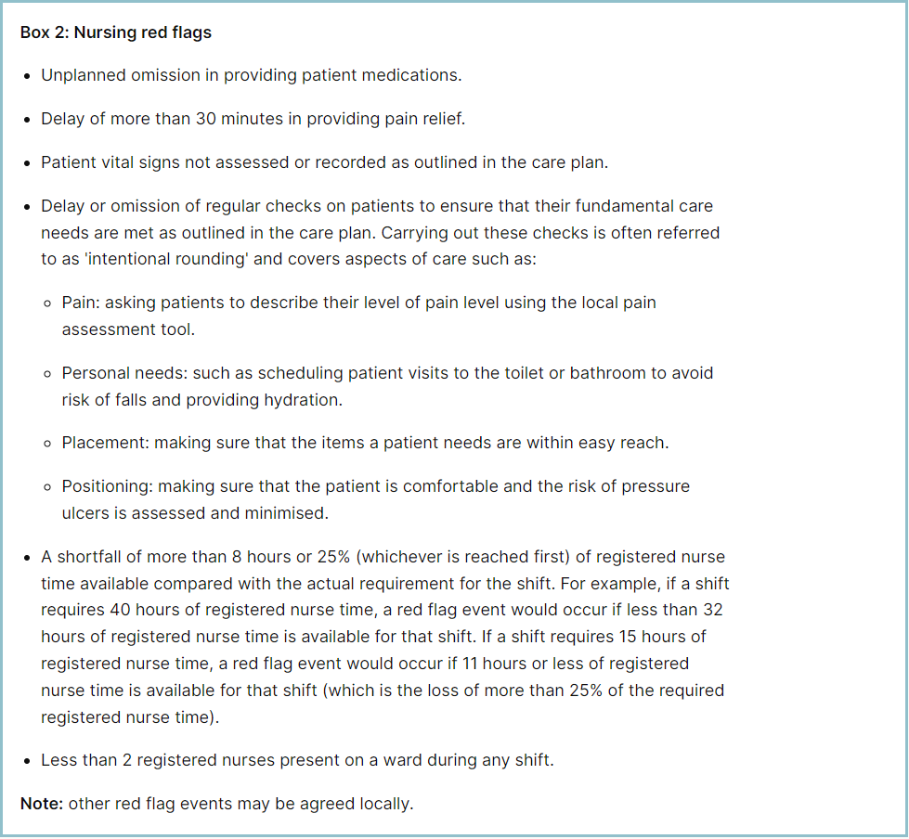

Staffing Red Flags and Trend Data

Table 1. Occasions when registered staffing fell below 75% of standard template Jan-26

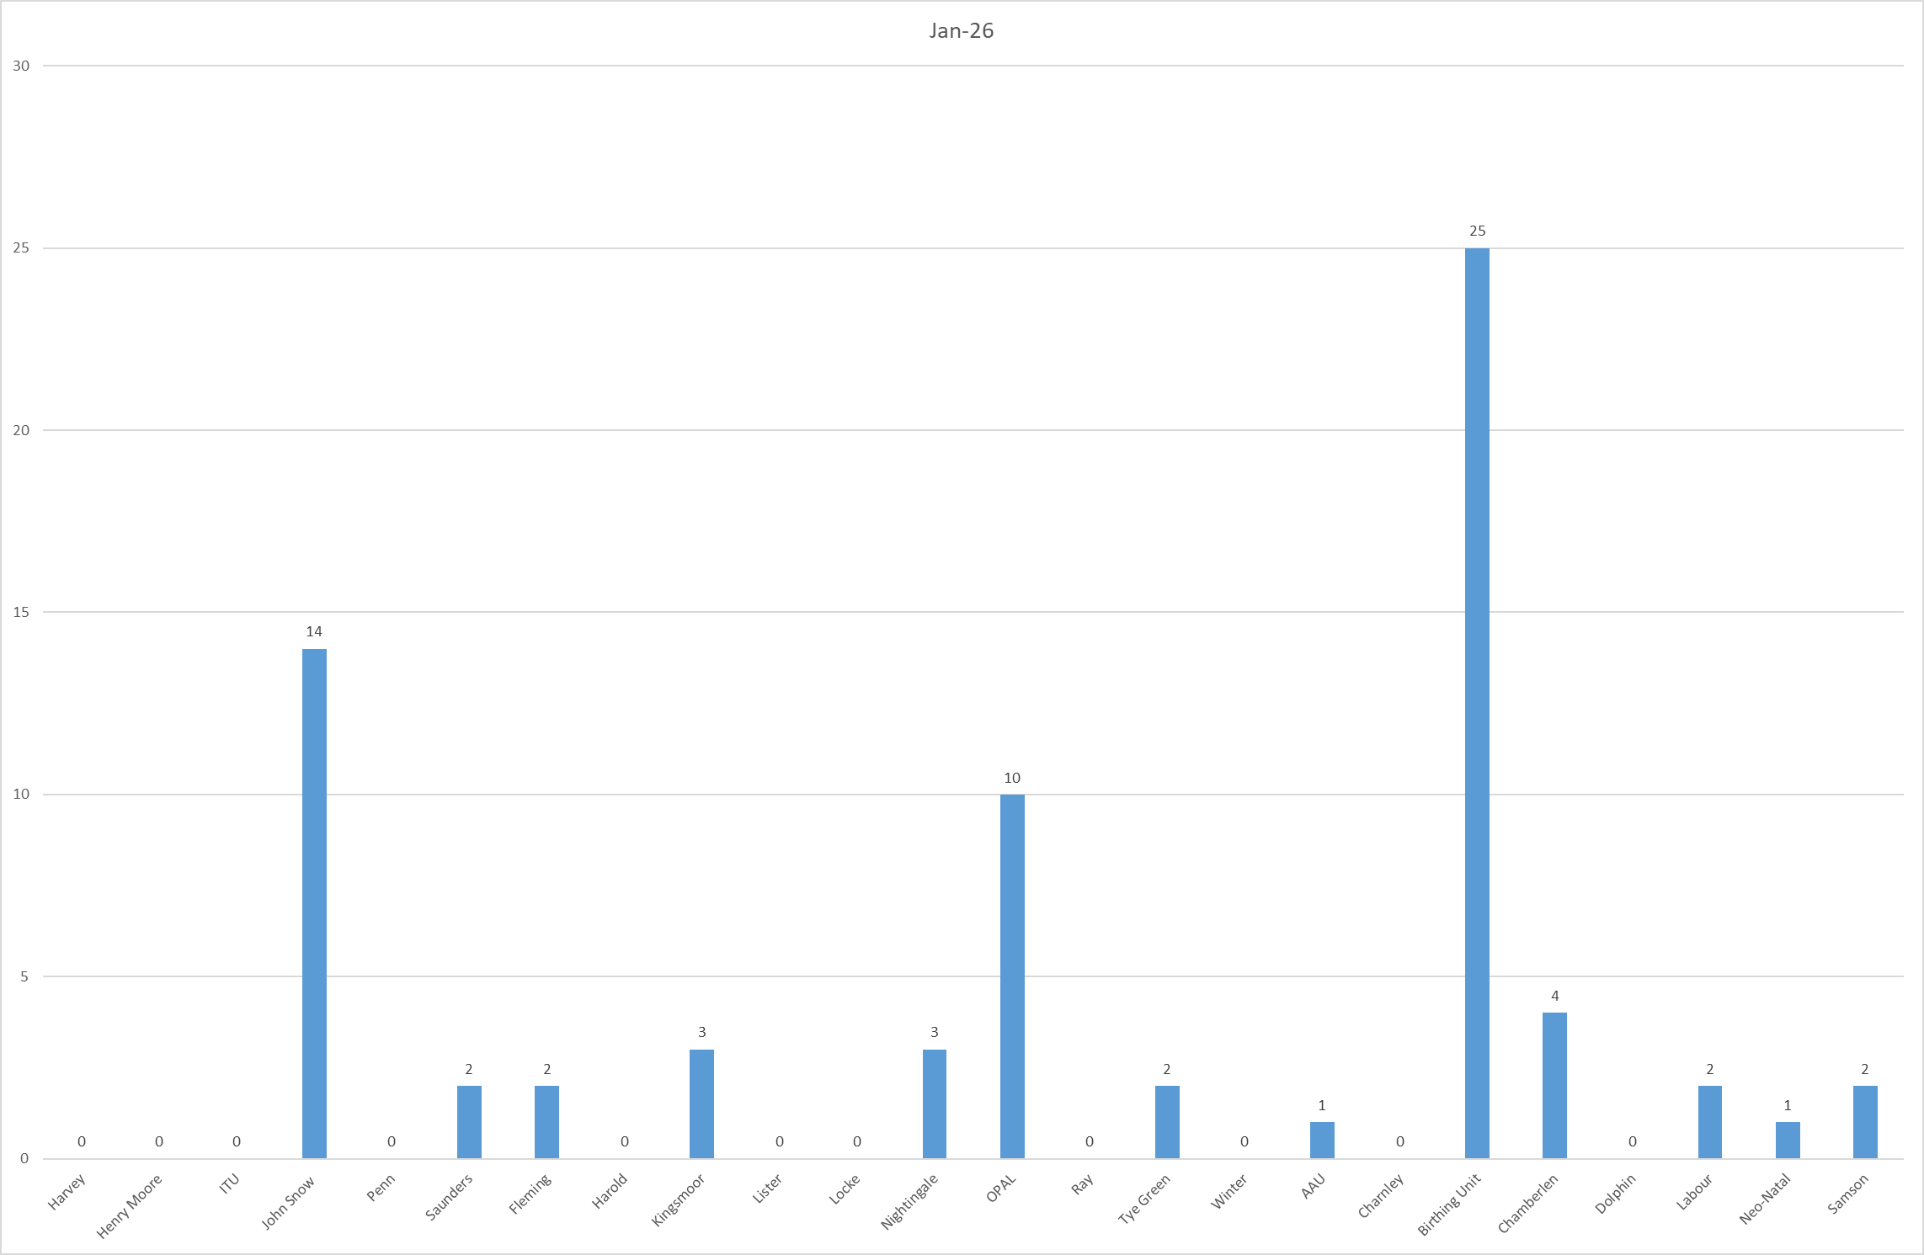

Table 2a. Occasions when all registered staffing fell below 75% of standard template. Trend Data Feb-25 – Jan-26

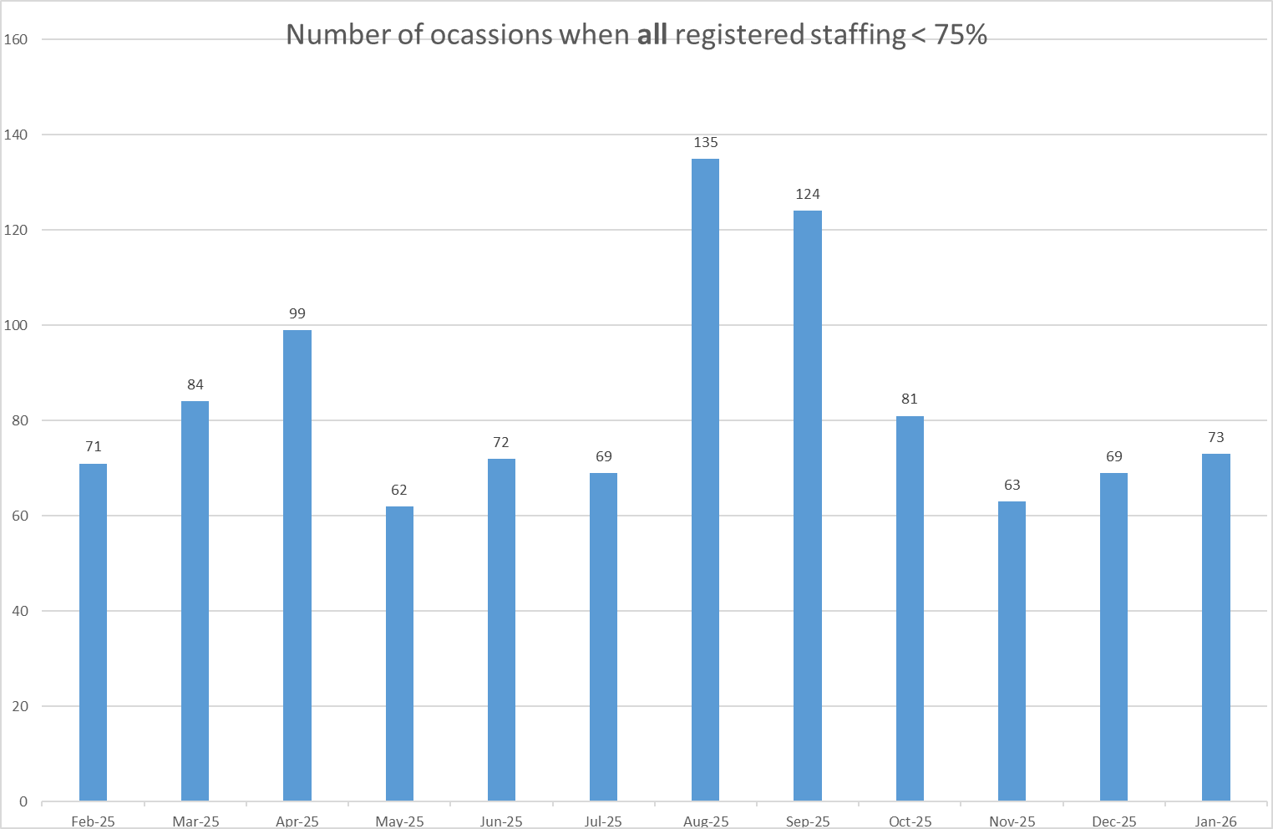

Table 2b. Occasions when registered maternity staffing fell below 75% of standard template. Trend Data Feb-25 – Jan-26

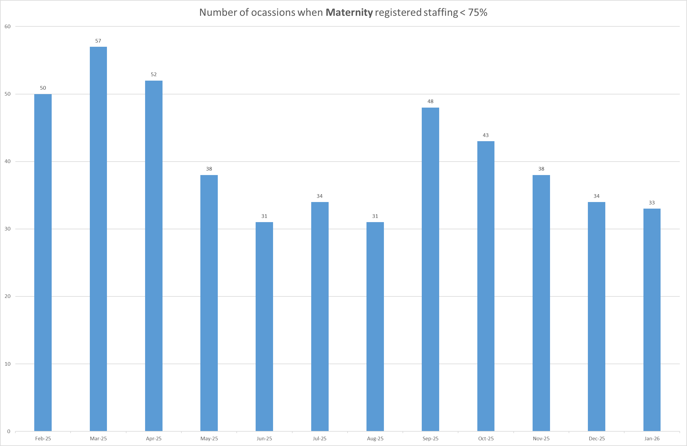

Table 3a. Red Flags raised via SafeCare Jan-26

Table 3b. Red Flags raised via SafeCare trend Feb-25 – Jan-26

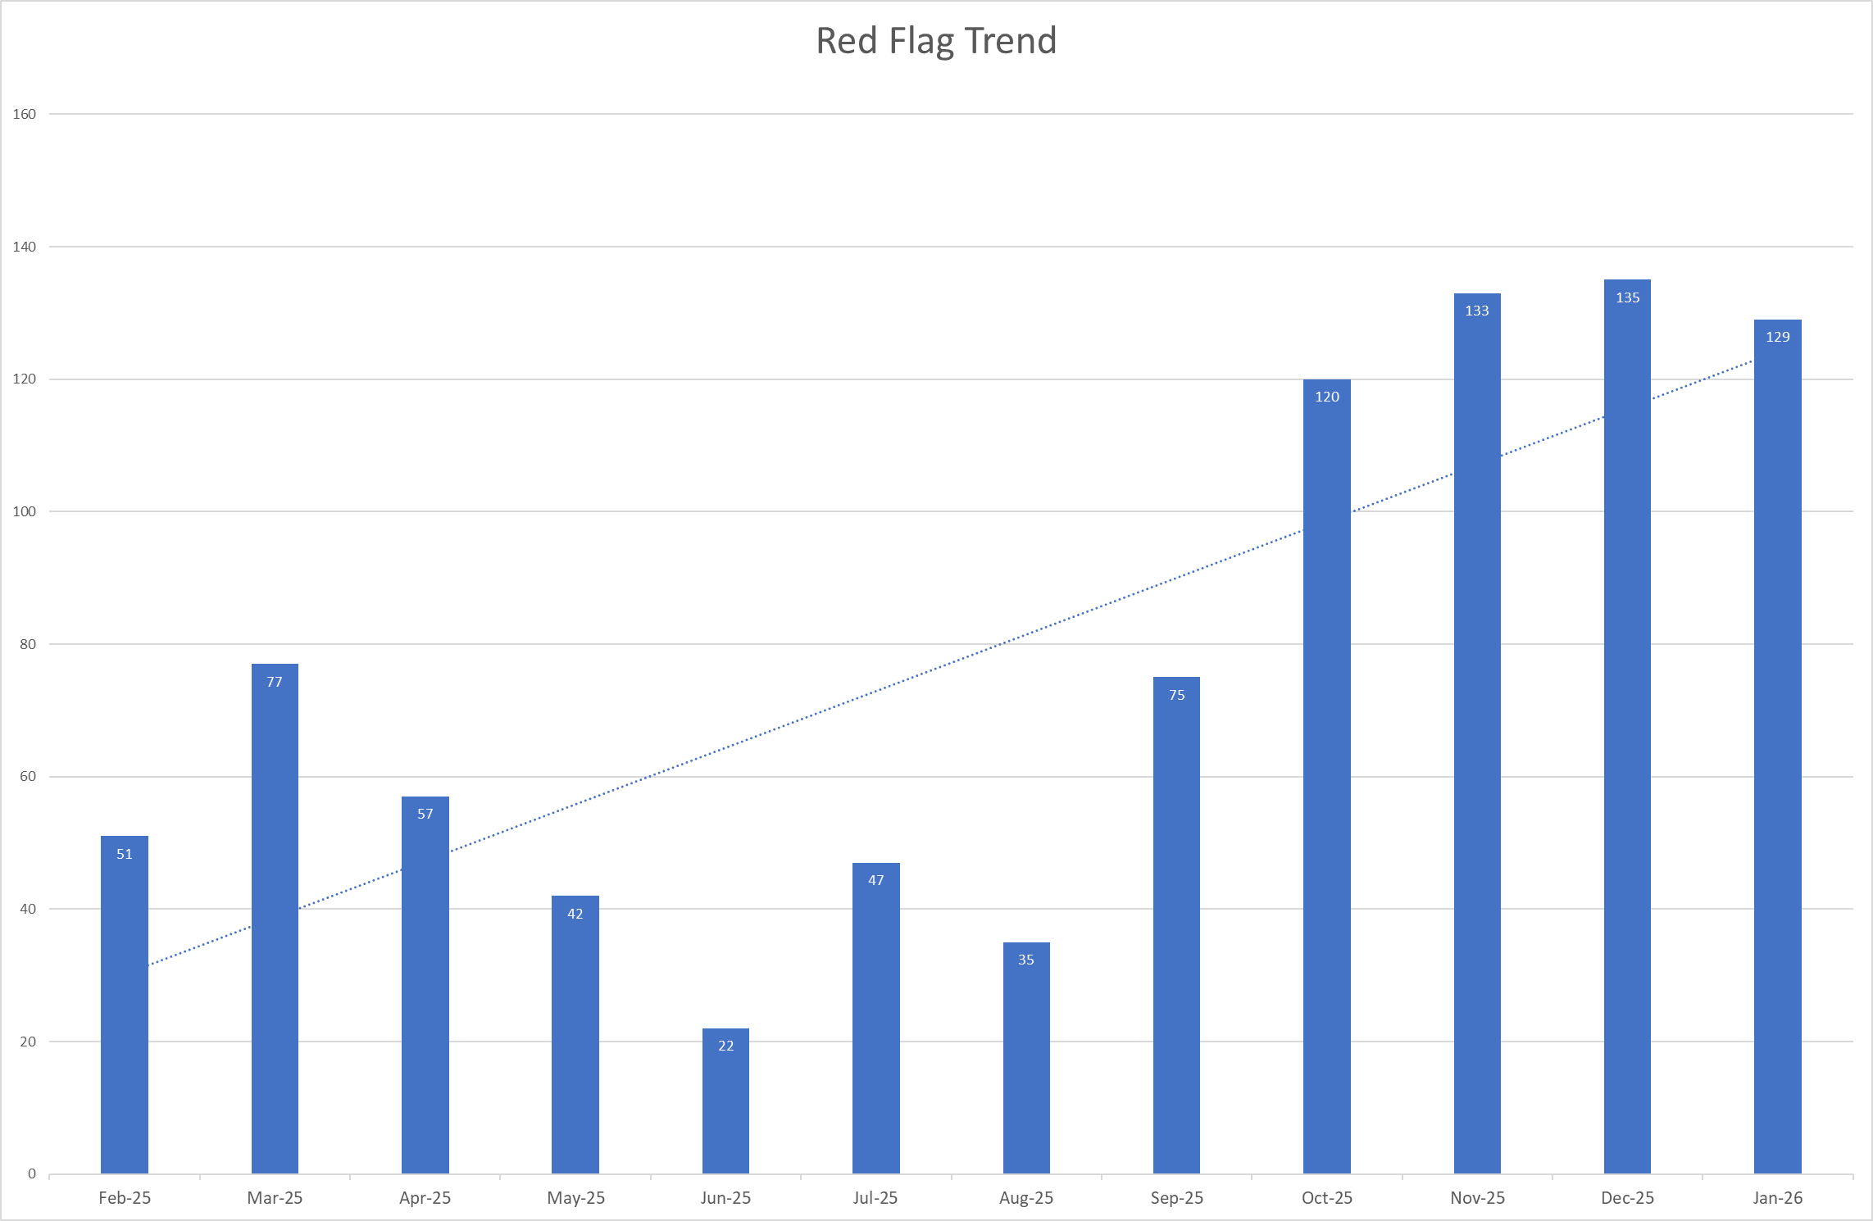

Table 3c. Datix for lack of suitably trained / skilled staff Jul-25 – Jan-26
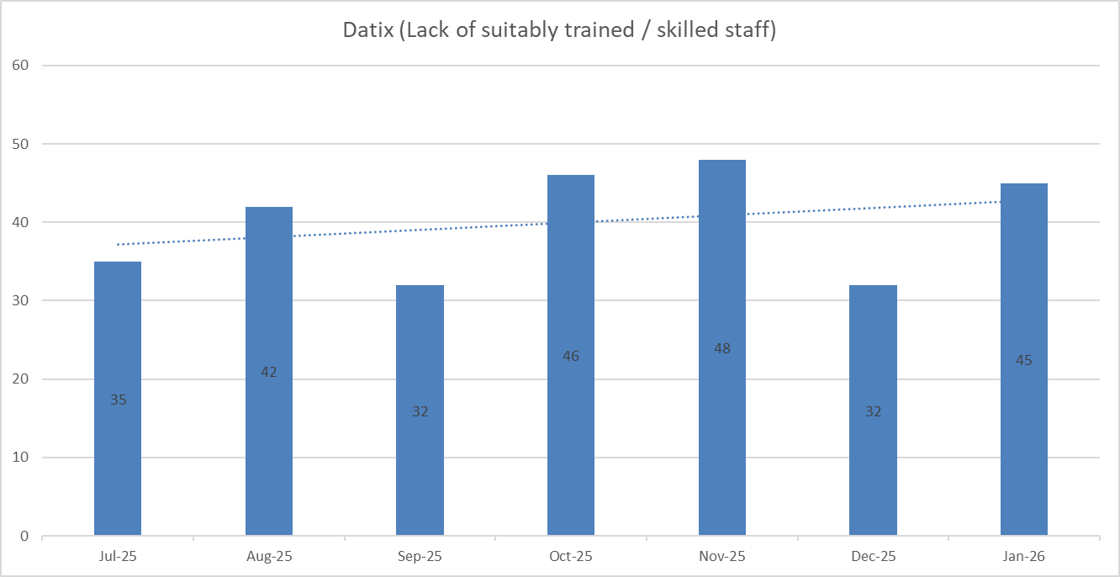

Appendix 5: Nursing quality indicators
Falls
Table 1. Number of falls and categories in January 2026, with the top 3 wards highlighted.
 | Total falls in month | Top 3 wards
Total falls | 76 | Lister – 9 | AAU – 7 | Kingsmoor – 7
Unwitnessed falls | 54 | Lister – 6 | Saunders – 6 | Kingsmoor - 5
Falls with harm * | 19 | AAU – 3 | A&E – 3 | Lister, Saunders, Locke, Harvey - 2
*Subject to change following review at Falls Incident Oversight Group

Falls Rate per 1000 bed days January 2026 data

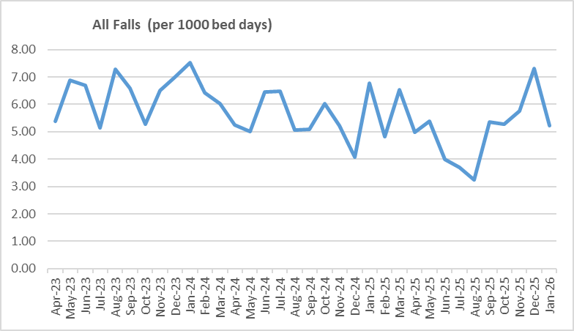

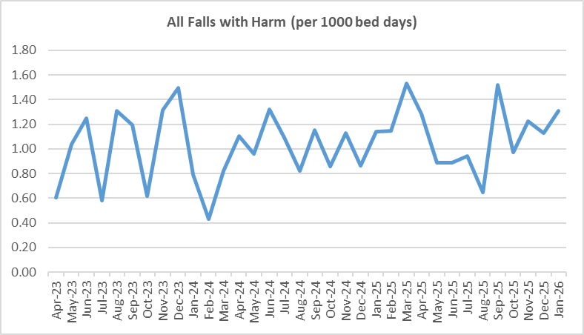
Pressure Ulcers

Table 2a. Number of Hospital Acquired Pressure Ulcers (HAPU) Cat 2 and Cat 3 Pressure Ulcers
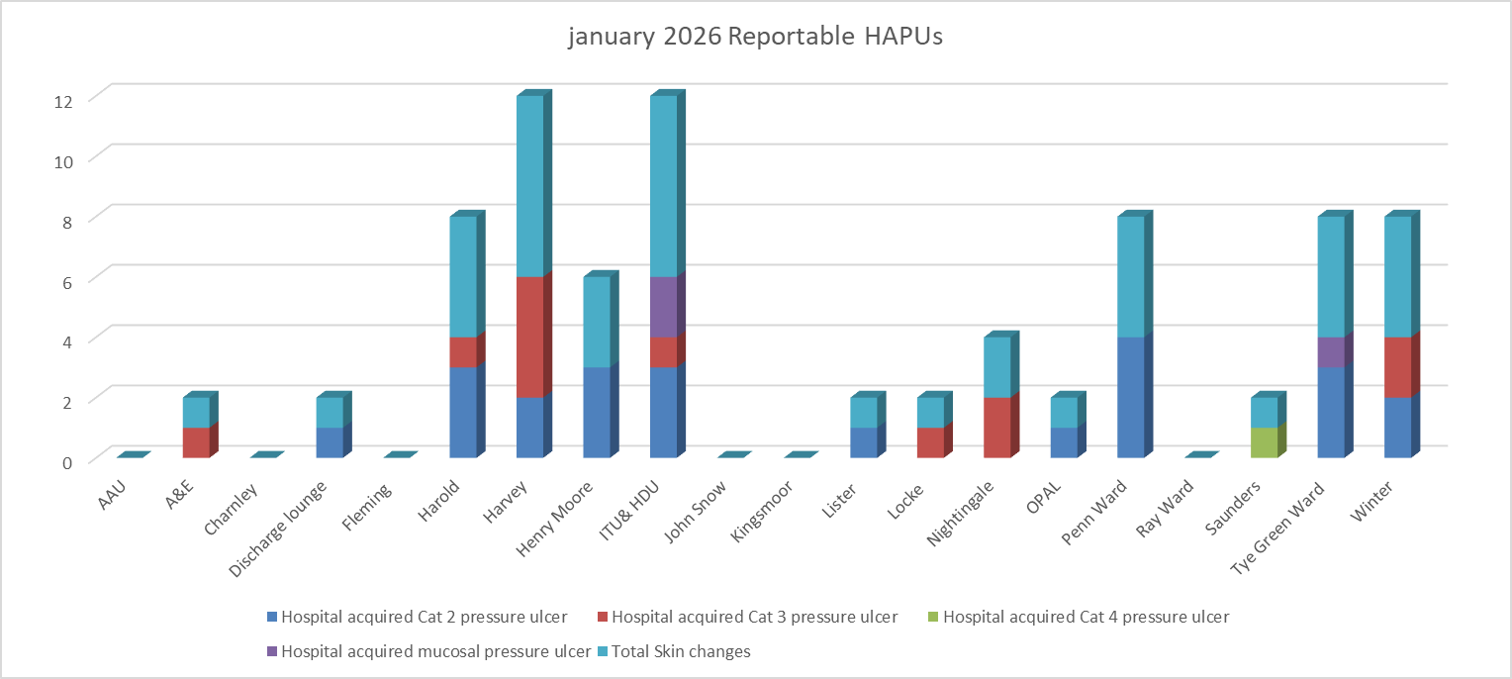

Total in month | Top 3 wards
39 | ITU – 6 | Harvey - 6 | Tye green, Winter, Harold and Penn – 4

Table 2b. Reported Incidents and Actual Hospital Acquired Pressure Ulcers January 2026

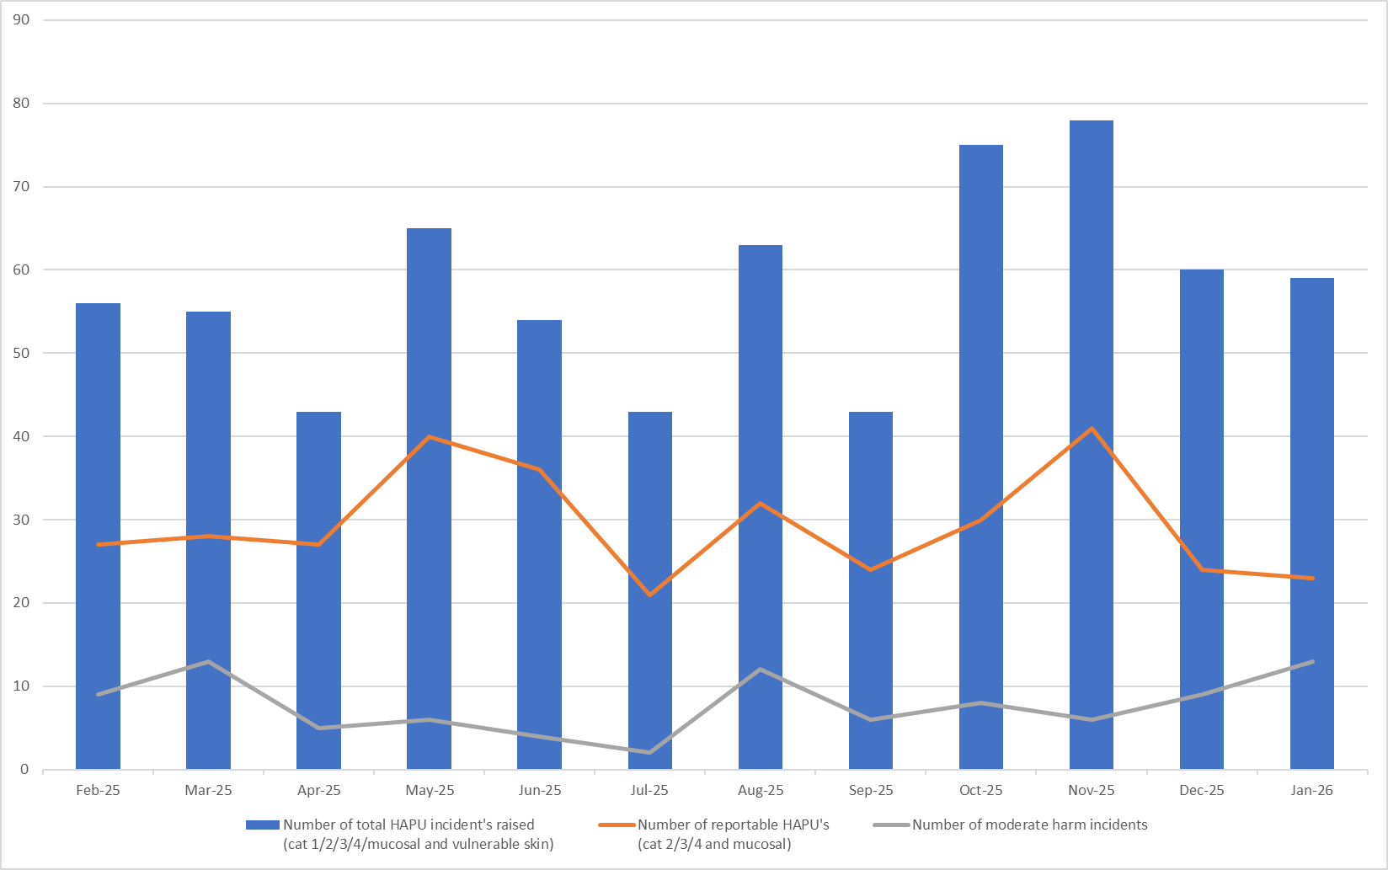
Complaints, PALS and Compliments Trend Data August 2025 – January 2026
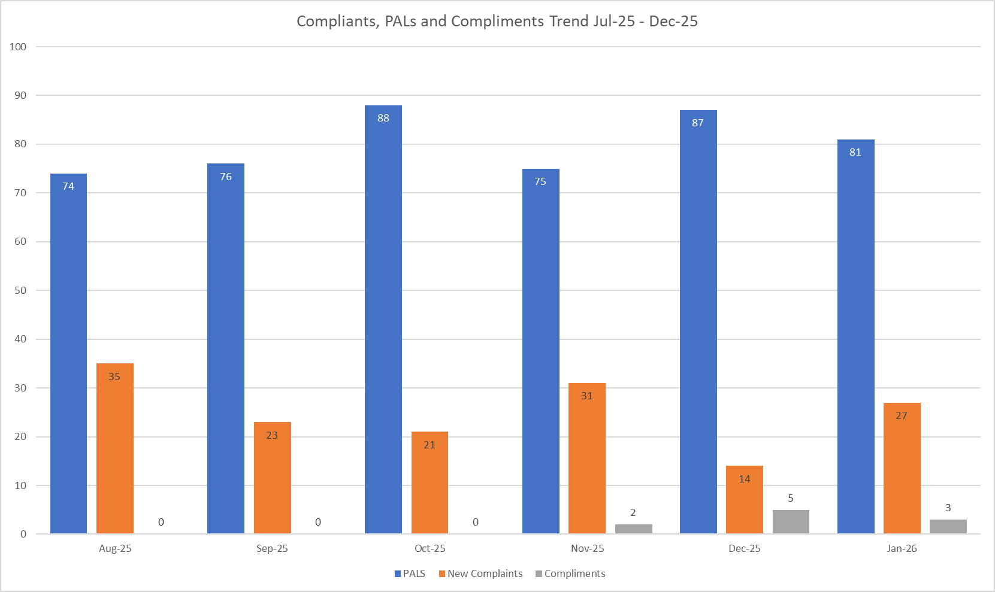
Table 3. Number of new Complaints, PALS and Compliments in January 2026 with top three wards highlighted
 | Total in month | Top Departments
New complaints | 27 | A&E – 9 | Labour – 3 | Paeds ED – 3
PALs | 81 | A&E – 25 | Ray – 6 | Winter – 5
Compliments | 3 | A&E – 3
Complaints: main themes: Medical care – 29.46%, Delay – 14.29%, Communications – 12.5% PALS: main themes: Delay – 41.05%, Communication – 25.48%, Cancellations – 9.78%
Compliments: Only 5 recorded; themes not provided – data capture remains inconsistent.

