|  |  |  |  |  |  |  |  |  |  |  |  |
| --- | --- | --- | --- | --- | --- | --- | --- | --- | --- | --- | --- |
| **Agenda item:**  **Presented by:**  **Prepared by:**  **Date prepared:**  **Subject / title:** | Giuseppe Labriola – Deputy Chief Nurse  David Dellow – Safe Staffing Lead and Giuseppe Labriola – Deputy Chief Nurse    19.02.2025  Report on Nursing and Midwifery staff levels for January 2025. | | | | | | | | | | |
| **Purpose:** | **Approval** |  | **Decision** | |  | **Information** | | **x** | **Assurance** | | **x** |
| **Key issues:** | There has been a sustained overall registered fill of > 95%.  No wards achieved < 75% overall fill rate in month. The increase in overall fill rates is due to enhanced care needs.    The next interim establishment review (which underpins the rota templates) is due to commence in March 2025. | | | | | | | | | | |
| **Recommendation:** | The committee are asked to note the information within this report. | | | | | | | | | | |
| **Trust strategic objectives:** | Princess Alexandra_strap line blocks NHS blue text  **Patients** | **People** | | **Performance** | | | **Places** | | | **Pounds** | |
| x | x | | x | | |  | | | x | |
|  |  | | | | | | | | | | |
| **Previously considered by:** | NA | | | | | | | | | | |
| **Risk / links with the BAF:** | BAF: 2.1 Workforce capacity | | | | | | | | | | |
| **Legislation, regulatory, equality, diversity and dignity implications:** | NHS England and CQC letter to NHSFT CEOs (31.3.14): Hard Truths Commitment regarding publishing of staffing data.  NHS Improvement letter: 22.4.16  NHS Improvement letter re CHPPD: 29/6/18 | | | | | | | | | | |
| **Appendices:** | **Appendix 1:** Ward and divisional fill rates by month against adjusted standard planned template.  **Appendix 2**: Ward and divisional CHPPD data  **Appendix 3:** Nursing red flags  **Appendix 4:** Nursing quality indicators | | | | | | | | | | |

**1.0 Introduction**

This paper illustrates how PAHT’s nursing and midwifery staffing has been deployed for the month of January 2025. It evidences how planned staffing has been successfully achieved and how this is supported by nursing and midwifery recruitment and deployment.

**2.0 Background**

The National Quality Board (NQB 2016) recommend that monthly, actual staffing data is compared with expected staffing and reviewed alongside quality of care, patient safety, and patient and staff experience data. The Trust is committed to ensuring that improvements are learned from and celebrated, and areas of emerging concern are identified and addressed promptly. This paper will identify safe staffing and actions taken in January 2025. The following sections identify the processes in place to demonstrate that the Trust proactively manages nursing and midwifery staffing to support patient safety.

**3.0 Inpatient wards fill rate**

The Trust’s safer staffing submission has been submitted to NHS Digital for January 2025 within the data submission deadline. Table 1 shows the summary of the overall fill rate for this month. Table 2 shows a summary of overall fill rate percentages for a rolling 12-month period.

Appendix 1 illustrates a ward-by-ward breakdown for this period.

**3.1 Wards with < 75% average fill rate**

No wards that had an overall fill rate of < 75%:

**3.2 Wards with > 100% average fill rate**

Henry Moore Ward has an increased fill rate due to fluctuating capacity and opening of additional surgical beds and a Level 1 area for post-operative patients, the Level 1 bay is staffed by ITU and the staffing is reflected in their numbers. Therefore, the additional staff are reflective of the required workforce to meet the activity demands.

The impact of staffing requirements for patients requiring enhanced care is shown in the number of wards which continue to have greater than 100% fillrate, this is demonstrated in wards such as Penn, Saunders, Nightingale and Henry Moore Wards night fill rate for Healthcare support workers (HCSWs). The fill rate is based against the standard ward template

Greater than 100% fill rate for Registered Nurse (RN) shifts continues to be mainly attributable to enhanced care requirements, although supernumerary status for newly qualified nurses contributes towards this.

The Trust continues to utilise NHS Professionals and agency to mitigate vacant shifts. Additional control measures continue to be in place regarding the creation of additional duties. Furthermore, our senior nurses and midwives are also supporting individual areas when required. SafeCare data continues to be collected three times a day to enhance staffing governance across the organisation.

Further detail can be found in Appendix 1

**Table 1. Overall fill rate**

|  |  |  |  |  |  |  |
| --- | --- | --- | --- | --- | --- | --- |
| **Average day fill rate - registered nurses/midwives** | **Average day fill rate - care staff** | **Average night fill rate - registered nurses/midwives** | **Average night fill rate - care staff** | **% Registered overall fill rate** | **% HCSW overall fill rate** | **% Overall fill rate** |
| **94.7%** | **101.5%** | **103.9%** | **132.1%** | **98.8%** | **115.2%** | **104.2%** |

**Table 2. Inpatient fill rate including Maternity Wards Trend**

**4.0 Care Hours Per Patient Day (CHPPD)**

CHPPD allows comparison of a ward’s CHPPD figure with that of other wards in the hospital, or with similar wards in other hospitals. It can be used to look at variation between similar wards to ensure the right staff are being used in the right way and in the right numbers.

The hours worked during day and night shifts by registered nurses and midwives and healthcare assistants are added together. This figure is then divided by the number of patients at midnight, this then gives the total CHPPD

By itself, the CHPPD does not reflect the total amount of care provided on a ward nor does it directly show whether care is safe, effective or responsive. It should therefore be considered alongside measures of quality and safety.

**Table 3. Overall Care Hours Per Patient Day (CHPPD) January 2025**

|  |  |  |
| --- | --- | --- |
| Registered CHPPD | Unregistered CHPPD | Total CHPPD |
| 4.9 | 2.8 | 7.7 |

The Model Hospital data for November 2024 shows the Trust with a CHPPD of 7.7 against the national median of 8.6**.** Table 4 also shows the Trusts total CHPPD against our peers (East and North Hertfordshire NHS Trust and West Hertfordshire Teaching Hospitals NHS Trust)

Appendix 2 shows the individual ward and divisional CHPPD for January 2025

**Table 4. CHPPD Trend**

**5.0 Quality Indicators**

**5.1 Nursing Red Flags**

Nursing red flags prompt an immediate response by the registered nurse in charge of the ward. The response may include allocating additional nursing staff to the ward or other appropriate responses. Appendix 3 details the NICE (2014) definition of Nursing Red Flags, the number of occasions when registered staffing fell below 75% of the standard template and trend and the number of Red Flags raised in SafeCare. Currently, this information cannot be monitored for all nursing red flags on the DATIX system and a system has been implemented to capture these in SafeCare.

**5.2 Quality indicators (Falls, pressure ulcers and complaints, PALS and compliments)**

Nursing quality indicators have been reviewed and there is no correlation between these, fill rates or red flags which are a cause of concern. A review of quality indicators can be found in Appendix 4

**6.0 Conclusion**

The Trust continues to achieve a sustained overall registered fill of > 95%. The increase in overall fill rates are primarily due to enhanced care needs. The Trust is part of an enhanced care collaborative working group supported by NHS England that is reviewing the provision of enhanced care including the workforce and training requirements to sustainably manage this demand. Outputs from this working group will be available during quarter one.

**7.0 Recommendation**

The committee are asked to note the information in this report to provide assurance on the daily mitigation of nursing and midwifery staffing.

**Appendix 1:** **Ward level data and narrative: fill rates January 2025 *(Adjusted Standard Planned Ward Demand)***

|  |  |  |  |
| --- | --- | --- | --- |
| >100% | 95 – 100% | 75-95% | <75% |

|  |  |  |  |  |  |  |  |
| --- | --- | --- | --- | --- | --- | --- | --- |
|  | **Day** | | **Night** | |  | | |
| **Ward name** | **Average fill rate - registered nurses/midwives (%)** | **Average fill rate - care staff (%)** | **Average fill rate - registered nurses/midwives (%)** | **Average fill rate - care staff (%)** | **% Registered overall fill rate** | **% HCSW overall fill rate** | **% Overall fill rate** |
| Harvey | **90.2%** | **130.7%** | **111.4%** | **143.3%** | **98.9%** | **136.7%** | **112.6%** |
| Henry Moore | **132.5%** | **151.5%** | **183.0%** | **183.2%** | **152.7%** | **166.7%** | **158.8%** |
| ITU & HDU | **96.1%** | **69.8%** | **104.5%** | **100.0%** | **100.3%** | **84.9%** | **98.9%** |
| John Snow | **109.8%** | **42.3%** | **106.5%** | **82.8%** | **108.2%** | **55.1%** | **85.3%** |
| Penn | **109.7%** | **123.9%** | **121.0%** | **210.8%** | **114.5%** | **156.9%** | **129.7%** |
| Saunders | **96.4%** | **119.0%** | **126.2%** | **212.8%** | **107.5%** | **154.6%** | **125.3%** |
| ***Surgery Total*** | **102.5%** | **111.5%** | **117.9%** | **168.0%** | **109.3%** | **135.0%** | **117.0%** |
| Fleming | **92.2%** | **92.6%** | **100.7%** | **126.7%** | **95.8%** | **108.9%** | **99.8%** |
| Harold | **89.6%** | **89.9%** | **103.8%** | **114.0%** | **95.8%** | **101.4%** | **97.6%** |
| Kingsmoor | **85.3%** | **113.8%** | **108.1%** | **132.1%** | **94.0%** | **122.5%** | **104.6%** |
| Lister | **92.8%** | **107.0%** | **104.0%** | **134.9%** | **97.6%** | **120.3%** | **106.6%** |
| Locke | **90.5%** | **103.7%** | **100.0%** | **132.1%** | **94.5%** | **117.3%** | **103.6%** |
| Nightingale | **110.6%** | **81.6%** | **111.5%** | **206.5%** | **111.0%** | **120.8%** | **115.3%** |
| Opal | **105.5%** | **94.1%** | **102.8%** | **125.7%** | **104.2%** | **109.2%** | **106.2%** |
| Ray | **96.7%** | **101.7%** | **102.8%** | **176.9%** | **99.3%** | **130.2%** | **110.4%** |
| Tye Green | **96.6%** | **103.2%** | **103.9%** | **143.6%** | **99.8%** | **119.7%** | **107.5%** |
| Winter | **95.2%** | **94.7%** | **107.3%** | **110.9%** | **100.3%** | **102.4%** | **101.2%** |
| ***Medicine Total*** | **93.7%** | **99.4%** | **104.1%** | **134.7%** | **98.2%** | **115.3%** | **104.6%** |
| AAU | **87.1%** | **140.3%** | **95.4%** | **158.0%** | **90.8%** | **148.8%** | **103.0%** |
| Charnley | **94.9%** | **108.0%** | **105.9%** | **135.0%** | **100.1%** | **120.9%** | **106.1%** |
| ***UEC Total*** | **90.1%** | **124.1%** | **99.8%** | **146.5%** | **94.5%** | **134.8%** | **104.3%** |
| Birthing | **83.9%** | **83.5%** | **81.1%** | **86.8%** | **82.5%** | **85.1%** | **83.4%** |
| Chamberlen | **90.9%** | **52.2%** | **85.0%** | **87.1%** | **88.1%** | **68.9%** | **83.3%** |
| Dolphin | **92.8%** | **73.4%** | **95.8%** | **88.6%** | **94.2%** | **78.5%** | **90.2%** |
| Labour | **84.9%** | **96.0%** | **91.0%** | **80.8%** | **87.8%** | **88.7%** | **88.0%** |
| Neo-Natal Unit | **91.7%** | **93.9%** | **95.6%** | **77.4%** | **93.6%** | **85.6%** | **92.3%** |
| Samson | **98.2%** | **95.8%** | **92.4%** | **85.5%** | **95.4%** | **90.9%** | **92.8%** |
| ***CHAWS Total*** | **90.0%** | **86.6%** | **91.4%** | **84.3%** | **90.7%** | **85.5%** | **89.1%** |
| ***Total*** | **94.7%** | **101.5%** | **103.9%** | **132.1%** | **98.8%** | **115.2%** | **104.2%** |

**John Snow Ward** - continues to have fluctuating capacity and has not consistently been sending 1 of the 2-day HCSW shifts to NHS Professionals (NHSP). The HCSW night shift is being filled, though depending on overnight patient numbers and acuity these staff may be redeployed to other areas. During January these factors continued to impact on the number of HCSW shifts being redeployed from the ward, and to impact on the HCSW fill rate for day and night. The ward template is being adjusted.

**Henry Moore Ward** - if the Level one bay is not required then this is available for all patients to ease site pressures and additional staff booked if required via additional duties.

**Critical Care** - it has been identified in the divisional roster reviews that critical care are not consistently sending all HCSW shifts out to NHSP, the division is currently reviewing the critical care establishment. An improvement plan has been requested and a recruitment campaign for support workers will commence centrally in February, for surgery and critical care.

**Maternity** - the service continues to robustly review staffing through twice weekly staffing reviews and the use of Birthrate Plus. Safety is maintained by daily staffing huddles and staff deployment according to acuity, support continues to be provided by specialist midwives and matrons being redeployed as required. A Maternity Support Worker (MSW) recruitment event took place in January 2025 with 10.60 WTE vacancy being offered to 11 successful candidates. New MSW staff will cover vacancies throughout all maternity areas including community. Midwifery vacancies are now at zero with newly qualified midwives joining gradually and commencing their preceptorship period

The next interim establishment review (which underpins the rota templates) is due to commence in March 2025. This is for adult and paediatric inpatient wards and assessment units along with main and paediatric emergency departments.

**Appendix 2: Ward level data: CHPPD January 2025**

|  |  |  |  |
| --- | --- | --- | --- |
| Care Hours Per Patient Day (CHPPD) | | | |
| Ward | Registered Nurses/Midwives | Non-registered Nurses/Midwives | Overall |
| ***Trust Total*** | ***4.9*** | ***2.8*** | ***7.7*** |
| Harvey Ward | 4.0 | 3.2 | 7.2 |
| Henry Moore Ward | 3.4 | 2.9 | 6.3 |
| ITU & HDU | 19.5 | 1.6 | 21.1 |
| John Snow Ward | 5.0 | 2.0 | 7.0 |
| Penn Ward | 4.3 | 3.3 | 7.6 |
| Saunders Unit | 3.7 | 3.2 | 7.0 |
| **Surgery Total** | ***5.5*** | ***2.9*** | ***8.4*** |
| Fleming Ward | 3.9 | 2.0 | 5.8 |
| Harold Ward | 4.5 | 2.2 | 6.7 |
| Kingsmoor General | 3.4 | 2.7 | 6.1 |
| Lister Ward | 3.7 | 3.0 | 6.7 |
| Locke Ward | 3.6 | 3.0 | 6.6 |
| Nightingale Ward | 3.0 | 2.5 | 5.5 |
| Opal Unit | 5.0 | 3.5 | 8.4 |
| Ray Ward | 3.7 | 2.7 | 6.5 |
| Tye Green Ward | 4.2 | 3.2 | 7.4 |
| Winter Ward | 3.8 | 2.6 | 6.4 |
| ***Medicine Total*** | ***3.9*** | ***2.7*** | ***6.6*** |
| AAU | 6.0 | 2.6 | 8.6 |
| Charnley Ward | 4.4 | 2.1 | 6.5 |
| ***UEC Total*** | ***5.2*** | ***2.4*** | ***7.5*** |
| Birthing Unit | 13.4 | 6.9 | 20.3 |
| Chamberlen Ward | 7.2 | 1.9 | 9.1 |
| Dolphin Ward | 9.3 | 2.6 | 11.9 |
| Labour Ward | 28.5 | 8.2 | 36.7 |
| Neo-Natal Unit | 10.4 | 1.9 | 12.3 |
| Samson Ward | 2.6 | 3.3 | 5.9 |
| ***CHAWS Total*** | ***8.2*** | ***3.3*** | ***11.5*** |

**Appendix 3. Nursing Red Flags (NICE 2014)and trend data**

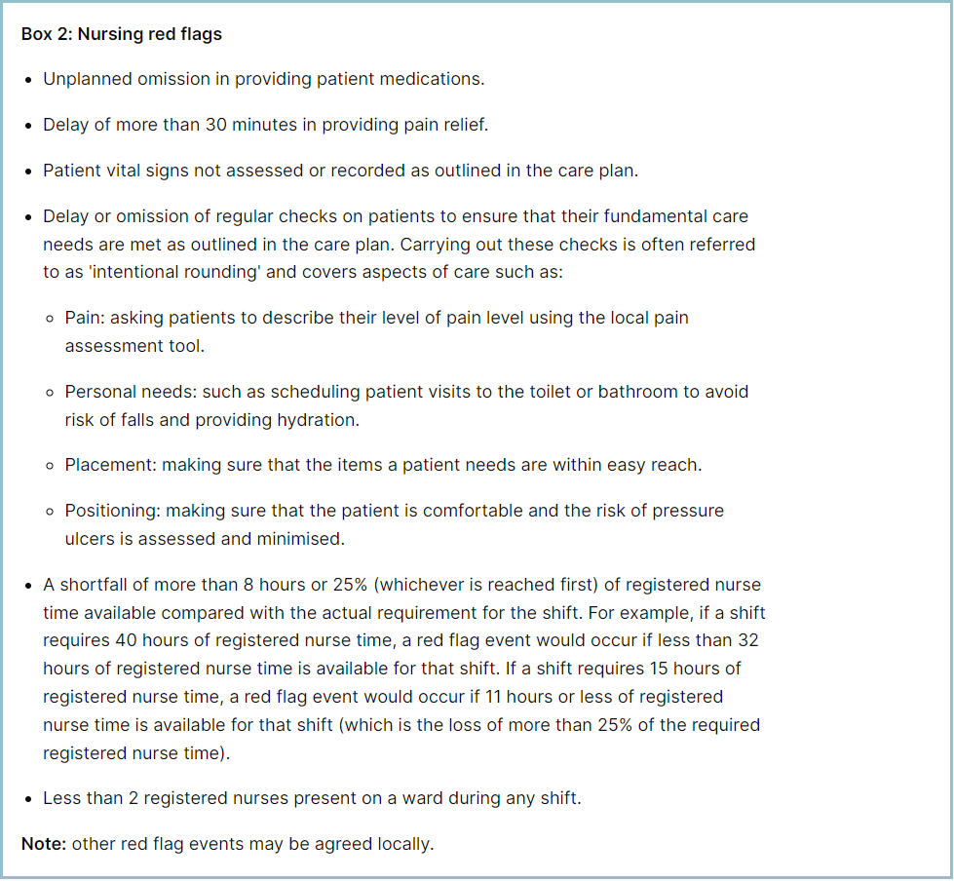

**Staffing red flags and trend data**

The number of occasions/shifts where the reported fill rate has fallen below 75% across the wards is available in Table 1. This decreased by 14 occasions in January 2025 to 85. The majority of these shortfalls were in Maternity, which had 59. Table 2 shows the trend for when registered staffing fell below 75% of standard template.

**Table 1. Occasions when registered staffing fell below 75% of standard template**

**Table 2. Staffing Red Flags Trend Data February 2024 – January 2025**

Going forward all adult inpatient areas will be capturing staffing shortfalls on SafeCare by raising a Red Flag on the system. Table 3a shows the Red Flags raised through SafeCare in January 2025. Table 3b shows the number of Red Flags raised for adult inpatient wards has decreased with 82 raised in January against 86 for December.

To improve oversight into how many incidents relating to when Enhanced Care could not be provided, the Trust has also added a local Red Flag highlighting when this occurs in SafeCare. This and the addition of Enhanced Care Level 3 Patient task will also enable the Trust to provide data to the Enhanced Care Collaborative and ensure staffing is appropriately deployed. These have now been rolled out across all adult inpatient wards.

There needs to be robust validation of the red flags by managers and matrons to understand which have been mitigated and closed, which is not demonstrated in Table 3a below. This will be a focused aspect of work with the divisions.

**Table 3a. Red Flags raised via SafeCare January 2025**



**Table 3b. Red Flags raised via SafeCare Trend**

**Redeployment**

Redeployment of staff continues to be undertaken to support safe staffing as part of the daily staffing huddles. Table 4 details the trend in January 2025 with Tye Green redeploying the highest number of substantive staff with ITU and AAU being the next highest. The highest net receiver of staff was Nightingale followed by A&E and Saunders Ward.Table 5 demonstrates the number of substantive staff redeployments per month trend

**Table 4. Hours of sunstantive staff redeployed January 2025**

**Table 5. Substantive staff redeployment trend**

This reports looks at the number of shifts substantive staff working a shift are redployed, it does not include the shifts when agency, bank or multi post holders are redeployed.

Table 6 shows the hours of substantive staff moved as a percentage of total hours worked.

Table 7 shows the hours of all staff including bank and agency, excluding the Enhanced Care Team, Bank Pool and Rapid Response Pool staff.

**Table 6. % of substantive staff redeployed as % of total hours worked**

|  |  |  |
| --- | --- | --- |
| Substantive staff hours redeployed | Total hours worked (inc bank and agency) | % of total hours worked / substantive staff redeployed |
| 1592 | 143074 | 1.1% |

**Table 7. % of staff redeployed as % of total hours worked**

|  |  |  |
| --- | --- | --- |
| All staff hours redeployed (including bank and agency but excluding Enhanced Care Team, Bank Pool and Rapid Response Pool) | Total hours worked (inc bank and agency) | % of total hours worked / staff redeployed (including bank and agency but excluding Enhanced Care Team, Bank Pool and Rapid Response Pool) |
| 3539 | 143074 | 2.47% |

The data detailing nurse redeployment indicates that the numbers of staff reassigned are minimal and continues to not be a cause of concern. The redeployment process is efficiently managed with improved governance and oversight.

**Appendix 4: Nursing quality indicators**

**Table 1. Number of falls, unwitnessed falls and falls with harm in January 2025, with the top 3 wards being highlighted**

|  |  |  |  |  |
| --- | --- | --- | --- | --- |
|  | Total falls in month | Top 3 wards | | |
| Total falls | 102 | Kingsmoor 15 | Tye Green 10 | AAU 9 |
| Unwitnessed falls | 84 | Kingsmoor 13 | Tye Green 8 | Saunders 8 |
| Falls with harm \* | 16 | AAU 2 | Charnley 2 | Ray 2 |

*\*subject to change following review at Falls Incident Oversight Group*

The Trust falls reduction strategy and workplan (2024/2025) remains in place and mandatory falls training has increased to 97%.

**Falls Rate per 1000 bed days**

**Pressure Ulcers**

**Table 2. Number of Hospital Acquired Pressure Ulcers (HAPU) Cat 2 and Cat 3 Pressure Ulcers (including unstageable)**

In January 2025 there was an increase in HAPU, with 39 HAPU’s in month compared to 29 in December.

|  |  |  |
| --- | --- | --- |
| Total in month | Top 3 wards | |
| 39 | Tye Green 6 | Harold, ITU & Ray 5 each |

**Total Pressure Ulcer Rate per 1000 bed days and Moderate Harm Pressure Ulcer Rate per 1000 bed days trend.**

**Complaints, PALS and Compliments Trend Data August 2024 – January 2025**

**Complaints, PALS and Compliments**

**Table 3. Number of new Complaints, PALS and Compliments in January 2025 with top three wards highlighted**

|  |  |  |  |  |
| --- | --- | --- | --- | --- |
|  | Total in month | Top 3 wards | | |
| New complaints | 20 | A&E 5 | Lister 3 | Dolphin, Henry Moore & Kingsmoor 2 each |
| PALs | 73 | A&E 19 | Ray 6 | Tye Green 5 |
| Compliments | 4 | Henry Moore, Labour Ward, Saunders and Tye Green 1 each | | |

The 3 main PALS themes for January were:

* Delay – 34.7%, Communication – 26.8%, Cancellations – 9.8%

Complaints themes for January were as follows

* Communication – 22.3%, Medical care – 16% and Delay – 14.3%