Agenda item:  Presented by:  Prepared by:  Date prepared:  Subject / title: | Jo Ward - Interim Chief Nurse  Charlotte Collings – Lead Nurse for Safe Staffing and Workforce  Polly Read – Interim Deputy Chief Nurse  March 2026  Safe Staffing Monthly report – February 2026
Purpose: | Approval |  | Decision |  |  | Information |  | x | Assurance |  | x
Key issues: | - A sustained overall registered staffing fill rate of >95% has been maintained.  - No wards recorded an overall fill rate below 75% during the reporting month.  - The continued increase in overall fill rates is multifactorial, including a rise in enhanced care requirements.  - The full year nursing and midwifery establishment review was completed in September 2025 and has since been approved at Board in February 2026  - Mid-Year establishment review is taking place in March 2026
Recommendation: | The committee are asked to note the information within this report.
Trust strategic objectives: |   Patients |   People |  |   Performance |  |  |   Places |  |  |   Pounds
Trust strategic objectives: | x | x |  | x |  |  |  |  |  | x
Previously considered by: | NA
Risk / links with the BAF: | BAF: 2.3 Workforce capacity
Legislation, regulatory, equality, diversity and dignity implications: | NHS England and CQC letter to NHSFT CEOs (31.3.14): Hard Truths Commitment regarding publishing of staffing data.  NHS Improvement letter: 22.4.16  NHS Improvement letter re CHPPD: 29/6/18
Appendices: | Appendix 1: Ward and divisional fill rates by month against adjusted standard planned template.  Appendix 2: Ward and divisional CHPPD data  Appendix 3: Nursing red flags  Appendix 4: Nursing quality indicators

Executive Summary
Safe staffing was maintained in February 2026 with reasonable assurance. Registered nurse fill rates improved to an average of 101.9%, with overall staffing fill reaching 106.2%, and no wards recording an average fill rate below the 75% threshold. Care Hours Per Patient Day (CHPPD) increased to 8.2, reflecting improved registered staffing input, though levels remain below the national median benchmark.
Quality indicators showed continued improvement, with total inpatient falls reducing to 65 and reportable hospital-acquired pressure ulcers decreasing to 31. Complaints and PALS activity remained broadly consistent with January and continued to be concentrated in high-acuity areas, while compliment capture improved slightly but remains inconsistent.
A sustained volume of Nursing Red Flags continued to be reported; however, the majority remain unactioned within SafeCare, limiting assurance on whether risks were mitigated at the point of escalation. Enhanced Care (ETOC) remains the most significant workforce risk due to the absence of a substantive establishment great enough to meet needs and ongoing reliance on temporary staffing.
Overall judgement: Overall, staffing in February was safe and demonstrated improving resilience. However, assurance continues to be constrained by enhanced care pressures and inconsistent Red Flag closure, reinforcing the need for strengthened governance and continued executive oversight.
1.0 Introduction
This report outlines nursing and midwifery staffing deployment at PAHT during February 2026, demonstrating how safe staffing levels were achieved and maintained. It also sets out governance and workforce management arrangements supporting this position.
2.0 Background
Monthly staffing data is reviewed against expected levels and quality indicators in line with National Quality Board (NQB, 2016) guidance. The Trust remains committed to identifying improvements, addressing risks promptly, and sustaining high-quality patient care.
3.0 Inpatient Wards Fill Rate and Redeployment
The Trust’s safer staffing submission for February 2026 was submitted to NHS Digital within the required data submission timeframe. Table 1 presents a summary of the overall fill rate for the month, while Table 2 provides the overall fill rate percentages across a rolling 12-month period.
Table 1. Overall fill rate
Average day fill rate - registered nurses/midwives | Average day fill rate - care staff | Average night fill rate - registered nurses/midwives | Average night fill rate - care staff | % Registered overall fill rate | % HCSW overall fill rate | % Overall fill rate
101.7% | 104.2% | 102.0% | 128.5% | 101.9% | 115.3% | 106.2%

Table 2. Inpatient fill rate including Maternity Wards Trend

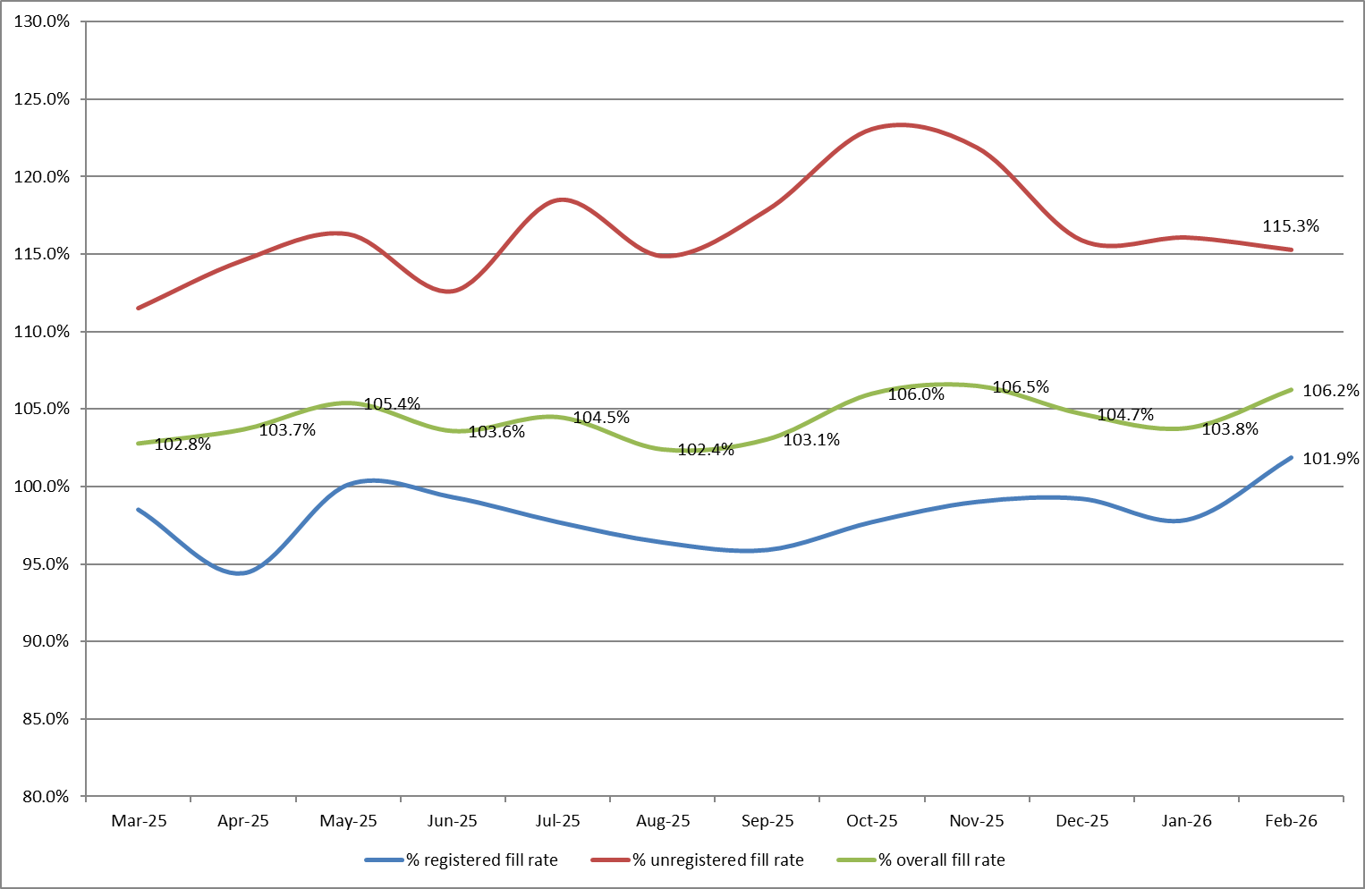
Appendix 1 sets out a ward-by-ward breakdown for the same period.
Trust wide – Recruitment activity remained positive in February 2026, with 7 registered nurses and midwives and 7 healthcare support workers joining the Trust. Further recruitment events are planned for Spring and Summer 2026, including targeted events for newly qualified graduates and a rolling programme of HCSW recruitment, with the first event well attended.
The end-of-year establishment review, covering adult and paediatric inpatient wards, assessment units and Emergency Departments, was approved by the Board in February 2026. A Mid-Year establishment review will commence from 2 March 2026 to further assess acuity-driven pressures, including those identified through CHPPD benchmarking and enhanced care demand, and will inform future roster templates.
John Snow Ward – Apparent low HCSW fill rates reflect a template mismatch rather than unmet staffing, with the ward consistently staffed to one HCSW per shift, which is fully delivered. The HCSW establishment will reduce accordingly from May 2026 following formal review through the September 2025 SNCT submission.
Maternity – Registered midwife fill rates improved across the division in February, though some areas remain amber due to vacancies and sickness absence. Twice‑weekly staffing reviews and deployment adjustments continue to support safe staffing, overseen by matrons and specialist midwives.
Emergency Departments – Although Emergency Departments are excluded from national safer staffing reporting, local Adult and Paediatric ED data continues to be reported for assurance purposes (Appendix 1, Tables 1b and 1c). Both departments maintained stable overall and registered nurse fill rates in February. However, Paediatric ED experienced a further approximate 3% reduction in HCSW fill, highlighting ongoing fragility.
Enhanced Care – Enhanced care demand remains structurally misaligned with the current workforce model, with registered ETOC hours continuing to rely on temporary staffing and no substantive registered establishment aligned to this activity. Historically, unregistered enhanced care hours have been partially unmet and absorbed by substantive ward teams, resulting in internal workforce displacement and increased workload intensity, with implications for operational resilience and staff wellbeing (Appendix 1, Table 1d).
In February 2026, the Board approved an increase to the substantive unregistered ETOC establishment, providing a mechanism to reduce reliance on bank staffing and associated cost pressures (noting that agency usage applies only to registered staff). A Task and Finish Group has been established, with agreed terms of reference, to oversee delivery of a sustainable enhanced care workforce model.
Actions – The Task and Finish Group will finalise and implement a sustainable ETOC model, including recruitment planning for the unregistered ETOC workforce, transition towards substantive capacity, strengthened governance around request, approval and closure processes, and reduced reliance on bank staffing through clearer risk criteria, training and improved rostering.
3.1 Wards with < 75% average fill rate
No wards recorded an average fill rate below 75% during February 2026.
3.2 Wards with > 100% average fill rate
Harvey and Saunders fill rates remain over 100% for registered staff during February 2026 because of needing prolonged registered mental health nurses and is therefore not concerning.
4.0 Redeployment
Appendix 2 outlines the data and trends for this month.
Redeployment continued to support safe staffing through daily safety huddles and real‑time acuity review. In February 2026, substantive redeployment increased to 1.43% of total hours worked (January: 1.17%); however, overall redeployment reduced to 1.75% (January: 1.99%), indicating improved baseline staffing availability.
An emerging feature was the redeployment of 409 hours to the Site Management and Patient Flow Team, primarily to support discharge lounge activity and temporary escalation spaces, reflecting system flow mitigation rather than ward‑level staffing shortfalls. John Snow Ward remained the largest net giver of staff, while the Adult Emergency Department continued to be the largest net receiver. All redeployments were clinically risk‑assessed and governed through daily safety huddles and SafeCare.
5.0 Care Hours Per Patient Day (CHPPD)
CHPPD measures staffing input rather than patient need. It is a simple calculation based on staff hours worked and patient numbers and does not account for skill mix, acuity or dependency. As such, it reflects the estimated care time available, not the level of care required, and should be considered alongside fill rates, acuity indicators, Red Flags and quality outcomes for assurance.
Appendix 3 provides the ward and divisional CHPPD breakdown and a planned versus actual comparison to identify areas where staffing deployment may not align with demand.
Variance between planned and actual CHPPD during February reflects changes in patient dependency and periods of enhanced care demand rather than patient numbers, as shown in Table 2 for AAU, Nightingale and John Snow, with staffing flexed, often through bank unregistered hours, to maintain safety.
Table 3. Overall Care Hours Per Patient Day (CHPPD) February 2026
Registered CHPPD | Unregistered CHPPD | Total CHPPD
5.3 | 2.9 | 8.2
Appendix 3 provides a detailed breakdown of CHPPD by ward and division for February 2026.
Table 4. CHPPD Trend and benchmarking with peer and national data
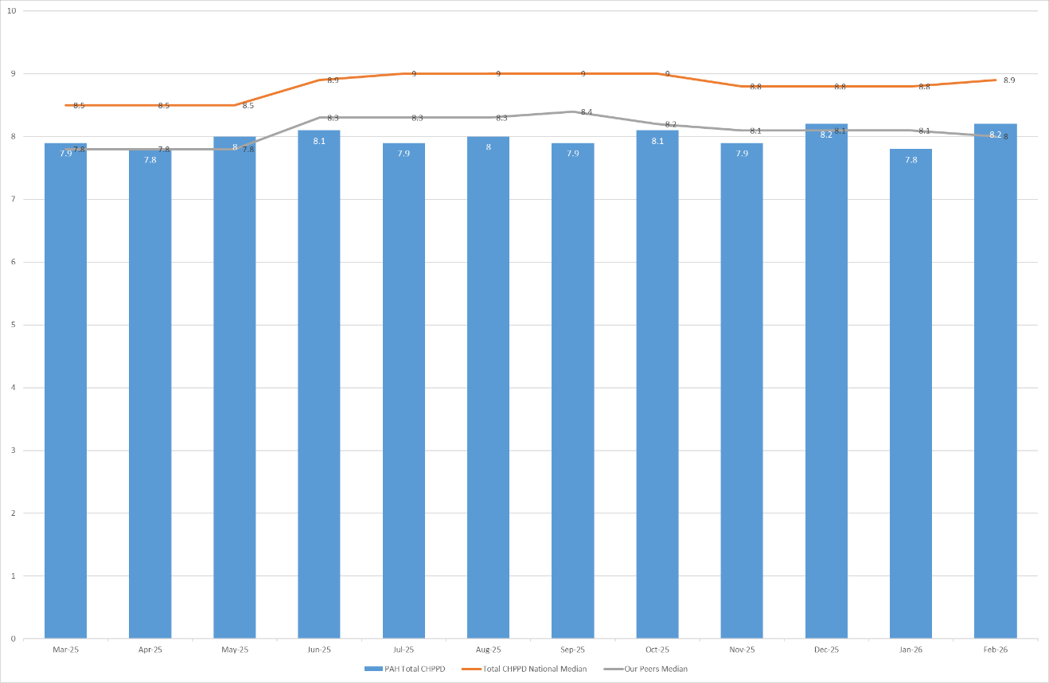
Peer organisations are: East and North Hertfordshire NHS Trust and West Hertfordshire Teaching Hospitals NHS Trust. The Trust’s CHPPD remains similar to peers but below national median benchmarks. The value has increased in February 2026.
6.0 Quality Indicators
6.1 Red Flags and Incident Reports Relating to Staffing
Appendix 4 outlines data and trends for Nursing Red Flags and staffing-related incidents.
Two distinct Red Flag mechanisms are used within the Trust. Automatic Red Flags, generated through the national safer staffing dataset when registered staffing falls below 75% of template, reduced in February compared to January, indicating improved compliance with minimum staffing thresholds. Locally raised Red Flags, recorded via SafeCare to reflect real‑time operational risk, include the six NICE (2014) indicators alongside two locally agreed flags: inability to provide enhanced care and, from February, shortfall of unregistered (HCSW) staffing. These SafeCare Red Flags continued to relate predominantly to registered nurse shortfalls and enhanced care demand within high‑acuity areas.
While reporting remains consistent, the majority of SafeCare Red Flags remain unactioned or unresolved, limiting assurance that risks were mitigated at the point of escalation and constraining ward‑to‑board visibility. Oversight continues through daily safety huddles, supported by local leadership and development programmes. Staffing‑related incidents reported via Datix remained broadly consistent with January and provide complementary assurance alongside Red Flag and redeployment data.
6.2 Falls, pressure ulcers and complaints, PALS and compliments
February data demonstrates overall improvement across several quality indicators, though variation remains in areas of sustained acuity.
Falls reduced to 65 (January: 76), with unwitnessed falls continuing to decrease and falls resulting in harm reducing to 17. Falls activity remained concentrated within a small number of wards, with targeted support and training ongoing. Mandatory training compliance remains high (>97%).
Pressure ulcers reduced to 31 (January: 40), although skin integrity concerns continue to require close oversight. Pressure ulcer activity remains concentrated within a small number of wards, with enhanced surveillance and strengthened tissue viability governance in place.
Patient experience broadly stable. Complaints increased marginally to 28, while PALS contacts reduced to 74, with recurring themes of delays and communication, predominantly within Emergency and other high‑acuity areas. Compliment capture improved to 6, though remains inconsistent and continues to limit opportunities to share positive feedback.
Overall, quality indicators in February show signs of improvement; however, fragility persists in areas experiencing sustained acuity and enhanced care demand. Continued leadership oversight and triangulation of staffing, acuity and quality data remain essential to embedding improvement.
Data and trends of quality indicators is provided in Appendix 5.
7.0 Conclusion: Assurance and Governance
The Trust maintained a sustained registered nurse fill rate above 95% in February, with further improvement in overall staffing resilience, providing assurance that nursing and midwifery staffing levels remained safe. However, acuity-driven pressures persist, particularly in relation to enhanced care demand, continuing to challenge workforce sustainability and requiring active mitigation.

Throughout February, staffing risks were managed through established governance controls, including daily SafeCare huddles and real-time acuity review, senior clinical oversight in high-risk areas, and proportionate use of temporary staffing where required. Redeployment remained a key mitigation, with increased use of substantive staff alongside reduced overall redeployment, indicating improved baseline staffing availability.

Red Flag, CHPPD, redeployment and quality data were reviewed in combination to support ward-to-board assurance. While improvements are evident across several indicators, inconsistent actioning and closure of SafeCare Red Flags continues to constrain assurance on real-time risk mitigation, reinforcing the need for strengthened governance and continued executive oversight.
8.0 Recommendation
The Board is asked to note the contents of this report, which provide assurance on the management and mitigation of nursing and midwifery staffing risks during February 2026, and to support continued focus on strengthened governance arrangements for enhanced care delivery and Red Flag assurance.

Appendix 1: Fill Rates
Table 1a: Ward level data – fill rates February 2026 (Adjusted Standard Planned Ward Demand)
 | >100% |  | 95 – 100% |  |  | 75-95% |  |  | <75%
 |  | Day |  |  | Night
Ward name |  | Average fill rate - registered nurses/midwives (%) |  | Average fill rate - care staff (%) | Average fill rate - registered nurses/midwives (%) |  | Average fill rate - care staff (%) | % Registered overall fill rate |  | % HCSW overall fill rate | % Overall fill rate
Harvey |  | 117.4% |  | 134.9% | 134.6% |  | 151.8% | 124.4% |  | 143.0% | 131.1%
Henry Moore |  | 92.9% |  | 93.9% | 129.7% |  | 101.2% | 106.7% |  | 97.4% | 102.8%
ITU & HDU |  | 92.3% |  | 101.4% | 99.7% |  | 119.5% | 96.0% |  | 110.1% | 97.2%
John Snow |  | 112.3% |  | 68.9% | 96.9% |  | 51.2% | 104.9% |  | 60.5% | 90.1%
Penn |  | 105.7% |  | 111.1% | 99.1% |  | 167.5% | 102.9% |  | 132.5% | 113.5%
Saunders |  | 106.8% |  | 110.0% | 124.4% |  | 176.3% | 113.4% |  | 135.2% | 121.6%
Planned Pathways Total |  | 101.5% |  | 106.6% | 110.3% |  | 133.2% | 105.4% |  | 118.2% | 109.2%
Fleming |  | 95.4% |  | 83.7% | 100.9% |  | 103.4% | 97.8% |  | 93.1% | 96.3%
Harold |  | 96.6% |  | 104.5% | 101.2% |  | 127.3% | 98.6% |  | 115.4% | 103.9%
Kingsmoor |  | 96.7% |  | 113.0% | 102.5% |  | 153.8% | 98.9% |  | 132.5% | 111.4%
Lister |  | 101.8% |  | 110.5% | 98.3% |  | 128.5% | 100.3% |  | 119.1% | 107.8%
Locke |  | 104.5% |  | 107.0% | 100.0% |  | 137.7% | 102.6% |  | 121.7% | 110.2%
Nightingale |  | 125.2% |  | 60.7% | 100.0% |  | 96.4% | 113.2% |  | 77.8% | 95.5%
Opal |  | 124.5% |  | 126.7% | 99.1% |  | 138.8% | 112.3% |  | 132.5% | 120.4%
Ray |  | 106.5% |  | 95.1% | 105.4% |  | 172.5% | 106.0% |  | 124.4% | 112.6%
Tye Green |  | 99.3% |  | 104.8% | 95.8% |  | 144.1% | 97.7% |  | 120.8% | 106.7%
Winter |  | 103.5% |  | 115.5% | 99.9% |  | 144.9% | 102.0% |  | 129.6% | 113.0%
AAU |  | 94.0% |  | 156.7% | 102.3% |  | 157.5% | 97.7% |  | 157.1% | 110.2%
Charnley |  | 96.7% |  | 169.9% | 97.1% |  | 187.0% | 96.9% |  | 178.1% | 120.1%
Integrated Emergency and Medical Pathways Total |  | 101.1% |  | 111.0% | 100.3% |  | 140.7% | 100.7% |  | 124.7% | 109.2%
Birthing |  | 107.3% |  | 95.1% | 95.6% |  | 92.9% | 101.7% |  | 94.0% | 99.1%
Chamberlen |  | 101.9% |  | 66.2% | 101.6% |  | 82.1% | 101.7% |  | 73.8% | 94.8%
Dolphin |  | 96.8% |  | 62.2% | 98.9% |  | 97.8% | 97.7% |  | 74.1% | 91.8%
Labour |  | 105.0% |  | 82.9% | 93.2% |  | 78.6% | 99.3% |  | 80.8% | 95.2%
Neo-Natal Unit |  | 103.3% |  | 96.4% | 98.6% |  | 82.1% | 101.0% |  | 89.3% | 99.0%
Samson |  | 110.8% |  | 86.3% | 95.2% |  | 90.2% | 103.4% |  | 88.2% | 94.7%
Family, Diagnostics and community Total |  | 103.6% |  | 81.3% | 96.8% |  | 87.3% | 100.4% |  | 84.1% | 95.5%
Total |  | 101.7% |  | 104.2% | 102.0% |  | 128.5% | 101.9% |  | 115.3% | 106.2%
Table 1b: ED data – fill rates February 2026 (Standard Planned Demand)
Average day fill rate - registered nurses/midwives | Average day fill rate - care staff | Average night fill rate - registered nurses/midwives | Average night fill rate - care staff | % Registered overall fill rate | % HCSW overall fill rate | % Overall fill rate
111.0% | 100.3% | 116.6% | 120.7% | 113.5% | 109.4% | 112.2%

Table 1c: Paediatric ED data – fill rates February 2026 (Standard Planned Demand)
Average day fill rate - registered nurses/midwives | Average day fill rate - care staff | Average night fill rate - registered nurses/midwives | Average night fill rate - care staff | % Registered overall fill rate | % HCSW overall fill rate | % Overall fill rate
128.0% | 51.5% | 139.1% | 86.9% | 132.9% | 69.2% | 113.3%

Table 1d: Enhanced Care Data Demand Vs. Fill Rates February 2026

Appendix 2: Redeployment and trend data
Table 1. Hours of substantive staff redeployed Feb-26

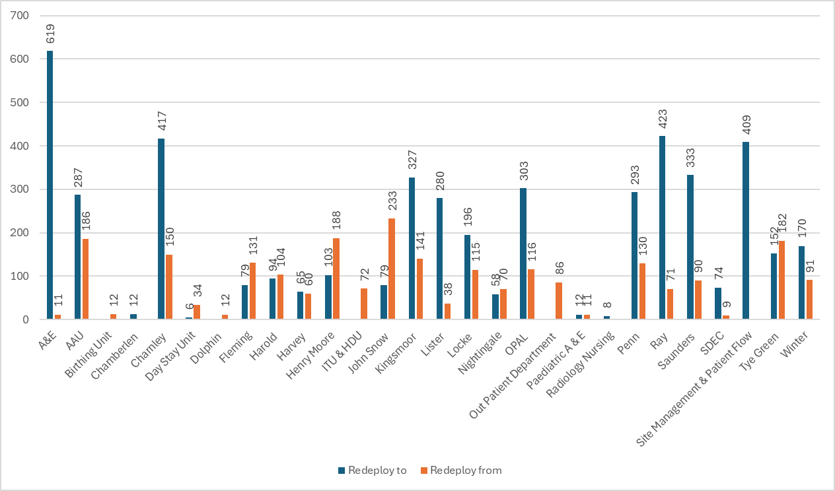

Table 2. Substantive staff redeployment ocasions trend Mar-25 – Feb-26
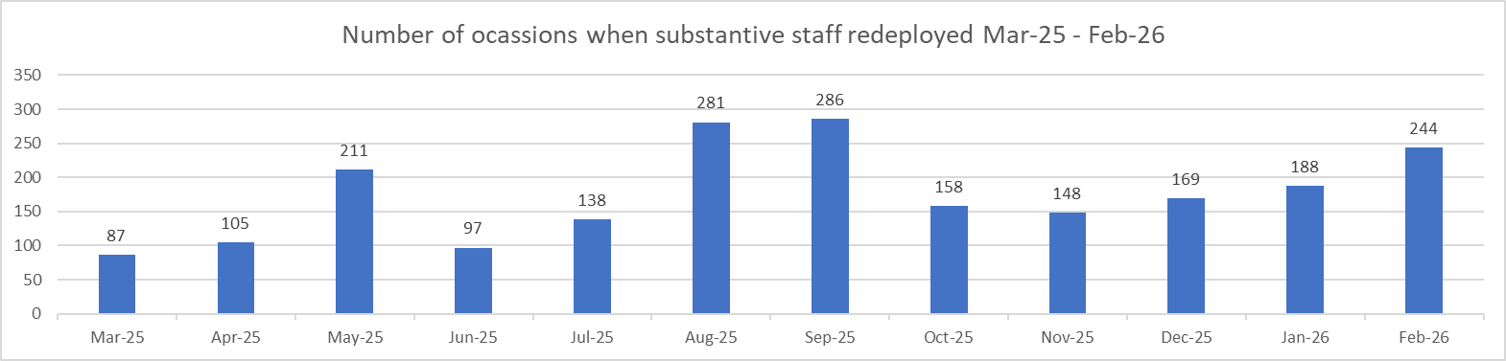

Table 3. % of substantive staff redeployed as % of total hours worked
Substantive staff hours redeployed | Total hours worked (inc. bank and agency) | % of total hours worked / substantive staff redeployed
1914 | 133842 | 1.43% (Jan - 1.17%)

Table 4. % of staff redeployed as % of total hours worked
All staff hours redeployed (including bank and agency but excluding Enhanced Care Team, Bank Pool and Rapid Response Pool) | Total hours worked (inc. bank and agency) | % of total hours worked / staff redeployed (including bank and agency but excluding Enhanced Care Team, Bank Pool and Rapid Response Pool)
2338.41 | 133842 | 1.75% (Jan - 1.99%)

Appendix 3: CHPPD

Table 1. Ward level data: CHPPD February 2026
Care Hours Per Patient Day (CHPPD)
Ward/Unit | Registered Nurses/Midwives | Non-registered Nurses/Midwives | Overall
Trust Total | 5.3 | 2.9 | 8.2
Harvey | 5.1 | 3.3 | 8.5
Henry Moore | 3.9 | 2.5 | 6.4
ITU & HDU | 18.5 | 2.1 | 20.6
John Snow | 6.0 | 1.7 | 7.7
Penn | 3.9 | 2.8 | 6.7
Saunders | 4.0 | 2.9 | 6.9
Planned Pathways Total | 5.7 | 2.7 | 8.4
Fleming | 3.9 | 1.7 | 5.6
Harold | 4.7 | 2.5 | 7.2
Kingsmoor | 3.6 | 2.9 | 6.5
Lister | 3.8 | 3.0 | 6.8
Locke | 3.8 | 3.0 | 6.9
Nightingale | 3.9 | 2.7 | 6.6
Opal | 4.9 | 3.8 | 8.7
Ray | 4.0 | 2.6 | 6.5
Tye Green | 4.1 | 3.2 | 7.2
Winter | 3.8 | 3.2 | 7.0
AAU | 6.3 | 2.7 | 9.0
Charnley | 4.2 | 3.1 | 7.3
Integrated Emergency and Medical Pathways Total | 4.2 | 2.8 | 7.1
Birthing Unit | 17.9 | 8.3 | 26.2
Chamberlen | 7.9 | 1.9 | 9.8
Dolphin | 9.9 | 2.5 | 12.4
Labour | 24.9 | 5.8 | 30.7
Neo-Natal | 13.6 | 2.4 | 16.0
Samson | 3.6 | 4.1 | 7.8
Family, Diagnostics and community Total | 10.1 | 3.6 | 13.7

Table 2. Planned Vs. Actual CHPPD needs 1.2.26 – 28.2.26

John Snow

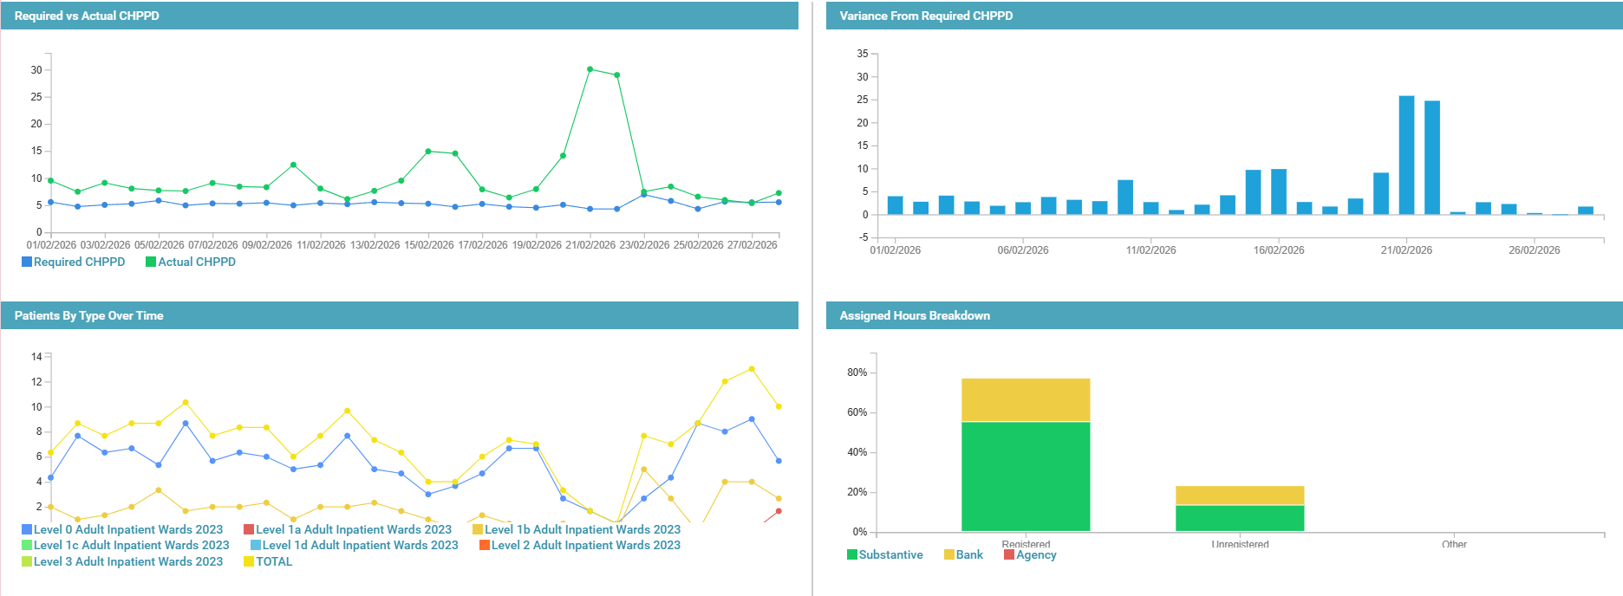
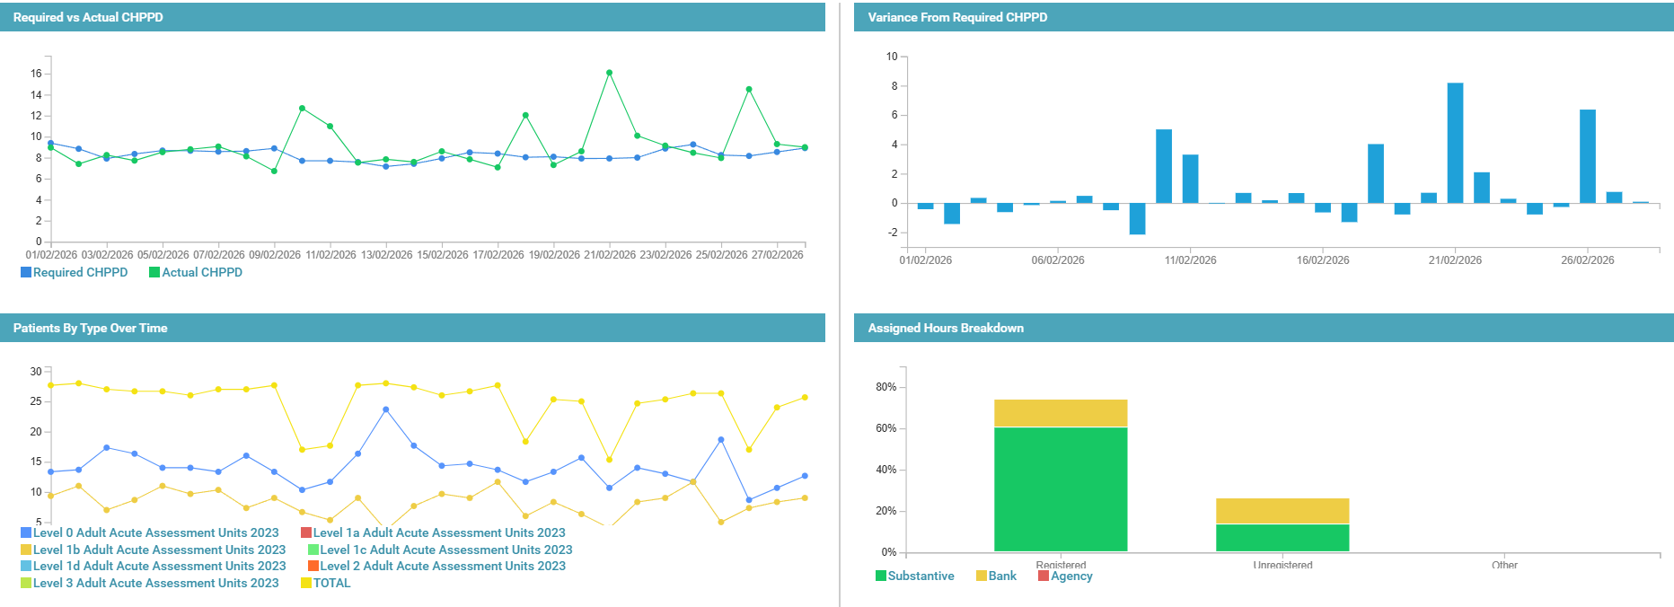
AAU

Nightingale

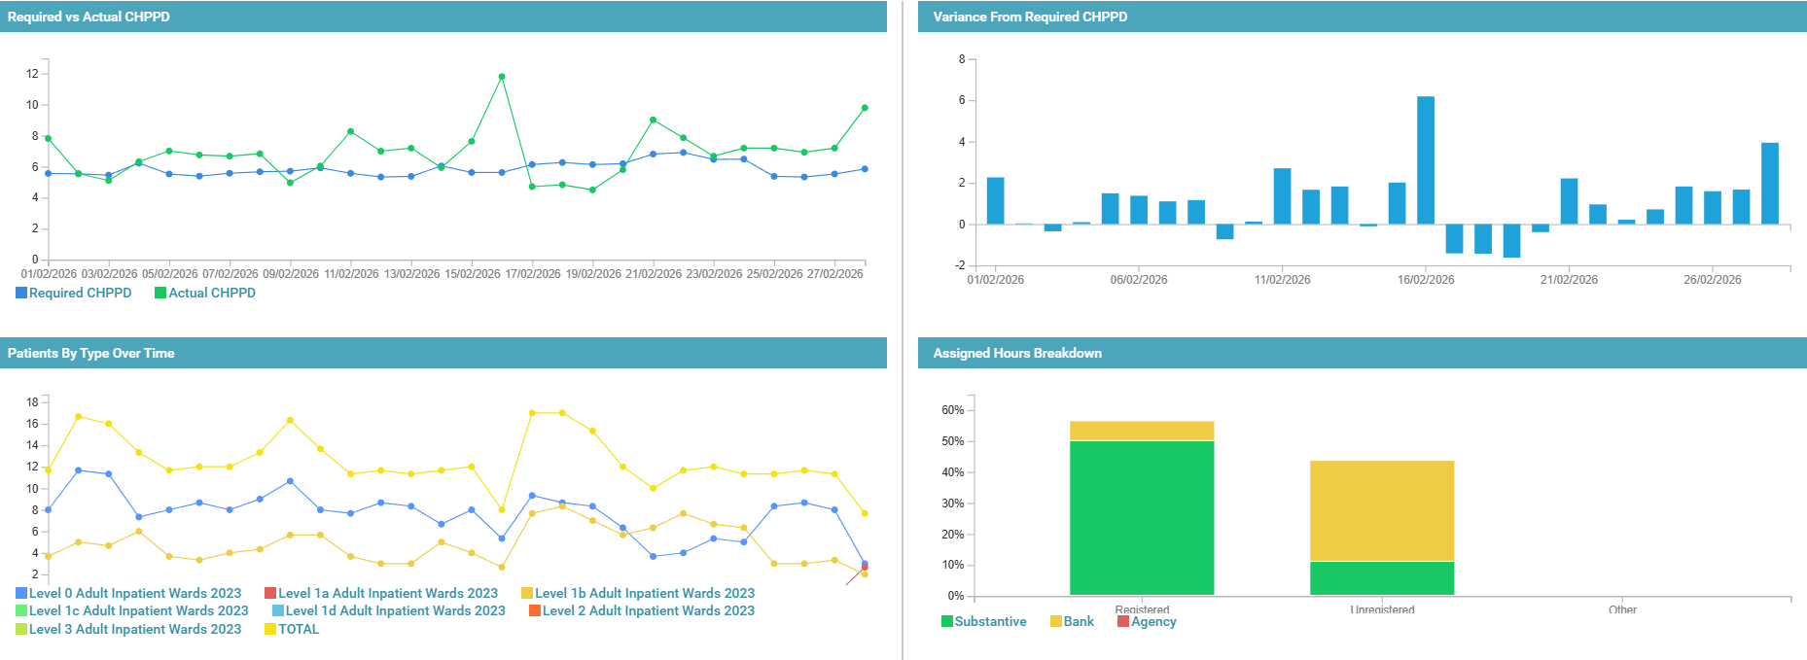

Appendix 4. Nursing Red Flags (NICE 2014), Incident Reports and Trend Data

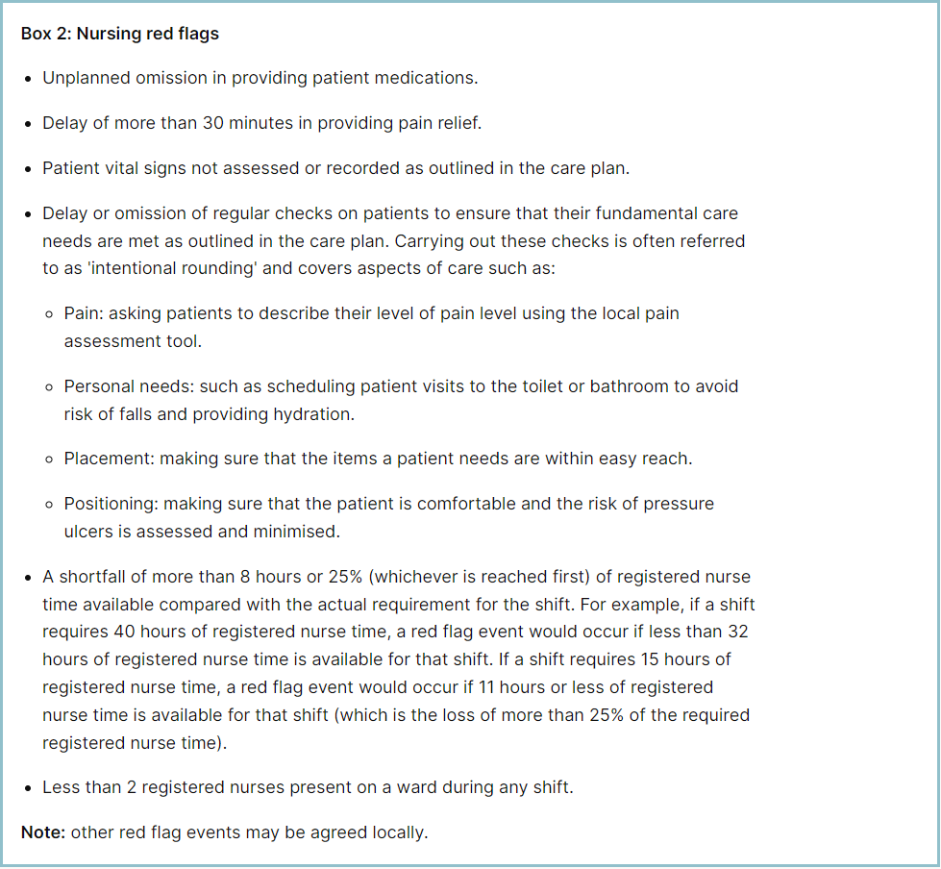

Staffing Red Flags and Trend Data
Table 1. Occasions when registered staffing fell below 75% of standard template Feb-26
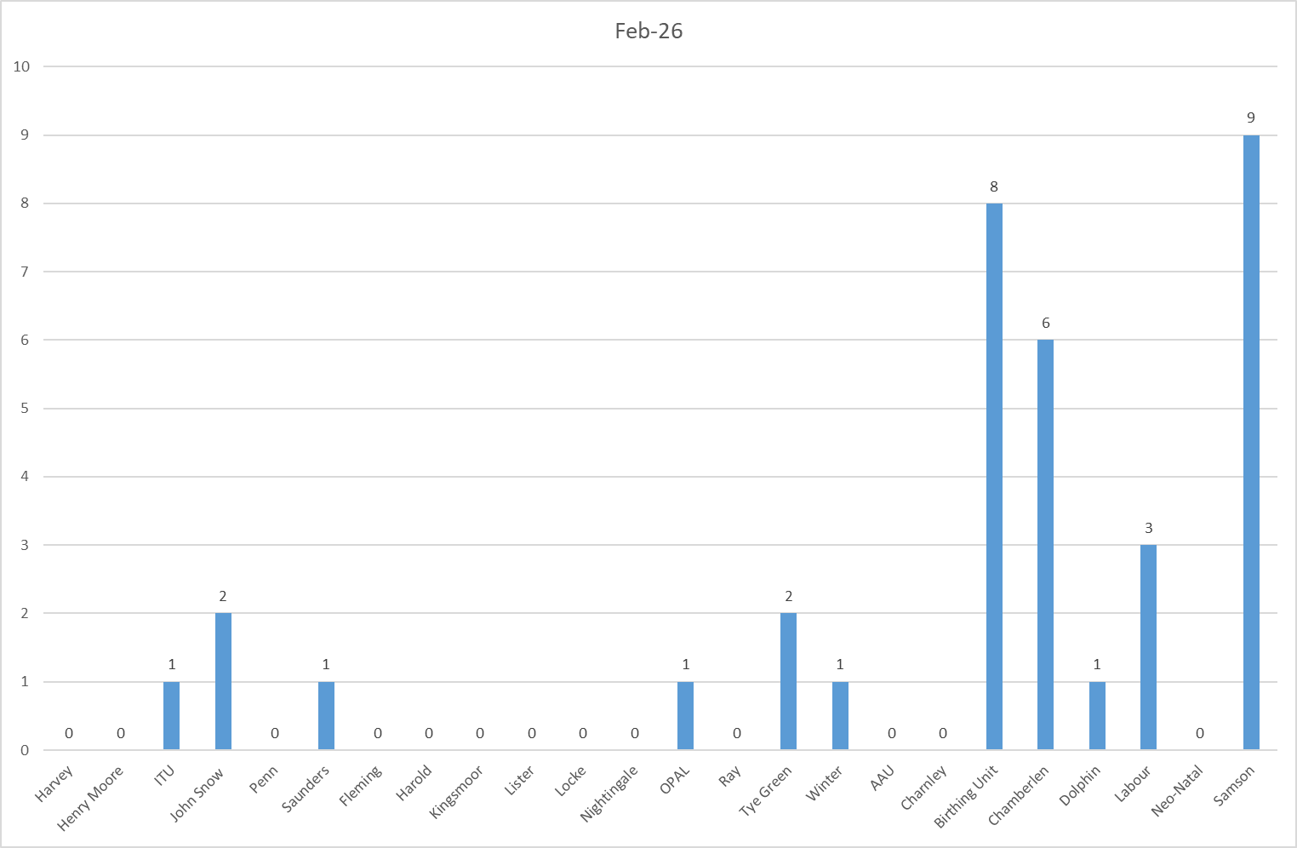

Table 2a. Occasions when all registered staffing fell below 75% of standard template. Trend Data Mar-25 – Feb-26
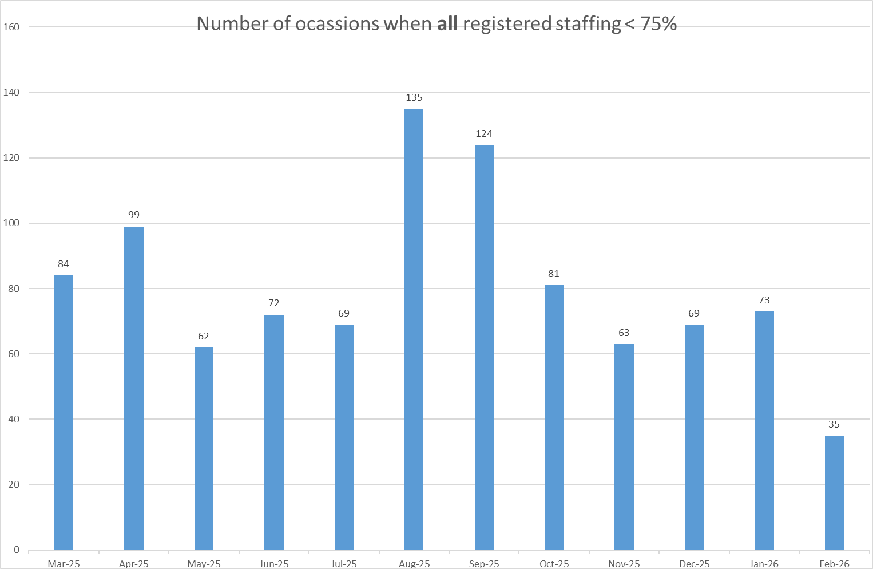

Table 2b. Occasions when registered maternity staffing fell below 75% of standard template. Trend Data Jan-25 – Feb-26
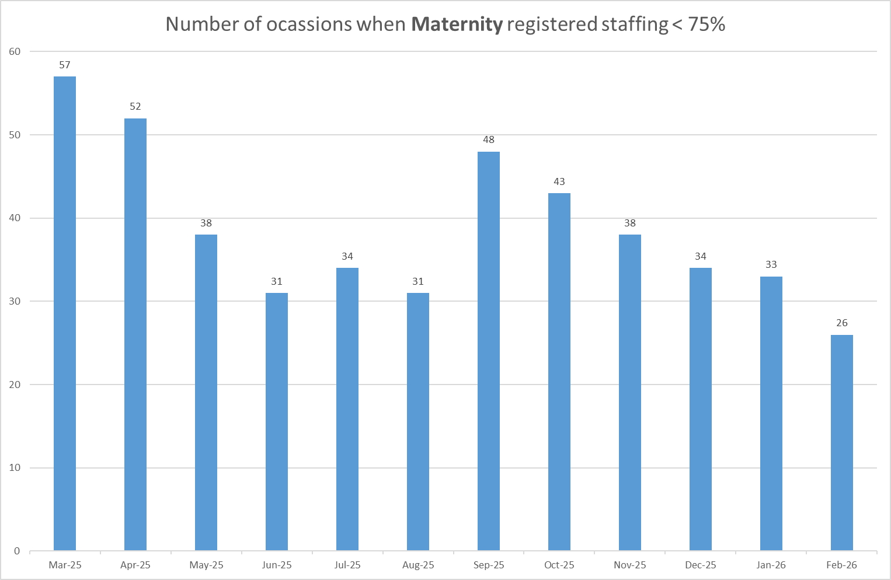

Table 3a. Red Flags raised via SafeCare Feb-26

Table 3b. Red Flags raised via SafeCare trend Mar-25 – Feb-26
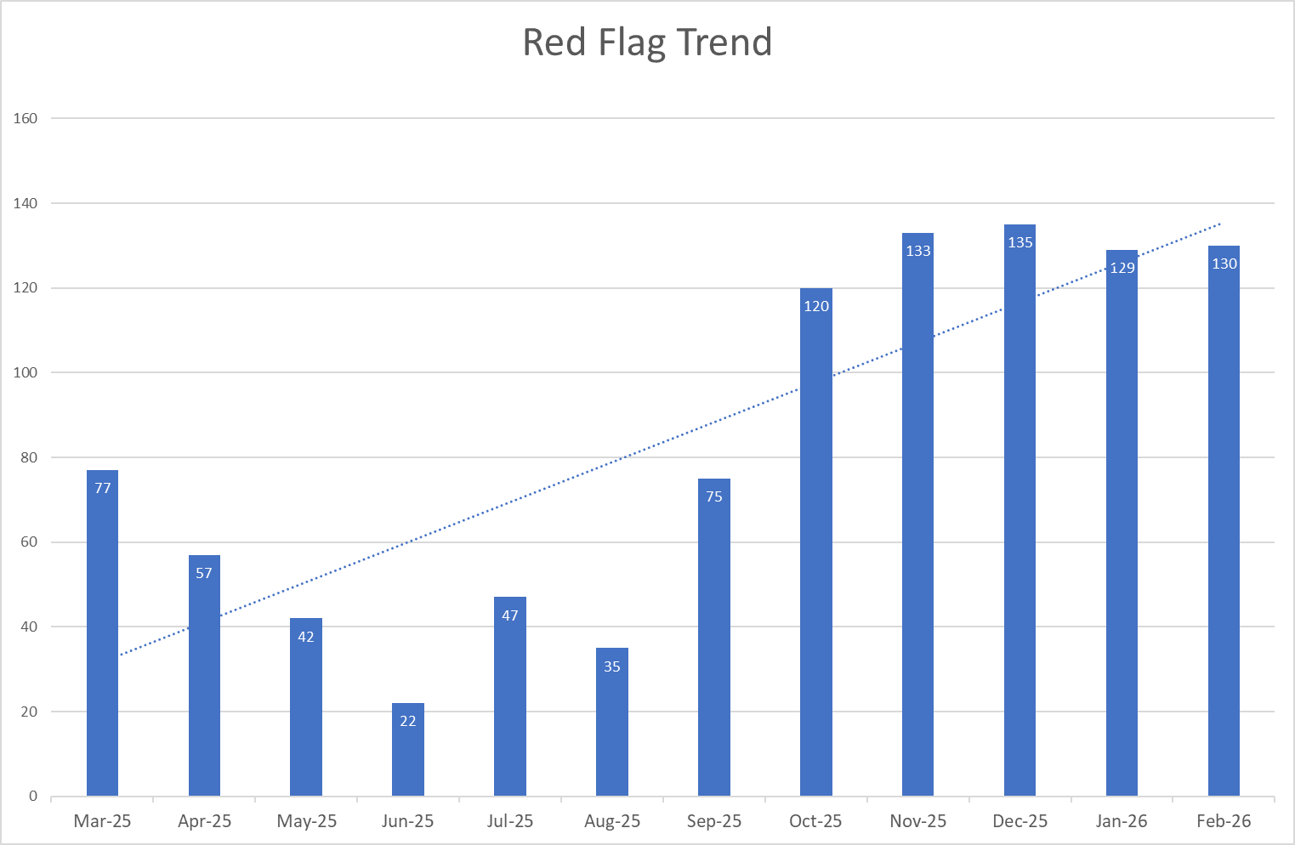

Table 3c. Datix for lack of suitably trained / skilled staff Aug-25 – Feb-26
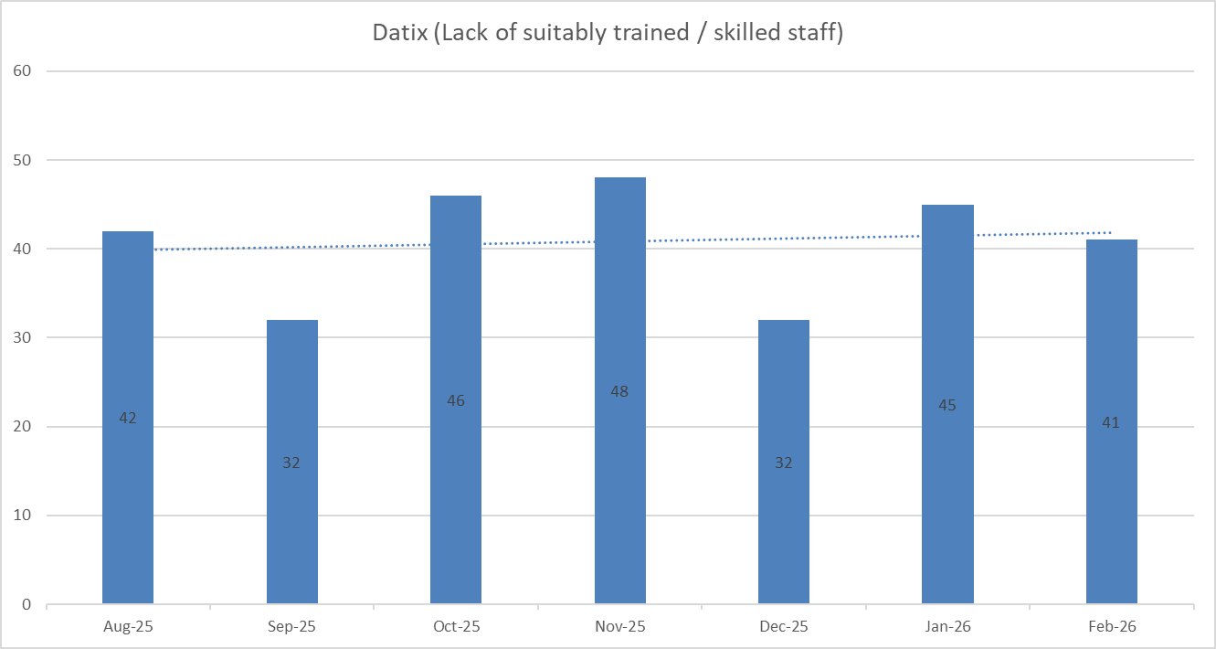

Appendix 5: Nursing quality indicators
Falls
Table 1. Number of falls and categories in February 2026, with the top 3 wards highlighted.
 | Total falls in month | Top 3 wards
Total falls | 65 | Harold – 8 | Ray – 8 | Kingsmoor – 7
Unwitnessed falls | 46 | Ray – 6 | Other (A&E and PAHT) – 5 | Harold, Kingsmoor, AAU, Charnley, Fleming & Saunders – 4
Falls with harm * | 17 | Harold – 3 | Other (A&E and PAHT), Kingsmoor, AAU, Charnley – 2
*Subject to change following review at Falls Incident Oversight Group

Falls Rate per 1000 bed days February 2026 data
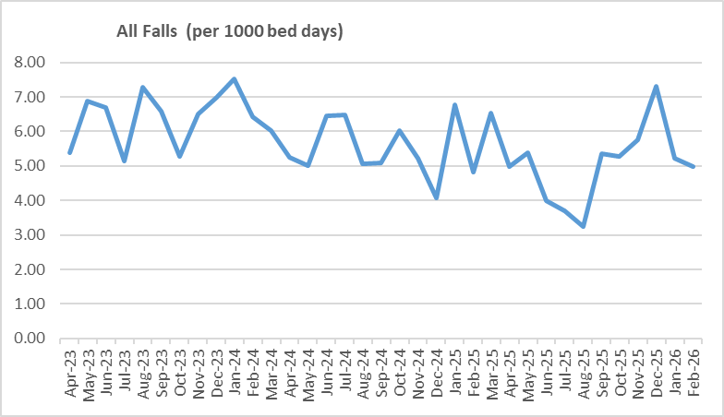
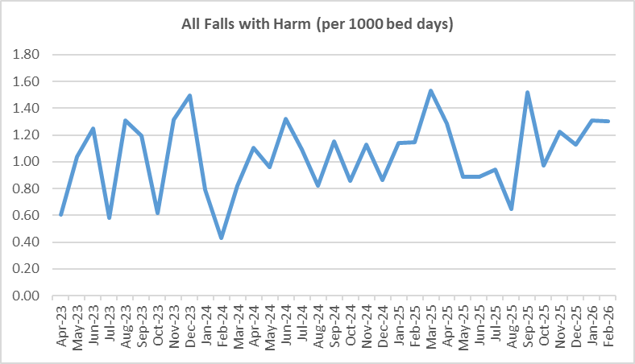

Pressure Ulcers

Table 2a. Number of Hospital Acquired Pressure Ulcers (HAPU) Cat 2, 3 and 4 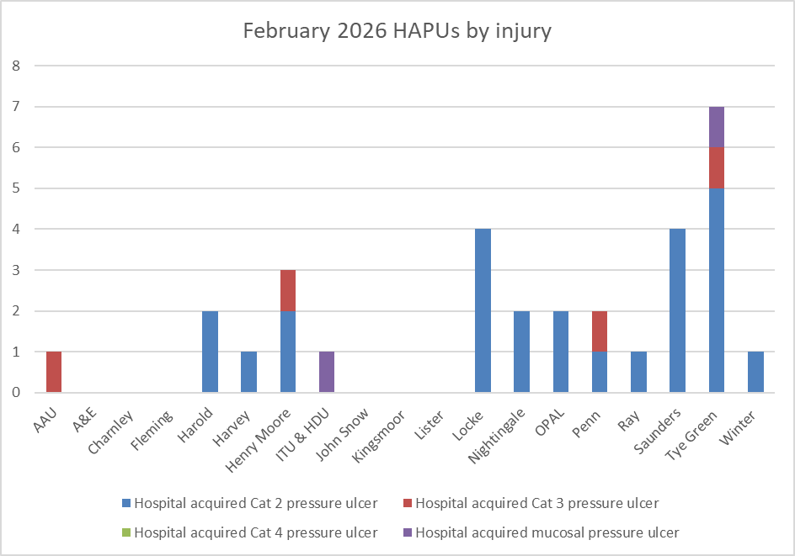

 | Total in month | Top Departments
Total skin changes | 80 | Tye Green – 11 | Saunders – 10 | Locke – 9
Reportable HAPU’s | 31 | Tye Green – 7 | Saunders – 4 | Locke – 4

Table 2b. Reported Incidents and Actual Hospital Acquired Pressure Ulcers February 2026
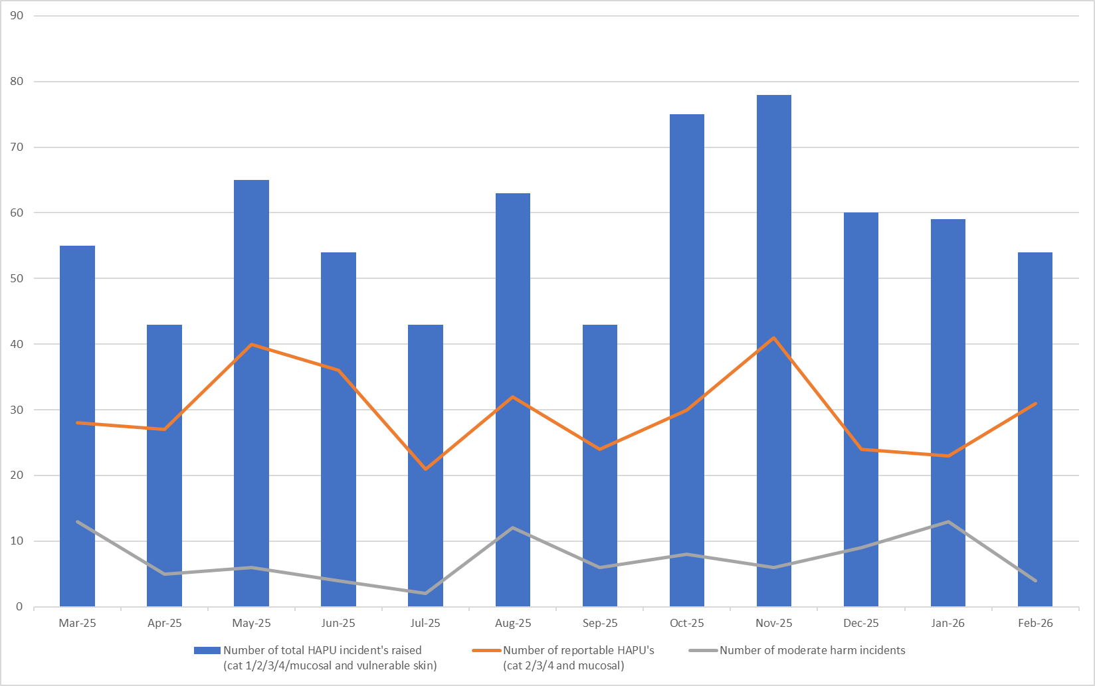

Complaints, PALS and Compliments Trend Data Sep-25 – Feb-26
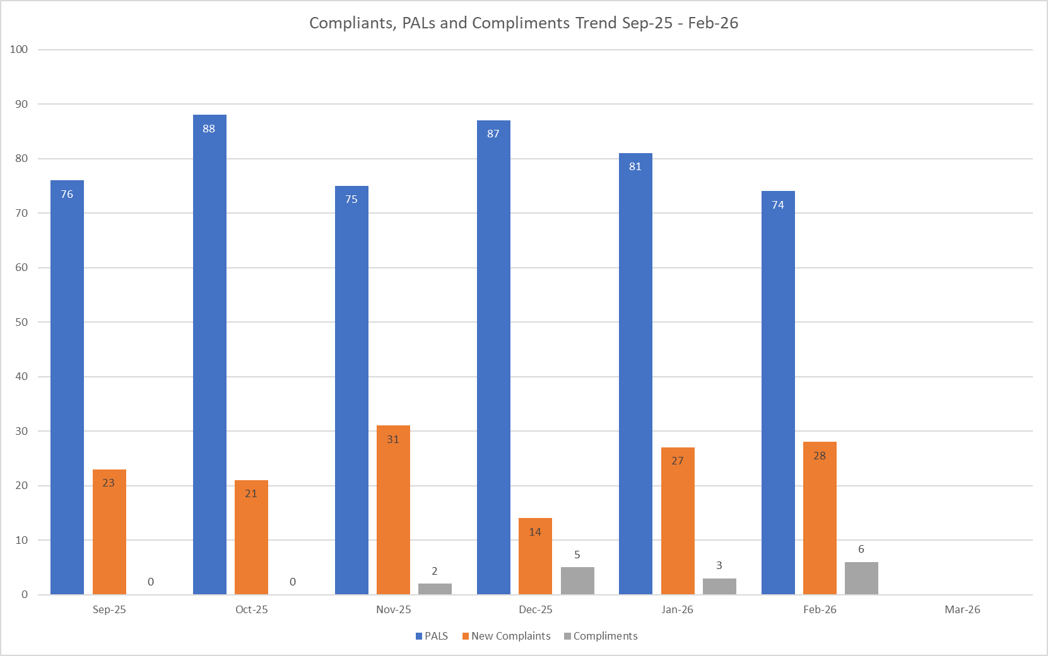
Table 3. Number of new Complaints, PALS and Compliments in February 2026 with top three wards highlighted
 | Total in month | Top Departments
New complaints | 28 | A&E – 7 | Samson – 4 | Kingsmoor, Saunders & Labour – 3
PALs | 74 | A&E – 19 | Harold & Ray – 7 | Kingsmoor – 6
Compliments | 6 | A&E – 5 | Charnley – 1
Complaints: main themes: Medical care – 23.62%, Nursing care – 16.54%, Communication – 15.75%
PALS: main themes: Delay – 39.73%, Communication – 23.96%, Cancellations – 8.68%
Compliments: themes not provided – data capture remains inconsistent.

