Meeting Title
Date Agenda item:
Report Title: Safer Staffing Monthly Report – August 2026
Presented by: Jo Ward – Interim Chief Nurse
Prepared by: Charlotte Collings – Lead Nurse for Safer Staffing and Workforce
Purpose: (please tick) | Approval/Decision |  |  | Information/Assurance |  |  | √
Executive Summary
Overall, nursing and midwifery staffing remains stable, with workforce, quality and staffing indicators providing assurance that safe care is being maintained across the Trust. Redeployment continues to be used to manage operational pressures and fluctuating demand, with no significant concerns identified through quality or patient safety metrics. While some workforce challenges remain, the data does not indicate any deterioration in the overall staffing position.
Risks and Issues (including links to BAF/Corporate Risk Register/Other risk registers)
BAF: 2.3 Workforce capacity

Recommendation
The Committee is asked to:
- Note the information of the August 2026 safer staffing report.

Strategic Objectives
 |  |  |  |  |  | 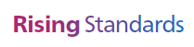
√ |  | √ |  |  |  | √
Relevant legal/statutory issues
National Quality Board (NQB) Supporting NHS providers to deliver the right staff, with the right skills, in the right place at the right time; NHS Improvement Developing Workforce Safeguards; NHS England safe staffing guidance; NIHR Professional Judgement Framework: A guide to applying professional judgement in nurse staffing reviews
Impact Assessments
Quality |  |  |  |  | Positive impact through continued assurance of safe staffing and workforce planning.
Equality, Diversity and Inclusion |  |  |  |  | No adverse equality impacts identified.
Health inequalities |  |  |  |  | No direct impact identified.
Previously Considered By |  |  |  |  | N/A
Appendices |  |  |  |  | Appendix 1: Fill Rates  Appendix 2: Redeployment and trend data  Appendix 3: CHPPD  Appendix 4. Nursing Red Flags (NICE 2014), Incident Reports and Trend Data  Appendix 5: Nursing quality indicators

1.0 Introduction
This report outlines nursing and midwifery staffing across the Trust and has been prepared in accordance with National Quality Board (NQB) Guidance and NHS England's Developing Workforce Safeguards (DWS). The report presents workforce, staffing and quality indicators, together with professional judgement, to support oversight of safe staffing and inform any actions required in response to identified risks or pressures
2.0 Evidence-Based Data: Workforce and Demand
2.1 Workforce Supply
Workforce gaps continue to be managed through a combination of temporary staffing, workforce flexibility and redeployment to support safe staffing levels and respond to fluctuations in patient demand. (Appendix 5, Table 4).
At the end of August 2026, registered nursing vacancies stood at 72.5 WTE (5.34%), including 27.06 WTE Band 5 vacancies (4.50%). Midwifery vacancies remained at 0 WTE, reflecting participation in the NHS England-funded maternity over-recruitment programme. However, in September the Trust Board approved an uplift to midwifery establishments to support Birth-rate plus recommendations and maternity triage operating 24 hours a day. Support worker vacancies continue to represent the most significant workforce supply challenge, with 60.04 WTE vacancies (13.67%). Overall vacancy levels remain broadly stable; however, workforce supply continues to present a risk, particularly within support worker roles, requiring ongoing mitigation through temporary staffing, workforce flexibility and redeployment arrangements.
2.2 Staffing Delivery Against Planned Establishment
Overall staffing delivery remained broadly stable during August, with an overall fill rate of 99.1%. Whilst registered nurse fill rates reduced compared to July, this reflected a combination of lower occupancy and service-specific operational factors, particularly within Planned Pathways. Towards the end of the month, four beds within Henry Moore Ward were designated for high dependency care and staffed by the ITU/HDU team, with this arrangement expected to continue throughout September. ITU/HDU also experienced lower occupancy than in previous months, which should be considered when interpreting staffing metrics.
Staffing delivery across other divisions remained broadly consistent and review against actual demand continues to provide assurance that staffing resources remained aligned to patient need. A small number of clinical areas continued to fall below the 75% registered staffing threshold on occasion, with an increase observed during August. This was largely concentrated within a limited number of services and should be considered alongside local operational factors, including temporary staffing model changes, ward occupancy and service activity, when interpreting these results. (Appendix 1, Table 1a)
Table 1. Overall fill rate
Average day fill rate – registered | Average day fill rate - care staff | Average night fill rate - registered | Average night fill rate - care staff | % Registered overall fill rate | % HCSW overall fill rate | % Overall fill rate
92.9% | 98.5% | 96.7% | 120.2% | 94.6% | 108.4% | 99.1%

Table 2. Inpatient fill rate inc. Maternity Trend
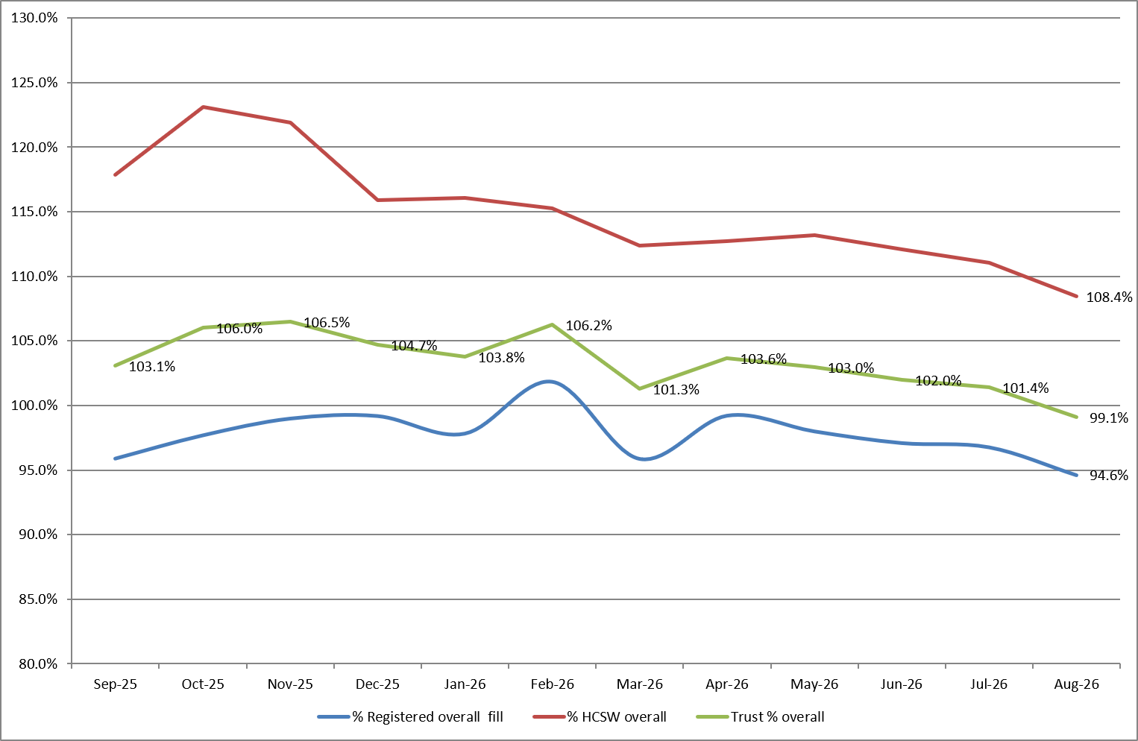
2.3 Staffing Delivery Against Actual Demand
Actual demand varied throughout August and continued to reflect additional workforce requirements that sit outside planned staffing establishments, including patient acuity, dependency and other patient-specific needs. Review of actual demand alongside fill rates, quality indicators and professional judgement provides assurance that staffing resources remained aligned to patient need throughout the month (Appendix 1, Table 1e).
Weekly scrutiny of additional duties continues to support oversight of workforce deployment and provides assurance that the majority reflect identified patient need, whilst enabling duties created outside agreed staffing templates to be identified and corrected in real time. Enhanced care remains a significant driver of additional workforce demand, although associated data should be interpreted with caution given ongoing national work to improve the consistency of enhanced care definitions and recording.
2.4 Key Drivers of Workforce Demand
Emergency Departments
Although Emergency Departments are excluded from national safer staffing reporting, local staffing data continues to be reviewed for assurance (Appendix 1, Tables 1B and 1C).
Adult Emergency Department remained the largest recipient of redeployed staff during August, reflecting ongoing demand associated with ambulance cohort areas and patient flow. Workforce pressures continued to be managed through local escalation processes and workforce flexibility, including redeployment where required.
Within Children's Emergency Department, the revised shift pattern introduced to increase staffing availability during periods of peak demand remains in place. The effectiveness of this approach, alongside future workforce requirements, will be considered as part of the September SNCT review.
Enhanced Care
Enhanced care continued to be a significant driver of workforce demand during August and remains subject to daily review through staffing huddles, SafeCare reporting, matron oversight and professional judgement to support workforce planning and escalation where required.
Education and training continue to support a more consistent approach to enhanced care assessment and recording, including the introduction of a multidisciplinary enhanced care study day from October 2026. In response to sustained enhanced care requirements within Tye Green and Kingsmoor, healthcare support worker establishments have been increased by one staff member per shift, seven days a week, from 1 October 2026 to support a more sustainable approach to meeting patient demand (Appendix 1, Table 1D).
2.5 Workforce Utilisation (CHPPD Context)
Care Hours Per Patient Day (CHPPD) provides an indication of workforce utilisation and is reported against both national benchmarking and locally agreed expectations. During August, Trust CHPPD remained broadly stable at 7.9 hours per patient day, providing assurance that overall workforce utilisation remained consistent with previous months (Appendix 3).
Model Hospital benchmarking continues to demonstrate a workforce profile with proportionally higher registered nursing hours and lower support worker hours when compared to some peer organisations. As CHPPD does not account for patient acuity, dependency, enhanced care requirements or ward configuration, it should be considered alongside workforce, demand, quality and professional judgement indicators when assessing staffing effectiveness and patient safety. (Table 3).
Table 3. Overall Care Hours Per Patient Day (CHPPD) August 2026
Registered CHPPD | Unregistered CHPPD | Total CHPPD
5.1 | 2.8 | 7.9
3.0 Outcomes: Quality and Patient Safety Indicators
Quality and patient safety indicators remained broadly stable during August 2026. Whilst variation was observed across individual measures, triangulation of workforce, patient safety and patient experience data has not identified a consistent pattern to suggest staffing pressures are adversely impacting patient outcomes. Falls activity increased during the month, including an increase in falls resulting in harm, whilst both overall skin changes and reportable hospital-acquired pressure ulcers reduced. Continued monitoring is undertaken to identify emerging themes and ensure areas experiencing higher demand remain appropriately supported (Appendices 4 and 5).
3.1 Patient Safety Indicators
Falls activity increased during August, including an increase in falls resulting in harm. In contrast, both total skin changes and reportable hospital-acquired pressure ulcers reduced compared to the previous month. Whilst variation was observed across individual measures, patient safety indicators do not demonstrate a consistent pattern of deterioration and continue to be reviewed alongside workforce, quality and staffing data to identify emerging themes and support targeted interventions where required.
3.2 Patient Experience
Patient experience indicators improved during August, with complaints and PALS contacts reducing and compliments increasing. Feedback themes remained broadly unchanged, with communication and delays continuing to be the predominant reasons for contact. No emerging concerns were identified through triangulation with workforce and quality indicators. (Appendix 5).
3.3 Red Flags and Incident reports
Staff-raised red flags and incident reports continue to provide important insight into perceived workforce risks and support real-time oversight of staffing and patient care. During August, the number of red flags raised reduced, whilst the number reviewed and resolved increased, providing assurance that concerns continue to be identified, reviewed and addressed through established governance processes (Appendix 4, Tables 3a and 3b).
Reports relating to lack of suitably trained or skilled staff also reduced during the month. Whilst reporting activity is influenced by local reporting culture and practice, triangulation of red flag reporting, incident data, workforce indicators and quality outcomes has not identified any organisation-wide themes or emerging concerns requiring escalation. These indicators continue to be reviewed alongside workforce and quality metrics to support a comprehensive assessment of staffing-related risks and patient outcomes (Appendix 4 and 5).
4.0 Professional Judgement
Professional judgement continues to play a key role in safe staffing decision-making. Daily staffing huddles, matron oversight, red flag reviews and escalation processes are used alongside workforce, demand and quality indicators to support staff deployment and respond to changes in patient need and service pressures.
4.1 Key Themes Identified
Professional judgement identifies several consistent themes across services:
- Workforce demand continues to be influenced by patient acuity, dependency, enhanced care requirements and service-specific operational pressures, resulting in variation between planned establishments and actual demand.
- Enhanced care remains a significant driver of workforce demand across inpatient services and has informed targeted investment in healthcare support worker establishments within Kingsmoor and Tye Green from October 2026.
- Workforce flexibility, including redeployment and temporary staffing, continues to support operational resilience and the delivery of safe care during periods of higher demand.
- Whilst registered nurse fill rates reduced and occasions where staffing fell below the 75% threshold increased during August, triangulation of workforce, quality, patient safety, patient experience and incident reporting data does not identify any organisation-wide themes to suggest staffing pressures adversely impacted patient care.
- Ongoing review of staffing demand through SafeCare, red flag reporting, daily staffing huddles and the current SNCT data collection continue to support assessment of whether workforce establishments remain aligned to patient need.
4.2 Actions and Escalation
In response to these themes, a range of actions continue to support safe staffing:
- Daily review of staffing levels through Trust-wide staffing huddles and divisional oversight.
- Targeted use of redeployment and temporary staffing to respond to changes in patient acuity, dependency and demand.
- Ongoing review of enhanced care requirements through SafeCare, professional judgement and escalation processes.
- Additional investment in healthcare support worker establishments within Kingsmoor and Tye Green to support sustained enhanced care demand.
- Continued scrutiny of additional duties to support appropriate workforce utilisation and oversight of demand.
- Delivery of safer staffing education, including enhanced care training and support for staff participating in the September 2026 SNCT review.
- Completion of September 2026 SNCT data collection to inform the year-end establishment review and future workforce planning.
5.0 Overall Interpretation
Triangulation of workforce, demand, quality, patient safety and professional judgement indicators provides assurance that safe care was maintained throughout August 2026. Whilst registered nurse fill rates reduced and occasions where staffing fell below the 75% threshold increased during the month, review against actual demand, workforce deployment, red flag reporting and quality indicators does not identify evidence of a corresponding deterioration in patient outcomes.
Enhanced care, patient acuity and dependency continue to be significant drivers of workforce demand across inpatient services. Workforce flexibility, redeployment and established staffing governance processes have supported services in responding to operational pressures, with targeted investment in healthcare support worker establishments within Kingsmoor and Tye Green agreed in response to sustained demand requirements.
Whilst variation was observed across individual quality and patient safety indicators, patient experience indicators improved during the month, with reductions in complaints and PALS contacts and an increase in compliments received. Overall, the evidence does not identify any organisation-wide themes to suggest staffing pressures adversely impacted patient care. September 2026 SNCT data collection is currently underway and will inform the year-end establishment review, providing a further opportunity to assess whether nursing and midwifery establishments remain aligned to patient demand and service requirements.
Reporting note: Workforce supply data are provided by separate departments and remained subject to final validation at the time of drafting. Sections 2.1 will be updated once the August data is available.
Appendix 1: Fill Rates
Table 1a: Ward level data – Average fill rates against Standard Template (%) August 2026
 | >100% |  | 95 - 100% |  | 75 - 95% |  | <75%
 |  | Day |  | Night
Ward name |  | registered (%) | Unregistered (%) | registered (%) | Unregistered (%) | % Registered Overall | % Unregistered Overall | % Overall fill rate
Harvey |  | 97.6% | 112.8% | 133.4% | 112.5% | 112.2% | 112.7% | 112.4%
Henry Moore |  | 90.7% | 101.5% | 93.5% | 114.9% | 92.0% | 107.9% | 98.0%
ITU & HDU |  | 78.7% | 52.3% | 82.2% | 74.2% | 80.4% | 63.3% | 78.9%
John Snow |  | 86.2% | 43.4% | 79.0% | 35.5% | 82.8% | 39.6% | 68.4%
Penn |  | 88.5% | 111.4% | 98.4% | 133.8% | 92.7% | 119.9% | 102.4%
Saunders |  | 87.5% | 124.6% | 99.2% | 176.1% | 92.5% | 144.1% | 111.0%
PP Total |  | 86.6% | 102.8% | 94.0% | 117.9% | 90.0% | 109.4% | 95.7%
Fleming |  | 84.4% | 88.6% | 98.5% | 103.1% | 90.4% | 95.5% | 92.0%
Harold |  | 89.5% | 90.0% | 98.9% | 108.5% | 93.6% | 98.8% | 95.3%
Kingsmoor |  | 104.5% | 124.2% | 128.2% | 141.7% | 113.5% | 132.6% | 120.6%
Lister |  | 91.3% | 100.0% | 100.9% | 124.3% | 95.3% | 111.6% | 101.8%
Locke |  | 91.2% | 108.2% | 98.8% | 139.2% | 94.4% | 123.0% | 105.8%
Nightingale |  | 100.5% | 69.8% | 100.0% | 97.4% | 100.3% | 83.1% | 91.7%
Opal |  | 126.9% | 88.5% | 75.6% | 114.2% | 102.4% | 100.8% | 101.8%
Ray |  | 101.9% | 107.6% | 119.4% | 160.1% | 109.3% | 127.5% | 115.8%
Tye Green |  | 88.5% | 122.2% | 93.7% | 158.3% | 90.7% | 136.9% | 108.7%
Winter |  | 96.5% | 105.5% | 99.2% | 140.1% | 97.6% | 122.0% | 107.4%
AAU |  | 85.9% | 127.6% | 98.5% | 147.9% | 91.5% | 137.3% | 101.1%
Charnley |  | 92.1% | 117.4% | 89.7% | 132.3% | 90.9% | 124.5% | 100.5%
IEMP Total |  | 94.2% | 105.6% | 100.1% | 131.5% | 96.8% | 117.6% | 104.1%
Birthing |  | 97.4% | 68.5% | 96.0% | 90.3% | 96.7% | 78.9% | 90.8%
Chamberlen |  | 90.0% | 75.4% | 90.8% | 90.3% | 90.4% | 82.5% | 88.4%
Dolphin |  | 87.8% | 64.5% | 89.1% | 95.7% | 88.4% | 74.9% | 85.0%
Labour |  | 110.8% | 79.4% | 97.5% | 87.2% | 104.4% | 83.2% | 99.7%
Neo-Natal Unit |  | 89.5% | 58.1% | 86.5% | 74.2% | 88.0% | 66.1% | 84.3%
Samson |  | 100.8% | 77.2% | 97.0% | 91.8% | 98.9% | 84.1% | 90.5%
FDC Total |  | 97.3% | 72.7% | 92.7% | 89.2% | 95.1% | 80.3% | 90.7%
Total |  | 92.9% | 98.5% | 96.7% | 120.2% | 94.6% | 108.4% | 99.1%

Table 1b: ED data – Average fill rates against Standard Template (%) August 2026
Average day fill rate - registered | Average day fill rate - care staff | Average night fill rate - registered | Average night fill rate - care staff | % Registered overall fill rate | % HCSW overall fill rate | % Overall fill rate
105.8% | 91.1% | 115.3% | 118.6% | 110.1% | 103.4% | 107.9%
Table 1c: Children’s ED data – Average fill rates against Standard Template (%) August 2026
Average day fill rate - registered | Average day fill rate - care staff | Average night fill rate - registered | Average night fill rate - care staff | % Registered overall fill rate | % HCSW overall fill rate | % Overall fill rate
98.8% | 44.4% | 122.2% | 84.6% | 109.2% | 64.5% | 95.4%

Table 1d: Enhanced Care Data Demand Vs. Fill Rates August 2026

Registered | Hours
Overall number of ETOC hours provided in month | 1762
Number of ETOC hours provided by substantive staff | 0
Number of ETOC hours provided by bank staff | 1762
Number of ETOC hours provided by agency staff | 0
Number of unfilled hours for staff relating to ETOC | 2314
Unregistered
Overall number of ETOC hours provided in month | 6557
Number of ETOC hours provided by substantive staff | 790
Number of ETOC hours provided by bank staff | 5767
Number of ETOC hours provided by agency staff | 0
Number of unfilled hours for staff relating to ETOC | 16545

Table 1e: Average Fill Rate % - Standard Template and All Demands with Associated Variances – August 2026

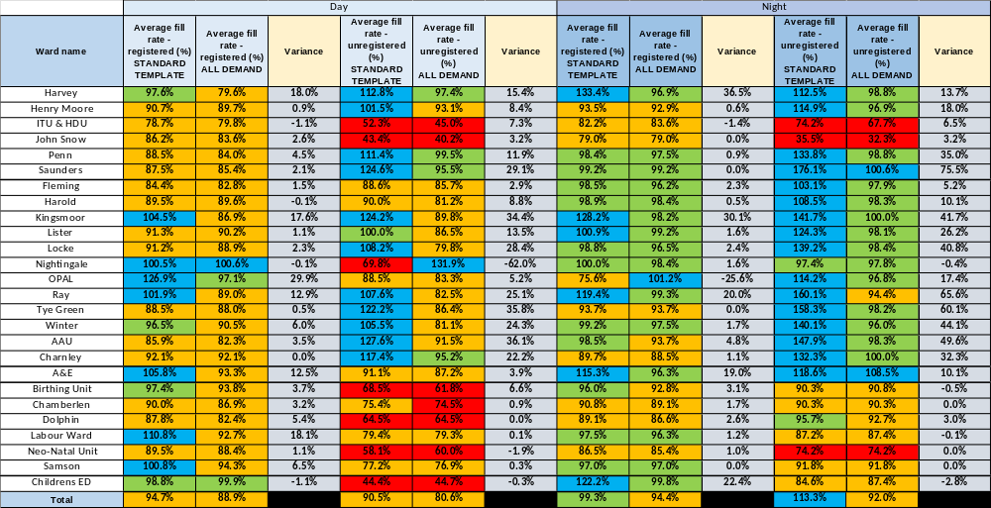

Appendix 2: Redeployment and trend data
Table 1. Hours of substantive staff redeployed Aug-26
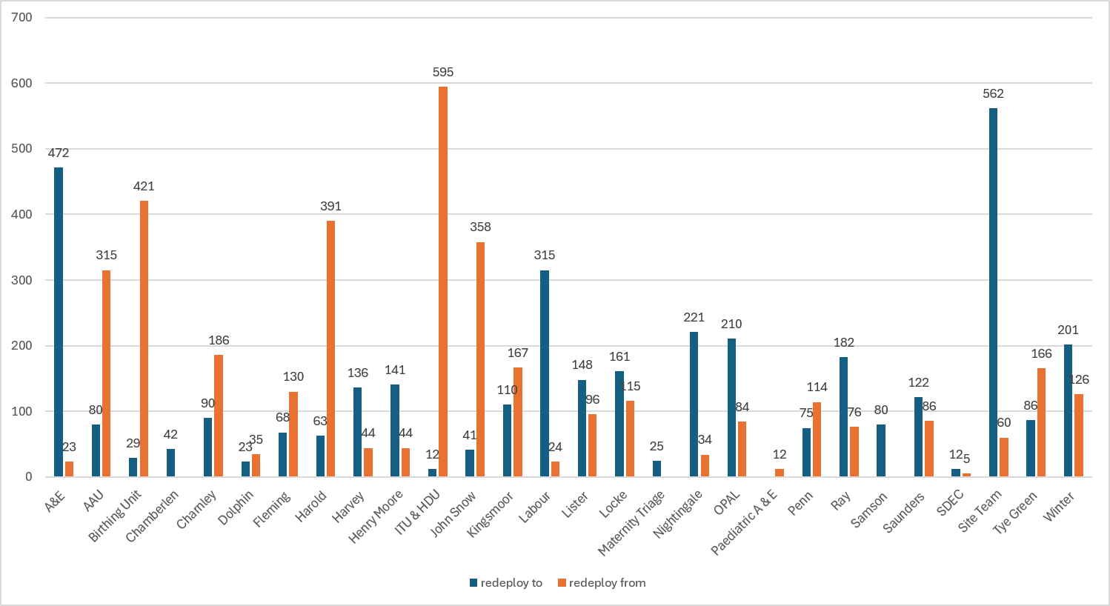

Table 2. Substantive staff redeployment ocasions trend
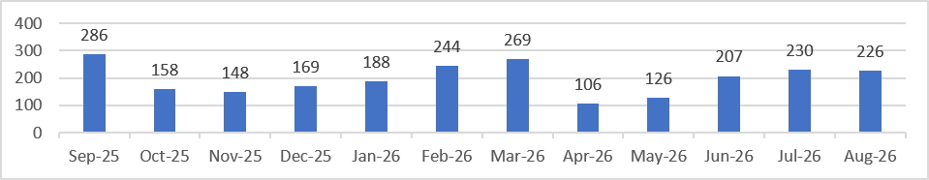

Table 3. % of substantive staff redeployed as % of total hours worked
Substantive staff hours redeployed | Total hours worked (inc. bank and agency) | % of total hours worked / substantive staff redeployed
2234.25 | 139134 | 1.60% (Jul: 2.31%)
Table 4. % of all staff redeployed as % of total hours worked
All staff hours redeployed (including bank and agency but excluding Enhanced Care Team, Bank Pool and Rapid Response Pool) | Total hours worked (inc. bank and agency) | % of total hours worked / staff redeployed (including bank and agency but excluding Enhanced Care Team, Bank Pool and Rapid Response Pool)
3702.92 | 139134 | 2.66% (Jul: 2.50%)

Appendix 3: CHPPD
Table 1. Ward level data: CHPPD August 2026
Care Hours Per Patient Day (CHPPD)
Ward/Unit | Registered Nurses/Midwives | Non-registered Nurses/Midwives | Overall
Trust Total | 5.1 | 2.8 | 7.9
Harvey | 4.6 | 2.6 | 7.2
Henry Moore | 4.4 | 3.1 | 7.5
ITU & HDU | 21.5 | 1.7 | 23.2
John Snow | 6.9 | 1.6 | 8.5
Penn | 3.8 | 2.7 | 6.5
Saunders | 3.6 | 3.2 | 6.8
Planned Pathways Total | 5.6 | 2.7 | 8.3
Fleming | 3.7 | 1.7 | 5.4
Harold | 4.6 | 2.2 | 6.8
Kingsmoor | 4.2 | 2.9 | 7.1
Lister | 3.6 | 2.8 | 6.4
Locke | 3.6 | 3.1 | 6.7
Nightingale | 2.8 | 2.3 | 5.1
Opal | 4.8 | 3.1 | 7.9
Ray | 4.1 | 2.7 | 6.8
Tye Green | 3.8 | 3.7 | 7.5
Winter | 3.7 | 3.0 | 6.7
AAU | 6.0 | 2.4 | 8.4
Charnley | 3.9 | 2.1 | 6.1
Integrated Emergency and Medical Pathways Total | 4.1 | 2.7 | 6.8
Birthing Unit | 11.5 | 4.7 | 16.2
Chamberlen | 6.3 | 1.9 | 8.2
Dolphin | 13.1 | 3.7 | 16.8
Labour | 21.8 | 5.0 | 26.8
Neo-Natal | 11.3 | 1.7 | 13.0
Samson | 4.5 | 5.1 | 9.6
Family, Diagnostics and community Total | 10.2 | 3.7 | 13.9

Table 2 – Total CHPPD trend Nursing and Midwifery Staff

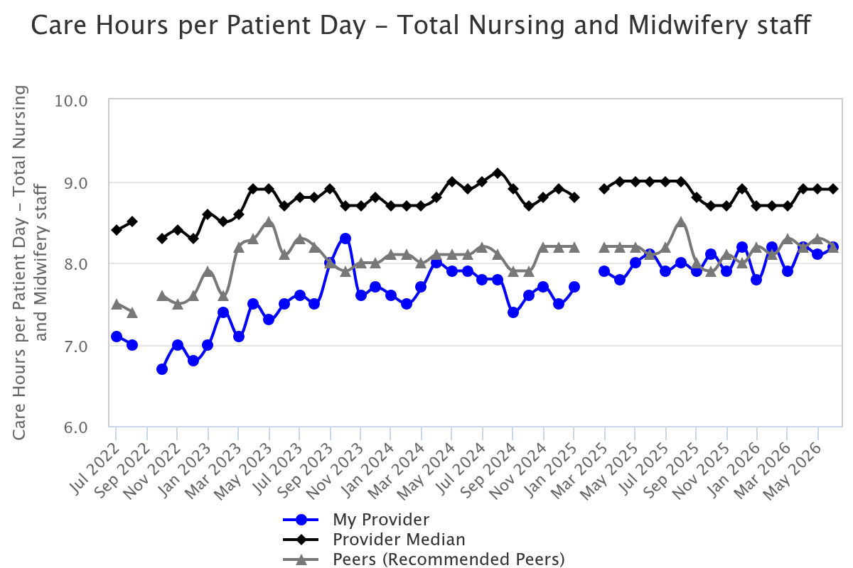

Appendix 4. Nursing Red Flags (NICE 2014), Incident Reports and

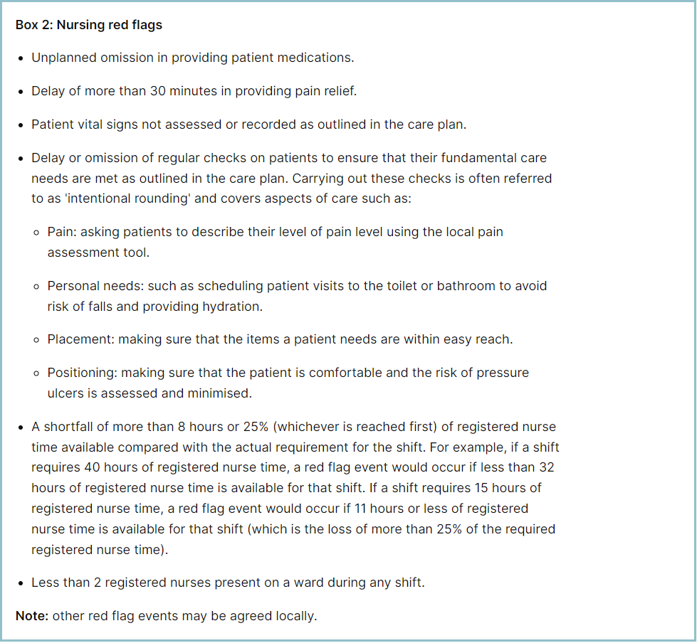 Table 1. Occasions registered staffing fell below 75% of standard template – August 2026
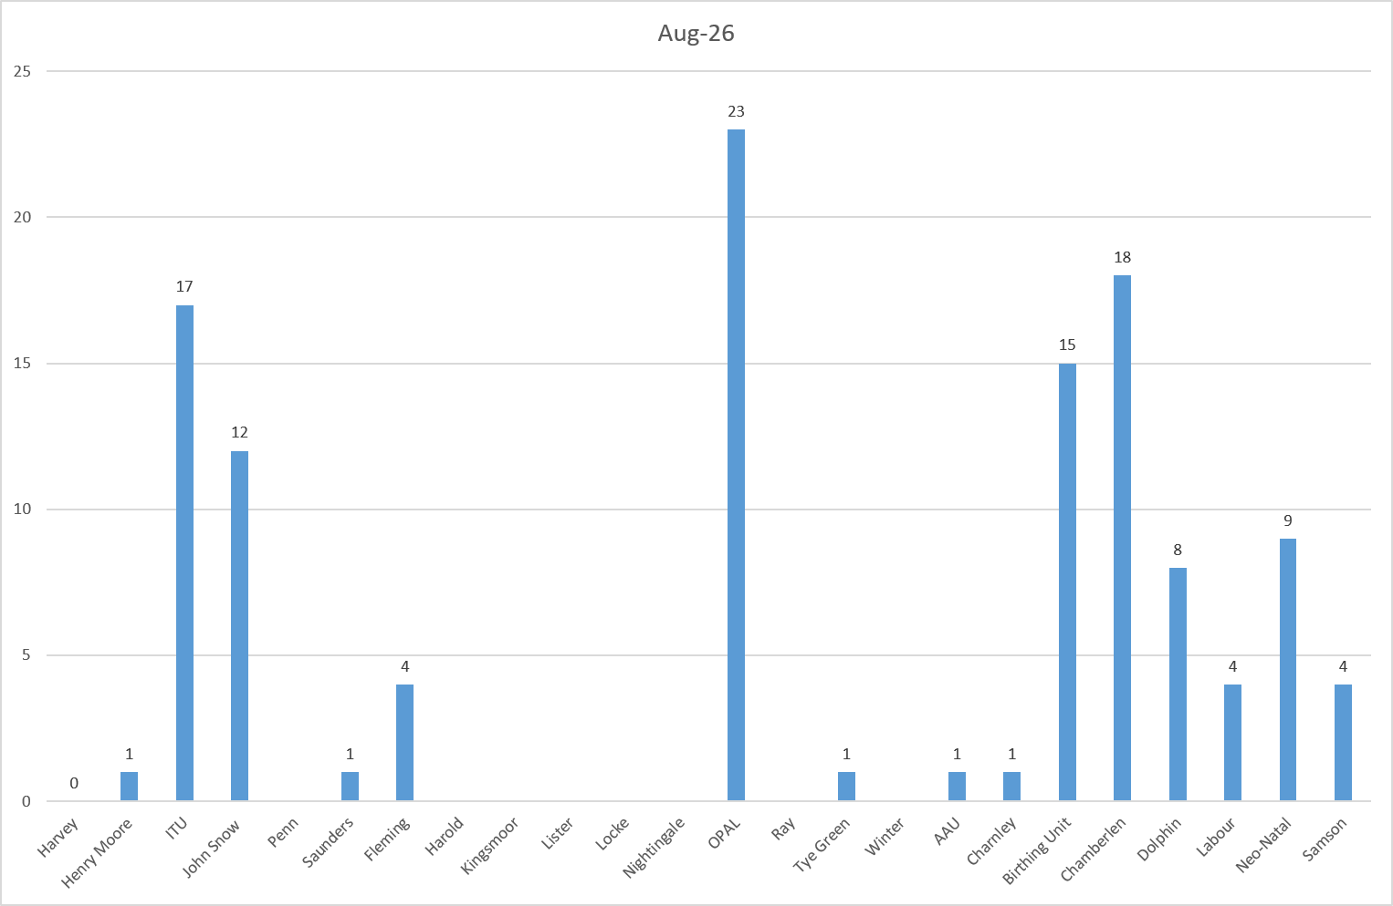
Table 2a. Occasions when registered staffing fell below 75% of standard template. Trend Data Aug-25 –Jul-26
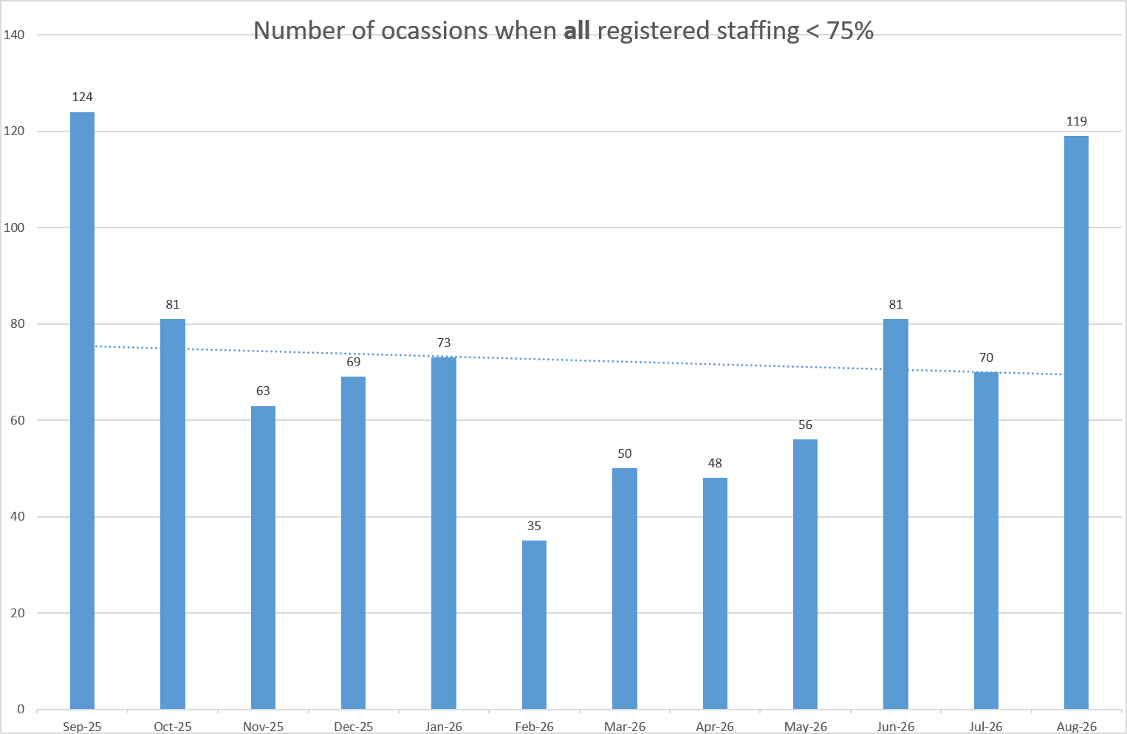
Table 2b. Occasions when registered maternity staffing fell below 75% of standard template. Trend Data Aug-25 –Jul-26
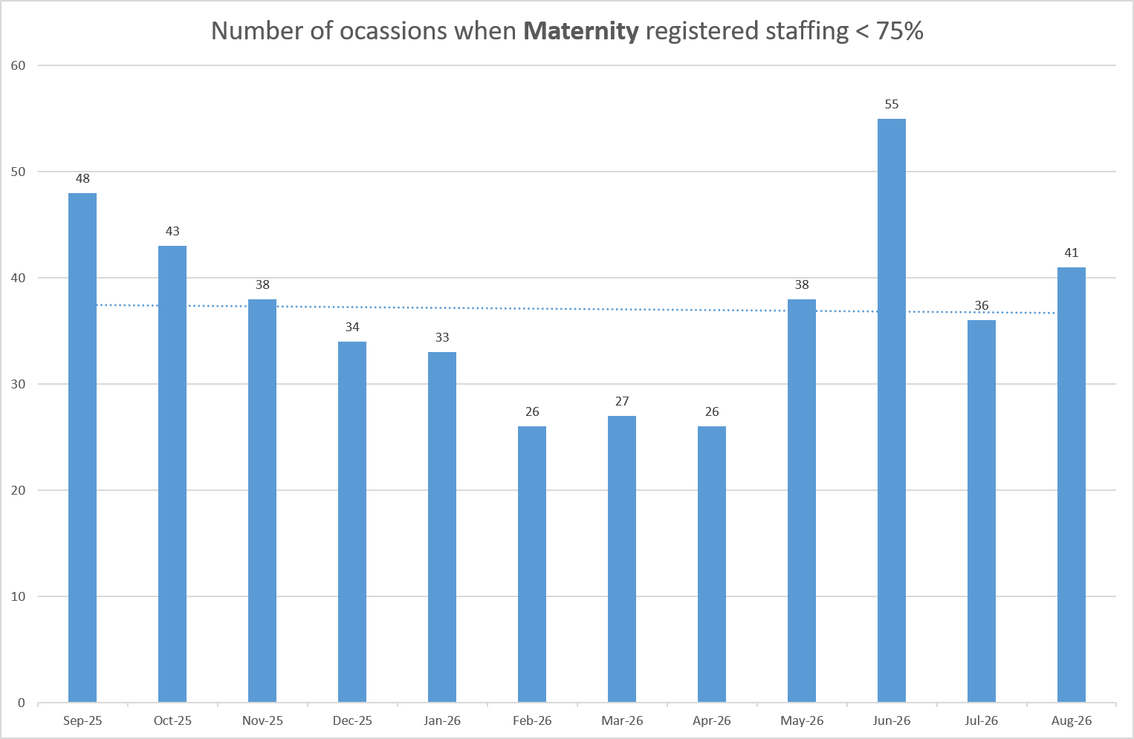
Table 3a. Red Flags raised via SafeCare Aug-26
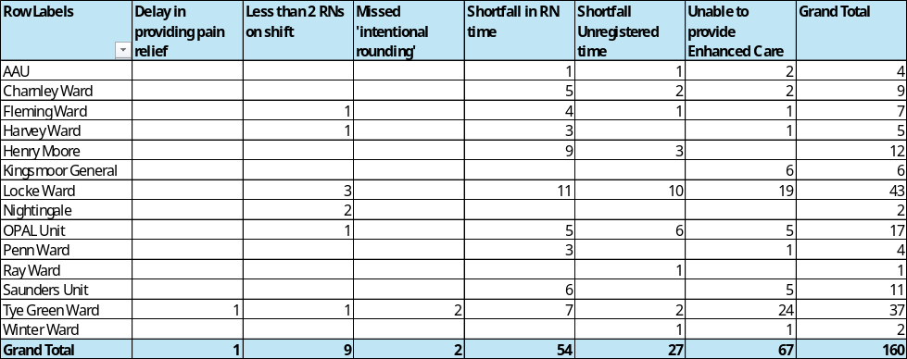
Table 3b. Red Flags raised via SafeCare trend Sep-25 – Aug-26
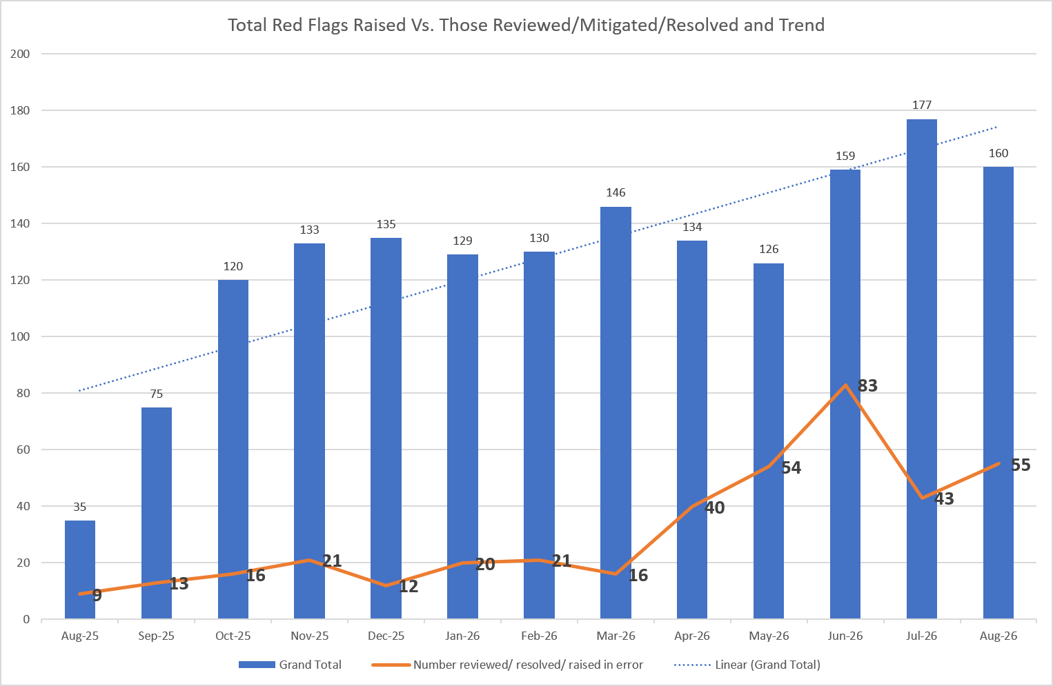
Table 3c. Datix for lack of suitably trained / skilled staff

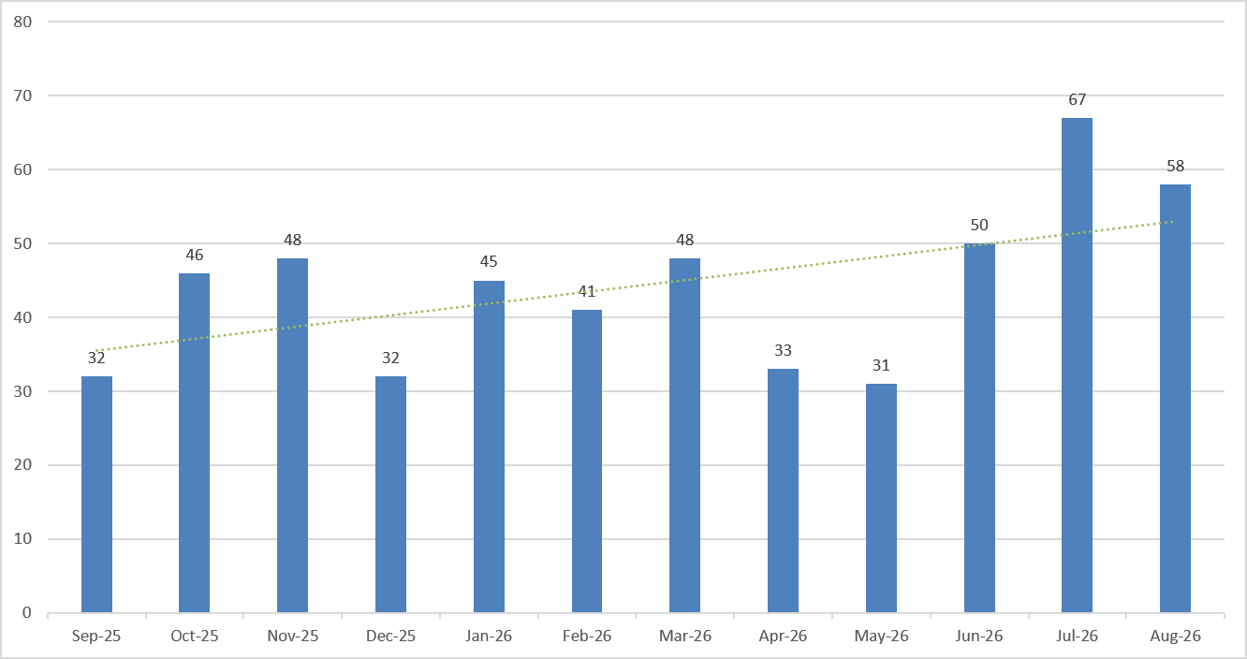

Appendix 5: Nursing quality indicators
Falls
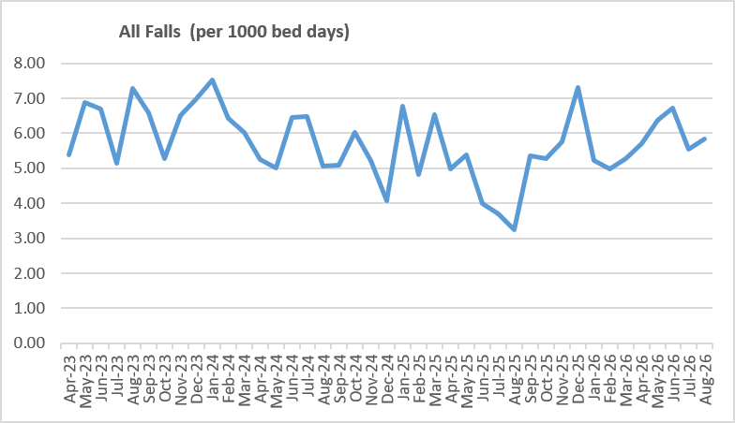
Table 1: Falls Rate per 1000 bed days August 2026

Table 2: Number of falls and categories in August 2026
 | Total falls in month | Top 3 wards
Total falls | 82 ↑ | AAU & Locke – 8 |  | Kingsmoor, Ray & Tye Green – 7
Unwitnessed falls | 51 ↓ | AAU - 7 | Tye Green – 6 |  | Locke & Ray – 5
Falls with harm * | 22 ↑ | OPAL – 4 | AAU – 3 |  | Lister – 3
*Subject to change following review at Falls Incident Oversight Group

Pressure Ulcers
Table 2: Number of Hospital Acquired Pressure Ulcers (HAPU)
 | Total in month | Top Departments
Total skin changes | 36↓ | Harold – 10 | Lister – 6 |  | Tye Green, Locke & Charnley – 3
Reportable HAPU’s | 11↓ | Lister – 3 |  | Harold – 2
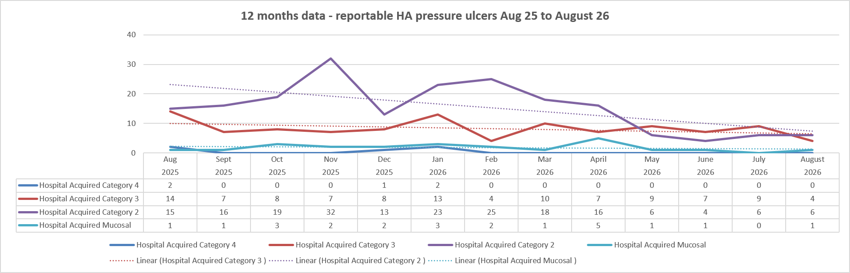

Complaints, PALS and Compliments Trend Data Sept-25 – Aug-26
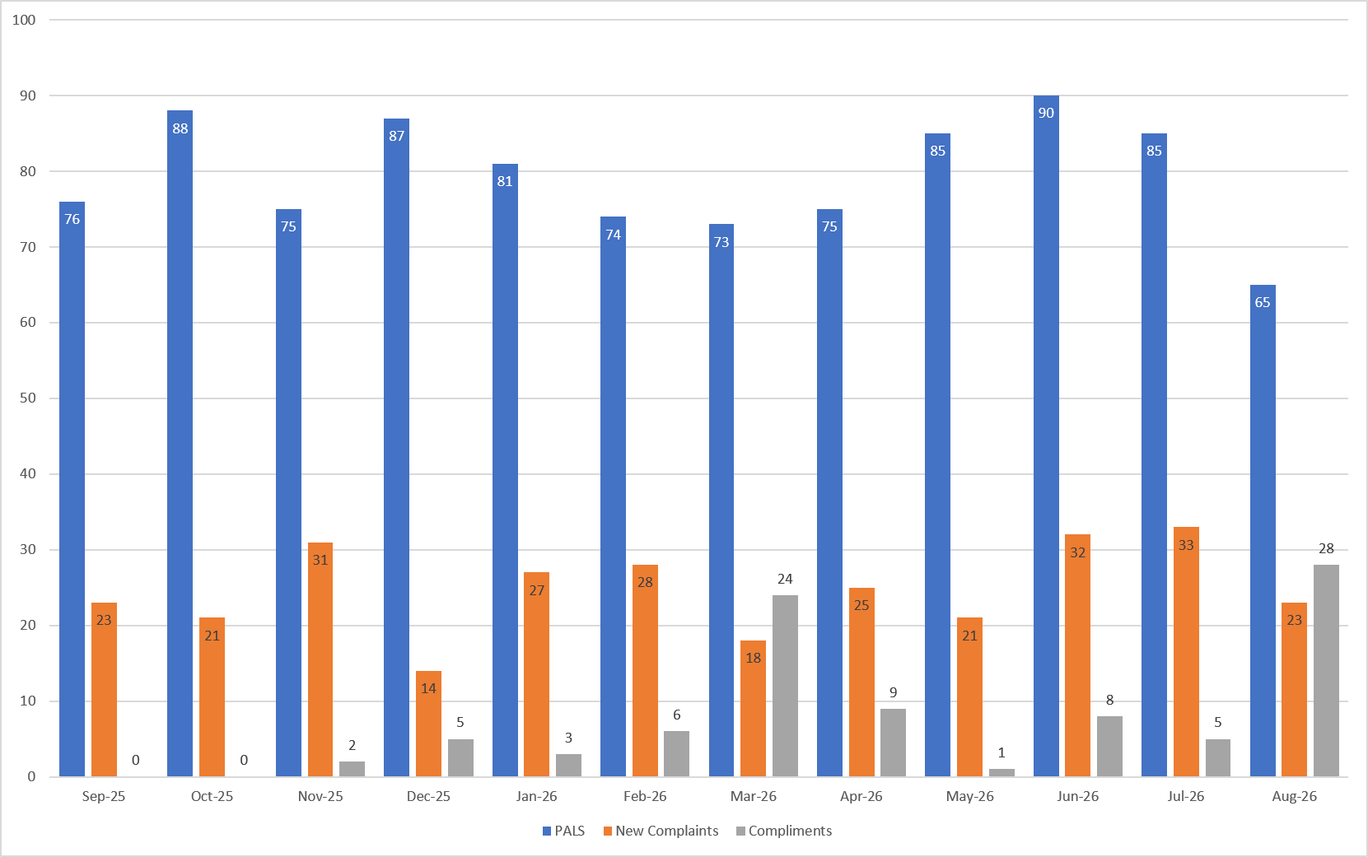
Table 3. Number of new Complaints, PALS and Compliments in July 2026 with top three wards highlighted

 | Total in month | Top Departments
New complaints | 23 ↓ | A&E – 9 | Locke – 3 |  | Labour – 2
PALs | 65 ↓ | A&E – 17 | Ray - 7 |  | Penn – 6
Compliments | 28 ↑ | A&E & Fleming – 7 |  | Henry Moore & Harvey – 3

Complaints: main themes: Communications – 19.82%, Cancellations – 18.92%, Medical care – 13.51%
PALS: main themes: Delay – 33.29%, Communication – 24.47%, Appointments – 15.79%
Compliments: themes not provided.

Table 4: Nursing and Midwifery Staffing and Quality data – August 2026
