Agenda item:  Presented by:  Prepared by:  Date prepared:  Subject / title: | Safe Staffing Monthly report  Giuseppe Labriola – Deputy Chief Nurse  Charlotte Collings, Lead Nurse for Safer Staffing and Workforce and Giuseppe Labriola – Deputy Chief Nurse  17 September 2025  Report on Nursing and Midwifery staff levels for August 2025.
Purpose: | Approval |  | Decision |  |  | Information |  | x | Assurance |  | x
Key issues: | There has been a sustained overall registered fill of > 95%.  No wards achieved < 75% overall fill rate in month.  The increase in overall fill rates continue to be multifaced with an increase of enhanced care needs
Recommendation: | The committee are asked to note the information within this report.
Trust strategic objectives: |   Patients |   People |  |   Performance |  |  |   Places |  |  |   Pounds
Trust strategic objectives: | x | x |  | x |  |  |  |  |  | x
Previously considered by: | NA
Risk / links with the BAF: | BAF: 2.3 Workforce capacity
Legislation, regulatory, equality, diversity and dignity implications: | NHS England and CQC letter to NHSFT CEOs (31.3.14): Hard Truths Commitment regarding publishing of staffing data.  NHS Improvement letter: 22.4.16  NHS Improvement letter re CHPPD: 29/6/18
Appendices: | Appendix 1: Ward and divisional fill rates by month against adjusted standard planned template.  Appendix 2: Ward and divisional CHPPD data  Appendix 3: Nursing red flags  Appendix 4: Nursing quality indicators

1.0 Introduction
This paper illustrates how PAHT’s nursing and midwifery staffing has been deployed for August 2025. It shows how planned staffing has been successfully achieved and how this is supported by nursing and midwifery recruitment and deployment.

2.0 Background
The National Quality Board (NQB 2016) recommend that monthly, actual staffing data is compared with expected staffing and reviewed alongside quality of care, patient safety, and patient and staff experience data. The Trust is committed to ensuring that improvements are learned from and celebrated, and areas of emerging concern are identified and addressed promptly. This paper will show safe staffing and actions taken in August 2025. The following sections identify the processes in place to demonstrate that the Trust proactively manages nursing and midwifery staffing to support patient safety.
3.0 Inpatient wards fill rate
The Trust’s safer staffing submission has been submitted to NHS Digital for August 2025 within the data submission deadline. Table 1 shows the summary of the overall fill rate for this month. Table 2 shows a summary of overall fill rate percentages for a rolling 12-month period.
Appendix 1 illustrates a ward-by-ward breakdown for this period.
3.1 Wards with < 75% average fill rate
Nightingale had an overall fill rate of <75% in August.
Nightingale was temporarily closed with staff redeployed across the organisation and to Poplar ward at St Margaret’s Hospital.
3.2 Wards with > 100% average fill rate
Henry Moore Ward continues to have an increased fill rate due to fluctuating capacity and opening of additional surgical beds and a Level 1 area for post-operative patients, the Level 1 bay is staffed by ITU, and the staffing is reflected in their numbers. The mid-year nursing and midwifery establishment review, which has been approved, proposed changes to the workforce model which will inform the required establishment.
Greater than 100% fill rate for Registered Nurse (RN) shifts continues to be mainly attributable to enhanced care requirements, a task and finish group is now in place reviewing enhanced care requirements.
The Trust continues to use NHS Professionals to mitigate vacant shifts and in addition agency nursing to support patients that need Registered Mental Health Nurse’s. Additional control measures continue to be in place about the creation of additional duties.
Furthermore, our senior nurses and midwives are also supporting individual areas when needed. SafeCare data continues to be collected three times a day to enhance staffing governance across the organisation.
Further detail can be found in Appendix 1

Table 1. Overall fill rate
Average day fill rate - registered nurses/midwives | Average day fill rate - care staff | Average night fill rate - registered nurses/midwives | Average night fill rate - care staff | % Registered overall fill rate | % HCSW overall fill rate | % Overall fill rate
94.3% | 108.6% | 99.0% | 122.4% | 96.4% | 114.9% | 102.4%

Table 2. Inpatient fill rate including Maternity Wards Trend

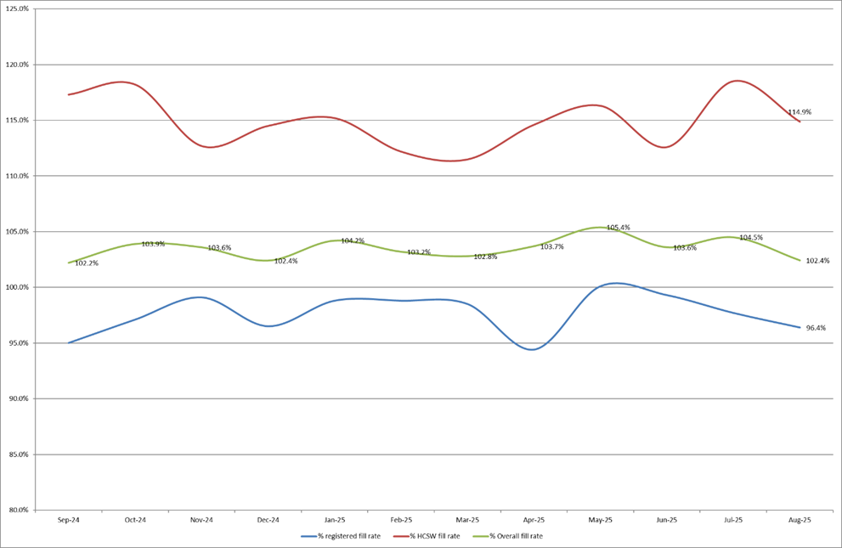

4.0 Care Hours Per Patient Day (CHPPD)

CHPPD allows comparison and benchmarking of a ward’s CHPPD figure with that of other wards in the hospital, or with similar wards in other hospitals. It can be used to look at variation between similar wards to ensure the right staff are being used in the right way and in the right numbers.
The hours worked during day and night shifts by registered nurses and midwives and healthcare assistants are added together. This figure is then divided by the number of patients at midnight; this then gives the total CHPPD.
By itself, the CHPPD does not reflect the total amount of care provided on a ward nor does it directly show whether care is safe, effective or responsive. It should therefore be considered alongside measures of quality and safety.

Table 3. Overall Care Hours Per Patient Day (CHPPD) August 2025

Registered CHPPD | Unregistered CHPPD | Total CHPPD
5.0 | 2.9 | 8.0

The Model Hospital data (June 2025) shows the Trust with a CHPPD of 8.0 against the national median of 9.0. Table 4 also shows the Trusts total CHPPD against our peers (East and North Hertfordshire NHS Trust and West Hertfordshire Teaching Hospitals NHS Trust).
Appendix 2 shows the individual ward and divisional CHPPD for August 2025
Table 4. CHPPD Trend

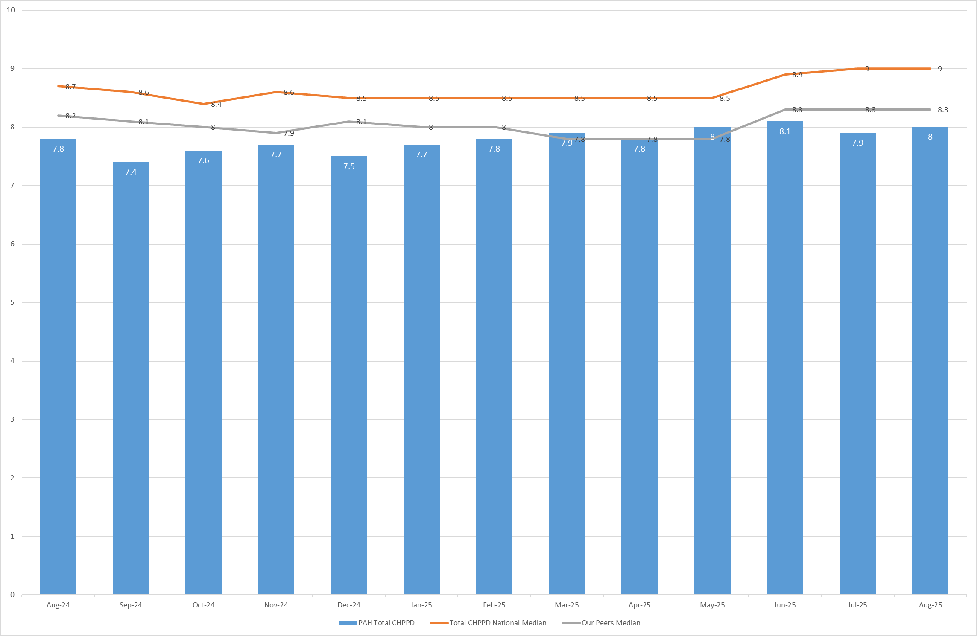

5.0 Quality Indicators

5.1 Nursing Red Flags
Nursing red flags prompt an immediate response by the registered nurse in charge of the ward. The response may include distributing additional nursing staff to the ward or other appropriate responses. Appendix 3 details the NICE (2014) definition of Nursing Red Flags. This includes the number of occasions when registered staffing fell below 75% of the standard template with trend, and the number of Red Flags raised in SafeCare.

5.2 Quality indicators (Falls, pressure ulcers and complaints, PALS and compliments)
Nursing quality indicators have been reviewed and there is no correlation between these, fill rates or red flags which are a cause of concern. A review of quality indicators can be found in Appendix 4.

6.0 Conclusion
The Trust continues to achieve a sustained overall registered fill of > 95%. The increase in overall fill rates for support workers is due to enhanced care needs.
7.0 Recommendation
The board are asked to note the information in this report to provide assurance on the daily mitigation of nursing and midwifery staffing.

Appendix 1: Ward level data and narrative: fill rates August 2025 (Adjusted Standard Planned Ward Demand)
>100% | 95 – 100% | 75-95% | <75%

 | Day |  | Night
Ward name | Average fill rate - registered nurses/midwives (%) | Average fill rate - care staff (%) | Average fill rate - registered nurses/midwives (%) | Average fill rate - care staff (%) | % Registered overall fill rate | % HCSW overall fill rate | % Overall fill rate
Harvey | 88.5% | 155.3% | 100.0% | 160.9% | 93.2% | 158.0% | 116.7%
Henry Moore | 137.9% | 172.2% | 175.9% | 183.5% | 153.1% | 177.6% | 163.8%
ITU & HDU | 91.5% | 119.9% | 98.2% | 101.0% | 94.9% | 110.9% | 96.3%
John Snow | 94.1% | 47.2% | 88.7% | 32.3% | 91.5% | 40.1% | 74.3%
Penn | 94.9% | 133.7% | 99.2% | 174.3% | 96.7% | 149.1% | 115.5%
Saunders | 78.6% | 111.1% | 110.3% | 142.9% | 90.5% | 123.2% | 102.8%
Surgery Total | 94.5% | 129.7% | 106.2% | 145.7% | 99.7% | 136.6% | 110.5%
Fleming | 86.8% | 118.1% | 100.0% | 123.4% | 92.4% | 120.6% | 101.0%
Harold | 92.3% | 110.0% | 99.5% | 118.2% | 95.4% | 113.9% | 101.3%
Kingsmoor | 93.9% | 143.9% | 111.3% | 157.7% | 100.5% | 150.5% | 119.1%
Lister | 86.2% | 91.0% | 93.3% | 107.5% | 89.2% | 98.9% | 93.1%
Locke | 92.0% | 116.4% | 100.0% | 140.4% | 95.4% | 127.9% | 108.4%
Nightingale | 58.2% | 2.4% | 11.3% | 1.5% | 35.8% | 1.9% | 18.8%
Opal | 114.8% | 114.0% | 78.1% | 107.7% | 97.2% | 111.0% | 102.7%
Ray | 102.7% | 111.4% | 112.9% | 157.8% | 107.0% | 129.0% | 114.9%
Tye Green | 106.9% | 120.7% | 109.7% | 164.4% | 108.1% | 138.5% | 119.9%
Winter | 91.5% | 120.1% | 100.0% | 138.4% | 95.1% | 128.9% | 108.6%
Medicine Total | 94.0% | 108.2% | 96.8% | 125.4% | 95.2% | 116.1% | 103.1%
AAU | 88.5% | 134.4% | 100.0% | 150.9% | 93.6% | 142.3% | 103.8%
Charnley | 97.0% | 137.9% | 94.6% | 146.7% | 95.8% | 142.1% | 109.0%
UEC Total | 91.7% | 136.2% | 97.7% | 148.8% | 94.5% | 142.2% | 106.0%
Birthing | 84.8% | 85.8% | 84.4% | 87.1% | 84.6% | 86.4% | 85.2%
Chamberlen | 98.7% | 84.4% | 93.5% | 74.2% | 96.2% | 79.5% | 92.0%
Dolphin | 88.3% | 59.2% | 94.1% | 87.1% | 90.9% | 68.5% | 85.3%
Labour | 96.5% | 86.3% | 96.5% | 86.4% | 96.5% | 86.4% | 94.2%
Neo-Natal Unit | 101.5% | 45.2% | 102.8% | 71.0% | 102.2% | 58.1% | 94.8%
Samson | 102.7% | 81.6% | 94.5% | 80.2% | 98.8% | 80.9% | 88.6%
CHAWS Total | 95.9% | 75.9% | 95.8% | 81.3% | 95.9% | 78.4% | 90.6%
Total | 94.3% | 108.6% | 99.0% | 122.4% | 96.4% | 114.9% | 102.4%

Trust wide – there has been a successful recruitment event for newly qualified nurses to join trust wide positions, offers were made for 6 children’s nurses, 28 adult nurses and 2 dual-registered adult/mental health nurses. It is expected they will join teams throughout the Autumn.
Lister and Saunders Ward – both areas had a temporary relocation to Nightingale ward to facilitate repairs and deep cleaning of their clinical areas. Nightingale is a smaller ward and therefore full staffing establishments relative to the reduced inpatient beds were applied for these temporary movements, this provides accounts for the lower registered nursing fill rate throughout August.
John Snow Ward – the HCSW shifts are often under template by 1 WTE, this is due to fluctuating ward capacity throughout the month in addition to the HCSW being re-deployed to other areas through the daily safe staffing meetings.
OPAL Unit – have been trialling a new shift pattern which isn’t currently reflected in their template, this accounts for the over fill for RNs on a day shift, and under fill for the Night shift. They now staff 4 RNs for the day and 2 at Night if assessment beds remain closed through the night. This will be formally reviewed with SNCT.
Dolphin and Neonatal Unit – low fill rates on day shifts for HCSW and nursery nurse shifts, both areas have vacancies and have recently recruited into these, this should be reflected in future data collections.
Maternity – the service continues to robustly review staffing through twice weekly staffing reviews and the use of BirthRate Plus. Safety is maintained by daily staffing huddles and staff deployment according to acuity, support continues to be provided by specialist midwives and matrons being redeployed as needed. Birthrate Plus have been commissioned to review the workforce, and the workforce intentions will be available within the full year nursing and midwifery establishment review starting in September 2025.
The Trust continues as part of an Enhanced Care Collaborative working group supported by NHS England that is reviewing the provision of Enhanced Care including the workforce and training requirements to sustainably manage this demand.

Emergency Departments – national reporting is currently for inpatient areas and therefore does not include areas including the emergency department. To ensure the Board is sighted to staffing in these areas, the data for both adult ED and Paediatric ED is included below (Appendix 1a and 1b) using the same methodology as the full UNIFY report.

Appendix 1a: ED data and narrative: fill rates August 2025 (Standard Planned Demand)

Average day fill rate - registered nurses/midwives | Average day fill rate - care staff | Average night fill rate - registered nurses/midwives | Average night fill rate - care staff | % Registered overall fill rate | % HCSW overall fill rate | % Overall fill rate
98.4% | 97.0% | 112.0% | 112.5% | 104.5% | 103.9% | 104.3%

Appendix 1b: Paediatric ED data and narrative: fill rates August 2025 (Standard Planned Demand)
Average day fill rate - registered nurses/midwives | Average day fill rate - care staff | Average night fill rate - registered nurses/midwives | Average night fill rate - care staff | % Registered overall fill rate | % HCSW overall fill rate | % Overall fill rate
119.6% | 75.2% | 146.3% | 86.1% | 131.4% | 80.6% | 115.8%

Paediatric Emergency Department – Shows a low overall fill rate for HCSW’s and higher than template for RNs in ED. Following discussions with the divisional team and reviewing SNCT data, it has been identified that creating a middle shift should mitigate some of these figures as the key driver is improving the workforce efficiency, this is under review.

Appendix 2: Ward level data: CHPPD August 2025

Care Hours Per Patient Day (CHPPD)
Ward | Registered Nurses/Midwives | Non-registered Nurses/Midwives | Overall
Trust Total | 5.0 | 2.9 | 8.0
Harvey Ward | 5.4 | 3.1 | 8.5
Henry Moore Ward | 3.9 | 3.8 | 7.7
ITU & HDU | 3.7 | 3.3 | 6.9
John Snow Ward | 18.2 | 2.1 | 20.3
Penn Ward | 6.3 | 1.4 | 7.6
Saunders Unit | 3.6 | 3.1 | 6.8
Surgery Total | 3.9 | 3.2 | 7.0
Fleming Ward | 3.8 | 2.2 | 6.0
Harold Ward | 4.6 | 2.5 | 7.1
Kingsmoor General | 3.7 | 3.3 | 6.9
Lister Ward | 3.9 | 2.9 | 6.8
Locke Ward | 3.6 | 3.2 | 6.8
Nightingale Ward | 1.3 | 0.1 | 1.4
Opal Unit | 5.6 | 4.2 | 9.8
Ray Ward | 4.0 | 2.7 | 6.7
Tye Green Ward | 4.5 | 3.7 | 8.2
Winter Ward | 3.5 | 3.2 | 6.7
Medicine Total | 3.9 | 2.9 | 6.8
AAU | 6.1 | 2.5 | 8.5
Charnley Ward | 4.2 | 2.5 | 6.8
UEC Total | 5.2 | 2.5 | 7.7
Birthing Unit | 12.7 | 6.5 | 19.2
Chamberlen Ward | 7.7 | 2.1 | 9.9
Dolphin Ward | 12.7 | 3.2 | 15.9
Labour Ward | 24.8 | 6.3 | 31.2
Neo-Natal Unit | 11.0 | 1.2 | 12.2
Samson Ward | 2.7 | 3.0 | 5.7
CHAWS Total | 8.8 | 3.1 | 11.9

Appendix 3. Nursing Red Flags (NICE 2014) and trend data

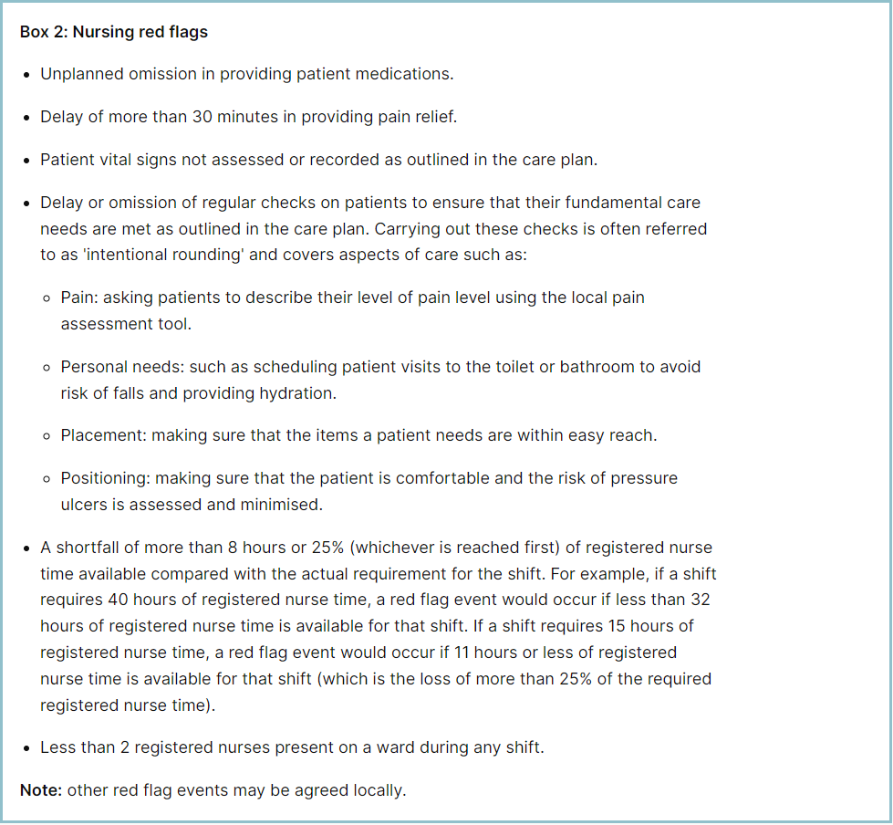

Staffing red flags and trend data

The number of occasions / shifts where the reported fill rate has fallen below 75% across the wards is available in Table 1. This increased by 66 occasions in August 2025 to 135, with 31 within maternity. The large rise is largely attributed to the temporary closure of Nightingale ward who accounted for 54 of these incidences, when we remove Nightingales figures from this – who typically have between 0-3 staffing red flags per month as per last 12-month data – the occasions of staffing red flags is 81, which is comparable to other months.
Table 2 shows the trend for when registered staffing fell below 75% of standard template.

Table 1. Occasions when registered staffing fell below 75% of standard template August 2025
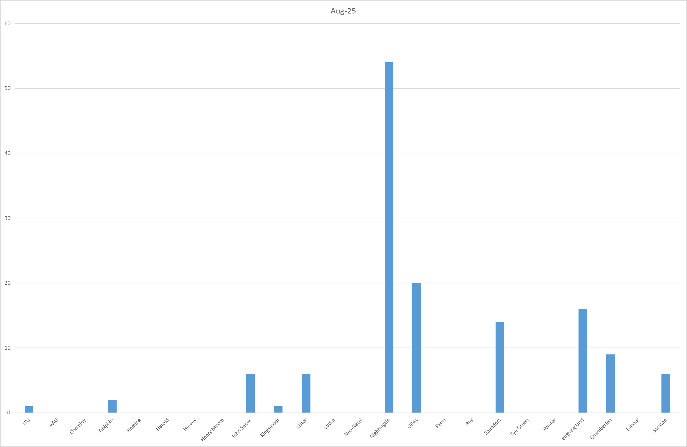

Table 2. Occasions when registered staffing fell below 75% of standard template.
Trend Data September 2024 – August 2025
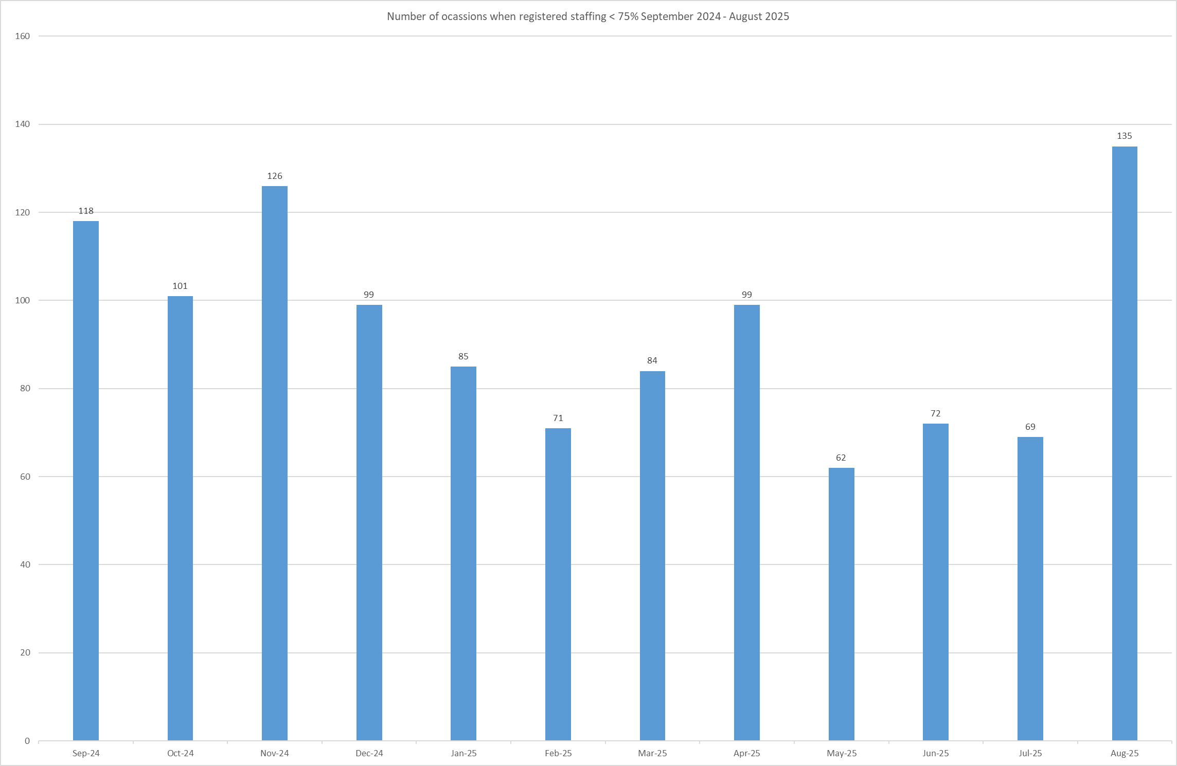

All adult inpatient areas capture staffing shortfalls on SafeCare by raising a Red Flag on the system. Table 3a shows the Red Flags raised through SafeCare in August 2025. Table 3b shows the number of Red Flags raised for adult inpatient wards has decreased with 35 raised in August against 47 for July.
To improve oversight into how many incidents relating to when Enhanced Care could not be provided, the Trust has also added a local Red Flag highlighting when this occurs in SafeCare. This and the addition of Enhanced Care Level 3 Patient task will also enable the Trust to provide data to the Enhanced Care Collaborative and ensure staffing is appropriately deployed. These have now been rolled out across all adult inpatient wards. From September, Adult ED will also be able to log enhanced care patients to support staff deployment decisions.
There needs to be robust validation of the red flags by managers and matrons to understand which have been mitigated and closed, which is not currently demonstrated in Table 3a below. This will be a focused aspect of work with the divisions.
Table 3a. Red Flags raised via SafeCare August 2025

Table 3b. Red Flags raised via SafeCare trend Nov-24 – Aug-25

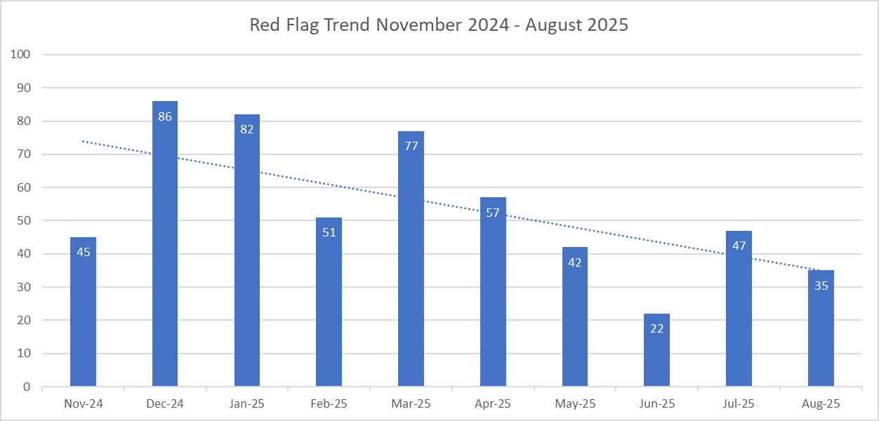

It can be noted that raising red flags remains inconsistent, and typically demonstrates a reduced trend monthly, more needs to be explored to encourage staff reporting red flags in SafeCare as it is believed these are under-reported.

Redeployment

Redeployment of staff continues to be undertaken to support safe staffing as part of the daily staffing huddles. Table 4 details the trend in August 2025 with Nightingale redeploying the highest number of substantive staff with John Snow being the next highest. The highest net receiver of staff was A&E followed by Charnley. Table 5 shows the number of substantive staff redeployments per month trend

Table 4. Hours of substantive staff redeployed August 2025 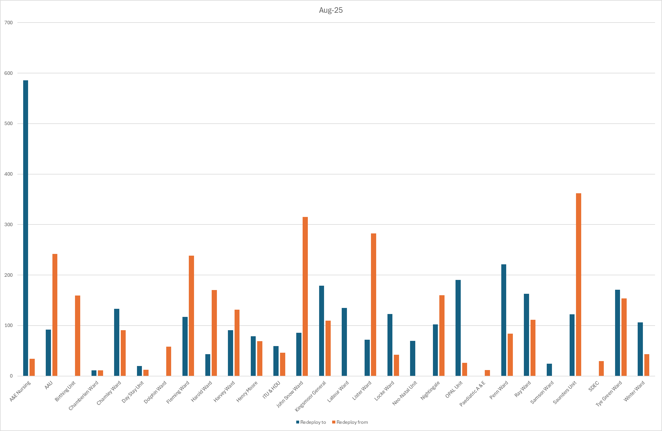

Table 5. Substantive staff redeployment trend

This report looks at the number of shifts substantive staff working are redeployed, it does not include the shifts when agency, bank or multi-post holders are redeployed.

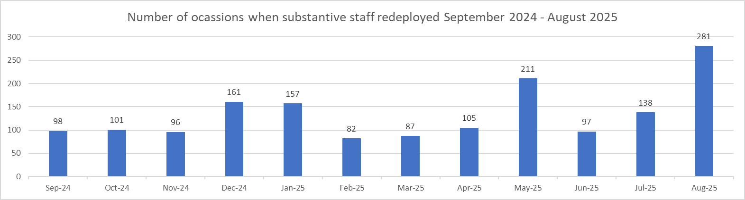

Table 6. % of substantive staff redeployed as % of total hours worked
Substantive staff hours redeployed | Total hours worked (inc bank and agency) | % of total hours worked / substantive staff redeployed
2619.5 | 140625 | 1.86%

Table 7. % of staff redeployed as % of total hours worked
All staff hours redeployed (including bank and agency but excluding Enhanced Care Team, Bank Pool and Rapid Response Pool) | Total hours worked (inc bank and agency) | % of total hours worked / staff redeployed (including bank and agency but excluding Enhanced Care Team, Bank Pool and Rapid Response Pool)
2993.6 | 140625 | 2.13%

Table 6 shows the hours of substantive staff moved as a percentage of total hours worked.
Table 7 shows the hours of all staff including bank and agency, excluding the Enhanced Care Team, Bank Pool and Rapid Response Pool staff.

The data detailing nurse redeployment shows that the numbers of staff reassigned are minimal and continues to not be a cause of concern, however, has increased marginally from last month (0.24% Substantive, 0.27% all staff). The redeployment process is efficiently managed with improved governance and oversight.

Appendix 4: Nursing quality indicators

Table 1. Number of falls, unwitnessed falls and falls with harm in August 2025, with the top 3 wards being highlighted.
 | Total falls in month | Top 3 wards
Total falls | 59 | Winter – 11 | Kingsmoor – 6 | Ray – 6
Unwitnessed falls | 43 | Winter – 9 | Ray – 6 | Kingsmoor – 5
Falls with harm * | 10 | Winter - 4 | Charnley, ED, Fleming, Harvey, Ray, Saunders – 1
*Subject to change following review at Falls Incident Oversight Group

August’s data sees an overall decrease in total falls from 63 to 59, an increase of unwitnessed falls from 41 to 43 and decrease of falls with harm from 17 to 10.

The Trust falls reduction strategy and workplan (2025/2026) is still in place and mandatory falls training has increased to 97%. The matron for Kingsmoor and Harold wards is doing targeted work to support reducing unwitnessed falls in these areas.

Falls Rate per 1000 bed days August 2025 data

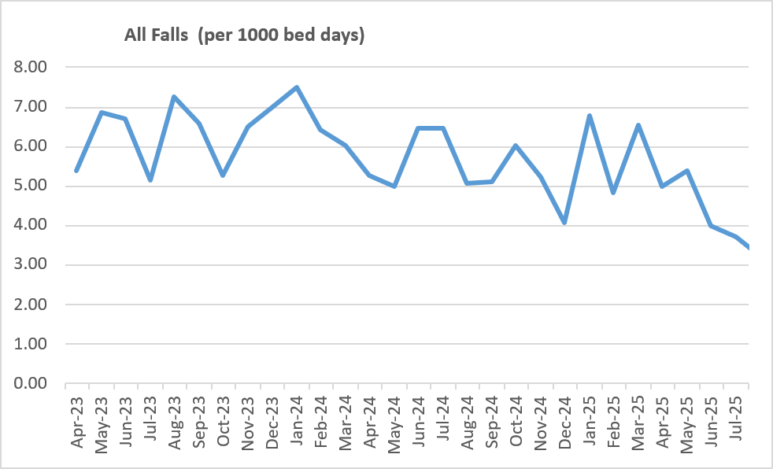

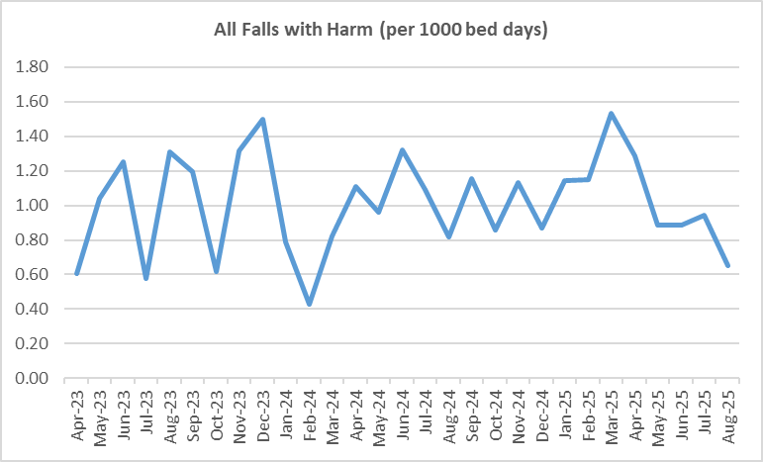

Pressure Ulcers

Table 2a. Number of Hospital Acquired Pressure Ulcers (HAPU) Cat 2 and Cat 3 Pressure Ulcers
There was an increase in August for reportable HAPUs (21 to 32) and non-reportable skin changes (43 to 63) compared to last month and a significant increase in category 3 HAPUs (14 from 4). There were also 2 HAPU category 4s (Penn and ITU). Of the 16 incidents for category 3s and 4s currently 12 are deemed moderate harms and 4 minor harms – this will be validated with PS&Q discussion once all investigations are complete.

Through August, the practice development team had pressure ulcers as their ‘Hot Topic’ of the month, reaching 350 members of staff.

"Pressure Ulcer Prevention Wednesday" will recommence in September with a focus on
Moisture Associated Skin Damage, a contributory factor for pressure ulcers.

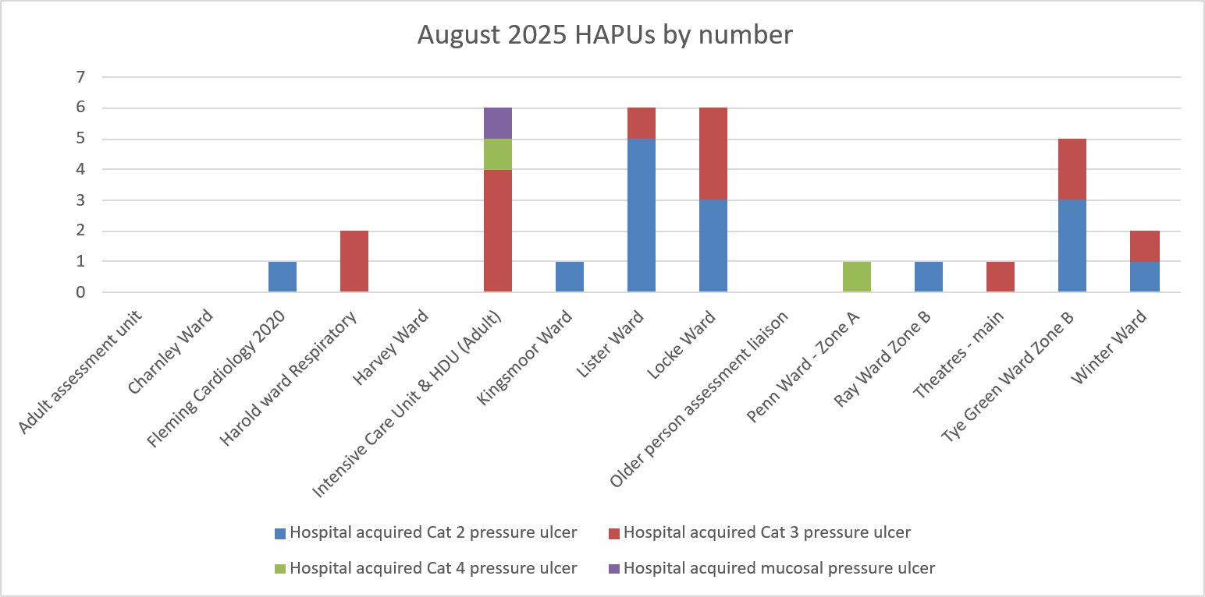

Total in month | Top 3 wards
32 | ITU/HDU - 6 | Lister - 6 | Locke - 6

Table 2b. Reported Incidents and Actual Hospital Acquired Pressure Ulcers August 2025

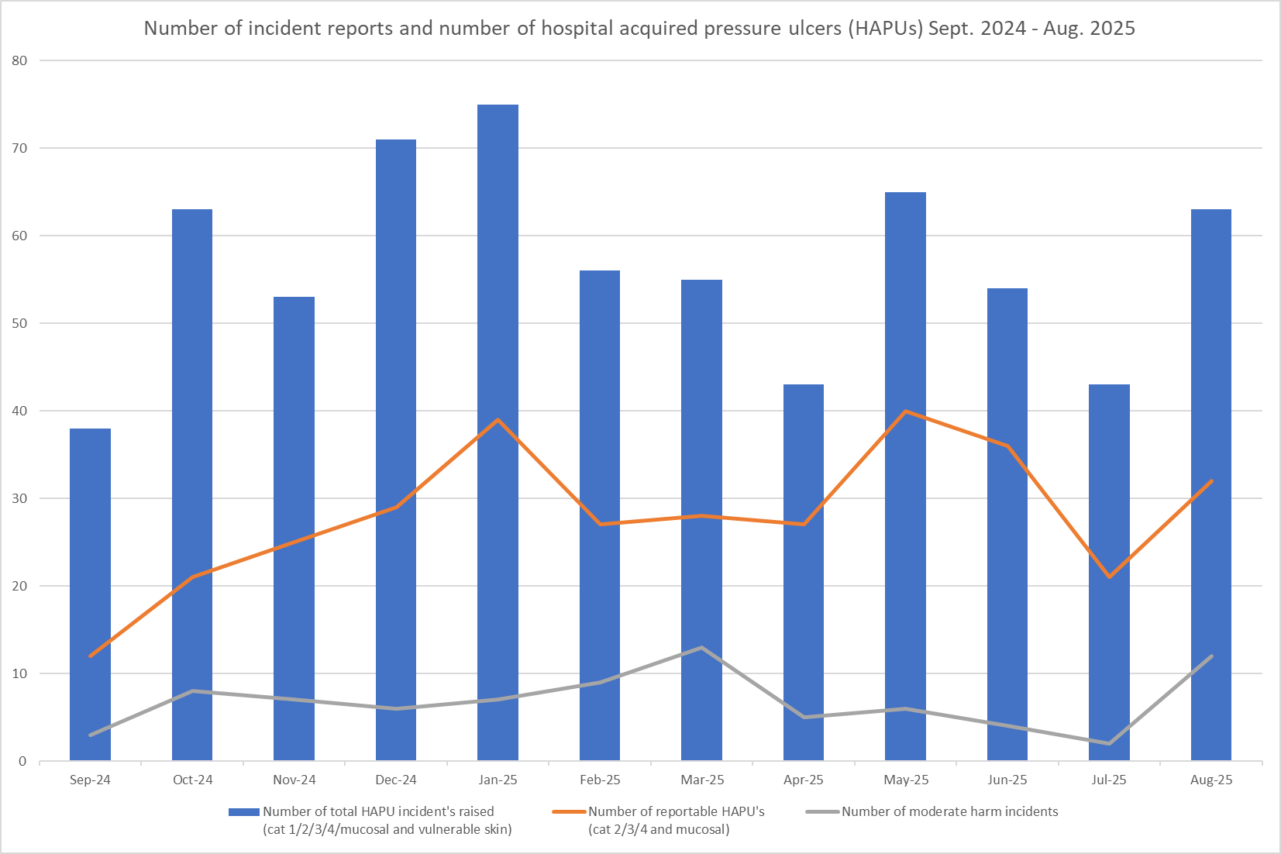


Hospital acquired pressure ulcer data taken from different sources can be inconsistent and not comparable. Due to these variables a more unified approach to data capture and data reporting is underway and therefore the rate per 1000 occupied bed days is currently not being completed. As a consequence the footfall is not reflected in the graph.
The above chart captures:
- The number of incident forms completed per month relating to total number of skin changes (category 1,2,3,4, mucosal and vulnerable skin/deep tissue injury)
- The actual number of reportable pressure ulcers per month
- The number of moderate harm incidents validated.

The number of reportable HAPU’s has increased this month, as have the number of validated moderate harm incidents.

It is important to note that the number of incidents reported does not equal the number of HAPUs. Multiple incidents reported in the year will have included more than one HAPU per incident due to the patient's skin being vulnerable.

Complaints, PALS and Compliments Trend Data January 2025 – August 2025

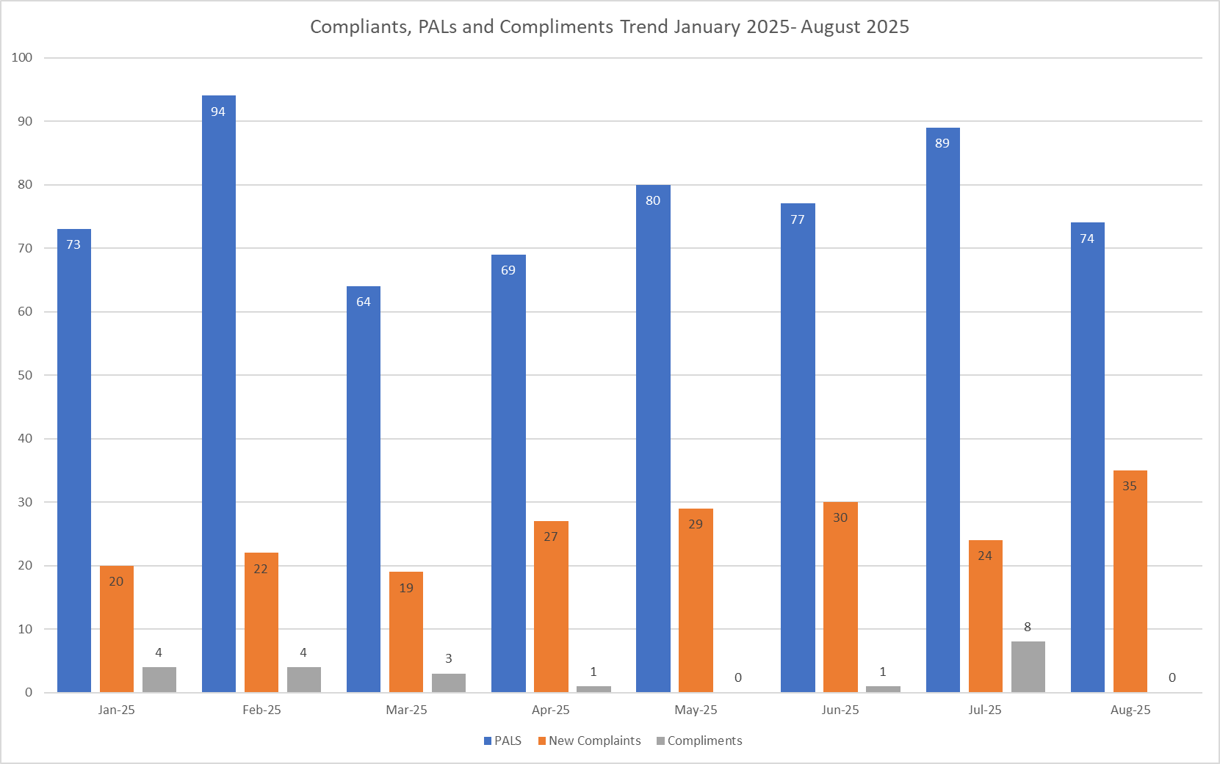

Table 3. Number of new Complaints, PALS and Compliments in August 2025 with top three wards highlighted

 | Total in month | Top Departments
New complaints | 35 | A&E 15 | Birthing Unit - 6 | Charnley, Lister, Ray - 5
PALs | 74 | A&E 10 | Labour - 4 | Lister - 3
Compliments | None recorded

The main themes for PALS concerns received in August 2025 are as follows:

- Delay – 33.73%
- Communication – 25.00%
- Appointments – 10.61%

The main themes for Complaints received in August 2025 are as follows:

- Communication – 19.73%
- Medical care – 13.61%
- Delay – 12.93%

The main themes for Compliments received in August 2025 are as follows:
Unfortunately, compliments received in August 2025 have not been logged on Datix this month.

