|  |  |  |  |  |  |  |  |  |  |  |  |
| --- | --- | --- | --- | --- | --- | --- | --- | --- | --- | --- | --- |
| **Agenda item:**  **Presented by:**  **Prepared by:**  **Date prepared:**  **Subject / title:** | Jo Ward – Deputy Chief Nurse  David Dellow – Safe Staffing Lead and Jo Ward – Deputy Chief Nurse    16.9 2024  Report on Nursing and Midwifery staff levels for August 2024. | | | | | | | | | | |
| **Purpose:** | **Approval** |  | **Decision** | |  | **Information** | | **x** | **Assurance** | | **x** |
| **Key issues:** | The overall fill rate remains stable. No ward reported average fill rates below 75% for RN’s against the standard planned template during the reporting period. | | | | | | | | | | |
| **Recommendation:** | The committee are asked to note the information within this report. | | | | | | | | | | |
| **Trust strategic objectives:** | Princess Alexandra_strap line blocks NHS blue text  **Patients** | Princess Alexandra_strap line blocks NHS blue text  **People** | | **Performance** | | | **Places** | | | Princess Alexandra_strap line blocks NHS blue text  **Pounds** | |
| x | x | | x | | |  | | | x | |
|  |  | | | | | | | | | | |
| **Previously considered by:** | NA | | | | | | | | | | |
| **Risk / links with the BAF:** | BAF: 2.1 Workforce capacity  All divisions have both recruitment and retention on their risk registers | | | | | | | | | | |
| **Legislation, regulatory, equality, diversity and dignity implications:** | NHS England and CQC letter to NHSFT CEOs (31.3.14): Hard Truths Commitment regarding publishing of staffing data.  NHS Improvement letter: 22.4.16  NHS Improvement letter re CHPPD: 29/6/18 | | | | | | | | | | |
| **Appendices:** | **Appendix 1:** Ward and divisional fill rates by month against adjusted standard planned template. RAG rated.  **Appendix 2**: Ward and divisional CHPPD data  **Appendix 3:** Nursing Red Flags (NICE 2014)  **Appendix 4:** Occasions when registered staffing fell below 75% trend  **Appendix 5:** Substantive staff redeployment trend  **Appendix 6:** Falls SPC charts  **Appendix 7:** Pressure Ulcers SPC charts  **Appendix 8:** Complaints, PALS and Compliments Trend | | | | | | | | | | |

**1.0 Introduction**

This paper illustrates how PAHT’s nursing and midwifery staffing has been deployed for the month of August 2024. It evidences how planned staffing has been successfully achieved and how this is supported by nursing and midwifery recruitment and deployment.

**2.0 Background**

The National Quality Board (NQB 2016) recommend that monthly, actual staffing data is compared with expected staffing and reviewed alongside quality of care, patient safety, and patient and staff experience data. The trust is committed to ensuring that improvements are learned from and celebrated, and areas of emerging concern are identified and addressed promptly. This paper will identify safe staffing and actions taken in August 2024. The following sections identify the processes in place to demonstrate that the Trust proactively manages nursing and midwifery staffing to support patient safety.

**3.0 Inpatient wards fill rate**

The Trust’s safer staffing submission has been submitted to NHS Digital for August 2024 within the data submission deadline. Table 1 shows the summary of the overall fill rate for this month. Appendix 1 illustrates a ward-by-ward breakdown for this period. Table 2 shows a summary of overall fill rate percentages for a rolling 12-month period.

Due to the continuing fluctuating capacity John Snow Ward has not consistently been sending 1 of the 2 day HCA shifts to NHSP. This continues to impact on the number of HCA shifts being redeployed from the ward during August, both of these factors continue to impact on the HCA fill rate for day and night.

Maternity continue to robustly review staffing through twice weekly staffing reviews and use of Birthrate Plus. Safety is maintained by daily staffing huddles and staff deployment according to acuity, while support is provided by specialist practitioners and Matrons being redeployed as required.

The impact of staffing requirements for patients requiring enhanced care is shown in the number of wards which continue to have greater than 100% fillrate, this is especially demonstrated in wards such as Nightingale, Ray and Harvey night fillrate for HCAs. The fillrate is based against the standard ward template.

Greater than 100% fill rate for RN shifts is attributable to RMN 1:1 requirements or supporting the induction of newly qualified/registered RNs.

We continue to utilise NHS Professionals (NHSP) and agency to mitigate vacant shifts, though continue to reduce our temporary staffing pools. New control measures have been put in place regarding the creation of additional duties. In addition, our senior nurses and midwives are also supporting individual areas if required. SafeCare data continues to be collected three times a day to improve staffing governance across the organisation.

**Table 1. Overall fill rate**

|  |  |  |  |  |  |  |
| --- | --- | --- | --- | --- | --- | --- |
| **Average day fill rate - registered nurses/midwives** | **Average day fill rate - care staff** | **Average night fill rate - registered nurses/midwives** | **Average night fill rate - care staff** | **% Registered overall fill rate** | **% HCSW overall fill rate** | **% Overall fill rate** |
| **95.2%** | **113.6%** | **101.8%** | **124.4%** | **98.1%** | **118.5%** | **104.7%** |

**Table 2. Inpatient fill rate including Maternity Wards Trend**

**4.0 Care Hours Per Patient Day (CHPPD)**

CHPPD allows comparison of a ward’s CHPPD figure with that of other wards in the hospital, or with similar wards in other hospitals. It can be used to look at variation between similar wards to ensure the right staff are being used in the right way and in the right numbers.

The hours worked during day and night shifts by registered nurses and midwives and healthcare assistants are added together. This figure is then divided by the number of patients at midnight, this then gives the total CHPPD. The number of registered and unregistered hours can be divided by the number of patients to understand the registered and unregistered CHPPD.

By itself the CHPPD does not reflect the total amount of care provided on a ward nor does it directly show whether care is safe, effective or responsive. It should therefore be considered alongside measures of quality and safety.

**Table 3. Overall Care Hours Per Patient Day (CHPPD) August 2024**

|  |  |  |
| --- | --- | --- |
| Registered CHPPD | Unregistered CHPPD | Total CHPPD |
| 5.0 | 2.9 | 7.8 |

The Model Hospital data for June 2024 shows the Trust with a CHPPD of 7.9 against the national median of 8.5**.** Table 4 also now shows the Trusts total CHPPD against our peers (East and North Hertfordshire NHS Trust and West Hertfordshire Teaching Hospitals NHS Trust)

Appendix 2 shows the individual ward and divisional CHPPD for August 2024

**Table 4. CHPPD Trend**

**5.0 Quality Indicators**

**5.1 Nursing Red Flags**

Nursing red flags prompt an immediate response by the registered nurse in charge of the ward. The response may include allocating additional nursing staff to the ward or other appropriate responses. Appendix 3 details the NICE (2014) definition of Nursing Red Flags. Currently this information cannot be monitored for all nursing red flags on the DATIX incident reporting system. Following a meeting on the 4th September chaired by the Deputy Chief Nurse (Interim) to discuss capturing Red Flags going forward it was decided that, due to the current configuration of SafeCare and the implementation of Alex Health we will delay introducing a new process to support additional oversight of Red Flags until Alex Health has been implemented.

In the interim a trial of using SafeCare to capture Red Flags will take place on Winter Ward to support an informed decision about how the process will work following the launch of Alex Health.

This report already captures staffing of less than 75% and less than 2 RNs on a shift.

The Trust has a robust Red Flag three times daily staffing review process where issues are raised, discussed and escalated.

Staff are still utilising Datix to raise staffing concerns and the number of staffing Datix relating to “lack of suitably trained / skilled staff” is being reinstated into this report. Table 5.5 shows the number of Datix relating to “lack of suitably trained / skilled staff” in August.

A shortfall of more than 8 hours or 25% (whichever is reached first) of registered nurse time available, compared with the actual requirement for the shift is a nursing red flag.

The number of occasions/shifts where the reported fill rate has fallen below 75% across the wards is available in Table 5. This increased by 23 occasions in August to 102. The majority of this was in Maternity which rose from 44 in July to 77 in August.

Appendix 4 details the staffing red flags trend.

**Table 5. Occasions when registered staffing fell below 75% of standard template**

**5.2 Falls**

**Table 6. Number of falls, unwitnessed falls and falls with harm in August, with the top 3 wards being highlighted**

|  |  |  |  |  |
| --- | --- | --- | --- | --- |
|  | Total falls in month | Top 3 wards | | |
| Total falls | 68 | Lister 10 | AAU 8 | Charnley 7 |
| Unwitnessed falls | 57 | Lister 8 | AAU 8 | Charnley, Harold, Kingsmoor and Locke 5 |
| Falls with harm \* | 11 | Lister 2 | AAU 2 |  |

*\*subject to change following review at Falls Incident Oversight Group*

The Trust falls reduction strategy and workplan (2024/2025) remains in place and mandatory falls training has increased to 92%.

**5.3 Pressure Ulcers**

**Table 7. Number of Hospital Acquired Pressure Ulcers (HAPU) Cat 2 and Cat 3 Pressure Ulcers (including unstageable)**

In August there were 25 HAPU’s compared to 34 last month. However, the number of category 3 and mucosal HAPUs have increased this month.

This month, the highest number of HAPUs developed on Charnley (5) followed by Harold and ITU with 4 each. Charnley and ITU are due to present their quality improvement action plan for pressure ulcers this month at the Pressure Ulcer Oversight Group

Tye Green reduced their number of HAPUs (2 from 4 last month), so they are on a downward trajectory. This month Locke ward and Winter ward have achieved zero HAPUs compared to 5 and 6

The tissue viability’s main focus continues to be around teaching staff about the new pressure ulcer risk assessment tool ‘Purpose T’ which will be implemented with AlexHealth and continuing to highlight the importance of pressure ulcer prevention.

**5.4 Complaints, PALS and Compliments**

**Table 8. Number of new Complaints, PALS and Compliments in August with top three wards highlighted**

|  |  |  |  |  |
| --- | --- | --- | --- | --- |
|  | Total in month | Top 3 wards | | |
| New complaints | 12 | Harvey 2 | Penn 2 | 8 wards with 1 each |
| PALs | 47 | A&E 8 | Ray 5 | Saunders 4 |
| Compliments | 0 |  |  |  |

The 3 main PALS themes for August were:

* Delay – 35.25%, Communication – 23.04%, Appointments 13.09%

Complaints themes for August were as follows

* Communication 20.18%, Medical Care 19.27% Nursing Care – 18.35%

Appendix 8 shows the trend for complaints, PALs and compliments.

**5.5** **Datix – Lack of suitably trained / skilled staff**

**Table 9. Number of Datix raised for lack of suitably trained / skilled staff in August**

Datix reports in relation to lack of suitability trained / skilled staff was 33 for August, with Labour Ward, Tye Green and Neo National Intensive Care raising 5 each.

**6.0 Redeployment**

Redeployment of staff continues to be undertaken to support safe staffing as part of the daily staffing huddles. Table 9 details the trend in August with OPAL redeploying the highest number of substantive staff with Tye Green being the next highest. The highest net receiver of staff remains Nightingale ward alongside Henry Moore and OPAL wards.Appendix 5 demonstrates the number of substantive staff redeployments per month trend.

**Table 10. Hours of substantive staff redeployed August 2024**

Table 11 shows the hours of substantive staff moved as a percentage of total hours worked.

Table 12 shows the hours of all staff including bank and agency, excluding the Enhanced Care Team, Bank Pool and Rapid Response Pool staff.

**Table 11. % of substantive staff redeployed as % of total hours worked**

|  |  |  |
| --- | --- | --- |
| Substantive staff hours redeployed | Total hours worked (inc bank and agency) | % of total hours worked / substantive staff redeployed |
| 1096 | 136986 | 0.8% |

**Table 12. % of staff redeployed as % of total hours worked**

|  |  |  |
| --- | --- | --- |
| All staff hours redeployed (including bank and agency but excluding Enhanced Care Team, Bank Pool and Rapid Response Pool) | Total hours worked (inc bank and agency) | % of total hours worked / staff redeployed (including bank and agency but excluding Enhanced Care Team, Bank Pool and Rapid Response Pool) |
| 2740 | 136986 | 2.0% |

The data detailing nurse redeployment indicates that the numbers of staff reassigned are minimal and not a cause of concern. The redeployment process is efficiently managed with improved governance and oversight.

**7.0 Conclusion**

This paper will evolve in the future to include the impact of staffing including additional nursing and midwifery sensitive indicators such as compliance with nationally mandated staffing such as CNST provision in midwifery. The paper will also demonstrate initiatives underway to review staffing establishments and activities to ensure nursing and midwifery workforce is deployed in the most cost-efficient way.

**8.0 Recommendation**

The committee are asked to note the information in this report to provide assurance on the daily mitigation of nursing and midwifery staffing.

**Appendix 1:** **Ward level data: fill rates August 2024. *(Adjusted Standard Planned Ward Demand)***

|  |  |  |  |
| --- | --- | --- | --- |
| >100% | 95 – 100% | 75-95% | <75% |

|  |  |  |  |  |  |  |  |
| --- | --- | --- | --- | --- | --- | --- | --- |
|  | **Day** | | **Night** | |  | | |
| **Ward name** | **Average fill rate - registered nurses/midwives (%)** | **Average fill rate - care staff (%)** | **Average fill rate - registered nurses/midwives (%)** | **Average fill rate - care staff (%)** | **% Registered overall fill rate** | **% HCSW overall fill rate** | **% Overall fill rate** |
| Harvey | 82.1% | 177.9% | 102.2% | 180.1% | 90.3% | 179.0% | 122.4% |
| Henry Moore | 105.6% | 126.9% | 142.0% | 121.0% | 120.2% | 124.1% | 121.9% |
| ITU & HDU | 102.7% | 106.7% | 105.5% | 128.3% | 104.1% | 117.5% | 105.3% |
| John Snow | 105.0% | 59.6% | 100.0% | 45.2% | 102.6% | 55.0% | 82.1% |
| Penn | 93.3% | 117.4% | 104.0% | 147.8% | 97.9% | 128.9% | 109.0% |
| Saunders | 93.7% | 113.4% | 123.3% | 131.5% | 104.8% | 120.3% | 110.6% |
| ***Surgery Total*** | ***97.1%*** | ***117.6%*** | ***110.0%*** | ***133.4%*** | ***102.8%*** | ***124.1%*** | ***109.2%*** |
| Fleming | 86.9% | 107.9% | 100.0% | 115.8% | 92.4% | 111.6% | 98.3% |
| Harold | 91.1% | 97.2% | 101.1% | 111.3% | 95.5% | 103.9% | 98.2% |
| Kingsmoor | 102.2% | 115.4% | 122.5% | 137.2% | 109.9% | 125.8% | 115.8% |
| Lister | 94.6% | 128.1% | 100.8% | 117.6% | 97.2% | 123.1% | 107.5% |
| Locke | 97.3% | 113.6% | 100.1% | 121.9% | 98.5% | 117.6% | 106.1% |
| Nightingale | 120.2% | 84.0% | 106.5% | 199.3% | 113.6% | 120.3% | 116.5% |
| Opal | 99.7% | 116.5% | 100.0% | 114.0% | 99.9% | 115.3% | 106.0% |
| Ray | 100.8% | 119.2% | 105.8% | 190.9% | 102.9% | 146.4% | 118.5% |
| Tye Green | 94.2% | 106.0% | 100.0% | 122.0% | 96.7% | 112.5% | 102.8% |
| Winter | 110.1% | 138.7% | 121.2% | 116.0% | 114.8% | 127.8% | 120.0% |
| ***Medicine Total*** | ***98.0%*** | ***113.5%*** | ***105.5%*** | ***128.8%*** | ***101.2%*** | ***120.3%*** | ***108.4%*** |
| AAU | 91.8% | 140.0% | 102.4% | 139.7% | 96.5% | 139.9% | 105.6% |
| Charnley | 101.9% | 148.1% | 102.8% | 153.0% | 102.4% | 150.5% | 116.1% |
| ***UEC Total*** | ***95.7%*** | ***144.1%*** | ***102.6%*** | ***146.4%*** | ***98.8%*** | ***145.2%*** | ***110.0%*** |
| Birthing | 96.5% | 100.4% | 70.7% | 96.8% | 84.2% | 98.7% | 89.0% |
| Chamberlen | 85.0% | 83.9% | 79.2% | 97.1% | 82.2% | 90.2% | 84.2% |
| Dolphin | 77.2% | 67.1% | 89.4% | 91.3% | 82.6% | 75.2% | 80.8% |
| Labour | 94.3% | 87.9% | 90.6% | 80.8% | 92.6% | 84.5% | 90.8% |
| Neo-Natal Unit | 88.2% | 96.8% | 91.0% | 93.5% | 89.6% | 95.2% | 90.5% |
| Samson | 79.4% | 124.3% | 87.2% | 98.9% | 83.1% | 112.2% | 97.7% |
| ***CHAWS Total*** | ***87.0%*** | ***96.6%*** | ***87.0%*** | ***93.0%*** | ***87.0%*** | ***95.0%*** | ***89.2%*** |
| ***Total*** | **95.2%** | **113.6%** | **101.8%** | **124.4%** | **98.1%** | **118.5%** | **104.7%** |

**Appendix 2: Ward level data: CHPPD August 2024.**

|  |  |  |  |
| --- | --- | --- | --- |
| Care Hours Per Patient Day (CHPPD) | | | |
| Ward | Registered Nurses/Midwives | Non-registered Nurses/Midwives | Overall |
| **Trust Total** |  |  |  |
| Harvey Ward | 3.7 | 4.2 | 7.9 |
| Henry Moore Ward | 4.4 | 3.5 | 7.9 |
| ITU & HDU | 28.0 | 3.2 | 31.2 |
| John Snow Ward | 6.8 | 2.8 | 9.5 |
| Penn Ward | 3.9 | 2.9 | 6.8 |
| Saunders Unit | 3.9 | 2.7 | 6.5 |
| **Surgery Total** | **6.1** | **3.2** | **9.3** |
| Fleming Ward | 3.7 | 2.0 | 5.7 |
| Harold Ward | 4.6 | 2.3 | 6.9 |
| Kingsmoor General | 4.1 | 2.8 | 6.8 |
| Lister Ward | 3.7 | 3.1 | 6.8 |
| Locke Ward | 3.7 | 2.9 | 6.6 |
| Nightingale Ward | 3.3 | 2.6 | 5.9 |
| Opal Unit | 4.5 | 3.5 | 8.0 |
| Ray Ward | 3.9 | 3.1 | 7.0 |
| Tye Green Ward | 4.3 | 3.2 | 7.4 |
| Winter Ward | 4.3 | 3.2 | 7.5 |
| **Medicine Total** | **4.0** | **2.8** | **6.9** |
| AAU | 6.5 | 2.5 | 9.0 |
| Charnley Ward | 4.6 | 2.7 | 7.3 |
| **UEC Total** | **5.5** | **2.6** | **8.1** |
| Birthing Unit | 17.2 | 10.1 | 27.2 |
| Chamberlen Ward | 4.9 | 1.8 | 6.7 |
| Dolphin Ward | 8.9 | 2.7 | 11.6 |
| Labour Ward | 12.8 | 3.3 | 16.1 |
| Neo-Natal Unit | 7.5 | 1.6 | 9.2 |
| Samson Ward | 1.9 | 2.5 | 4.4 |
| **CHAWS Total** | **6.2** | **2.6** | **8.8** |

**Appendix 3. Nursing Red Flags (NICE 2014)**

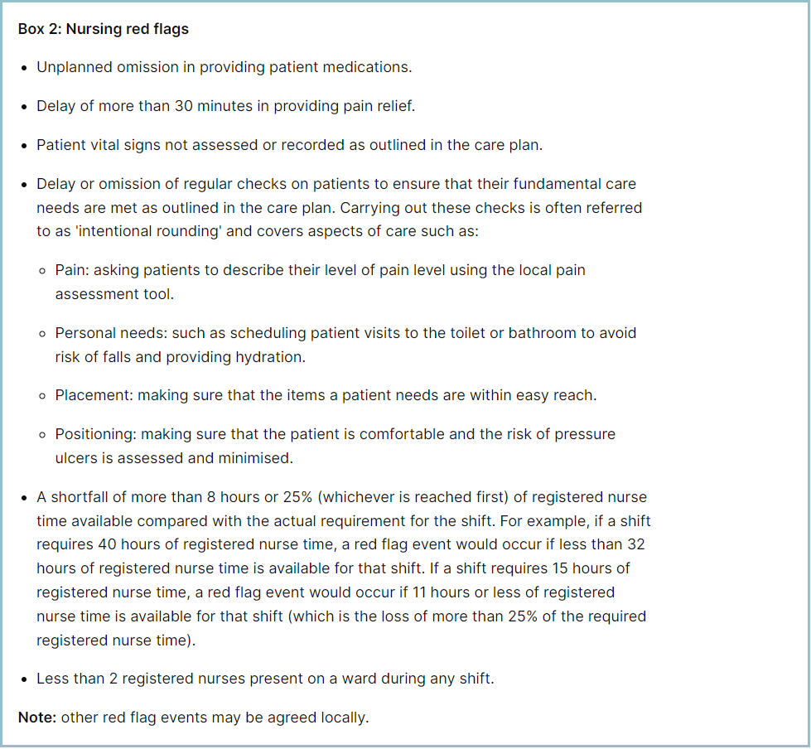

**Appendix 4: Staffing Red Flags Trend Data**

**Appendix 5: Substantive staff redeployment trend**

This reports looks at the number of shifts substantive staff working a shift are redployed, it does not include the shifts when agency, bank or multi post holders are redeployed.

**Appendix 6: Falls Rate per 1000 bed days**

**Appendix 7: Total Pressure Ulcer Rate per 1000 bed days and Moderate Harm Pressure Ulcer Rate per 1000 bed days trend.**

These reports were not available at the time of this report

**Appendix 8: Complaints, PALS and Compliments Trend Data**